HARDWARE SPECIFICATION
Flight Controller — Prototype v1

Parameter | Value
Document ID | HW-SPEC-PROTO-001
Version | 1.0 — Draft
Date | February 2026
Parent document | SYS-REQ-001
Status | Draft
Certification | Not certified — internal validation prototype only

1. Purpose
This document specifies the hardware requirements for the design and manufacture of the Flight Controller (FC) Prototype v1. It is intended for the hardware engineer responsible for PCB design, layout, and assembly.
The prototype serves to validate hardware choices prior to the certified DAL-B production design. It is not subject to DO-254 certification at this stage.

2. System Architecture
The FC system consists of three separate PCBs interconnected via board-to-board connectors:

Board | PCB Size | Role
FCU (Main Board) | 100 × 100 mm | MCU, inertial sensors, power interfaces, communication
GNSS + Compass Module | External module | u-blox ZOE-M8Q + AK09918C
Remote Control Module | External module | ExpressLRS SX1280 + ESP32-C3

- GNSS and RC modules connect to the FCU via board-to-board stacking connectors (left and right sides of the FCU)
- All three PCBs are 4-layer

2.1 Block Diagram
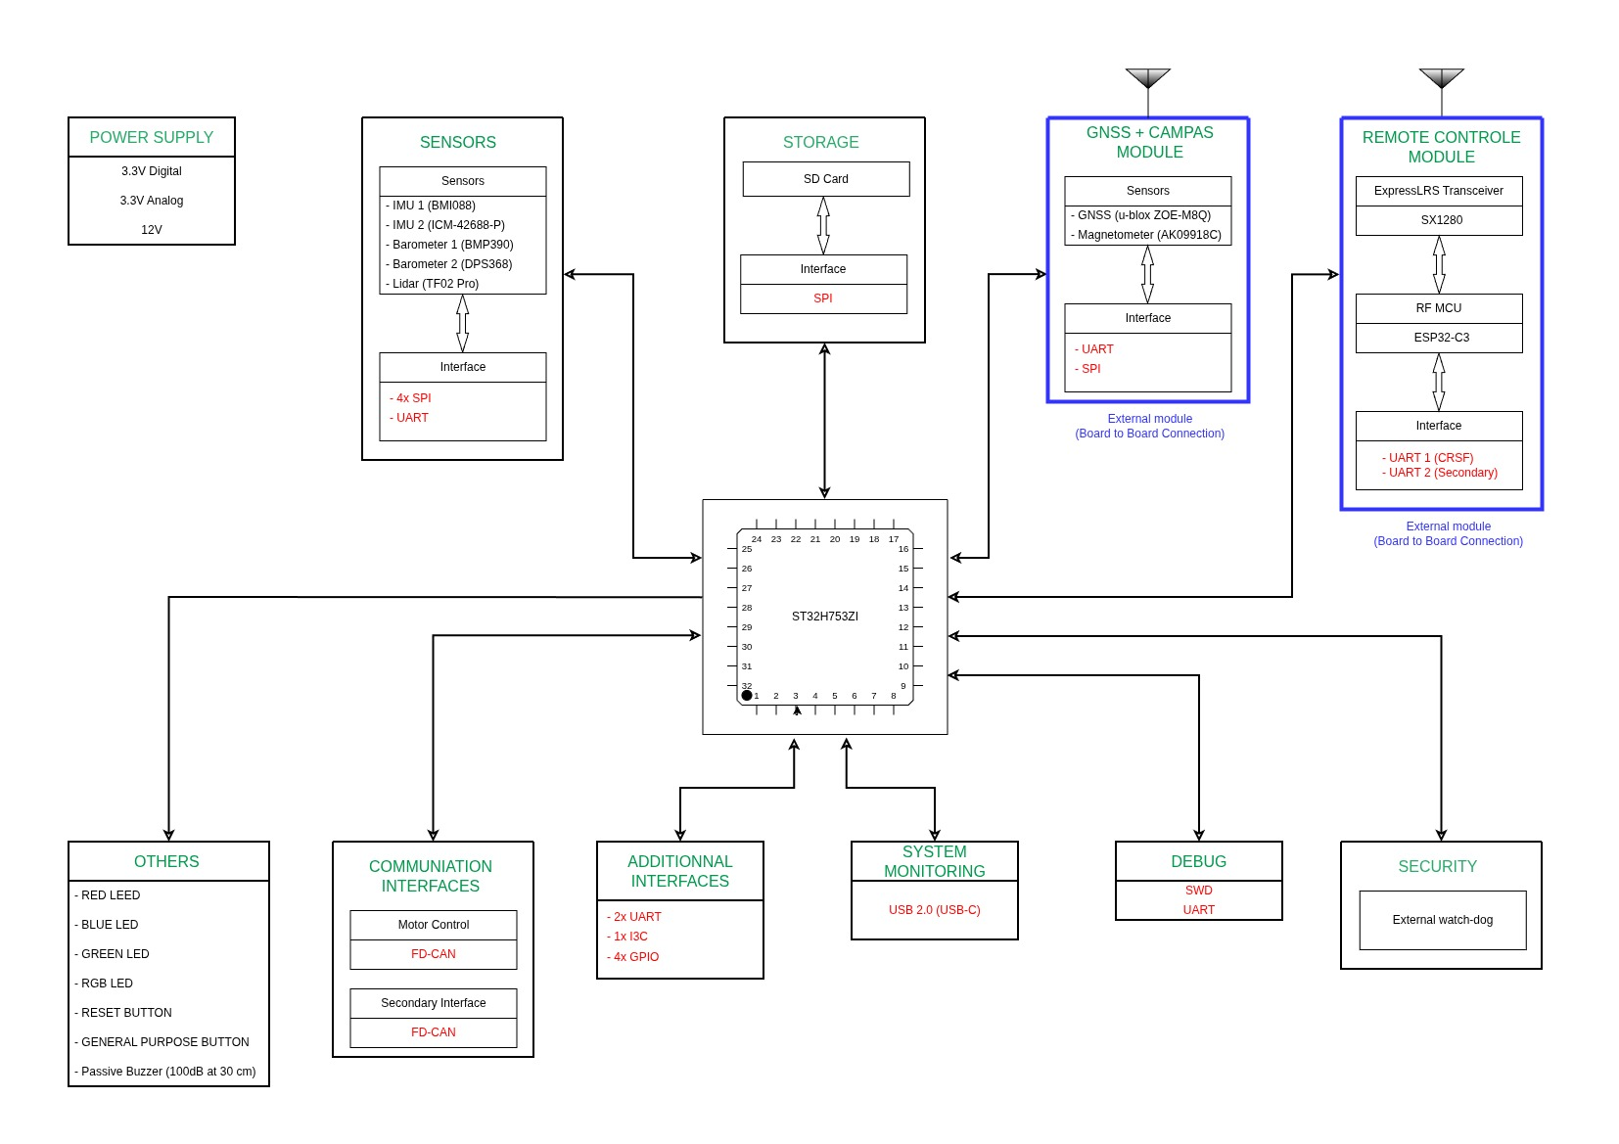
Figure 1 — FC System Block Diagram


2.2 Mechanical Layout
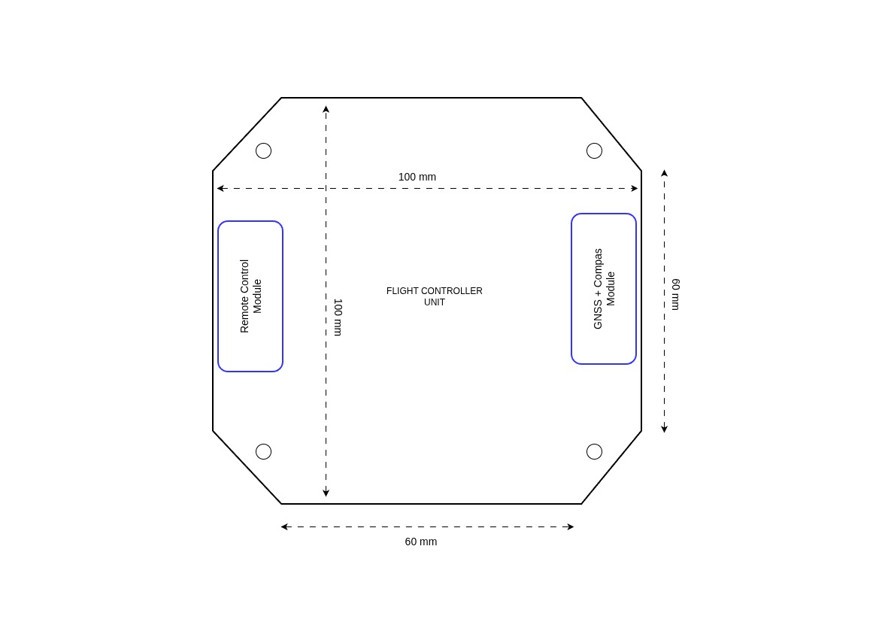
Figure 2 — FCU Board Layout (100 × 100 mm octagonal, modules on left and right sides)



3. Fixed Components
The following critical components are imposed. No substitution without prior validation.

3.1 FCU — Main Board
Microcontroller
Parameter | Value
MCU | ST32H753ZI
Architecture | ARM Cortex-M7 @ 480 MHz — hardware double-precision FPU
Justification | 16D EKF @ 1 kHz — SYS-REQ-F-010, SYS-REQ-F-013

Inertial Sensors — Redundancy Required (SYS-REQ-F-001)
Reference | Component | Bus | Rate | Notes
IMU 1 | BMI088 | SPI | ≥ 1 kHz | Gyro + Accel
IMU 2 | ICM-42688-P | SPI | ≥ 1 kHz | Gyro + Accel
Barometer 1 | BMP390 | SPI | ≥ 50 Hz
Barometer 2 | DPS368 | SPI | ≥ 50 Hz

IMPORTANT: Both IMUs and both barometers must be mounted on vibration isolation pads (soft-mount).

Distance Sensor
Reference | Component | Bus | Rate
Lidar | TF02 Pro | UART | ≥ 50 Hz — SYS-REQ-F-001

3.2 GNSS + Compass Module (external board)
Reference | Component | Interface to FCU | Rate
GNSS | u-blox ZOE-M8Q | UART | ≥ 5 Hz — SYS-REQ-F-001
Magnetometer | AK09918C | SPI | ≥ 50 Hz — SYS-REQ-F-001

- External GNSS antenna via U.FL or SMA connector
- Module positioned on the right/left side of the FCU (see Figure 2)

3.3 Remote Control Module (external board)
Reference | Component | Interface to FCU | Notes
RF Transceiver | SX1280 | SPI (via ESP32-C3) | ExpressLRS — SYS-REQ-IF-001
RF MCU | ESP32-C3 | UART CRSF to FCU | Primary CRSF protocol

- FCU interfaces: UART 1 (CRSF primary) + UART 2 (secondary)
- Module positioned on the left/right side of the FCU (see Figure 2)

4. Power Supply
The FCU has no direct access to the battery. All power rails are supplied by the propulsion board via dedicated JST-PH 2-pin connectors (one per rail). Maximum current per rail: 2A.

Rail | Voltage | Max Current | Connector | Usage
3.3V Digital | 3.3V regulated | 2A | JST-PH 2-pin | MCU, digital sensors, logic
3.3V Analog | 3.3V regulated | 2A | JST-PH 2-pin | Analog sensors, MCU ADC — filtered, isolated from digital rail
12V Regulated | 12V regulated | 2A | JST-PH 2-pin | Buzzer, peripherals

NOTE: The FCU does not include any DC-DC converters or LDOs for these rails. The three JST-PH connectors are the sole power inputs from the propulsion board. Current monitoring is not available on the FCU side.

Battery voltage and current monitoring (SYS-REQ-PWR-001/002) are provided by the propulsion board and transmitted to the FCU via CAN bus.

5. PCB Specifications
Parameter | Specification
FCU dimensions | 100 × 100 mm — octagonal shape (chamfered corners)
Module dimensions | Not specified
Number of layers | 4 layers — all boards
Mounting holes FCU | 4× M3 — one at each corner
Module mounting | Board-to-board stacking connectors, lateral overhang

6. Required Interfaces

6.1 Sensor Interfaces (FCU)
Bus | Qty | Assignment | Notes
SPI | 4× | IMU1, IMU2, Baro1, Baro2 | Dedicated CS per sensor
UART | 1× | Lidar TF02 Pro | Verify TF02 operating voltage (5V or 3.3V)

6.2 Motor Control Interface (FCU)
Interface | Qty | Usage
FD-CAN | 2× | Motor control (CAN Bus) — SYS-REQ-F-020

NOTE: FD-CAN is selected for motor control. ESCs are CAN-compatible.

6.3 Additional Communication Interfaces (FCU)
Interface | Qty | Usage
UART | 2× | Additional interfaces (e.g. telemetry, expansion)
I3C/I2C | 1× | Additional interface
GPIO | 4× | General purpose

6.4 System Interfaces (FCU)
Interface | Qty | Usage
USB-C | 1× | System monitoring (USB 2.0) — SYS-REQ-NF-030
SWD | 1× | MCU programming and debug
UART debug | 1× | MCU serial debug
SD Card | 1× | Flight data logging — SYS-REQ-IF-011 (SPI bus)

6.5 Board-to-Board Interfaces (FCU ↔ Modules)
Connection | Direction | Signals
FCU ↔ GNSS+Compass | Board-to-board | UART, SPI, 3.3V Digital, GND
FCU ↔ RC Module | Board-to-board | UART1 (CRSF), UART2, 3.3V Digital, GND

Connector reference, pitch, and stack height are left to the hardware engineer's judgment based on mechanical constraints and availability.

7. Visual and Audio Indicators
Component | Specification | SYS-REQ
Red LED | 1× red LED — critical state | SYS-REQ-ARM-003
Blue LED | 1× blue LED — info state | SYS-REQ-ARM-003
Green LED | 1× green LED — armed / OK | SYS-REQ-ARM-003
RGB LED | 1× RGB LED — general status | SYS-REQ-ARM-003
Passive Buzzer | 100 dB at 30 cm | SYS-REQ-ARM-003

8. Physical Controls
Element | Specification
RESET button | 1× push button — MCU reset
General purpose btn | 1× push button — configurable (e.g. manual arming)

9. Hardware Security
Element | Specification
External watchdog | 1× hardware watchdog — 500 ms timeout — SYS-REQ-NF-023
Justification | System reset if not refreshed by MCU — protects against software lockup

10. Timing Requirements
These constraints are critical for the flight control loop. The hardware engineer must ensure all interfaces support the following data rates.

Loop / Sensor | Rate / Period | Reference
IMU (gyro + accel) | ≥ 1 kHz | SYS-REQ-F-013, SYS-REQ-NF-010
Fast control loop (rate) | 1 ms — max jitter 0.2 ms | SYS-REQ-NF-010
Medium control (attitude) | 5 ms — max jitter 0.5 ms | SYS-REQ-NF-010
Barometer | ≥ 50 Hz | SYS-REQ-F-001
GNSS | ≥ 5 Hz | SYS-REQ-F-001
Telemetry / Logging | ≥ 1 Hz / ≥ 10 Hz | SYS-REQ-IF-005, SYS-REQ-IF-012

11. Deliverables
# | Deliverable | Details
1 | Schematic | PDF + source file (KiCad)
2 | PCB layout | Gerber files + drill files
3 | BOM | Manufacturer references, quantities, suppliers
4 | Design notes | Key decisions, known limitations, simulation results

12. Acceptance Criteria
The prototype is considered acceptable when all of the following checks pass:

# | Criterion | Reference
1 | MCU boots successfully in < 5 seconds | SYS-REQ-SM-002
2 | IMU 1 (BMI088) readable at 1 kHz via SPI | SYS-REQ-F-001
3 | IMU 2 (ICM-42688-P) readable at 1 kHz via SPI | SYS-REQ-F-001
4 | Barometer 1 (BMP390) and Barometer 2 (DPS368) readable at 50 Hz | SYS-REQ-F-001
5 | GNSS (ZOE-M8Q) — fix acquired, data @ 5 Hz | SYS-REQ-F-001
6 | Magnetometer (AK09918C) readable at 50 Hz | SYS-REQ-F-001
7 | Lidar (TF02 Pro) readable via UART at 50 Hz | SYS-REQ-F-001
8 | SD Card — read/write functional | SYS-REQ-IF-011
9 | FD-CAN — frame transmitted and received on both buses | SYS-REQ-F-020
10 | USB-C — serial communication active | SYS-REQ-NF-030
11 | External watchdog — system reset triggered if not refreshed in 500ms | SYS-REQ-NF-023
12 | All three power rails stable under load (3.3V dig, 3.3V ana, 12V) | SYS-REQ-PWR-001
13 | RGB LED + red/blue/green LEDs — all functional | SYS-REQ-ARM-003
14 | Buzzer — tone audible at 30 cm | SYS-REQ-ARM-003
15 | IMU loop jitter < 0.2 ms (measured via oscilloscope or GPIO toggle) | SYS-REQ-NF-010

13. Design Freedom
The following design decisions are left to the hardware engineer's judgment:

- Board-to-board connector selection (pitch, stack height, manufacturer reference)
- External connectors type and reference (JST-GH recommended but not mandatory)
- Component placement and PCB routing
- Analog power rail filtering strategy (EMI filters, ferrite beads, decoupling)
- Passive component footprints

Revision History
Version | Date | Author | Changes
1.0 | Feb. 2026 | BASSINGA Brisel Andresse | Initial release

