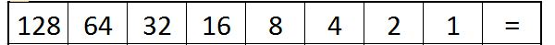
00000000 00000000 00000011 11000000
00000000 | 00000000 | 00000000 | 00000000

