Contents

Lista simpla inlantuita 1

Lista dubla inlantuita 2

STIVA si COADA 3

Tabela de dispersie 4

Heap 5

BINARY TREE!!! 6

AVL 7

**In seminarul 3 ai**

# Lista simpla inlantuita

//DACA ITI CERE O LISTA CIRCULARA, DE AICI PANA AICI FACI

* 2 structuri
* **citire_angajat_tastatura()**
* creare_lista_circulara()🡪 asta vrea **citire_angajat_tastatura()**
* inserare_element_circulara()

stergere_element_circulara()

* traversare_circulara() 🡪 asta vrea **citire_angajat_tastatura()**

//

* creare_lista()
* traversare()
* inserare_element

stergere_element

* nr_noduri
* inserare_element_pozitie

stergere_pozitie

**In seminarul 4 ai**

# Lista dubla inlantuita

AICI AI LISTA DUBLA NORMALA, A DOUA CRCULARA

//

* 2 structuri
* **citire_angajat_tastatura()**
* creare_lista() 🡪 asta vrea **citire_angajat_tastatura()**
* traversare()
* inserare_element()

stergere_element()

**nr_noduri()**

inserare_element_pozitie() 🡪asta vrea **nr_noduri**

stergere_pozitie() 🡪asta vrea **nr_noduri**

//

* creare_lista_circulara() 🡪 asta vrea **citire_angajat_tastaura**
* inserare_element_circulara()
* stergere_element_circulara()
* traversare_circulara()

**In seminarul 5 ai:**

# STIVA si COADA

**--Stiva**

* 2 structuri
* **citire_angajat_tastatura()**
* **afisare_angajat_tastatura**
* push()
* pop()
* afisare_stiva 🡪 asta vrea **afisare_angajat_tastatura**
* initializare_stiva() 🡪 asta vrea **citire_angajat_tastatura()**

**--Coada**

* 2 structuri
* **citire_angajat_tastatura()**
* afisare_angajat_tastatura
* push()
* pop()
* afisare_coada()
* initializare_coada 🡪 asta vrea **citire_angajat_tastatura()**

**In seminarul 6 ai**

# Tabela de dispersie

//AICI SCRII TOT (mai putin stergerile)

Mai ales cele 3 afisari

3 structuri

**citire_student()\***

🡪**afisare_student**

**cod_hash**

alocare_memorie()

**dezalocare_lista()**

dezalocare_memorie() 🡪 asta vrea pe **dezalocare_lista()**

**inserare()\*** 🡪 asta vrea **cod_hash**

**stergere()&** 🡪 si asta vrea **cod_hash**

🡪**afisare_lista()** 🡪 asta vrea **afisare_student**

🡪**afisare_hash()** 🡪 asta vrea pe **afisare_lista**

adaugare_studenti_hash—>vrea functiile **citire_student** si **inserare**\*\*

stergere_student_cod_matricol🡪 vrea functia de **stergere&**

**In seminarul 7 ai:**

# Heap

A **heap** is a tree-based data structure in which all the nodes of the tree are in a specific order

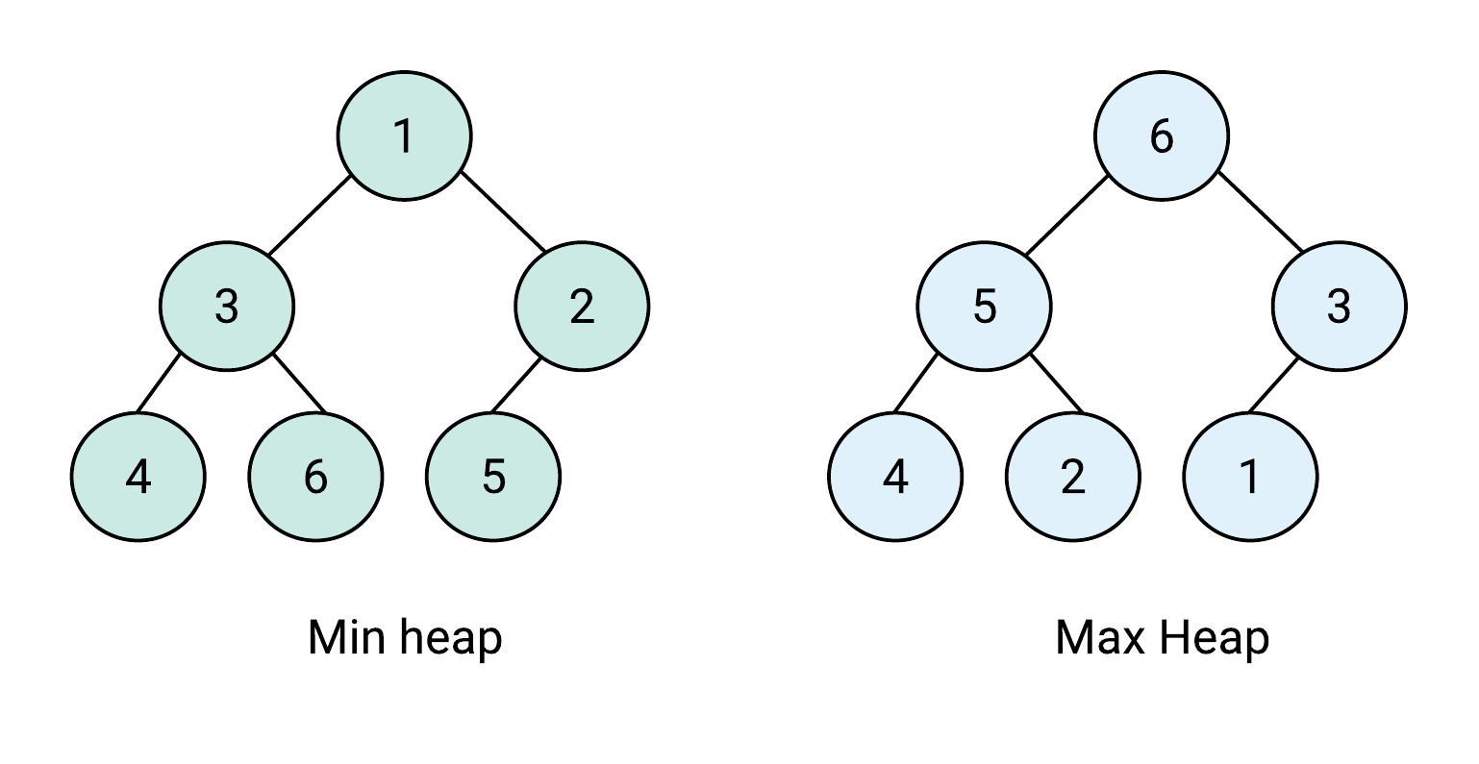

* 2 structuri

**citire_apel_urgenta_fisier\***

citire_apel_urgenta_consola()

* **afisare_apel_urgenta**

citire_apeluri_urgenta_fisier🡪 asta il vrea pe **citire_apel_urgenta_fisier\***

* **afisare_apeluri_urgenta**🡪 asta il vrea pe **afisare_apel_urgenta**
* **----Metode Heap----**
* **Interschimbare()**
* **Filtrare \*\*\*\***
* -------------------------
* afisare_heap 🡪 asta il vrea pe **afisare_apeluri_urgenta**
* initializare_heap 🡪 are nevoie de **filtrare()**
* inserare_heap 🡪 are nevoie de **interschimbare()**

extragere_heap 🡪 are nrevoie de **filtrare() \*\*\*\***

* dezalocare_heap

**In seminarul 8 ai:**

# BINARY TREE!!!

* 2 structuri
* **afisare_apel_urgenta**
* afisare_apeluri_urgenta() 🡪 asta il vrea pe **afisare_apel_urgenta**
* creare_nod
* inserare_nod –-> il vrea pe **creare_nod**

**stergere_nod_radacina**

sterge_nod –-> il vrea pe **stergere_nod_radacina**

cautare_cod

Numara

* afisare_preordine 🡪 asta il vrea **pe afisare_apel_urgenta**

afisare_inordine 🡪 asta il vrea **pe afisare_apel_urgenta**

afisare_postordine 🡪 asta il vrea **pe afisare_apel_urgenta**

inaltime_arbore

afisare_pe_nivel 🡪 asta il vrea **pe afisare_apel_urgenta**

* dezalocare

**In seminarul 9 ai**

# AVL

* 2 structuri
* --Meode carte??---

Citire_carte

* **Afisare_carte**

--Metode AVL---

* **Creare_nod**
* Afisare 🡪 asta vrea **afisare_carte**
* **Inaltime_arbore**
* **Grad_echilibru** 🡪 asta vrea **inaltime arbore**
* Rotire_stanga 🡪 asta vrea **grad de echilbru**
* Rotire_dreapta 🡪 asta vrea **grad de echilbru**
* rotire_stanga_dreapta 🡪rotire stanga + rotire dreapta
* rotire_dreapta_stanga 🡪 rotire dreapta + rotire stanga
* final—
* echilibrare 🡪 asta vrea multe..
* inserare_nod 🡪 vrea **echilibrare** + **creare_nod**

stergere_nod radacina

stergere_nod 🡪 stergere_nod_radacina + echilibrare

**In seminarul 12 ai…**

# Grafuri

3 structuri + header ul de la vecini

**cautaNodGrafDupaCheie()**

adaugareNodGraf()

adaugareNodVecin()

adaugareArcInGraf 🡪asta vrea pe **cautaNodGrafDupaCheie()**

**afisareNodVecin**

afisarNodGraf 🡪asta vrea pe **afisareNodVecin**

numarNoduri

**initializareNoduriVizitate** 🡪asta vrea pe numarNoduri

//I auzi fata nu are treaba, e lista simpla yeye

1 struct

**adaugareNodCarte()**

afisareNodCarte()

//

DF

1 struct

**pushStiva**

parcurgereAdancime 🡪vrea **pushStiva** +**initializareNoduriVizitate**+ **cautaNodGrafDupaCheie** + **adaugareNodCarte**

//BF

1 struct

pushCoada

popCoada

parcurgereLatime()🡪 asta vrea **initializareNoduriVizitate** + pushCoada + popCoada + **cautaNodGrafDupaCheie** + **adaugareNodCarte** 5

//

citesteCarteFisier

citesteNodGrafFisier 🡪asta vrea citesteCarteFisier + adaugareNodGraf

citesteMuchiiGrafFisier 🡪 asta vrea adaugareArcInGraf