**Proximal charge effects on guest binding to a non-polar pocket**† ‡

Paolo Suating,1 Thong T. Nguyen,2 Nicholas E. Ernst,1 Wang, Y., 3 Jacobs H. Jordan,4 Corinne L.D. Gibb,1 Henry S Ashbaugh,3 and Bruce C. Gibb1*

1 Department of Chemistry, Tulane University, New Orleans, LA 70118, USA

2 Current address, Winder Laboratories, LLC, 716 Patrick Industrial Ln, Winder, GA 30680, USA

3 Department of Chemical and Biomolecular Engineering, Tulane University, New Orleans, LA 70118, USA

4 Current address, the Southern Regional Research Center Agricultural Research Service, USDA, 1100 Robert E. Lee Blvd, New Orleans, LA 70124, USA

**†** A contribution of reference data for the seventh statistical assessment of modeling of proteins and ligands (SAMPL7)

**‡** Dedicated to Eric V Anslyn on the imminent arrival of his 60th birthday.

**The Hosts**

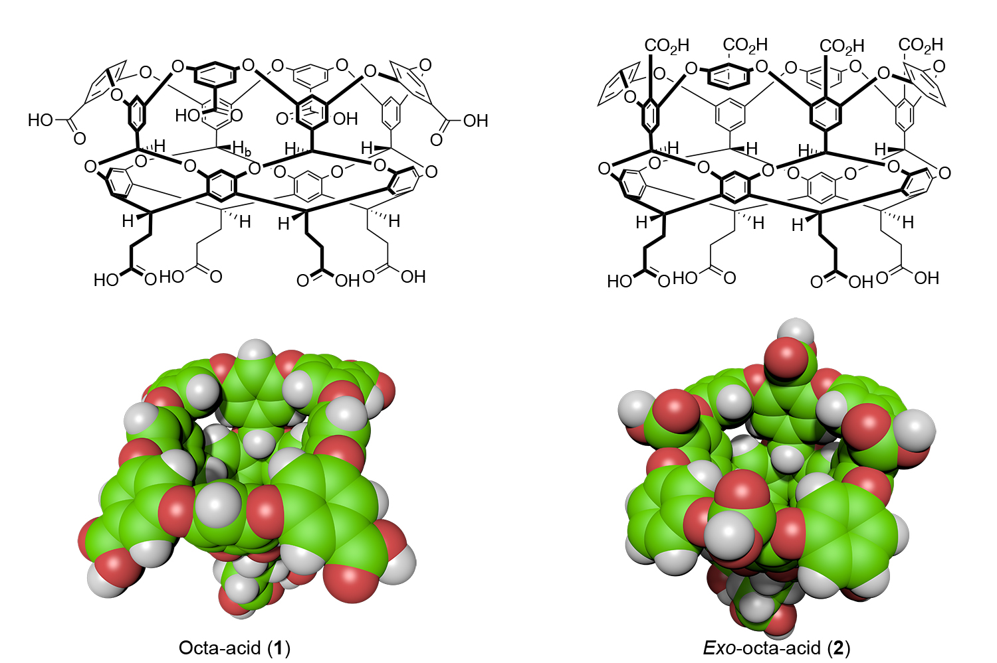

**Figure 1:** Structures and space-filling models of the two hosts in this study: octa-acid (**1**) and *exo*-octa-acid (**2**).

**The guests**



**Figure 2**: Guests used in this study. Guests **G4**-**G7** were used as their chloride salts.

**The data**

**Table 1**: Thermodynamic data from ITC for the binding of guests G0-G7 with hosts OA and *Exo*-OA.a

|  |  |  |  |  |  |  |
| --- | --- | --- | --- | --- | --- | --- |
| **Guest** | **Octa acid 1** | | | **Exo-Octa acid 2** | | |
|  | **Δ*G***  **(kJ mol–1)** | **Δ*H***  **(kJ mol–1)** | **–*T*Δ*S***  **(kJ mol–1)** | **Δ*G***  **(kJ mol–1)** | **Δ*H***  **(kJ mol–1)** | **–*T*Δ*S***  **(kJ mol–1)** |
| **G1** | –20.8 ± 0.1b | –23.2 ± 0.1b | 2.4 ± 0.3 b | – c | – c | – c |
| **G2** | –28.9 ± 0.1 b | –40.2 ± 1.1b | 11.0 ± 1.0b | –5.5 ± 1.2d | – | – |
| **G3** | –33.9 ± 0.1 | –50.2 ± 0.0 | 16.3 ± 0.1 | –14.1 ± 0.3 | –25.2 ± 0.6 | 11.1 ± 0.3 |
| **G4** | –28.3 ± 0.2 | –28.0 ± 0.7 | –0.3 ± 0.5 | –15.1 ± 0.1 | –30.5 ± 2.9 | 15.4 ± 2.8 |
| **G5** | –19.8 ± 0.0 e | –31.3 ± 0.2 e | 11.5 ± 0.2e | –23.3 ± 0.1 | –25.8 ± 0.0 | 2.5 ± 0.1 |
| **G6** | –20.8 ± 0.1e | –30.5 ± 1.4e | 9.6 ± 1.4e | –24.4 ± 0.0 | –13.6 ± 0.1 | –10.8 ± 0.1 |
| **G7** | –25.4 ± 0.2 | –24.0 ± 0.7 | –1.4 ± 0.5 | –29.2 ± 0.4 | –20.8 ± 0.3 | –8.4 ± 0.2 |
| **G8** | –34.5 ± 0.1 | –32.7 ± 0.8 | –1.7 ± 0.6 | –32.1 ± 0.0 | –21.1 ± 0.2 | –11.0 ± 0.1 |

a Data and errors in this table were determined as follows. The Δ*H* and Δ*G* values were obtained by carrying out at least three separate experiments, averaging each set of data, and calculating the respective standard deviation. These average Δ*H* and Δ*G* values were then used to calculate an average –TΔ*S*, and the corresponding standard deviation calculated using the standard equation for the propagation of uncertainties for subtraction.

b Data for this host-guest combination was determined as part of SAMPL4 in 50 mM borate.1

c No binding observed.

d Determined by 1H NMR spectroscopy.

e Data for this host-guest combination was determined as part of SAMPL5 in 50 mM phosphate.2

All uncertainties were determined by taking the standard deviation of three different ITC runs (each experiment is triplicated, or in some instances, quadruplicated). The three runs were performed on two different instruments set to the same experimental parameters, and the runs were performed using three different solutions of host, and three different solutions of guest. The three different solutions (of host and guest) were made using the same stock of sample. The numerical errors also account for slight (<5%) variations in buffer and solute concentrations.  
  
No evidence of binding could be observed by ITC for G4@exo-OA; similarly, no clear evidence of binding could be observed by 1H NMR spectroscopy, indicating a binding constant Ka(G1@exo-OA) < 5. Very weak binding was observed via ITC for G2@exo-OA, so much so that 1H NMR was the only way to determine a binding constant. All 1H NMR titrations were done in triplicate, with similar solution preparation as those of the ITC experiments.

**References**

1. Gibb C. L. D., Gibb B. C. *Binding of cyclic carboxylates to octa-acid deep-cavity cavitand*. J. Comput. Aided Mol. Des., **2014**, *28*(4), 319-25. doi: 10.1007/s10822-013-9690-2. PubMed PMID: 24218290; PubMed Central PMCID: PMC4018434.

2. Sullivan M. R., Sokkalingam P., Nguyen T., Donahue J. P., Gibb B. C. *Binding of carboxylate and trimethylammonium salts to octa-acid and TEMOA deep-cavity cavitands*. J. Comput. Aided Mol. Des., **2017**, *31*(1), 21-8. Epub 2016/07/20. doi: 10.1007/s10822-016-9925-0. PubMed PMID: 27432339; PubMed Central PMCID: PMCPMC5571645.