**NOESY NMR data for SAMPL**

# Methods

link to raw data and images

NMR spectra were collected at 298 K on a 600 MHz Bruker Avance III spectrometer fitted with a 5 mm triple resonance cryoprobe with z-axis gradients. All NMR studies were run in deuterium oxide. All samples were prepared with 2 molar equivalents of guest to host, with a constant host concentration of 5mM. 1H-NMR was collected with F1 presaturation of the water peak, with 16 scans. 2D NOESY spectra were run with water suppression using excitation sculpting with gradients and TPPI acquisition mode. In the raw data files you can copy the ACQUPARS if anyone wishes to reproduce this data, or use the same experimental set up in future. Note the receiver gain is the main variable between runs, as this is adjusted per sample. You should aim to get the highest possible receiver gain before running the NOESY experiment, to ensure the best sensitivity.

**Guest molecules**

Figure 1 shows the structures and numbering of both of the guest molecules used. NB the peaks will shift upon binding, therefore the same shift value will not be seen in all NOESY spectra for each binding pair. Given the symmetry of rimantadine and the peak shifts the CH and CH2 groups shift to give two separate quartets, with the CH groups consistently more deshielded.

*  

Figure 1. Chemical structures and numbering for a R-Rimantadine and trans-4-methylcyclohexanol is shown.

R-rimantadine can bind through either the primary or secondary face of β-cyclodextrin. Figure 2 shows the two possible orientations. Secondary binding means that the amine functionality is orientated out of the larger secondary opening of cyclodextrin, while in primary binding the amine group is orientate out of the narrow primary orientation. Note that in Figure 2 and 3 cyclodextrin is orientated with the secondary face at the top of the image.

Figure . Two possible binding orientations of R-rimantadine shown in β-cyclodextrin as an example. Primary binding (right) and secondary binding (left).

Trans-4-methylcyclodextrin can also binding through either the primary or secondary face of β-cyclodextrin. Figure 3 shows these two orientations. Secondary binding means that the hydroxyl functionality is orientated out of the larger secondary opening of cyclodextrin, while primary binding has the hydroxyl group orientated out of the narrow primary orientation.

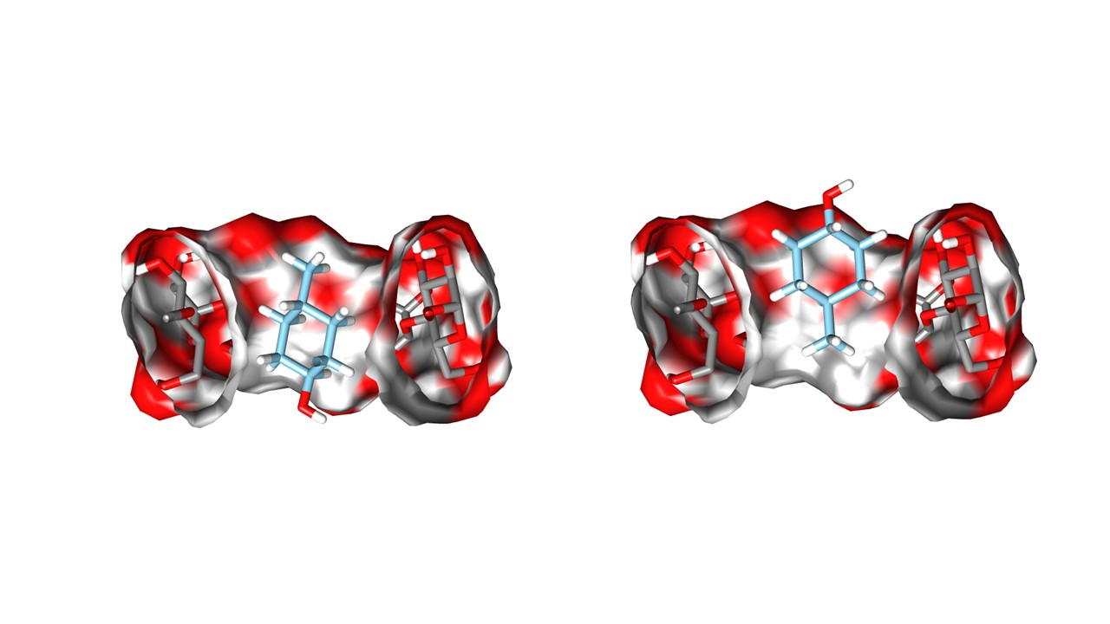

Figure . Figure 2. Two possible binding orientations of trans-4-methylcyclohexanol shown in β-cyclodextrin as an example. Primary binding (right) and secondary binding (left).

For both guest molecules it is possible to get a mixture of both orientations within solution. NOESY NMR helps to give an insight into the binding conformation based on intermolecular interactions between the cyclodextrin cavity protons are interacting with the guest.

**Host Molecules**

All cyclodextrin derivatives reported in this work are mono-substituted at either the 3 or 6 position, full structures are noted in supplementary files.

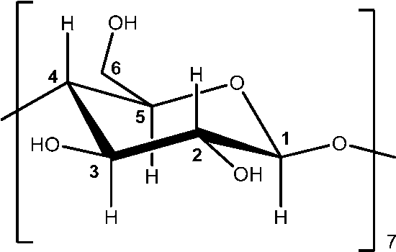

Figure 4. Numbering for a single monomer of glucose within β-cyclodextrin.

**How this data can be used**

Note that absence of NOEs for particular binding orientation does not necessarily mean that is does not occur, equilibrium may just be shifted more towards one orientation over the other, therefore NOEs are only present for one orientation. Positive NOE peaks are an indication of a large molecular weight molecule (>1kDa), while negative NOE peaks are for smaller molecules. There is some evidence to say that positive peaks for guests molecules bound to a host molecule is indicative of longer on rates for kinetics. However, some experimentalists dispute this.

The raw NMR data can be visualised using a number of free NMR software packages. Recommend Topspin which is free for academic use.

# Results

Hg denotes guest proton interaction, Hh denotes host proton interaction. I am not considering just an interaction with Hh5 to be strong evidence of one binding orientation, unless it is accompanied with another NOE from either Hh3,Hh6 or side chain interactions to the guest. This is because Hh5 is accessible to both guests in either binding orientation and it is unclear which conformation the guest is adopting, without additional evidence.

## R-rimantadine

**β-CDRRim**

Evidence for Secondary (S) binding. NOE δ ppm: 2.041-3.79 (Hh3-HgNH3), 1.172-3.76 (Hh3-HgCH3), 3.625-1.71 (Hh5-HgCHs)

**MGLab8RRim**

There is weak evidence for Primary (P) binding, but not conclusive. NOE δ ppm: 1.633-3.73 (HgCH- Hh5)

**MGLab9RRim**

There is no strong NOEs to suggest binding in either direction, not well distinguished from the noise. Possible NOE δ ppm: 1.643-5.01 (HgCH2 – Hh3), which would suggest primary face binding.

**MGLab19RRim**

There is substantial evidence for P binding. NOE δ ppm: 3.70-1.46 (Hh6- HgCH2), 3.69-1.68 (Hh6 - HgCH), 3.78-1.51 (Hh5 – HgCH2).



Figure . Schematic of primary face binding between MGLab19 and R-Rimantadine as suggested from NOESY data.

**MGLab23RRim**

Some evidence for P binding. NOE δ ppm: 1.652-3.69 (HgCH - Hh6), no other real interactions. Side chain peaks overlap with CD so hard to distinguish to determine binding to these peaks.

**MGLab24RRim**

Evidence suggests more S binding. There are interactions between CH3 of guest and side chain from succinic anhydride. NOE δ ppm: 1.144-2.88 (HgCH3 - HhCH2) as small molecule NOE, 3.755-1.56 (Hh5 - HhCH2), 3.661-1.61 (Hh6 – HgCHs).



Figure . Schematic of primary face binding between MGLab24 and R-Rimantadine as suggested from NOESY data.

**MGLab34RRim**

Some evidence for P binding. NOE δ ppm: 3.728-1.635 (Hh6 – HgCHs), 3.7716-1.525 (Hh5 – Hg3CH2). Notable, there is a large intramolecular NMR between succinic anhydride CH2 and Hh6, helps determine identity of host peaks in multiplet easier than on the secondary modified CDs.

**MGLab36RRim**

Evidence for both orientations, peaks to all CD cavity with guest, notable though, NOE δ ppm: 3.93-1.56 (Hh3-CHs), 3.79-1.88 (Hh3-Hg2).

**MGLab35RRim**

No useable data collected

## Tert-4-methylcyclohexanol

**β-CDt4mch**

Looks to be equal binding to both P and S orientation, large 1D shifts for Hh6 and Hh5 protons. NOE δ ppm: 3.423-1.73 (Hh6- Hg1) and 3.438-1.09/0.86 (H6 - 2'2''/3'3'').

**MGLab8t4mch**

Evidence for S binding. NOE δ ppm: 1.561-3.36 (Hg4-Hh6), 0.83-3.39 (Hg3'3''-Hh6), 1.726-3.85/3.46 (Hg1 – Hh3/5). No side chain interactions

**MGLab9t4mch**

Evidence for both orientations, one with a positive set of cross peaks (P), and the other negative (S). Negative and positive intermolecular NOEs. NOE δ ppm: large negative NOE 0.875-3.51 (Hg3’3’’-Hh6), smaller positive peak 0.90–3.78 (Hg4-Hh5), 1.155-3.45 (Hg2’2’’-Hh6), positive NOE 1.804-3.98 (Hg1-Hh3). There is a lot of cross peaks for this binding pair, would be a good test example for understand NOE and intermolecular interactions. No side chain interactions

**MGLab19t4mch**

Both faces, but somewhat preferentially P face. NOE δ ppm: 3.514-0.894 (Hh6-Hg3'3''), 3.522-1.146 (Hh6-Hg2'2''), 1.834-3.98 (Hg1 – Hh3).

**MGLab23t4mch**

Evidence for both P and S. NOE δ ppm: 1.732-3.85 (Hg1-Hh3), 1.546-3.47 (Hg4- Hh6). Side chain interaction CH2 Glu interacting with Hg3'3'' and Hg5, small NOEs. Suggesting P binding and side chain positioned over S face.

**MGLab24t4mch**

Looks to be P binding. NOE δ ppm: 2.862-1.56 (HhCH2 side chain – Hg4), 3.422-1.76 (Hh6- Hg1), 1.562-3.49 (Hg4 – Hh5).

Figure . Schematic of primary face binding between MGLab24 and tert-4-methylcyclohexanol as suggested from NOESY data.

**MGLab34t4mch**

Data suggests S binding, maybe presence of weaker P binding. NOE δ ppm: 3.42-1.08 (Hh5 – Hg2’2’’), 3.426-0.82 (Hh6 – Hg3’3’’). No side chain interactions.



Figure . Schematic of primary face binding between MGLab34 and tert-4-methylcyclohexanol as suggested from NOESY data. The CD cavity has been clipped for illustration purposes.

**MGLab35t4mch**

Evidence points towards P binding. NOE δ ppm: 3.396-1.13 (Hh6-Hg2'2''), 3.762-1.52 (Hh3-Hg4), 3.45-0.815 (Hh6-3'3'').

**MGLab36t4mch**

Large number of overlapping peaks between guest and internal cavity. Notably though 3.74-0.75 (Hh3-Hg5), 3.424-1.78 (Hh6-Hg1). The large number of overlapping peaks suggests both P and S binding is occurring. For example Hg4 has cross peaks with all the internal cavity protons of CD and Hh6. All intramolecular NOEs are negative, therefore showing that the complex is acting like a large molecule and the guest when bound is not acting like a small molecule. This suggests that the equilibrium is shifted to Kon.