8/20/2023

**Name: Andrew Adel Hosny Goued**

**Learn in depth diploma**

Assignment Lesson 2

Report of compilation, linking and simulation

# Contents

1) Contents 1

2) Files 2

I- App.c 2

II- Uart.c 2

III- Uart.h 2

IV- Startup.c 3

V- Linker_script.ld 3

3) Compile files 4

I- Commands for compile 4

II- Show sections of object_file 4

a- App.o 4

b- Uart.o 4

c- Startup.o 4

III- Show symbol table for object files 5

4) Use linker_script to get executable_file and mab file 5

I- Command 5

II- Show sections for learn-in-depth.elf 5

III- Show symbol table of learn-in-depth.elf 6

5) Binary file to use in burn 6

I- Command for get binary file 6

II- Burn binary file on board using qemu 6

a. Command 6

b. Running 6

# Files

## App.c

## Uart.c

## Uart.h

## Startup.c

## Linker_script.ld

# Compile files

## Commands for compile

arm-none-eabi-gcc.exe -c -I . -mcpu=arm926ej-s app.c -o app.o

arm-none-eabi-gcc.exe -c -I . -mcpu=arm926ej-s uart.c -o uart.o

arm-none-eabi-as.exe -mcpu=arm926ej-s -g startup.s -o startup.o

## Show sections of object_file

### App.o

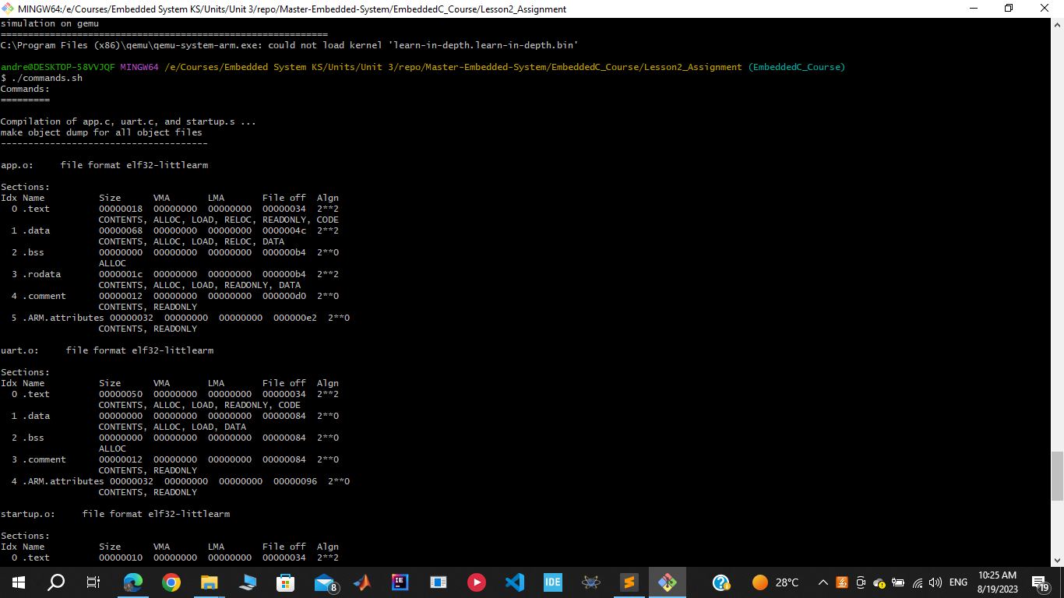

### Uart.o

### Startup.o

## Show symbol table for object files

# Use linker_script to get executable_file and mab file

## Command

arm-none-eabi-ld.exe -T linker_script.ld startup.o app.o uart.o -o learn-in-depth.elf -Map=Map_file.map

## Show sections for learn-in-depth.elf

## Show symbol table of learn-in-depth.elf

# Binary file to use in burn

## Command for get binary file

arm-none-eabi-objcopy -O binary learn-in-depth.elf learn-in-depth.bin

## Burn binary file on board using qemu

### Command

qemu-system-arm -M versatilepb -m 128M -nographic -kernel learn-in-depth.bin

### Running

