8/31/2023

**Name:** Andrew Adel Hosny Goued

**Report for:** Learn-In-depth deploma (K.S)

**Supervisor:** Kirollos Shenouda

My Profile: …

First Term (Final Project 1)

Project Report

# Contents

1) Contents 1

2) Introduction 2

a) Case Study 2

b) Assumptions 2

c) Lifecycle method 2

3) Requirements Diagram 3

4) System Analysis 4

a) Use Case Diagram 4

b) Activity Diagram 5

c) Sequence Diagram 6

5) System Design 7

a) Block Diagram 7

b) State Machine Diagram 8

1. Pressure_Sensor_Driver 8

2. FlashMemory_Driver 9

3. Alarm_System 10

4. Alarm_Actuatot_Driver 11

5. MainAlgo 12

6) Simulation Video 13

7) Codes and files 13

# Introduction

## Case Study

A pressure controller informs the crew of a cabin with an alarm when the pressure exceeds 20 bars in the cabin.

## Assumptions

There are drivers, IRQ, Hal to be defined later.

Pressure to start alarm is greater than 20 bar.

Controller setup and shutdown procedures are not modeled.

The controller maintenance is not modeled.

Pressure sensor will never fail.

ALARM LED will never fail.

The controller never faces power cut.

Storing in flash is not implemented, it can be implemented later.

Processor will check the driver of Pressure sensor each 1sec to save time of processor.

## Lifecycle method

**Waterfall model**

As the project is not very large, we can use the waterfall model.

We can end each stage without returning to it again.

We can develop each module separately until finishing it, without looping on code.

# Requirements Diagram

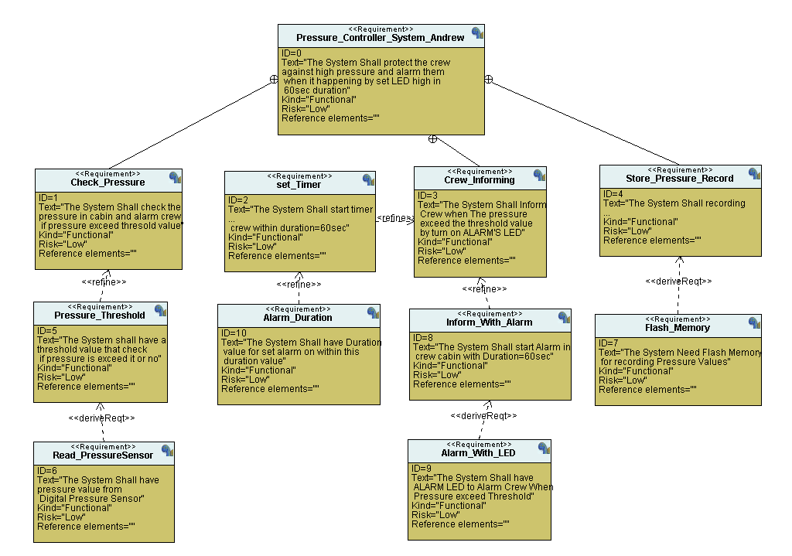

Figure : Requirement Diagram

# System Analysis

## Use Case Diagram

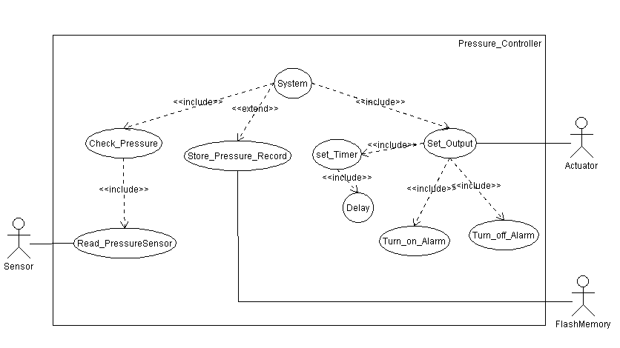

Figure : UseCase Diagram

## Activity Diagram

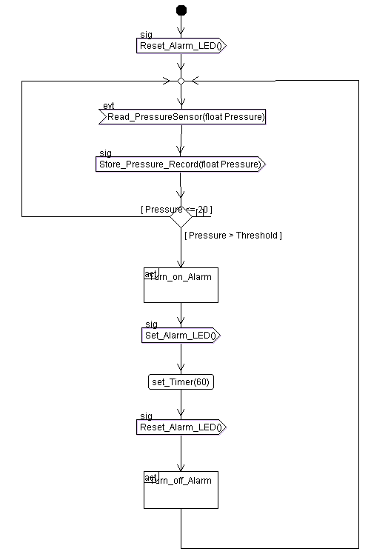

Figure : Activity Diagram

## Sequence Diagram

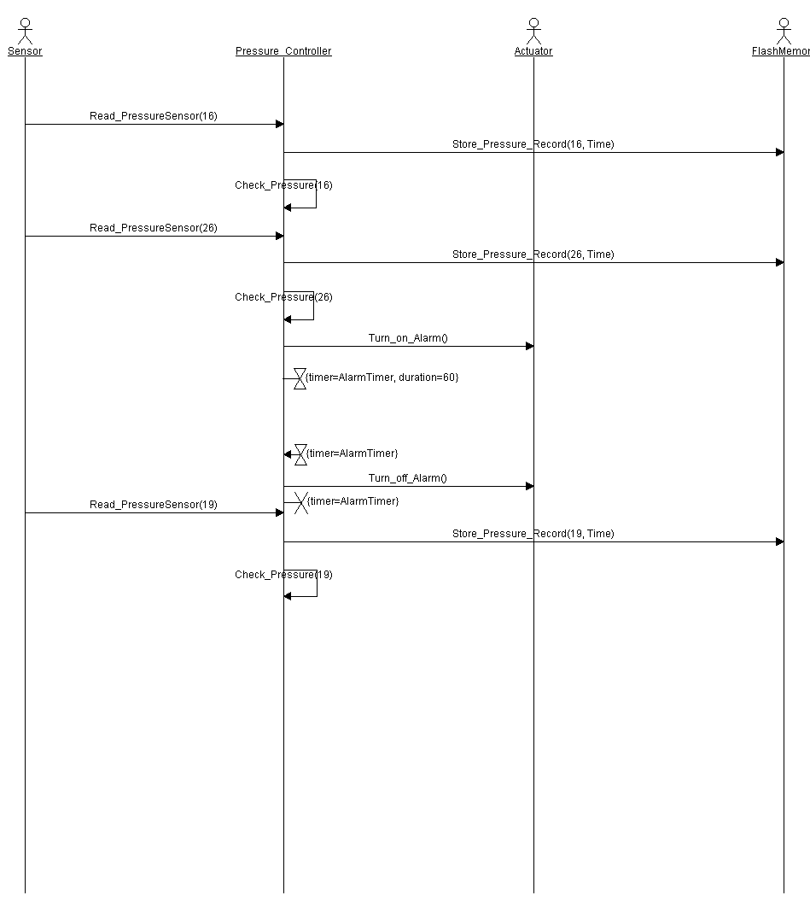

Figure : Sequence Diagram

# System Design

## Block Diagram

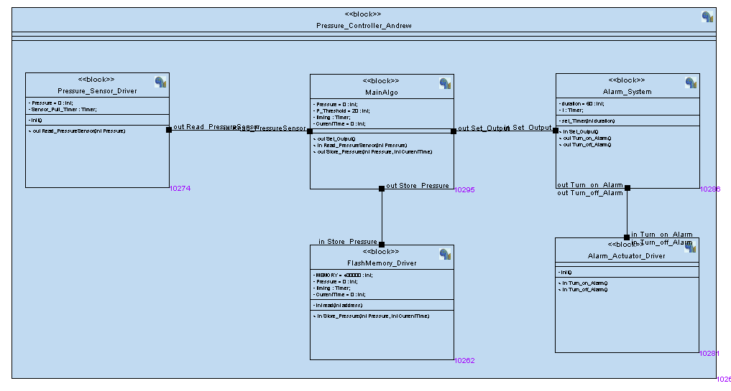

Figure : Block Diagram

## State Machine Diagram

### Pressure_Sensor_Driver

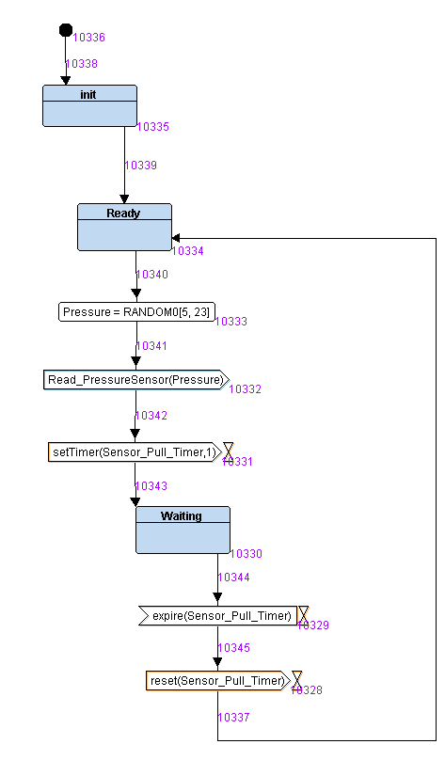

Figure :State Machine of Pressure Sensor Driver

### FlashMemory_Driver

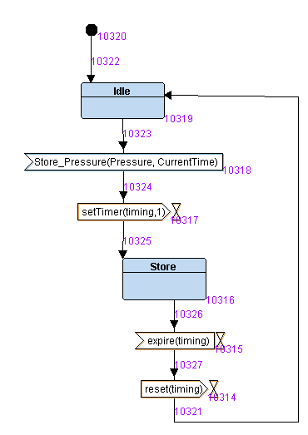

Figure : State Machine Diagram of Flash Memory Driver

### Alarm_System

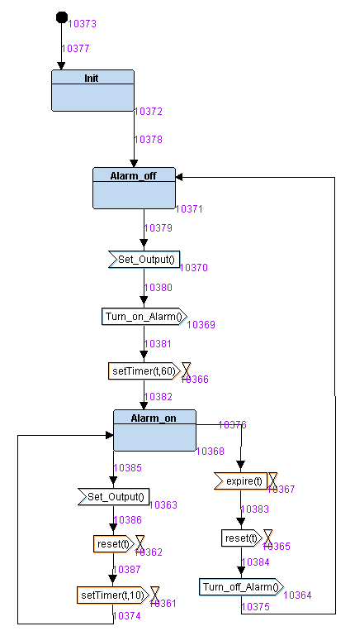

Figure : State Machine Diagram of Alarm System

### Alarm_Actuatot_Driver

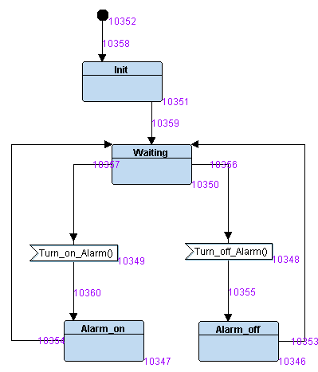

Figure : State Machine Diagram of Alarm Actuator Driver

### MainAlgo

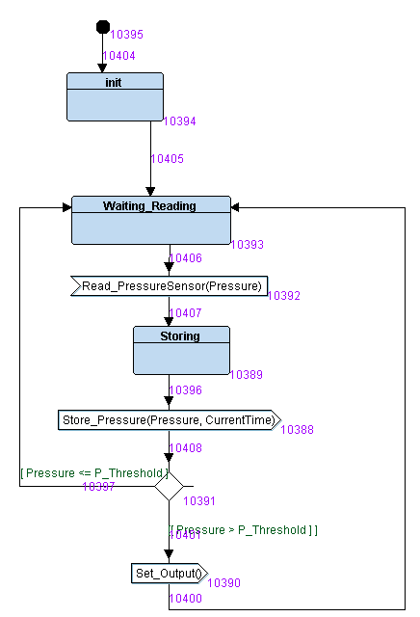

Figure : State Machine Diagram of MainAlgo

# Simulation Video

# Codes and files