**Mastering Embedded System Online Diploma**

8/29/2023

http://www.learn-in-depth.com

Name: Andrew Adel Hosny Goued

ID: 1900158

Report for: Learn-In-Depth Diploma (K.S)

Supervisor: Kirollos Shenouda

Student Management System Program

Report

# Contents

1) Contents 1

2) Table of Figure 1

3) Introduction 2

a) Case Study 2

b) Options can be used: 2

c) Assumptions 2

d) Lifecycle Method 2

4) Files 3

a) main.c 3

b) Queue.h 3

c) Queue.c 3

d) Student.h 3

e) Student.c 3

5) Requirement Diagram 4

6) Analysis Diagram 5

a) Use Cases Diagram 5

b) Activity Diagram 6

c) Sequence Diagram 7

7) System Diagram (Block Chain) 8

8) Simulation Video and Screenshot 9

9) Codes and files 9

# Table of Figure

Figure 1: Requirement Diagram 4

Figure 2:Usecase Diagram 5

Figure 3: Activity Diagram 6

Figure 4: Sequence Diagram 7

Figure 5: Block Diagram 8

# Introduction

## Case Study

The Student Management System is collecting student data into queue and give option to user to analysis, insert, update, delete and query in information of student in queue.

## Options can be used:

* + 1. Add The Student Details Manually.
    2. Add Student Details from Text.
    3. Find Student Details by Roll Number.
    4. Find Student Details by First Name.
    5. Find Student Details by Course ID.
    6. Find The Total Number of Students.
    7. Delete Student Details by Roll Number.
    8. Update Student Details by Roll Number.
    9. Show All Information.
    10. Exit.

## Assumptions

Student data is saved in typedef struct and contain data:

* First Name.
* Last Name.
* Roll Number.
* GPA.
* Courses registered.

Students can register for up to 10 courses.

In the program, we will put the max number of courses can be registered = 5.

The queue circular adds and deletes, so we don’t need to wait until the buffer is empty to add new students.

## Lifecycle Method

Waterfall model, so we develop each module separately until finishing it, without looping on code.

# Files

## main.c

contain main function which ask the user for an option to analysis the queue and choose prepare function depending on user’s choice.

## Queue.h

Contain MACROs, data type, and prototype of functions needed by queue’s implementation.

## Queue.c

Contain definitions of queue’s functions

## Student.h

Contain MACROs, data type, and prototype of functions needed to implement system’s needed functions.

## Student.c

Contain definitions of system’s functions.

# Requirement Diagram

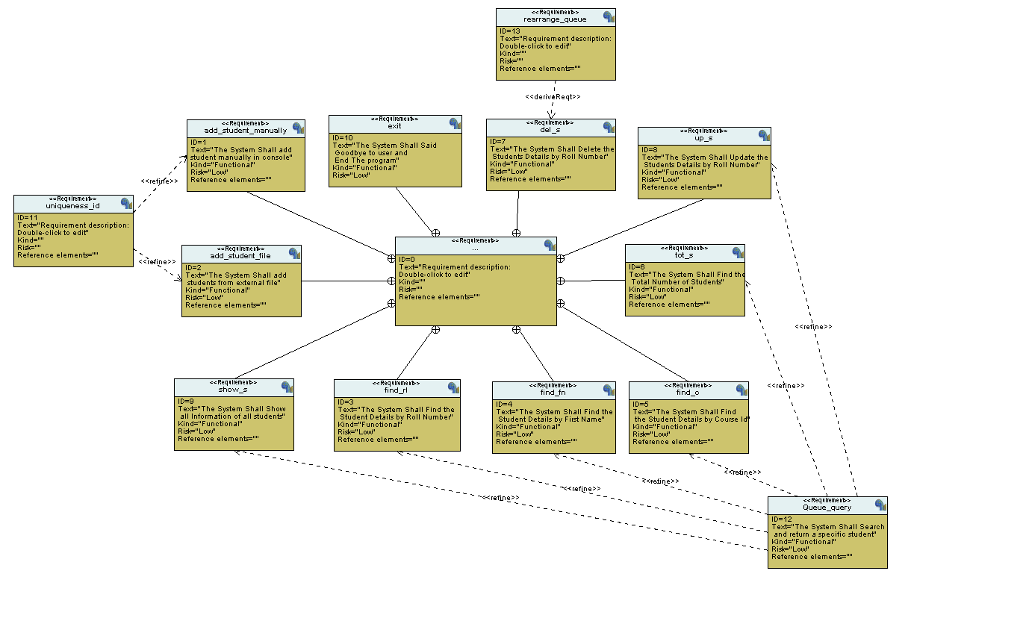

Figure : Requirement Diagram

# Analysis Diagram

## Use Cases Diagram

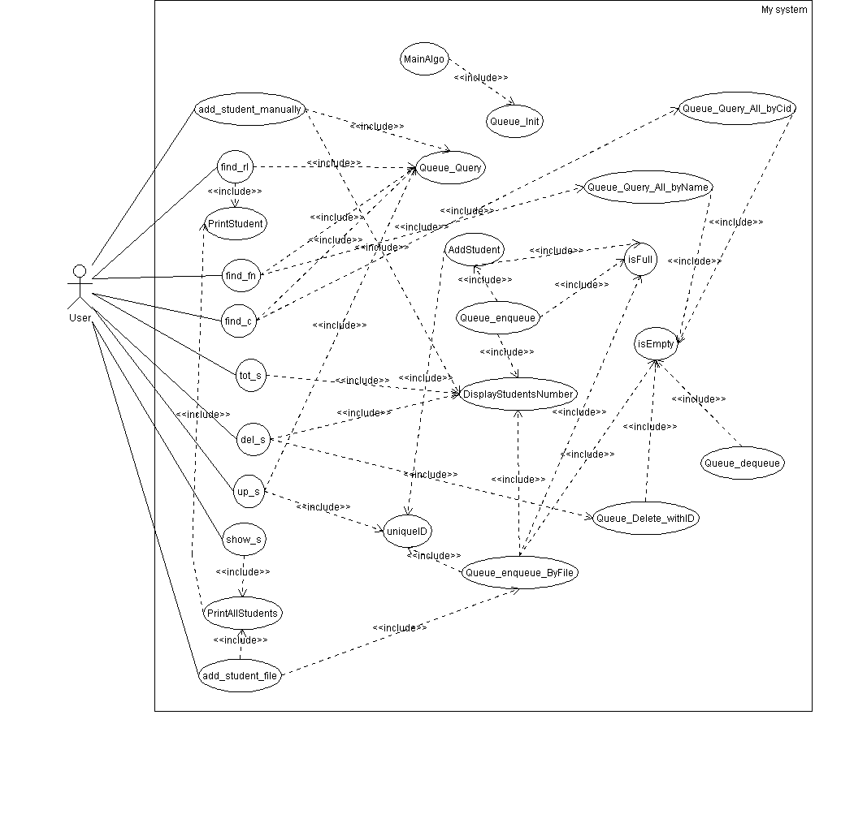

Figure :Usecase Diagram

## Activity Diagram

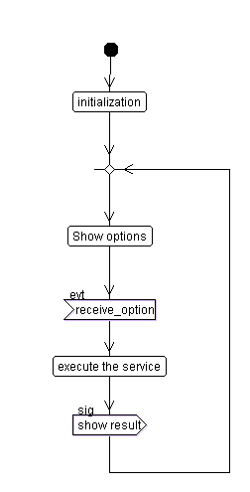

Figure : Activity Diagram

## Sequence Diagram

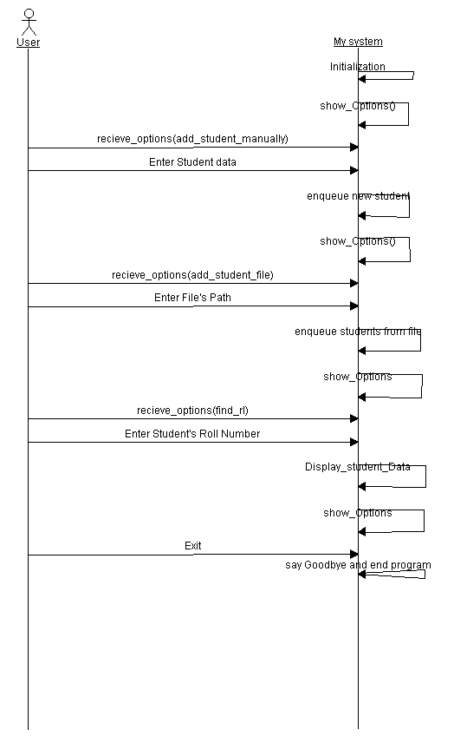

Figure : Sequence Diagram

# System Diagram (Block Chain)

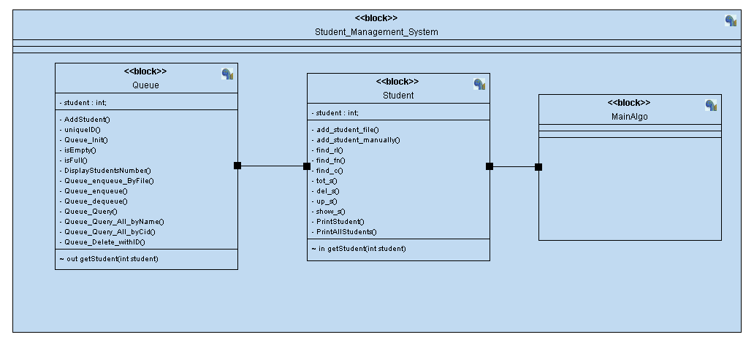

Figure : Block Diagram

# Simulation Video and Screenshot

[Project 2 - Google Drive](https://drive.google.com/drive/folders/1mntHaqeHkRpXvQ8YNGg0PnNF52m0DunS)

# Codes and files

[Master-Embedded-System/FirstTerm_Project/P2(Student_Management_System_using_queue) at FirstTerm_Project · Andrew-Adel/Master-Embedded-System (github.com)](https://github.com/Andrew-Adel/Master-Embedded-System/tree/FirstTerm_Project/FirstTerm_Project/P2(Student_Management_System_using_queue))