8/26/2023

Name: Andrew Adel Hosny Goued

Position: CSE Student at Faculty of engineering ASU

Report for: Learn-in-depth Diploma (K.S)

Collision Avoidance

Report

# Contents

1) Contents 1

2) Introduction 2

1. Case Study 2

2. Assumptions 2

3. Lifecycle method 2

3) Diagram 3

4. Use Case Diagram 3

5. Activity Diagram 3

6. 3

8. Requirements Diagram 4

9. Sequance Diagram 5

10. BlockDiagram 6

11. State Machine Diagram 6

I. Ultrasonic Sensor 6

II. DC_Motor 7

III. CA_Main 8

IV. Simulation 9

# Introduction

## Case Study

A collision avoidance system is a system to check if there is enough distance needed to be able to move without avoidance.

The enough distance to move is at least 50cm.

The speed, if there is enough distance, is 30m/s.

## Assumptions

There are drivers, IRQ, Hal to be defined later.

Min distance need to can move is 50cm.

Controller setup and shutdown procedures are not modeled.

The controller maintenance is not modeled.

Ultrasonic Sensors will never fail.

DC Motor will never fail.

The controller never faces power cut.

## Lifecycle method

Waterfall model, so we develop each module separately until finishing it, without looping on code.

# Diagram

## Use Case Diagram

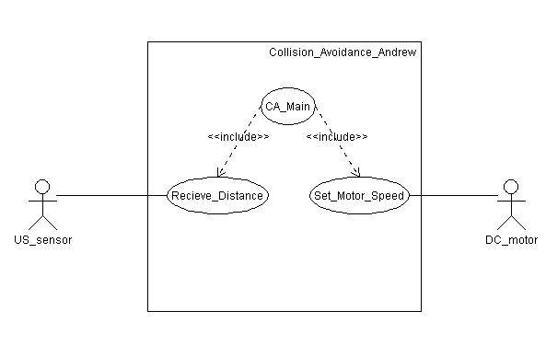

## Activity Diagram

## 

## Requirements Diagram

## Sequance Diagram

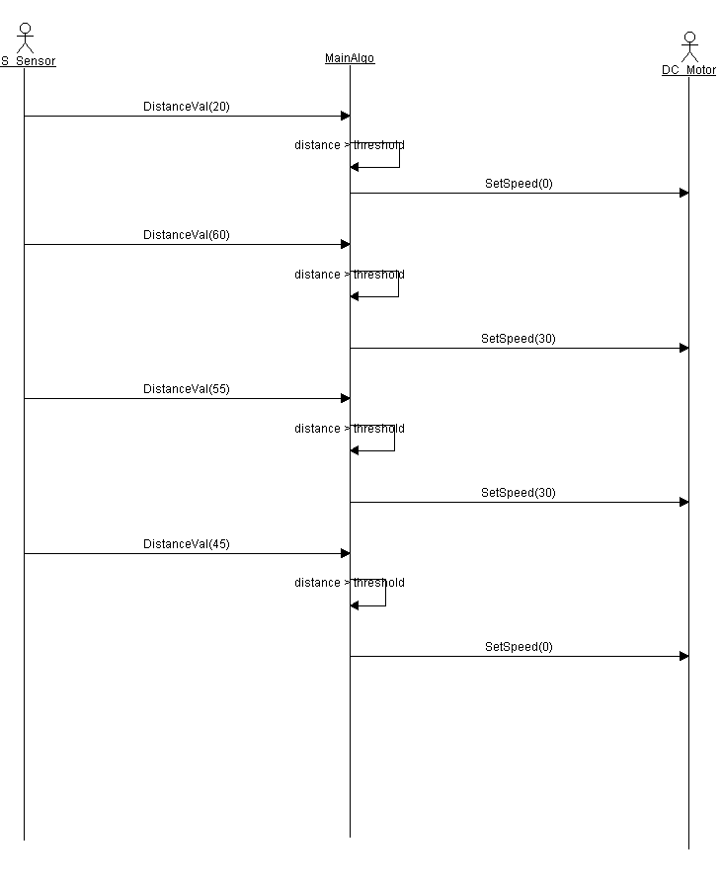

## BlockDiagram

## State Machine Diagram

### Ultrasonic Sensor

### DC_Motor

### CA_Main

### Simulation

