10/14/2014

8.5:1 Entertainment

PROPRIETARY INFORMATION

Fluffy Unicorn

Game Design Document

Version 1.0

Contents

1 Team Personnel 2

2 Game Overview 2

2.1 Game Description 2

2.2 Genre 2

2.3 Audience 2

2.4 Platform/Hardware 2

2.5 Requirements 2

3 Plot and Setting Information 2

3.1 Story 2

3.2 Characters 2

3.3 Enemies 2

3.4 Levels 2

4 Core Gameplay 2

4.1 Levels 2

4.2 Movement 2

4.3 Upgrades 2

4.4 Beans 2

4.5 Controls 2

4.6 Artificial Intelligence 2

4.7 Power-Ups 2

5 Character Stats 2

6 Enemy Stats 2

7 Interface and Interface Usage 2

7.1 Main Menu Interface 2

7.2 Game Menu Interface 2

8 Menu and General Game Usage 2

8.1 Game Flow Diagram 2

9 Audio 2

10 Notes 2

11 Wish list 2

12 Development Technical Milestones 2

12.1 Alpha Version 2

12.2 Beta Version 2

12.3 Silver Version 2

12.4 Gold Version 2

# Team Personnel

Director and Programming Lead: Alexander Sanchez  
Visual Artist: Alexander Sanchez  
Programming Intern Team Lead: Andrew Best  
Programming Interns: Jim Corrigan, Brandon Coulthard and Jon MacLachlan

# Game Overview

## Game Description

Fluffy Unicorn is a single player experience, following Fluffy the Unicorn through his adventures in converting what were once bullies into his new found friends.

Fluffy wants nothing more than for the world to be rid of bullies. Everyone should be friends! One night he wishes upon a shooting star for everyone to be friends and the next day he wakes up as a Unicorn. Fluffy makes it his mission to rid the town of all bullies by using his new power of farting rainbows to turn them into his friends.

## Genre

Side-scrolling shooter

## Audience

* General Audience
* Video Game Fanatics
* Ages 5 and up

## Platform/Hardware

The game will be developed using Unity’s free license. This means that there will be no costs for software used in developing the game. Since we are using Unity, we can target many platforms. However, to begin with, we will be submitting the game to the Android Play Store and the Apple App Store.

## Requirements

# Plot and Setting Information

## Story

**WORK IN PROGRESS** Fluffy is bullied and aims to convert all of the bullies into friends through the power of farting.

## Characters

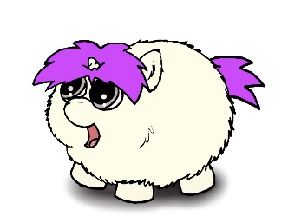**Fluffy** – Main protagonist of the game. This is who the player controls.

## Enemies

This section will contain details on individual bullies when they are created.

Enemies Base class should be created with virtual functions so that latter enemy classed derived from the base class can inherit all the basic enemy attacks and behaviours as well as aggregating his/her own special attack.

All Enemies will have a basic punch and kick. A randomized algorithm may be implemented to decide the variations of attacks that they will choose when fighting the player.

### Basic Enemies

#### Bully



#### Pepper Bully

#### Jock Bully

#### Fat Bully

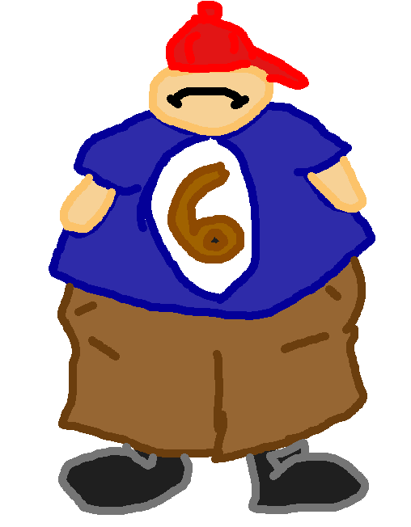

#### Bling Bully

### Bosses

#### Fattest Bully



## Levels

This section will contain the story on each level, describing whether or not it is the schoolyard or the cafeteria, etc.

* Stage 1:
  + Daytime Street Level: Fluffy moves through his street full of cars and small objects. Houses in the background, simple walk to school kind of level.
    - Secret Level - House

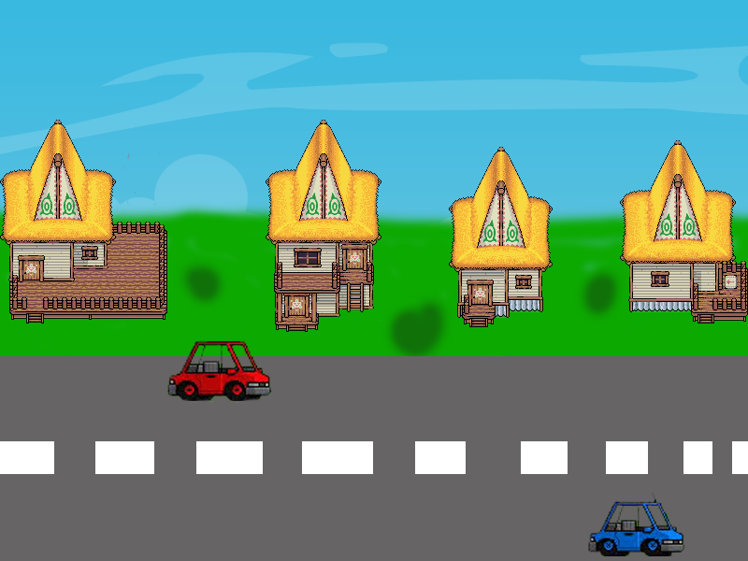

* + Playground Level: Fluffy arrives to school and moves around the level fighting bullies. Swings, jungle gym, sandbox, things like these are what the player sees as they move through this level.
    - Secret Level - Sandbox

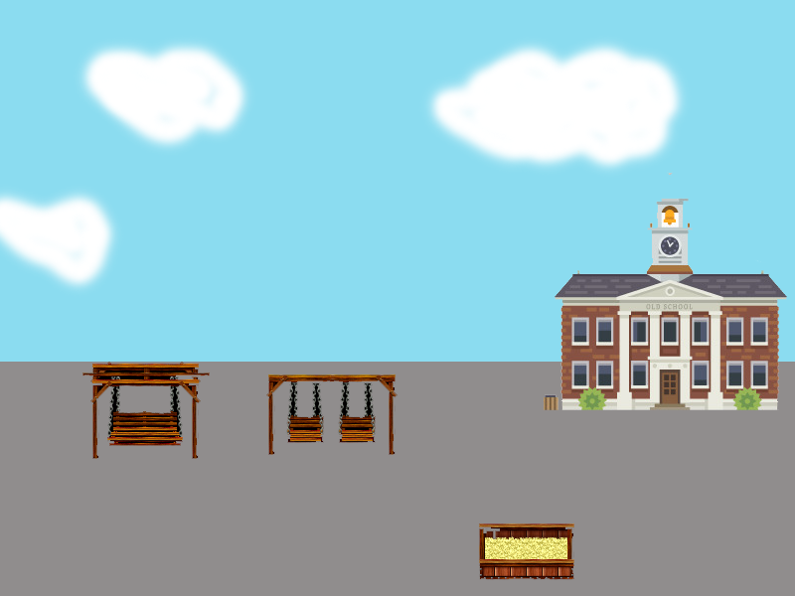

* + Homeroom Level: Fluffy moves through the hallway into his homeroom classroom where bullies are waiting for him left and right.
    - Secret Level - Locker

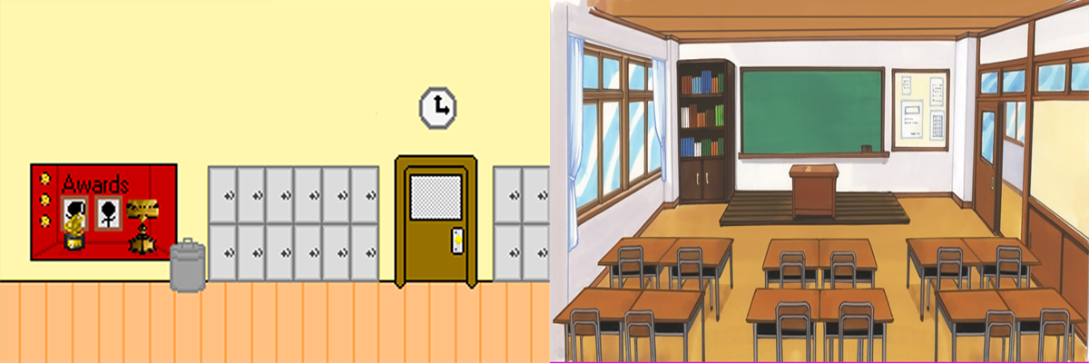

* + Science Class Level: Fluffy attends Science class and has to move through this laboratory while he fights off crazy bullies who hate Science.
    - - Secret Level – Cabinet

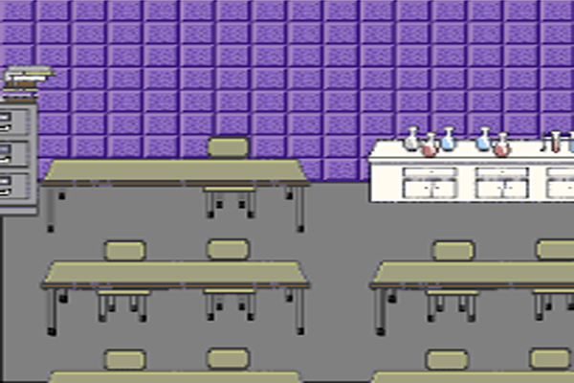

* + Cafeteria Level: Fluffy moves through the cafeteria to try to get his lunch but bullies are everywhere so he must cleanse the cafeteria first and stop these food fights.
    - Secret Level – Fridge

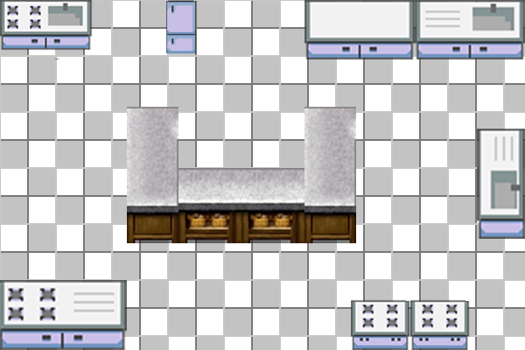

* + Library Level: Move through the library and protect the children being bullied for studying.
    - Secret Level – One of the bookshelves

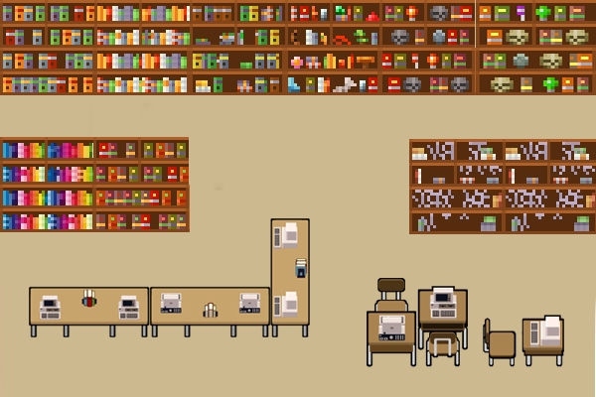

* + Track and Field Level: Start in the locker room, move through the gym to the outside track and field area. Sporty area that you traverse.
    - Secret Level – Storage room

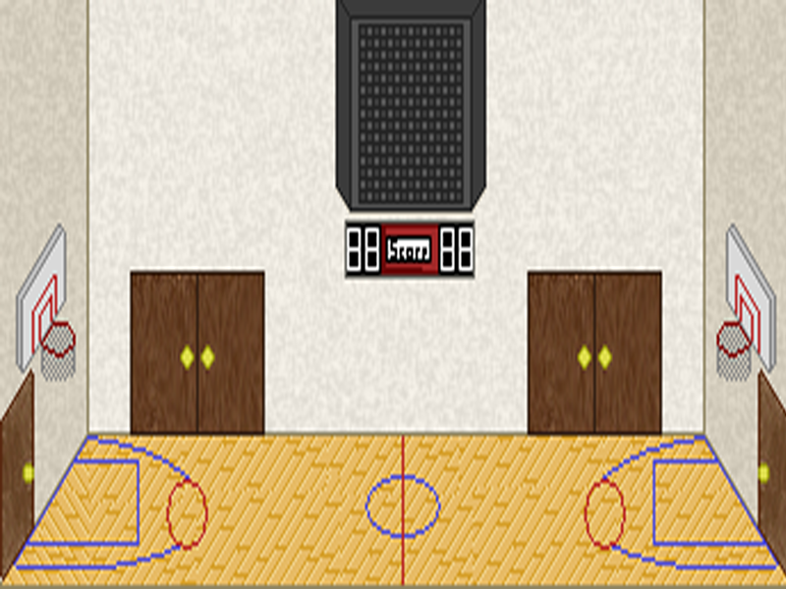

* + The Trip Home Level: Fluffy packs up his things and calls it a day. But before he can call it a day he must make his way home as the sun is setting. Fluffy decides to take a shortcut home and goes through the town’s main street but bullies are upset with Fluffy and are waiting for him.
    - Secret Level – Alleyway

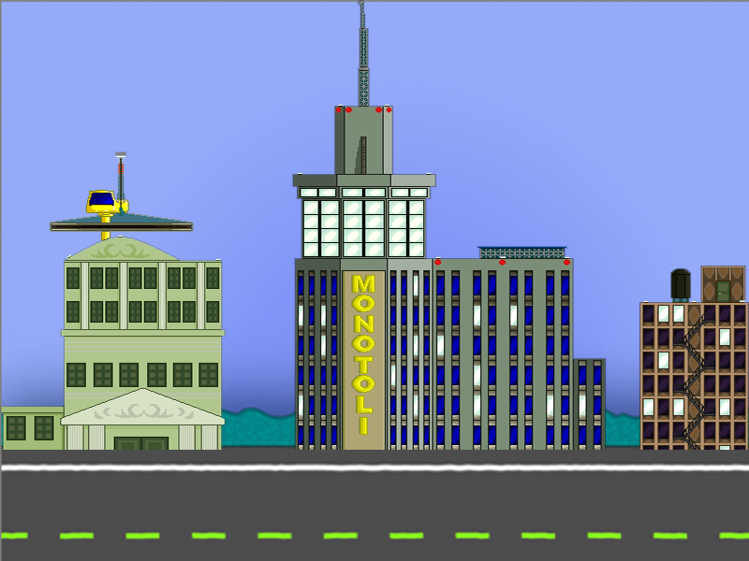

# Core Gameplay

## Levels

This section will contain level **functionality**

## Movement

The player will move around the levels using touch screen controls. Player movement will be approximately 5m/s, with their acceleration being 10m/s². This means that the player will reach top speed in 0.5 seconds. The player will decelerate at a speed of 20m/s², meaning it takes the player 0.25 seconds to stop from maximum speed.

## Upgrades

This section will contain details on the upgrades available to the player.

## Beans

Beans will drop from enemies killed as well as appear randomly on different parts of the levels. These are used to increase your fart gauge.

## Controls

The controls for the game utilize touch controls. Players will slide their finger up and down to move the unicorn and press buttons to activate the other controls.

## Artificial Intelligence

The Artificial Intelligence will spawn at set locations throughout the level and follow a set path in a “roam” setting. Once the player is within 20m of an enemy, the enemy will engage “seek” mode and begin to head towards the player.

The Artificial Intelligence will also try to choose the best path possible to also avoid the player’s fart cloud projectile.

## Power-Ups

There will be numerous power ups available for Fluffy to pick up. At this point in time there aren’t any ideas for them.

## Destructible Objects

Within the game there will be several different destructible objects, some will yield rewards for the player and some will be completely empty. Below are images of what they will be.



## Secret Areas/Events

Throughout the game there will be different areas that will be unlocked by triggered events. The full list will be here once we have figured them out, but they will be along the lines of the following:

Trigger: Pass a certain point  
Objective: Defeat 8 enemies  
Area: Secret area filled with currency

## Stats Explanation

Here is a breakdown of what the stats mean.  
  
**Health**: How much health the unit has  
**Punch Damage**: How much damage a punch does to the player’s health  
**Kick Damage**: How much damage a kick does to the player’s health  
**Unique Attack Damage**: How much damage a unique attack does to the player’s health  
**Punch Reset**: After punching, this time + the Attack Reset is how long until the enemy can attack again  
**Kick Reset**: After kicking, this time + the Attack Reset is how long until the enemy can attack again  
**Unique Attack Reset**: After performing a unique attack, this time + the Attack Reset is how long until the enemy can attack again  
**Odds**: This varies from bully to bully, the way this is determined is by the number next to the attacks. The random number generator will choose a number from 0-100, and depending on the number it will determine the type of attack performed.  
Example:  
**Bully**Punch Odds: 60  
Kick Odds: 80  
Unique Attack Odds: 100  
  
If the random number generator generates a number between 0 and 60, the bully will punch, if it is a number between 61-80 they will kick, and 81-100 the bully will perform a unique attack.  
  
**Attack Reset**: This is the base time that each bully has to wait to attack again, this usually has a modifier added to it.  
**Velocity**: How quickly the bully moves  
**Attack Distance**: The distance away the player must be from the bully in order for their attack to reach the player.  
**Change Track Delay**: Since the game runs on a 3 track system, this is (in seconds) how long the bullies will wait before they will change tracks again.

# Player and Enemy Stats

This section will contain an in depth look at the player’s and varying enemy stats. Note: These are base stats and do not reflect what they can be when upgraded.

## Player Stats

**Fluffy**  
Health: 3  
Damage: 1

## Enemy Stats

Here is the list of enemy stats, you can find the descriptions of the stats in section 4.10.

**Bully**Health: 3  
Punch Damage: 1  
Kick Damage: 2  
Unique Attack Damage: 3  
Punch Reset: 1 second  
Kick Reset: 2 seconds  
Unique Attack Reset: 3 seconds  
Punch Odds: 60  
Kick Odds: 80  
Unique Attack Odds: 100  
Attack Reset: 5 seconds  
Velocity: 2m/s²  
Attack Distance: 2 ft  
Change Track Delay: 3 seconds

**Pepper Bully**Health: 3  
Punch Damage: 1  
Kick Damage: 2  
Unique Attack Damage: 4  
Punch Reset: 0 seconds  
Kick Reset: 1 second  
Unique Attack Reset: 2 seconds  
Punch Odds: 40  
Kick Odds: 70  
Unique Attack Odds: 100  
Attack Reset: 4 seconds  
Velocity: 2 m/s²  
Attack Distance: 2 feet  
Change Track Delay: 2 seconds  
  
**Fat Bully**  
Health: 5  
Punch Damage: 1  
Kick Damage: 1  
Unique Attack Damage: 6  
Punch Reset: 3 seconds  
Kick Reset: 3 seconds  
Unique Attack Reset: 6 seconds  
Punch Odds: 10  
Kick Odds: 25  
Unique Attack Odds: 100  
Attack Reset: 8 seconds  
Velocity: 1 m/s²  
Attack Distance: 2 feet  
Change Track Delay: 5 seconds  
  
**Jock Bully**  
Health: 4  
Punch Damage: 3  
Kick Damage: 3  
Unique Attack Damage: 4  
Punch Reset: 1.5 seconds  
Kick Reset: 1 second  
Unique Attack Reset: 3.5 seconds  
Punch Odds: 40  
Kick Odds: 60  
Unique Attack Odds: 100  
Attack Reset: 3 seconds  
Velocity: 3 m/s²  
Attack Distance: 2 feet  
Change Track Delay: 1 second  
  
**Bling Bully**  
Health: 3  
Punch Damage: 2  
Kick Damage: 2  
Unique Attack Damage: 5  
Punch Reset: 1 second  
Kick Reset: 2 seconds  
Unique Attack Reset: 3 seconds  
Punch Odds: 60  
Kick Odds: 80  
Unique Attack Odds: 100  
Attack Reset: 1 second  
Velocity: 2 m/s²  
Attack Distance: 2 feet  
Change Track Delay: 3 seconds

## Life Bars (HUD)

Both the player and enemy should have life bars to display health up above in game screen the game HUD player and enemy health bars play an integral role in the look and feel of the game.

# Interface and Interface Usage

## Main Menu Interface

The main menu will contain normal, key elements that your average Main Menu has. It will contain a Start and Options button.

## Game Menu Interface

The game menu is the menu that appears when the player pauses the game. This menu should have Resume, Restart, Options and Quit buttons

# Menu and General Game Usage

## Game Flow Diagram

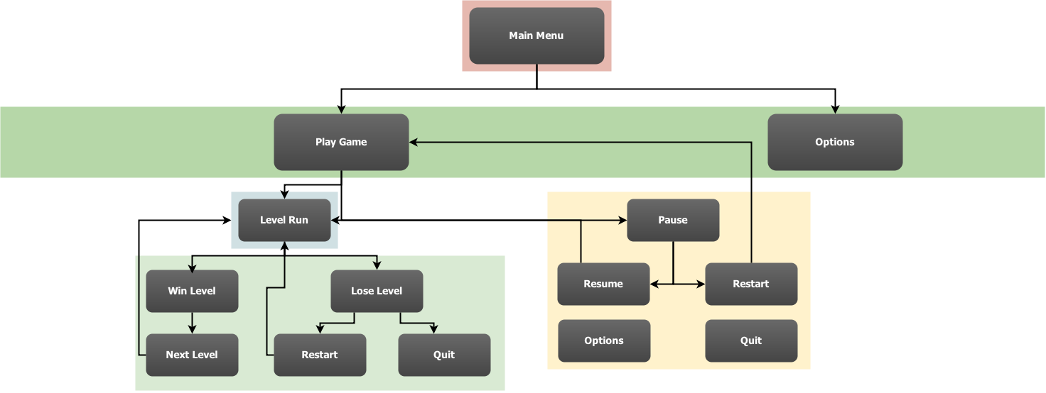

# Audio

This section will contain all audio information, in the following format:  
Song/Clip Name: 🡨 This will contain only the name of the song or the clip  
Artist (if applicable): 🡨 This will contain only the name of the artist, if not found, use **N/A**  
In Game Use: 🡨 This will contain where it is used in the game  
Credit: Yes/No 🡨 This is whether or not the artist wishes to be credited for their work, if Artist is **N/A** use **No**  
  
**Example:**  
Name: Fart Noise  
Artist: N/A  
In Game Use: On Player Attack  
Credit: No

# Notes

This section will contain any important notes, such as copyright information for any art or audio that is not suited for other places in the document.

# Wish list

Here will be the list of features we would like to have in the game, but may not be able to fit into the timeline.

* Achievements

# Development Technical Milestones

The following describes the technical goals that are required to be met during the development phases of the creation of the game along with their respective deadlines.

## Alpha Version

**Game Flow**

* Main Menu and Game State Machine, this includes the User Interface that runs the game from Main Menu to the start of the game and any other states that the game requires for user experience.
* Beans: Players are given an initial amount of coloured beans
* 3 Lives (implement the lives and display on game HUD)
* Basic Character movement
* Player class with movement and animation (touch events for touchscreen support)
* Side scrolling camera functionality with easing on player for visual elegance and games visual distinction
* Game Aspect Ratio all screens need to be scalable to all device width and heights

## Beta Version

**Character Development**

* All described in the Alpha Phase needs to be properly implemented including tidying code structures, scripts, organization and fixing any issues or bugs that may be occurring in games current state.
* Artificial Intelligence: Enemy Class implementation and enemy steering, seek player movement and behaviours, and enemy bosses.
* Player and Enemy collision
* Score
* Health Bars and Gas Bars
* Beans HUD (display the different coloured beans with a little number next to it to indicate how many are available in inventory at any given time while player is alive)
* Player Attack or Fart functionality
* Game Sounds: Atmospheric setting audio tracks for each level and in-game sound effects

## Silver Version

**Tech-Demo**

* Artificial Intelligence: Avoidance behaviour (basic behaviour to run from farts that may have different effects on the enemy’s nervous systems)
* Performance enhancements
* Load and Save Game Data
* Story Mode: Cut scenes where Fluffy advances in the game and the app narrates his adventure in between gameplay. Artwork will be required for this.
* Power-ups spawning and implementation inside areas of the games and upon character circumstances as required to sustain or extend gameplay or players chance of survival.
* Score and Gas % working and game timers
* Fart abilities or techniques should be developed as the player advances in levels he can learn new basic fart attacks or upgrade old farts
* Upgrades: Players are given an opportunity to upgrade their “Fluffy Unicorn”
* Upgrade Menu Implementation

## Gold Version

**Polish and Completion**

* Upgrade menu fully implemented
* Performance enhancements
* Load and Save Game Data
* Bug fixing
* Polish lighting effects, particle effects
* Fancy fonts for Level Intros