7/14/2014

Andrew Best

Brandon Coulthard

Link’s Good Day Gone Bad

Game Design Document

Version 1.0

Contents

1 Game Overview 2

1.1 Objective 2

1.2 Genre 2

1.3 Audience 2

2 The story 2

3 Core Gameplay 2

3.1 Map Level 3

3.2 In Battle 3

4 Environmental Elements 3

4.1 Poles 3

4.2 Clouds 3

5 Interface 3

5.1 Controls 4

6 Menu and General Game Usage 4

6.1 Screen Descriptions 4

6.2 Game Flow Diagram 4

7 Win and Lose Conditions 5

7.1 Win 5

7.2 Lose 5

# Game Overview

## Objective

You play the hero Link, in his quest to kill all enemy forces and reach the door at the end of the level. You will conquer this treacherous lands in hopes to discover what lies behind the unknown doorway.

## Genre

The genre is a side-scrolling action game.

## Audience

The Rob and any other poor soul who wishes to play this game.

# The story

One dark day enemies got fed up with Link’s shit and said “Screw this, let’s kill him and guard our sacred, mysterious doorway.” So Link has no choice but to defeat these scumbags and see what awaits him through the doorway.

# Core Gameplay

## Map Level

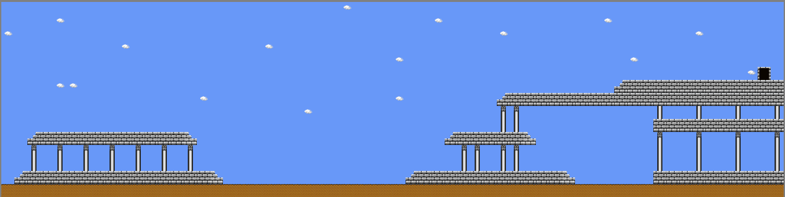

## In Battle

You have a basic sword attack that will kill any enemy who comes into contact with your Master Sword. However, with this great power comes a great restriction, you too will perish if you come into contact with the foes.

# Environmental Elements

## Poles

Everyone enjoys a good looking piece of scenery, so why not give the player what they want? They serve no real purpose but damn, do they look good.

## Clouds

Ever have a day where you just want to stare up into the sky and just admire the clouds? No, don’t blame you but if you happen to want to want to enjoy some fluffy white clouds we got that covered for you.

# Interface

## Controls

**Up Arrow:** Jump, if in contact with door enter it

**Left Arrow:** Move left

**Right Arrow:** Move right

**Space Bar:** Attack

**Left Shift:** Sprint when selecting either left or right arrow keys

# Menu and General Game Usage

## Screen Descriptions

Main menu will have a Play Game, Credits and Exit options.

## Game Flow Diagram

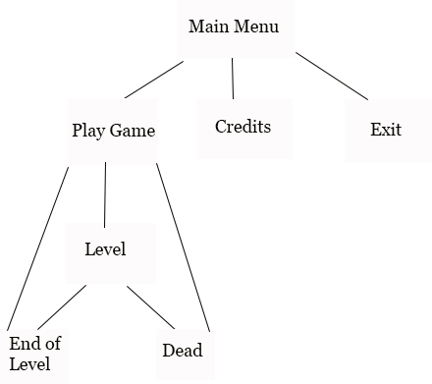

# Win and Lose Conditions

## Win

If you reach the doorway and press the up arrow you will restart the level. That’s right, you are stuck in this one level until the end of your days, Link really should have stayed in bed.

## Lose

Guess what, if you lose you restart the level. You may be asking yourself, why are both the win and lose conditions the same? Well to answer that question you must ask yourself this, why not? We call this innovation among all game mechanics.