Question 1:
Andrew Branum – 5291638
Question 2:
Yes
Question 3:
Part 1: To complete part 1, I used the flag package to capture the command line arguments as I did in the first project. After capturing the address and the user’s username, I modified the Dial parameters to contain the newly entered address as I did in the first project. I did the same for the chat.go code and changed the Listen parameters. Sending the username over was tricky at first, but once I did enough research on socket connections I found that the command line basically writes and reads from a file so I opted to use io.WriteString to write the username to the file by basing the function off of the provided mustCopy() function. The sendUsername function is called right before the mustCopy function with conn and username as parameters. To capture the username in chat.go, I moved the instantiation of the new scanner above the logic that sends messages into the channels to be able to capture the username correctly. I simply used the Scanner to scan for any text, trimmed the text’s whitespace, and assigned it to a variable “who”. To capture all the clients and their usernames, I chose to move the clients map to the global scope and changed it from map[client]bool to map[string]chan<-string where the key is the client’s username, and the value is the client’s channel address. These are assigned within the handleConn function and removed within the broadcaster function when the client leaves the chatroom.
Part 2: Since I moved the client map to the global scope, broadcasting the names of the current users to new clients was straightforward. Since the usernames and channels are added to the map upon connection and globally accessible, the broadcast function simply iterates over the clients map and sends the usernames across the cli channel. Since I changed the client map, I also had to change the leaving functionality within the broadcaster function. Instead of simply deleting the client from the map, the program iterates over the clients map until the channel within the map matches the channel that is leaving and deletes the user from the map based on the channel and username. The loop is then broken, and the connection is closed on that channel. I also had to modify the portion of the broadcaster that sends messages to all other clients because of the changed client map. I simply had to iterate over the values of the client map rather than the keys to extract the channels to send messages to.
Part 3: To implement private messages, I took some inspiration from Minecraft such that sending a private message to someone follows the format of /username message. This format allows for a simple string split to parse the message and username. I used the Scanner the same way it was used in the original code but checked to see if messages started with “/” before continuing. If no “/” is detected the message is sent normally. If a “/” is detected, the text is split using SplitN to capture the respective substrings: username and message. Once the substrings are captured, the username that is receiving the private message is used to find their respective channel value and it is assigned to a “channel” variable. The message is then sent across that channel in the form DM (username who sent the message): Message.
Screenshots:
Joining Server:
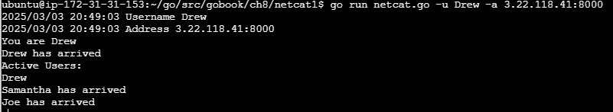
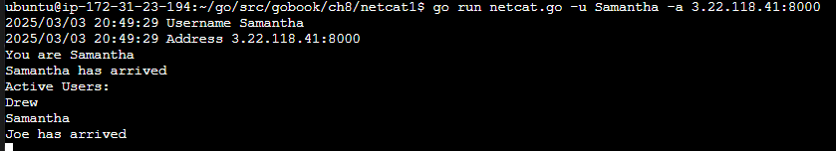
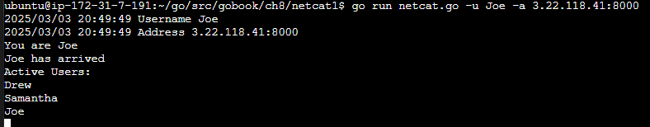

Sending Messages:
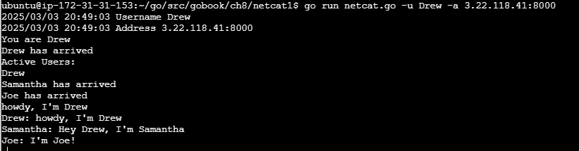
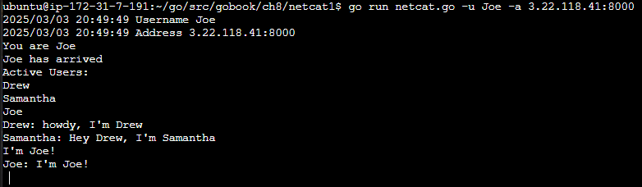
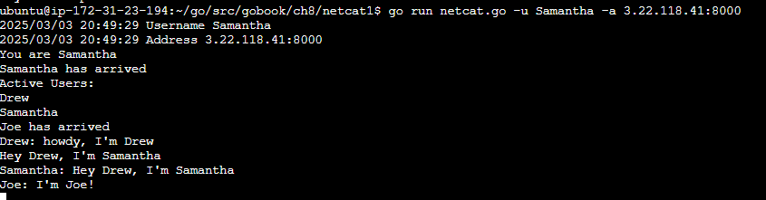
Private Messages:
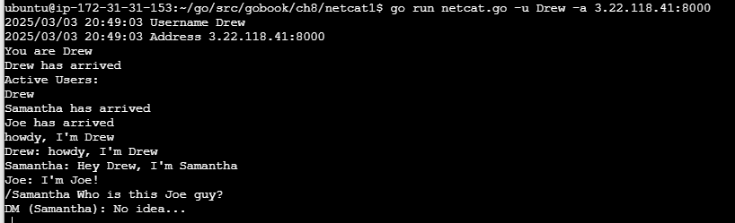
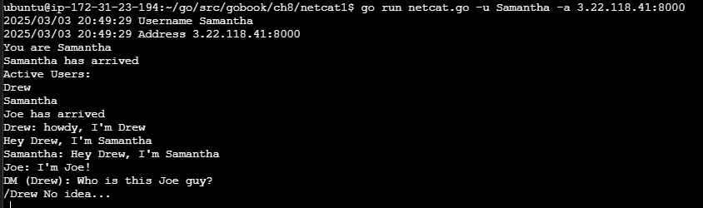
Leaving Server:
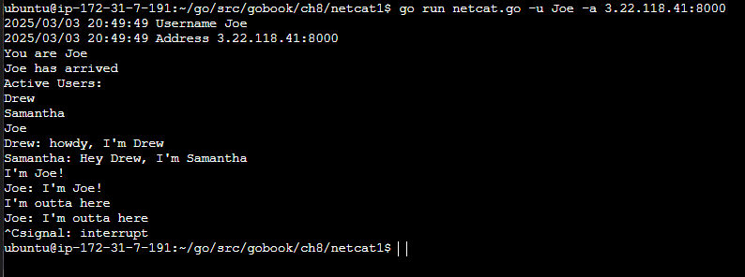
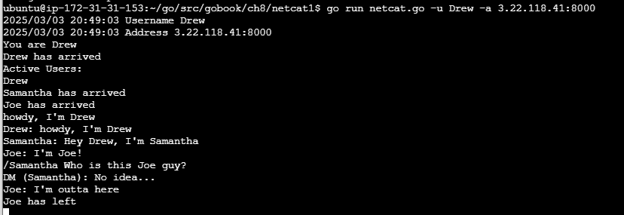
Joining after someone left (check map):
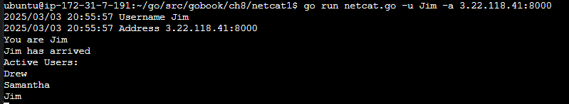
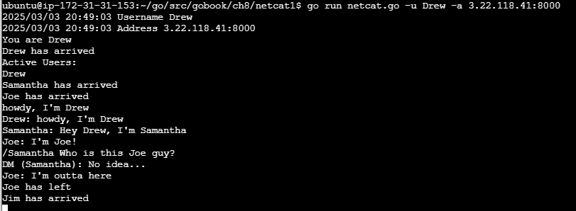
Server EC2 Setup:
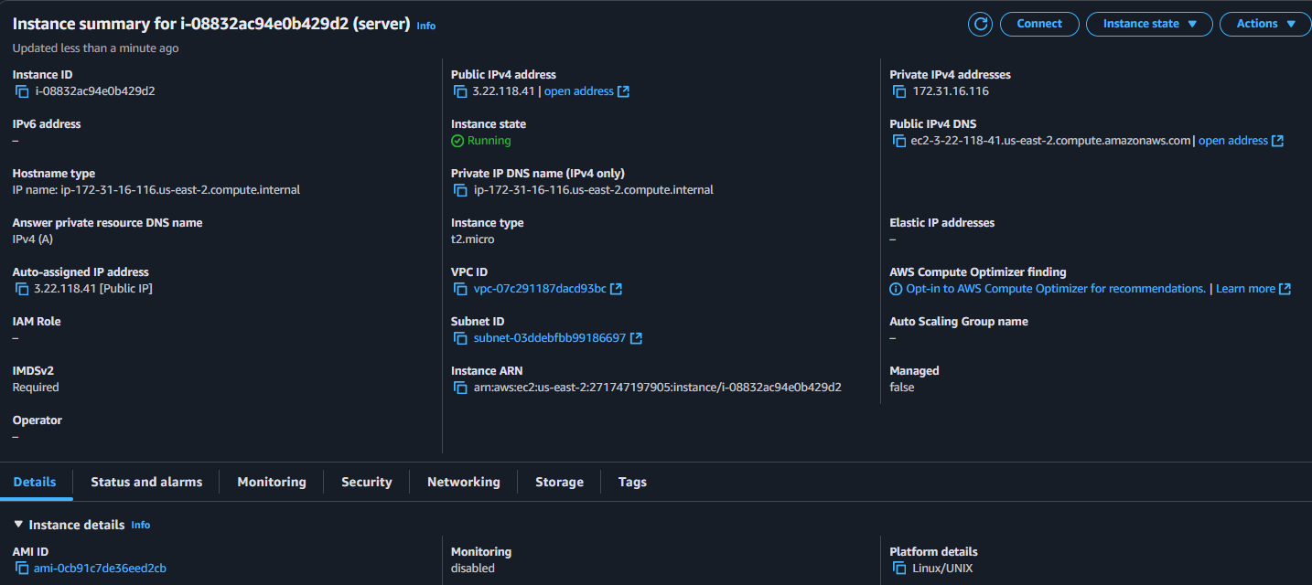

Client EC2 Instance Example:
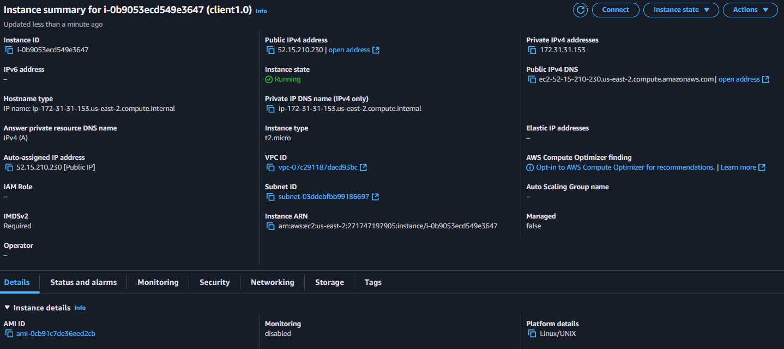
Local Example:
