Project Cat Specifications:

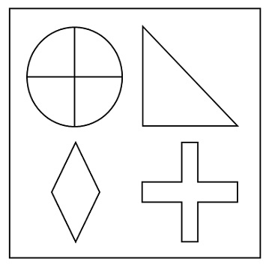An image with the image-code '1111'

Purpose:
This program was created as a data gathering device for a Bachelor’s-Degree Independant Directed Study course in psychology.
The experiment’s purpose was to gain insight into how people decide to categorize images based on a constructed set of images.

Image-Codes
Each image is given an image-code, the numbers in that code, along with the position of that number, corresponds to a given shape.
For example, the number 1 in the first space corresponds to a circle with a cross through it.
The number 1 in the second space corresponds to a triangle.
And so on...

All images have a unique image-code.
There are 4 different shapes available in each spot, and so image-codes will contain the numbers ‘1’ through ‘4’.

As the program progresses, the user will see new images (but not the image-codes), each with different shapes in different places. They will be asked to categorize the image as either ‘Category 1’ or ‘Category 2’.

‘Category 1’ images follow the pattern of only a single number in their image-code differing from any other number in the code. For example, ‘yxxx’ or ‘xyxx’ or ‘xxyx’ or ‘xxxy’ are the four variations available for a ‘Category 1’ image. Where each ‘x’ is a ‘1’ and ‘y’ is either a ‘3’ or ‘4’.
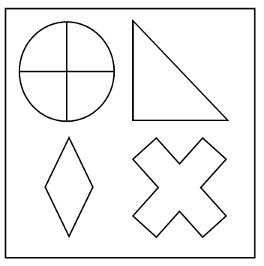An image with the image-code '1113'

‘Category 2’ images follow the same pattern, but any two numbers may be different and no ‘1’’s will appear in the image-code. For example ‘xxyz’ is a ‘Category 2’ image so long as all numbers are ‘2’ or greater with ‘x’ ≠ ‘y’ and ‘x’ ≠ ‘z’. Even ‘xxyy’ is a ‘Category 2’ image so long as all numbers are ‘2’ or greater and ‘x’ ≠ ‘y’.
This makes ‘Category 2’ much larger than ‘Category 1’.

There is a third category, known as ‘Test Category’. This category contains only the numbers ‘1’ and ‘2’ in the image-codes, with two ‘1’’s and two ‘2’’s.
Based on the patterns described, these ‘Test Category’ images should be sorted into ‘Category 2’, but that is the subject of this experiment.
Phases:
When the user starts the program they will have two ‘phases’ in the experiment.
In the first phase, the user will only be shown random images from ‘Category 1’ and ‘Category 2’, but will not see the same image back-to-back. No ‘Test Category’ images are shown. The user will only see a selected number of ‘Phase 1’ images.
In addition, the user will hear audio feedback on their categorization choices. There are right and wrong categorizations, so the user will hear a positive beep if they categorize correctly, and a negative beep if they categorize incorrectly.
This essentially serves as a training-mode, so the user can more clearly identify which sets of images belong in each category (remember that they do not see the image-codes).

In the second phase, the user will no longer hear any feedback, and will start seeing ‘Test Category’ images.
The duration of the ‘Phase 2’ will be random as the user will randomly be shown images from any category (but will not see the same image back-to-back), and must be shown all six ‘Test Category’ images before finishing the experiment.

Images from the ‘Test Category’ will not be shown back-to-back, and although they appear randomly they will always be shown in the same order: 1122, 1212, 1221, 2112, 2121, 2211.

Experiment
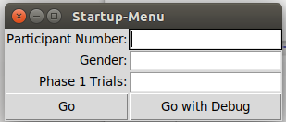
When the program starts the user will be presented with the following interface.

Participant Number is an arbitrary (but unique) identifier for the user. It determines what the output file is named.

Gender is the gender of the user, it was a metric that was thought to be interesting to track.

Phase 1 Trials is the number of images the user will see while in ‘Phase 1’ of the program.

The ‘Go’ button launches the program as per normal, whereas ‘Go with Debug’ will launch the program will image-codes visible for testing purposes.

Findings
Unfortunatly I do not have the experiment results.
No software issues were reported.

Programming Notes:
The experiment was conducted on two University owned computers running Windows 10 and so Python could not be installed without going through offical IT channels (which could take a substantial amount of time). Instead a program called ‘PyInstaller’ was used to convert the Python source code into an executable file, and so no administrator privilges were needed to run the experiment and Python was not necessary to install.

Final Note:
I was payed to write this program by the author of the psychology experiment.

