Digital Design 1 Course

Project report

Dr. Mohamed Taher

The American University in Cairo

Ahmed Elsaady :900183061

Andrew Nady :900184042

**Design of the program :-**

The program is designed to print a three variable KMAP using the number of minterms, which entered as a user input and its value in as a decimal number. First, the program askes the user to enter the value of minterms and the value of the decimal number. After that, it loops over the array of the KMAP [2][4] to put the [1] on the determined place to be equivalent to the value of the decimal number, which entered by the user. This k-map is designed to be (0,1,3,2,4,5,7,6), so we designed it using ((i+4*j)) equation to replace between (2) and (3) in addition to (6) and (7) The program is implemented by small if statement to the decimal number and a big [else statement] to cover all the possible values of the KMAP and this is the logic of the program.

**How to use the program: -**

To run and use the program, you can use any complier like GDP, visual studio or code block ..etc

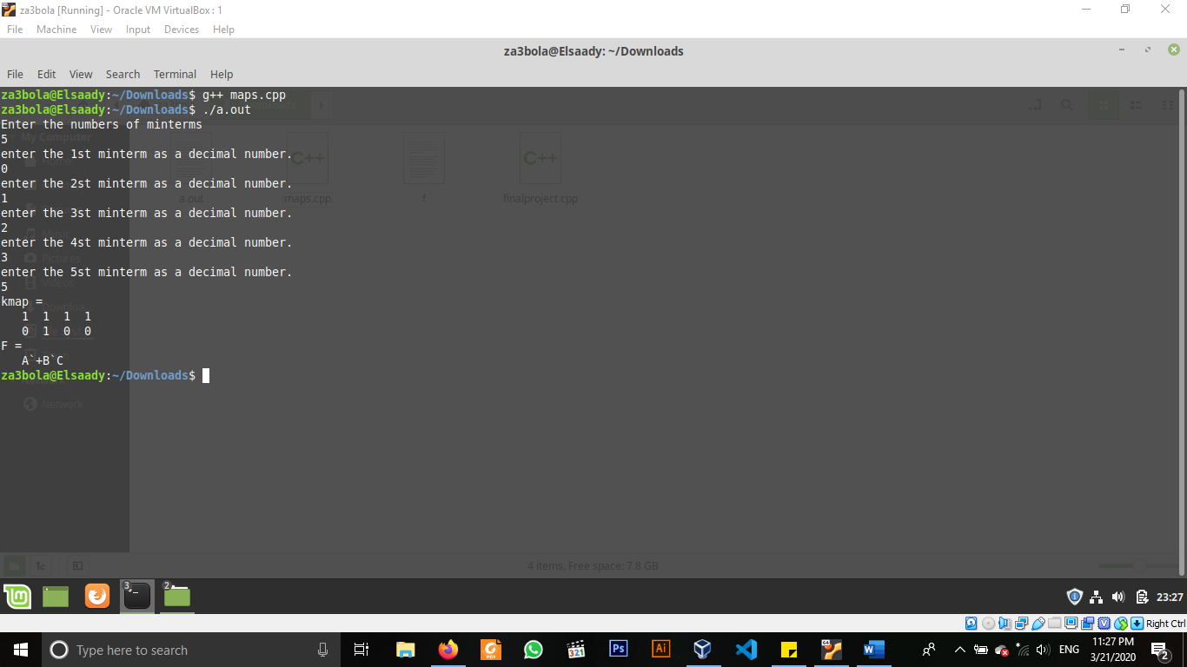For example, using gdp compiler in Linux -> write (g++ maps.cpp) ,then write (./a.out) and the program will run. Then , write the number of minterms and its values in decimal numbers like (0,1,2,3,5). The program will produce a full map with its Boolean function as you see in fig (1)

FIG(1)