**COSC 3304 – Algorithms Design and Analysis**

**Assignment 10**

**Due: 23:59:00pm, 04/20/2024**

**Andrew Kalathra**

1. Please show the Huffman tree to find Huffman codes for letters ‘a’, ‘b’, ‘c’, ‘d’, and ‘e’ in the character string '*addcebeadbadbaeddbacadceabaeddade*' and decode the binary string ‘*0111110000100011*’ (25 points)

Frequency and Codes (based off Tree):

Huffman Tree Walkthrough:

Huffman Tree:

Decode:

1. Please show the ***adjacency list*** and ***adjacency matrix*** of the graph below. (20 points)

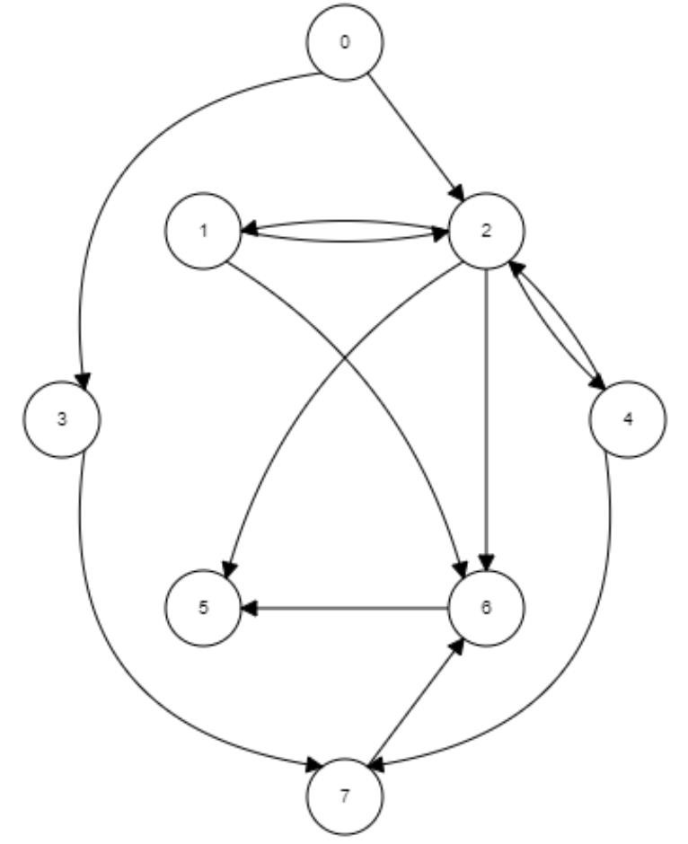

1. Please use **BFS** to search the graph below and show every updated queue. The **vertex 0** is the start vertex and all adjacent vertices are enqueued in **increasing order** (25 points)

**

1. Please use **DFS** to search the graph below and show the type of each edge in the graph.

Assume the first selected vertex is **vertex 0** following the **increasing order** for searching.

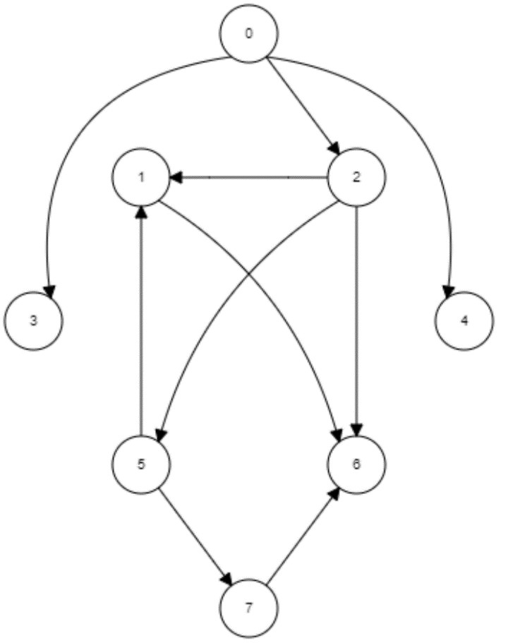

DFS (20 points)

|  |  |  |  |  |  |  |  |  |
| --- | --- | --- | --- | --- | --- | --- | --- | --- |
| Vertex | 0 | 1 | 2 | 3 | 4 | 5 | 6 | 7 |
| Timestamp  (d: start) | 1 | 3 | 2 | 12 | 14 | 7 | 4 | 8 |
| Timestamp  (f: finish) | 16 | 6 | 11 | 13 | 15 | 10 | 5 | 9 |

Edge Type (10 points)

|  |  |  |  |  |  |  |  |  |  |  |
| --- | --- | --- | --- | --- | --- | --- | --- | --- | --- | --- |
| Edge | 0-2 | 0-3 | 0-4 | 2-1 | 5-1 | 1-6 | 2-5 | 2-6 | 5-7 | 7-6 |
| Type | T | T | T | T | C | T | T | F | T | C |

Tree Edges = T

Back Edges = B

Forward Edges = F

Cross Edges = C

