**COSC 3304 – Algorithms Design and Analysis**

**Assignment 4**

**Due: 23:59:00pm, 02/13/2024**

1. (30 points) Please sort the input array [9, -9, 15, 35, -1, 14, 20, 7] using the **MERGESORT** algorithm (please show detailed steps for full credits).

* When two elements are left, the lesser automatically drops into the lower position, leaving the higher to automatically fall into the higher position.

1. (30 points) Please use **HEASORT** to sort the input array [7, 3, 13, -3, 26, 8, 10, 33, 17, -1, 9] (please show detailed steps for full credits)

* For future reference, I used this software to make my binary trees:
* <https://binary-tree-builder.netlify.app/>
* 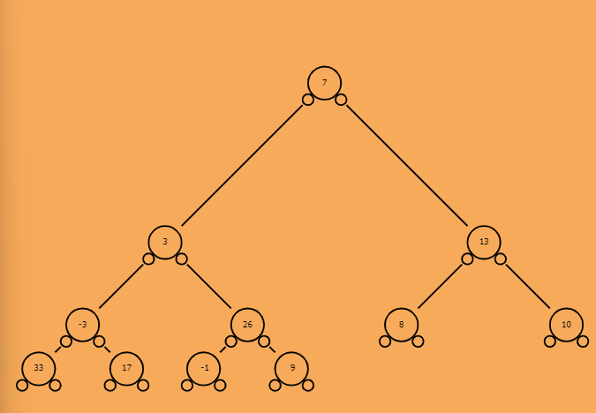Initial Tree: , [7, 3, 13, -3, 26, 8, 10, 33, 17, -1, 9]
* Build Max Heap: [33, 26, 13, 17, 9, 8, 10, -3, 3, -1, 7]

* First Pass: [26, 17, 13, 7, 9, 8, 10, -3, 3, -1, 33]

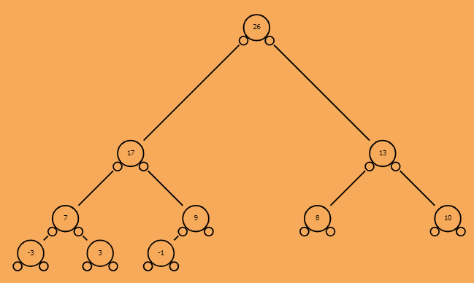

* Second Pass: [17, 9, 13, 7, -1, 8, 10, -3, 3, 26, 33]

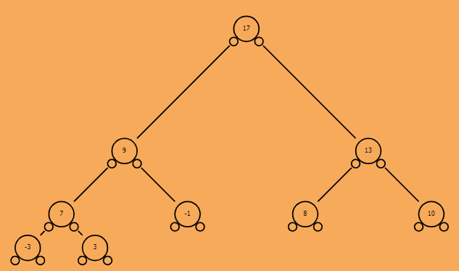

* Third Pass: [13, 9, 10, 7, -1, 8, 3, -3, 17, 26, 33]

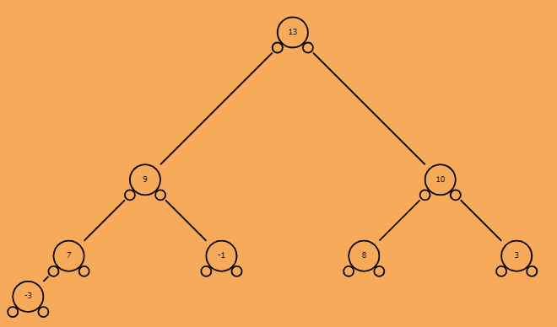

* Fourth Pass: [10, 9, 8, 7, -1, -3, 3, 13, 17, 26, 33]

* Fifth Pass: [9, 7, 8, 3, -1, -3, 10, 13, 17, 26, 33]

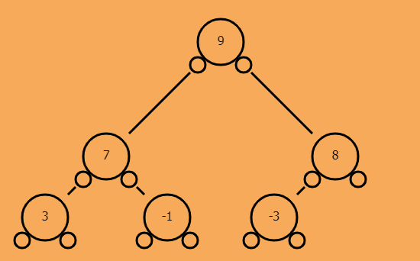

* Sixth Pass: [8, 7, -3, 3, -1, 9, 10, 13, 17, 26, 33]

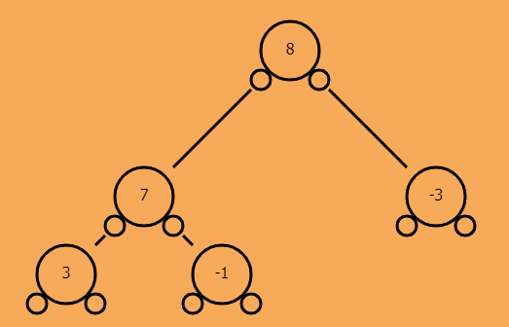

* Seventh Pass: [7, 3, -3, -1, 8, 9, 10, 13, 17, 26, 33]

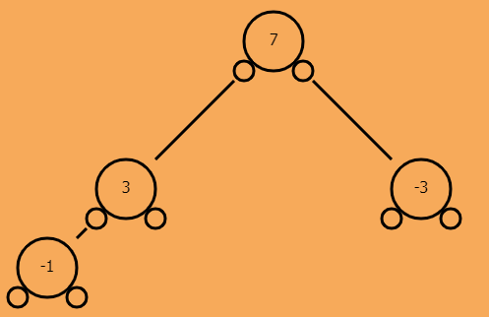

* Eighth Pass: [3, -1, -3, 7, 8, 9, 10, 13, 17, 26, 33]

* Nineth Pass: [-1, -3, 3, 7, 8, 9, 10, 13, 17, 26, 33]

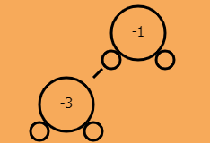

* Tenth Pass: [-3, -1, 3, 7, 8, 9, 10, 13, 17, 26, 33]

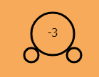

* Array is now sorted.

1. (40 points) Please sort the input array [9, -9, 15, 35, -1, 14, 20, 7] using the **QUICKSORT** algorithm to output an increasing order array. The last element is the Pivot (please show detailed steps for full credits)

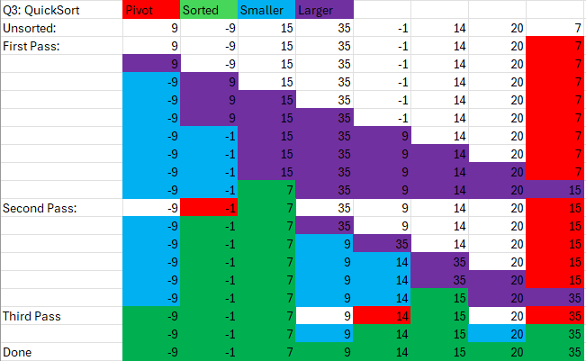

* When the array became one element, the if statement was false, so that element immediately became sorted
* This array took 3 passes to get sorted.