Cash Flow Forecasting Model — Group 2
Course: ACS 362A: Database Systems Group Project
Instructor: Japheth Mursi, Ph.D.
Prepared by: Group 2 — 22-2207 – Makau Andrew Nzyoki; 22-2203 – Wanjihia Serena Wairati; 22-2245 – Dorothy Vugutsa; 22-2337 – Lewis Kagia; 23-2189 – Kitavi Christoph
Date: November 05, 2025 • Version: v1.0

Executive Summary
Objective: Build a transparent monthly cash flow forecasting model to project cash position, identify funding needs, and evaluate scenarios.
Scope: 24‑month forecast in KES with Base / Upside / Downside scenarios; working capital (AR/AP/Inventory), CapEx/Depreciation, and optional debt.
Case Context: Nairobi-based consumer electronics retailer (store + online)

Key Charts
Closing cash — Base case:
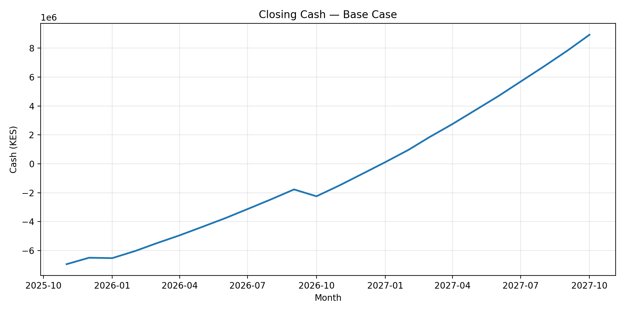
Closing cash — Base vs Upside vs Downside:
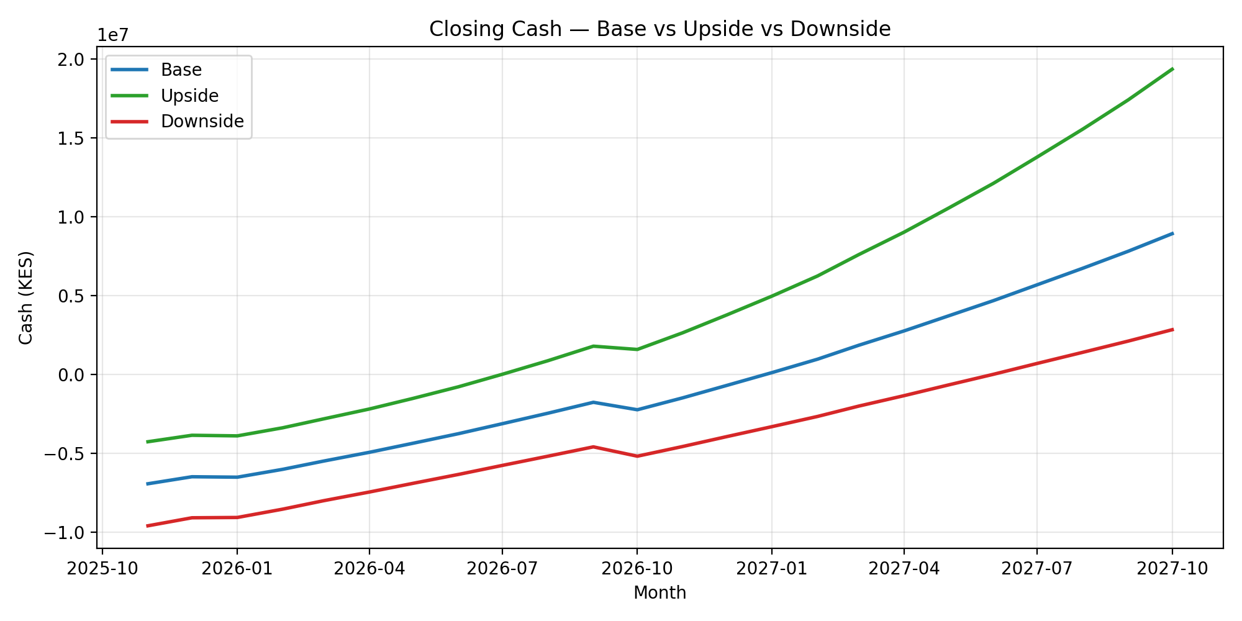
Working capital components (ΔAR, ΔInventory, −ΔAP):
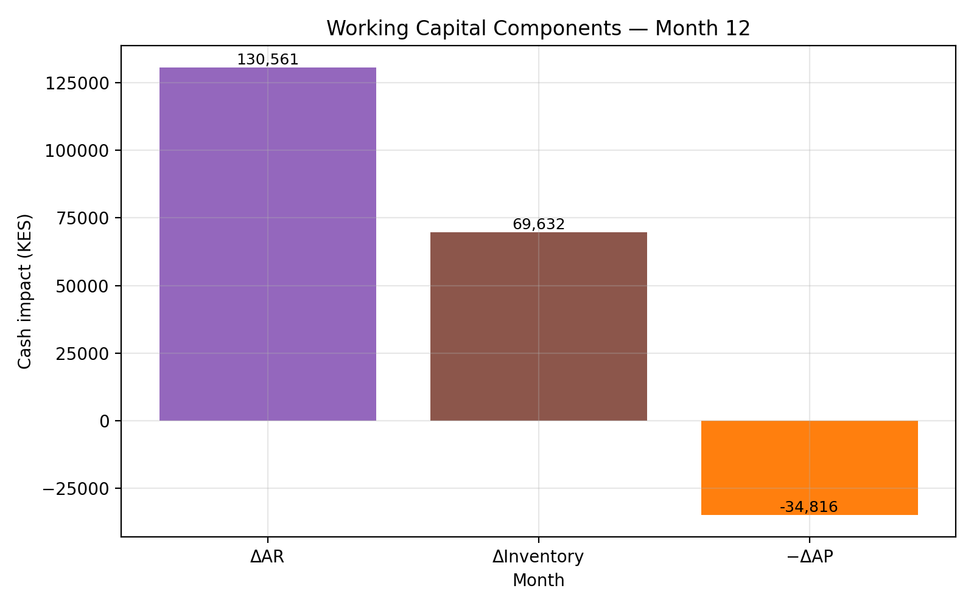

Methodology (summary)
Revenue via monthly growth; COGS as % of revenue; Opex with fixed and variable components; working capital using DSO/DPO/InventoryDays; CapEx and straight‑line depreciation; simple taxes; cash flow = Net Income + Depreciation − ΔWC − CapEx.

Scenario Assumptions
Base: growth 1.5%/mo, DSO 45d, DPO 30d, Inventory 60d
Upside: growth 3.0%/mo, DSO 35d, DPO 35d, Inventory 50d
Downside: growth 0.5%/mo, DSO 55d, DPO 25d, Inventory 70d

Notes & Recommendations
Focus on reducing DSO, negotiating DPO, and phasing CapEx to smooth the cash trough. Update actuals monthly and refresh scenarios quarterly.

