Functionality and Deficiencies

While the majority of the program works as intended, there were limitations in time that ultimately led to deficiencies. Some are features of the program that were implemented to save the time required to find a solution. An example is the way the programs handle spaces and letter case. Others are bugs that are detrimental to the program such as errors in encoding/decoding. The following is a summary of the functionality of the program and a description of it’s know bugs and limitations.
Note that all three ciphers provide the user with the same four options: keyboard encryption, file encryption, keyboard decryption, and file decryption. The function of the ciphers are designed similarly and contain some of the same functionality and limitations. For brevity, functionality and problems common to all three of the ciphers will be listed first.
Fundamentally, each cipher option allows the user to enter a message either from the keyboard or from a file to encode or decode. Some decode/decode options allow for the user to provide the names for output files to be created. Whenever this happens in the program, two output files are generated: one for the input that is being provided and one for the output produced by the cipher, be it the encoded or decoded input. The files are formatted so that they can be used by the cipher that created them. When the file encrypt or decrypt option is selected for a given cipher the user can (and is encouraged) to select the name of a file previously generated by the program. It is important however that the user takes care to select a file that is appropriate to the encode or decode option (i.e. an encoded file selected within the encode option will generate garbage). Certain options lack the feature of output file generation which will be covered in more detail later. Another function shared by each cipher is in how they process input. Before decoding, the given message is switched to all capital letters and spaces are closed. This was designed as a time saving measure as it would have been more complicated to deal with spaces and different cases at the cost of having a less user friendly output. The degree to which each cipher exhibits these features and deficiencies, as well as bugs specific to certain functions are covered below.

The Caesar Cipher option works accurately in that it will decode and encode accurately as long as the user follows the provided instructions. The biggest flaw of the Caesar Cipher is that is only dependable if the user enters an encryption key of 25 or less. This is because the cipher works by shifting the input a certain amount of letters over. The number of times each letter is shifted is provided by the key. If a letter is shifted beyond ‘Z’, it wraps back around to ‘A’ and finishes shifting. Thus if the user selects 26 as the key, the character array shifts the entire alphabet and the same message is returned. The code that shifts the array is only designed to wrap once, so key values greater than 26 can generate output errors. Another limitation is that Caesar Cipher only generates output files for the keyboard encrypt option. All other options work properly but do not generate files.
The Playfair Cipher is more robust in terms of file creation. Both the file encode and file decode options create two output files. The file encode option sends the decoded output to a file and the file decode option sends the encoded output to a file. Perhaps the biggest flaw in the program is with the encoding/ decoding process for the Playfair Cipher. Shorter messages work properly but sometimes inputting larger messages will result in garbled output toward the end of the message. More would be needed to identify the problem and implement a solution.
The Column Cipher creates output files for both of the user input options. The file input options do not created any output files, but they do correctly display the results. The Column Cipher functions very well however occasionally there may be conditions that cause the program to crash. This bug was discovered late in the development process and it happens rarely which makes it difficult to determine a cause. The main hypothesis is that under certain conditions, the program generates a blank .txt file instead of populating it with the appropriate message and key. Later when the user chooses to use that file to encode or decode, the program attempts to read a blank file which crashes the program. It is also possible that the crash was caused by human error when creating the file name input. In any case, the cipher typically works as expected.

finalProject.cpp User Manual

While many of the instructions for using finalProject.cpp are given to the user as he runs the program, the following is a guide to the nuances. Operation should be simple, but you may find this manual helpful. To provide a brief overview, finalProject.cpp provides the user three different encryption tools to encode or decode a message. The tools themselves are three different types of encryption. The user will have the option to encrypt or decrypt their message using either file input or input from the keyboard. Additionally, many of the options will write the output to a .txt file. These output files are formatted so that they themselves can be used as input for the program. It is important to remember that all the menus look similar, so make sure to read the title of the menu to be sure you are in the correct program. Also, each selection has it’s own special rules, particularly for the input of encryption keys and key words, so be sure to read the instructions as they are given to you.

The Main Menu
The program begins with a prompt for the user to select a cipher. You may choose one of the following options:
1. Caesar Cipher
Shifts letters of your message a set number to the right. The number of shifts is provided by an encryption key.
2. Playfair Cipher
Organizes letters into a 5X5 box with the box being filled with the unused letters of the alphabet. The messages letters are divided into groups of two and shifted based on a their r relative positions within the box.
3. Columnar Transposition Cipher
Creates a box that is the width of a keyword which is placed in the top row. The message then populates the rest of the box. The top row (keyword) is then sorted alphabetically, transposing the entire column with it.
4. Quit
Exit the program.

The Caesar Cipher
Selecting option 1 brings you to the Caesar Cipher menu and provides its own list of options.
1. Encode message using keyboard input
- Upon choosing option 1, the user will be prompted to enter a file name. The plain text and key that the user provides will be formatted and stored in this fill and can be used later to encode a message. Type in the desired file name followed by .txt to make it a text file and press “enter”
- The user will then be prompted to enter another filename. This file will contain the message coded from the users input. Follow the same steps to enter the file name. Be sure to give your second file a different name.
- After naming your output files, enter an encryption key. This can be any number between 1 and 25. This number is used to encrypt and decrypt the message. Any number entered over 25 can cause encoding errors.
- Once you choose an encryption key, you will be prompted to enter your message. Do not worry about capitalization or spacing, the program processes the message to all caps and removes spaces. Do not add any punctuation.

- Your encoded message will display along with an option to enter another message. If you wish to enter another message, enter ‘y’ and you will be returned to the encryption key prompt. Note that you were not asked to enter new file names. That is because the files you created will be appended with the new output you provide it. If you use to encode or decode these files later, the appended messages will be decoded as well, using their own encryption keys.
- Once you have entered your second message you will be prompted to ask if you want to add another message again. This time selecting ‘y’ returns the message, “Maximum number of messages entered” because the limit is two. From there you are returned to the Caesar Cipher menu.
2. Encode message using file input
- You will be prompted to enter a filename. Be careful to type in a filename that contains the plain text message formatted for the Caesar Cipher. Decoded and plain text files generated by the Caesar Cipher are valid options. Be sure to include .txt at the end of your filename.
- The file’s input will display on screen as well as the decrypted message below it. If the message selected was an appended file with two messages the second message will display below the first. You will be returned to the Caesar Cipher menu.
3. Decode message using keyboard inputting
- See option 1, directions are identical. Be sure to use your Caesar Encoded message with the correct key and not a plain text message.
4. Decode message using file input
- You will be prompted to enter a filename. Be careful to type in a filename that contains the formatted message encoded with the Caesar Cipher. Encoded files generated by the Caesar Cipher are valid options. Be sure to include .txt at the end of your filename.
- The file’s input will display on screen as well as the decrypted message below it. If the message selected was an appended file with two messages the second message will display below the first. You will be returned to the Caesar Cipher menu.
5. Return to main menu.
- If you are finished using the Caesar Cipher you can return to the main menu to use another cipher or exit the program.

The Playfair Cipher
Select one of the Playfair Cipher Menu options
1. Encode message using keyboard input
- Upon choosing option 1, the user will be prompted to enter a file name. The plain text and key that the user provides will be formatted and stored in this fill and can be used later to encode a message. Type in the desired file name followed by .txt to make it a text file and press “enter”.
- The user will then be prompted to enter another filename. This file will contain the message coded from the users input. Follow the same steps to enter the file name. Be sure to give your second file a different name.
- Next you will be prompted to enter a keyword. Make sure the keyword is under 25 characters long and contains no repeated characters or errors will be produced.
- Next, enter the message. The program will display the results and write them to their respective files that can be used later be the program.
2. Encode using file input
- You will be prompted to enter a filename. Be careful to type in a filename that contains the plain text message formatted for the Playfair Cipher. Decoded and plain text files generated by the Playfair Cipher are valid options. Be sure to include .txt at the end of your filename.

- Next you will be prompted to enter the name of a file. This file will contain the output generated from encoding the message and will be formatted for later use by the Playfair Cipher. Be sure to add .txt at the end of your file name.
- The keyword, message, and encoded message will display on screen. The file you named containing the encoded message was also created.
3. Decode message using keyboard inputting
- See option 1 for Playfair Cipher, instructions are the same. Files and output will be decoded instead of encoded so be sure to enter coded text and the appropriate key word.
4. Decode message using file input
- You will be prompted to enter a filename. Be careful to type in a filename that contains the message formatted and encoded for Playfair Cipher. Encoded files generated by the Playfair Cipher are valid options. Be sure to include .txt at the end of your filename.
- Next you will be prompted to enter the name of a file. This file will contain the output generated from encoding the message and will be formatted for later use by the Playfair Cipher. Be sure to add .txt at the end of your file name.
- The keyword, message, and encoded message will display on screen. The file you named containing the encoded message was also created.
5. Return to main menu
- If you are finished using the Caesar Cipher you can return to the main menu to use another cipher or exit the program.

The Columnar Transposition Cipher
Select one of the Columnar Transposition Cipher options
1. Encode message using keyboard inputting
- Upon choosing option 1, the user will be prompted to enter a file name. The plain text and key that the user provides will be formatted and stored in this fill and can be used later to encode a message. Type in the desired file name followed by .txt to make it a text file and press “enter”
- The user will then be prompted to enter another filename. This file will contain the message coded from the users input. Follow the same steps to enter the file name. Be sure to give your second file a different name.
- User will be prompted to enter a key word. This will be used to encode the message. It is important that the keyword be under 25 characters in length and contain no repeated characters or errors will be generated.
- Next you will be prompted to enter your message. The message can be 125 characters in length. Do not worry about spacing or capitalization. Your message will be processed to all caps and to close all spaces.
- Your keyword, message and encoded message will display on screen and the files you named will be created.
2. Encode message using file inputting
- You will be prompted to enter a filename. Be careful to type in a filename that contains the plain text message formatted for the Caesar Cipher. Decoded and plain text files generated by the Caesar Cipher are valid options. Be sure to include .txt at the end of your filename.
- The file’s input will display on screen as well as the decrypted message below it. If the message selected was an appended file with two messages the second message will display below the first. You will be returned to the Caesar Cipher menu.
3. Decode message using keyboard inputting
- Upon choosing option 3, the user will be prompted to enter a file name. The encoded text and key that the user provides will be formatted and stored in this file and can be used later to decode a message. Type in the desired file name followed by .txt to make it a text file and press “enter”
- The user will then be prompted to enter another filename. This file will contain the given key and decoded message. Follow the same steps to enter the file name. Be sure to give your second file a different name.
- User will be prompted to enter a key word. This will be used to encode the message. It is important that the keyword be under 25 characters in length and contain no repeated characters or errors will be generated.
- Next you will be prompted to enter your message. The message can be 125 characters in length. Do not worry about spacing or capitalization. Your message will be processed to all caps and to close all spaces.
- Your keyword, message and encoded message will display on screen and the files you named will be created.

finalProject.cpp Walkthrough

Main Menu:

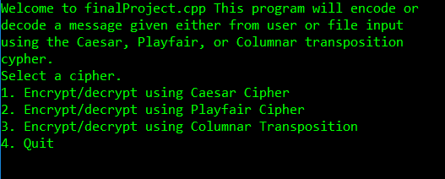

Caesar Cipher:

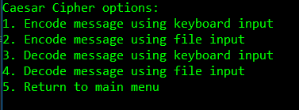

Moving into option 1 from the Caesar Cipher options menu, the user receives the following prompt. I have typed caesar1.txt following the prompt as an example. Note that .txt is provided by the user.
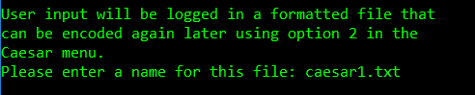

The following prompt:
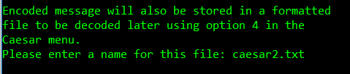

The message input prompt is below. Note that the user is limited to an integer value of 25. The reason is that this integer value tells the encode function how many times to shift the letters of the message to the right. If a letter reaches beyond ‘Z’ it wraps back around to ‘A’ . Thus if the user enters a key of 26, the encoded message will wrap back around and result in the same message the user inputted – not very useful for encoding! The wrap feature is only designed to happened once, so integer values larger than 26 can cause garbage output. Note that I inputted a value of 9.

The next prompt is for the message. The value is limited to because the array size is set 125. This is arbitrary and can be changed by altering the constant integer that sets it. Note that I entered the message “Take Your Time”. I used spaces and different cases to demonstrate how to program processes the users input.
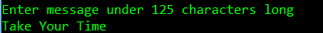

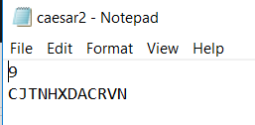
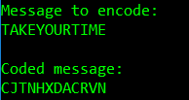
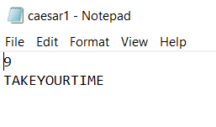
The processed user input and encoded message displays. Note that it changed the message to all caps and omitted spaces. This makes encoding easier. The following text messages were also generated which are formatted correctly to be read in by the program.

The user will then be asked if they want to add another file. An input other than ‘y’ brings the user back to the Caesar Cipher Menu. If the user enters ‘y’ they are prompted for another message. Note we are not asked to enter new file names, this is because the currently opened files we created, caesar1.txt and caesar2.txt will be appended.

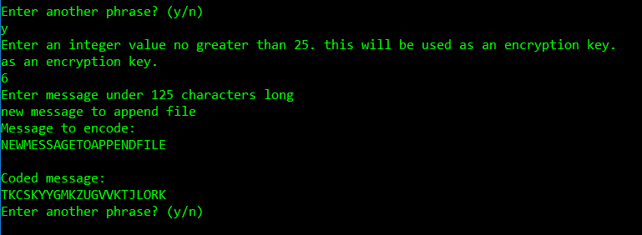

And here are the appended files:

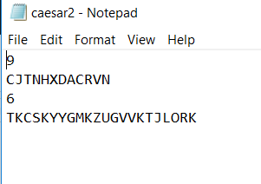
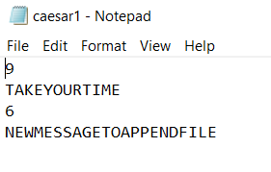

The program is only able to handle two messages, so if the user enters ‘y’ again he gets an error message, “Maximum number of messages entered” and is returned to the Caesar Cipher menu.

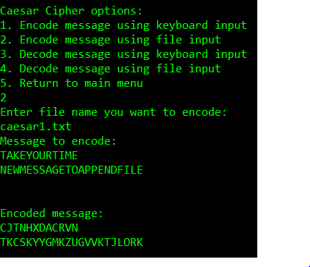
Option 2 for the Caesar Cipher is simpler in that the user simply selects a file to encrypt. Remember we already created the file caesar1.txt. This is a valid file for the program.

The file was read into the program and encoded the same way. Note that both messages display and the encoded output matches our messages from earlier. The user is returned the Caesar Cipher menu.

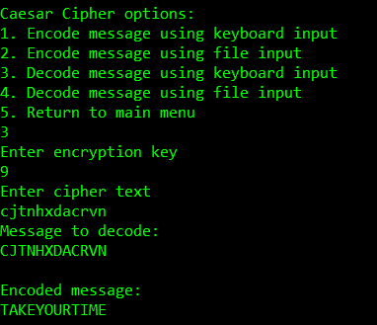

Option 3 is identical to option 1 except that there are no file name prompts. The input and output are not written to a file, only displayed on the screen. I used the same key (9) and encoded message from when we encoded “Take Your Time”.

Option 4 is identical to option 2 except we select an already encoded file instead of a plain text file. Recall that we created caesar2.txt. This is a valid option.

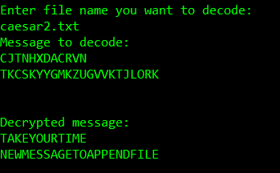

If the user selects option 5 from the Caesar menu, they will be returned to the main menu.

Errors that can occur are mostly caused by choosing an encryption key greater than 25.

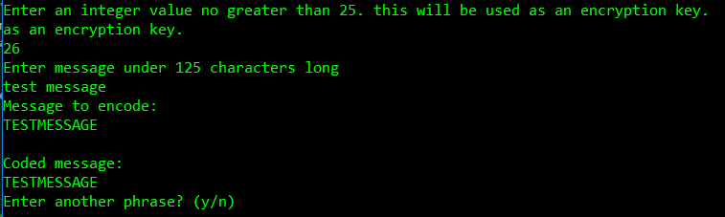
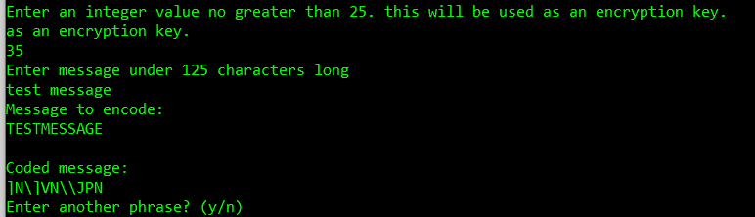

Playfair Cipher

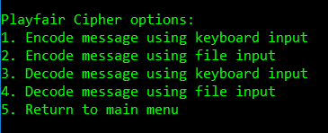

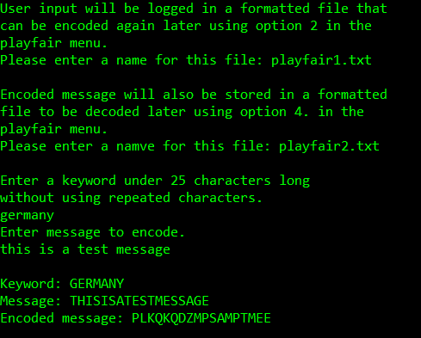
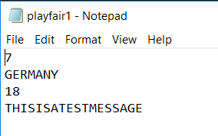
Option 1: Encode message using keyboard input Similar to option 1 of the Caesar Cipher. The only difference is that we use a keyword instead of an integer key. The Playfair option also lacks the capability of multiple messages. It is important that when the user inputs a keyword it does not have any repeated characters. This can cause errors in encoding. Note the message “germany” was changed to “GERMANY” similarly to the Caesar Cipher. The following files were also created:

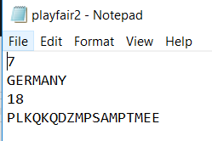
These text files contain the number of characters in the key word and message. This is used for encoding and decoding.

Option 2 for encoding with file input
is displayed here. Note that playfair1.txt which was created earlier was chosen as the input message.
Option 2 also prompts for another file name. The output is written to this file.
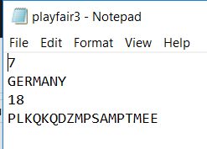
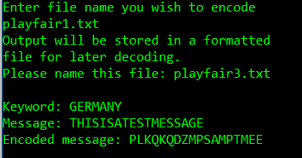

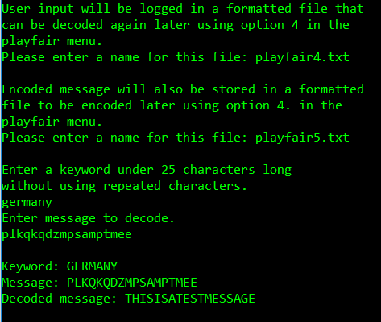
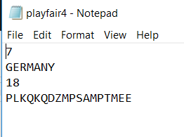
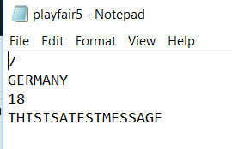
Option 3: Decode using keyboard input. Identical to option 1 except that encoded input from the user is entered instead of plain text. Previously encoded text was used for this example. The files playfair4.txt and playfair5.txt are generated.

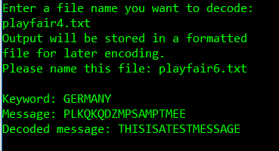
Option 4: Decode using file input. Identical to option 2 except this time an encoded message was chosen. The previously created playfair4.txt is a valid option. The user is once again prompted to enter a file name to generate another output file.
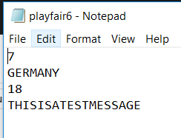

Option 5 returns the user to the main menu again.

The major problem with The Playfair Cipher implemented here is its inability to handle large messages. In the case, the selected file contained the encoded version of the phrase “THISMESSAGEISTOOLONGFORTHEPROGRAMTOHANDLEGARBAGEWILLAPPEAR”

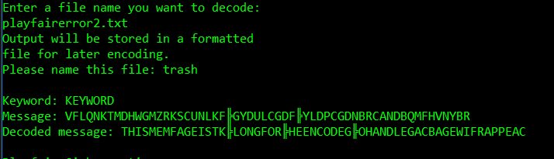

Columnar Transposition

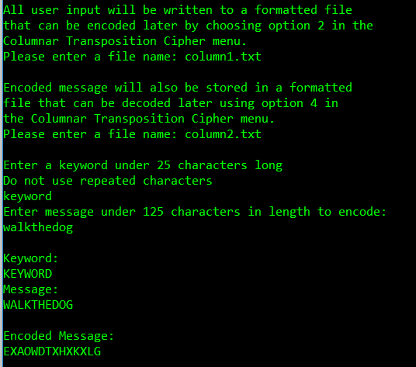
Option 1: Encode message using keyboard input. Appears almost identical to the user as option 1 of Caesar, though the methods for encoding are much different. Again, .txt files are created and can be used later.
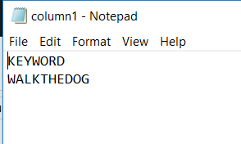

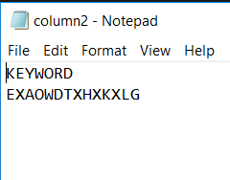

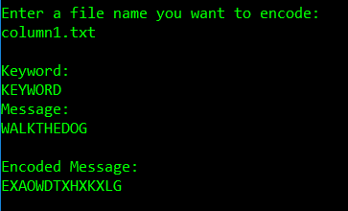
Option 2: Encode message using file inputted
In this case we use column1.txt. The keyword, message and encoded message are displayed to the screen.

Option 3: Decode message using keyboard input
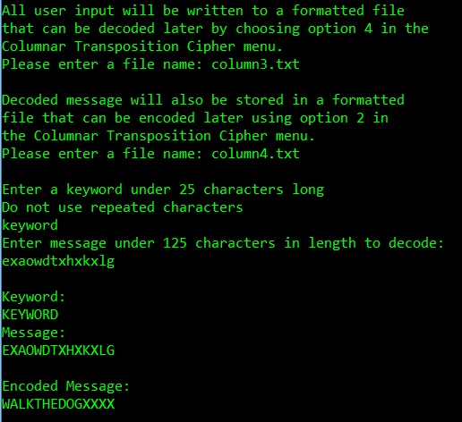
Identical to option 1 except that input should be encoded so that the output decodes. Output is displayed to screen and text files are created. Note the ‘X’s that appear at the end of the decoded messages. They become attached to the message because when input is entered, it is stored in a 2 dimensional array. When the message does not completely fill the array, ‘X’s are added to pad the message.

Option 4: Decode using file input

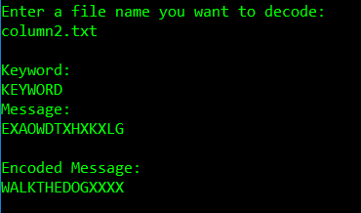
Identical to option 3 except an encoded file is selected to be decoded. In this case column2.txt which was created earlier was used.

