4-Way Intersection Control with Raspberry Pi 5

Team Name : Group-4

Student IDs : 2430745 & 2000000

Design
The controller treats North/South as one non-conflicting traffic group and the same is true for East/West. The program always starts in an all-red state; then, it follows the sequence :
START/ALL RED → NORTH-SOUTH GREEN → NORTH-SOUTH YELLOW → ALL RED/CLEARANCE → EAST-WEST GREEN → EAST-WEST YELLOW → ALL RED/CLEARANCE → REPEAT.
The code uses helper functions, a LIGHTS dictionary, a continuous loop, safety checking and try/except/finally handling.

Timing Choices
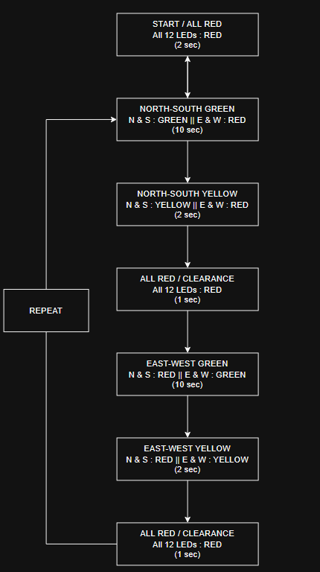
The assignment states that the GREEN right-of-way phase should last 10 seconds, so the GREEN_TIME constant is set to 10 seconds in the code. The YELLOW phase and the 1-second all-red clearance are additional transitions that last much less time. The all-red interval was selected as a brief safety clearance before the opposite light group turns to green.

Edge Cases and Safety
Edge Case | Response
Power-on / Startup | The system initializes in ALL RED and hold for 2 seconds before normal operation.
Conflicting greens | The state sequence never requests both groups green. Additionally, verify_no_conflicting_greens() runs after every transition and, if two conflicting greens are detected, forces a safe state and raises an error.
Green → Yellow → Red | Every green phase is followed by its yellow phase. The next opposite green is only enabled after an ALL RED clearance.
All-red clearance | A 1-second ALL RED interval is used between the transition of light groups to provide an explicit safety buffer.
Program interruption | The KeyboardInterrupt exception is caught and the finally block calls safe_shutdown(), which forces a safe state.
Unexpected exception | The program catches any exception using a try/except block. Then, the finally block forces a safe shutdown.
Invalid/incorrect pin setup | The program optionally runs a wiring_diagnostic() function that goes through each LED one by one in order to help the user check if they are all connected properly.
LED failure | There is no way to check for an LED failure using the software alone, which is something that a real safety-critical controller would need. If an LED was to fail, the system would most likely treat it as an unexpected exception and force a safe shutdown.
Timing drift/blocking | The program uses only the intended sleep() intervals in the state sequence. Once the main loop starts, there are no unnecessary delays.
Restart after failure | The program executes all_red() at startup, so every restart begins from a known software state.

Testing
Test | Expected Result | Observed Result
Individual LEDs | Each of 12 LEDs turns on with the correct BCM pin.
All four red LEDs | N/S/E/W red simultaneously
North-South group | N/S green together | E/W red
East-West group | E/W green together | N/S red.
Three full cycles | The sequence repeats correctly with no conflicting greens
Ctrl+C during green | Program leaves intersection ALL RED.
Restart | Program begins ALL RED before first green.

Troubleshooting
If an LED does not respond, stop the program and check the BCM number, LED orientation, resistor connection, jumper wire and the common ground.
Test one LED at a time before running the complete controller.
NEVER connect an LED directly to a Raspberry Pi GPIO without its current-limiting resistor.

Submission Checklist
- traffic_intersection.py
- circuit_diagram.png
- state_diagram.png
- report.pdf
- prototype.png
- Video/prototype.mp4
- Zip folder as Group4_2430745_2000000.zip

