Lab-4 Fall 2026

Database Design with an Introduction to SQL

Using the INVOICE table structure shown in Table 1, complete the following:

TABLE 1
Attribute Name | Sample Value | Sample Value | Sample Value | Sample Value | Sample Value
INV_NUM | 211347 | 211347 | 211347 | 211348 | 211349
PROD_NUM | AA-E3422QW | QD-300932X | RU-995748G | AA-E3422QW | GH-778345P
SALE_DATE | 15-Jan-2022 | 15-Jan-2022 | 15-Jan-2022 | 15-Jan-2022 | 16-Jan-2022
PROD_LABEL | Rotary sander | 0.25-in. drill bit | Band saw | Rotary sander | Power drill
VEND_CODE | 211 | 211 | 309 | 211 | 157
VEND_NAME | NeverFail, Inc. | NeverFail, Inc. | BeGood, Inc. | NeverFail, Inc. | ToughGo, Inc.
QUANT_SOLD | 1 | 8 | 1 | 2 | 1
PROD_PRICE | $49.95 | $3.45 | $39.99 | $49.95 | $87.75

- Relational Schema and Dependencies
- Write the relational schema
- Draw its dependency diagram. Identify all functional dependencies, including any partial and transitive dependencies. Assume that the table contains no repeating groups and that an invoice can contain more than one product.

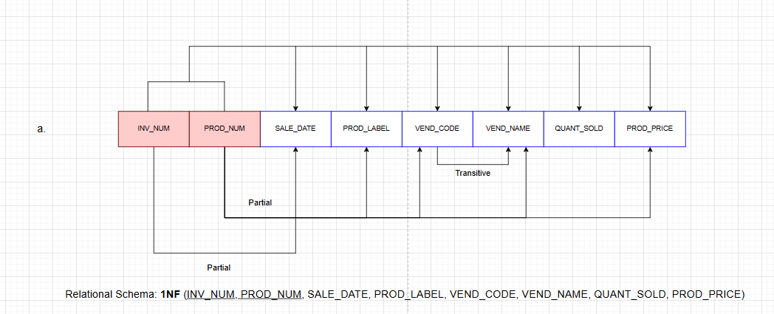

- Remove all partial dependencies then
- Write the new relational schemas,
- Draw the dependency diagram for each resulting table, and identify the normal form of each table.
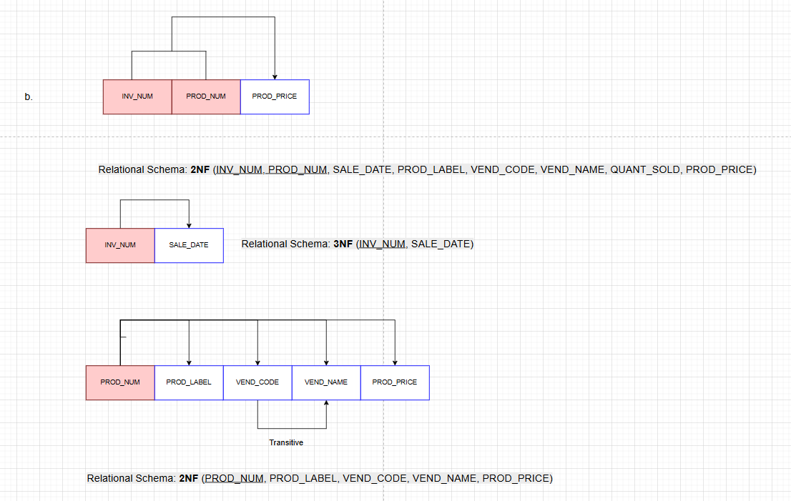

- Remove all transitive dependencies then
- Write the new relational schemas,
- Draw the dependency diagram for each resulting table, and identify the normal form of each table.
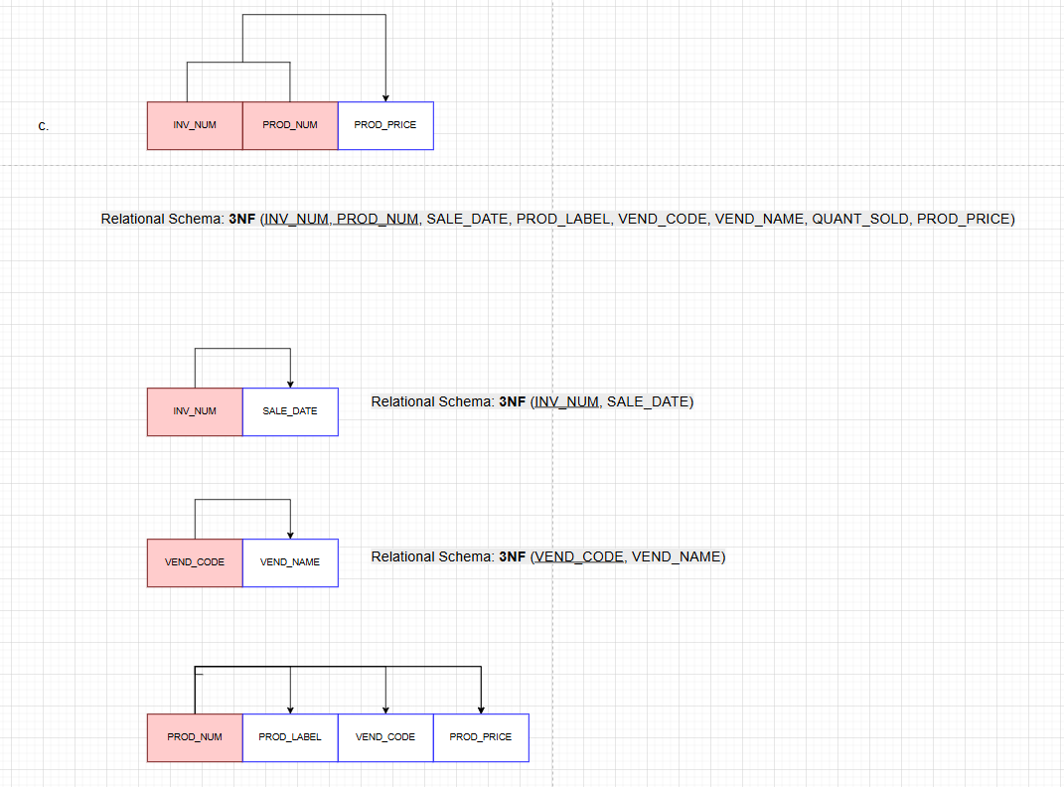
- Based on your final normalized tables, draw the Crow’s Foot ERD.
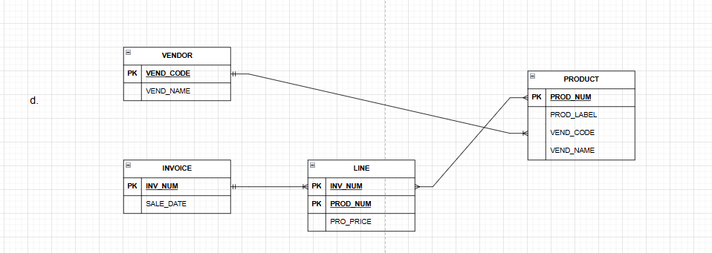
- Using the STUDENT table structure shown in Table 2, complete the following:

TABLE 2
Attribute Name | Sample Value | Sample Value | Sample Value | Sample Value | Sample Value
STU_NUM | 211343 | 200128 | 199876 | 198648 | 223456
STU_LNAME | Stephanos | Smith | Jones | Ortiz | McKulski
STU_MAJOR | Accounting | Accounting | Marketing | Marketing | Statistics
DEPT_CODE | ACCT | ACCT | MKTG | MKTG | MATH
DEPT_NAME | Accounting | Accounting | Marketing | Marketing | Mathematics
DEPT_PHONE | 4356 | 4356 | 4378 | 4378 | 3420
COLLEGE_NAME | Business Admin | Business Admin | Business Admin | Business Admin | Arts & Sciences
ADVISOR_LNAME | Grastrand | Grastrand | Gentry | Tillery | Chen
ADVISOR_OFFICE | T201 | T201 | T228 | T356 | J331
ADVISOR_BLDG | Torre Building | Torre Building | Torre Building | Torre Building | Jones Building
ADVISOR_PHONE | 2115 | 2115 | 2123 | 2159 | 3209
STU_GPA | 3.87 | 2.78 | 2.31 | 3.45 | 3.58
STU_HOURS | 75 | 45 | 117 | 113 | 87

- Write the relational schema and draw its dependency diagram. Identify all functional dependencies, including all transitive dependencies.
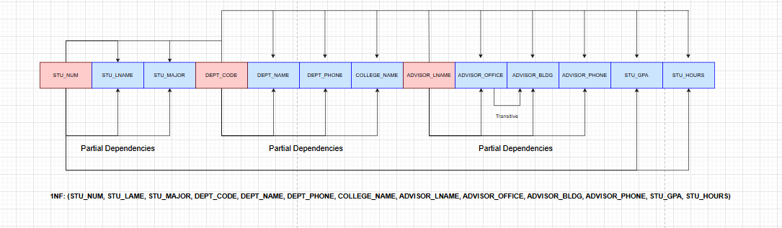

- Normalize the table to Third Normal Form (3NF) to the greatest practical extent possible. Write the relational schemas for the resulting tables, draw the dependency diagram for each table, and identify the normal form of each table. If you decide that a table should remain in 2NF for practical reasons, clearly explain why. If necessary, add or modify attributes to create appropriate determinants and follow proper naming conventions.
