Lab-2

Create a new database, call it Beneco, and create following tables.
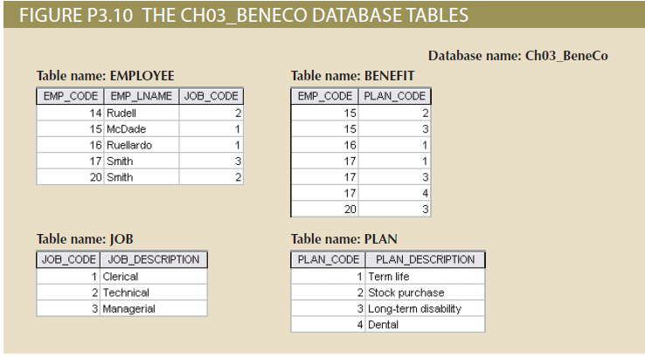

Note that the database is composed of four tables that reflect these relationships:
- An EMPLOYEE has only one JOB_CODE, but a JOB_CODE can be held by many EMPLOYEEs.
- An EMPLOYEE can participate in many PLANs, and any PLAN can be assigned to many EMPLOYEEs.
Note also that the M:N relationship has been broken down into two 1:M relationships for which the BENEFIT table serves as the composite or bridge entity.

- Create the four tables shown above in Microsoft Access. Define the appropriate data types, primary keys, and foreign keys, and enter the sample data provided.
- Create the ERD to show the relationship between EMPLOYEE and JOB. (Crow’s foot)
- Create the relational diagram to show the relationship between EMPLOYEE and JOB.
- Create the ERD to show the relationships among EMPLOYEE, BENEFIT, JOB, and PLAN. (Crow’s foot).
- Create the relational diagram to show the relationships among EMPLOYEE, BENEFIT, JOB, and PLAN.

Note: The relational diagram is the one shown in Access, in the menu Database Tools Relationships.

