Lab-3 Fall 2026

Database Design with an Introduction to SQL

- Create an ERD based on the Crow’s Foot notation using the following requirements:
- An INVOICE is written by a SALESREP. Each sales representative can write many invoices, but each invoice is written by a single sales representative.
- The INVOICE is written for a single CUSTOMER. However, each customer can have many invoices.
- An INVOICE can include many detail lines (LINE), each of which describes one product bought by the customer.
- A vendor can supply many products, and a product can be supplied by many vendors,
- The product information is stored in a PRODUCT entity.
- The product’s vendor information is found in a VENDOR entity.
NOTE
The ERD must reflect the business rules above. You may define additional reasonable business rules if needed. Make sure your ERD includes the appropriate entities, attributes, primary keys, foreign keys, relationships and cardinalities so that the model can be successfully implemented.

Copy your ERD here:

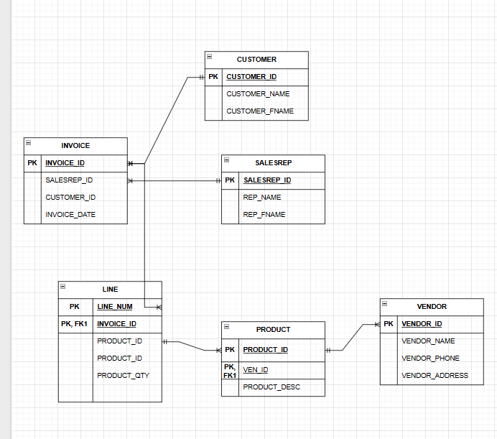

- Revise the ERD:
The current ERD shows a direct relationship between VENDOR and PRODUCT. Based on the business rules, determine whether this relationship is correct. If not, revise it by resolving the many-to-many relationship. Clearly show:
- The new associative entity
- Its primary key
- Its foreign keys
- The new cardinalities between the entities

Copy your revised ERD here:
