**Raven II Inertia and Center of Mass Parameters**

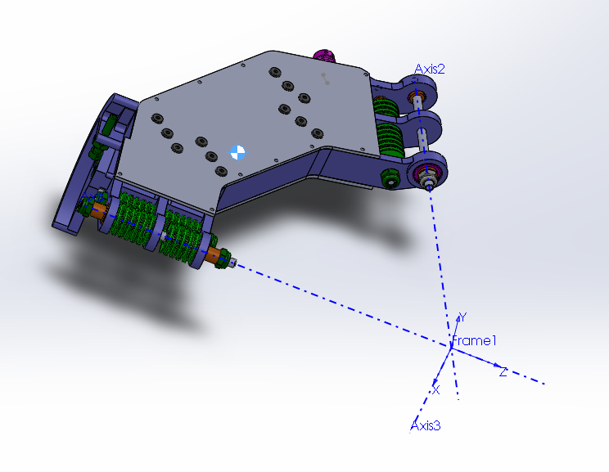

Figure 1: Cad model of link 1.

Link1:

Mass properties of link1

Configuration: Default

Coordinate system: Frame1

Actual Mass = 503.07 g

Calculated Mass = 252.75 grams

Volume = 211338.69 cubic millimeters

Surface area = 179575.08 square millimeters

Center of mass: ( millimeters )

X = 6.91

Y = 98.69

Z = -137.55

Principal axes of inertia and principal moments of inertia: ( grams * square millimeters )

Taken at the center of mass.

Ix = (-0.01, -0.78, -0.62) Px = 209633.75

Iy = (-0.04, -0.62, 0.78) Py = 1236881.98

Iz = (-1.00, 0.03, -0.02) Pz = 1397685.57

Moments of inertia: ( grams * square millimeters )

Taken at the center of mass and aligned with the output coordinate system.

Lxx = 1397316.09 Lxy = 14485.94 Lxz = 4164.24

Lyx = 14485.94 Lyy = 607489.68 Lyz = 500386.40

Lzx = 4164.24 Lzy = 500386.40 Lzz = 839395.53

Moments of inertia: ( grams * square millimeters )

Taken at the output coordinate system.

Ixx = 8641352.61 Ixy = 186854.01 Ixz = -236086.43

Iyx = 186854.01 Iyy = 5401935.31 Iyz = -2930733.77

Izx = -236086.43 Izy = -2930733.77 Izz = 3313125.21

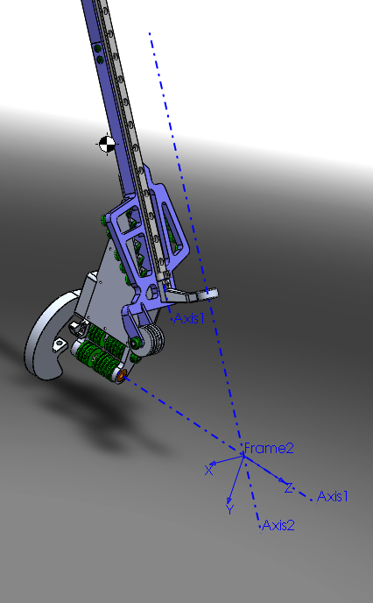

Figure 2: Cad model of link 2.

Link2:

Mass= 750.34 g

One of the components requires updating. This may cause the mass properties calculation to be out of date

Mass properties of link2

Configuration: Default

Coordinate system: Frame2

Calculated Mass = 650.18 grams

Volume = 248900.36 cubic millimeters

Surface area = 198525.62 square millimeters

Center of mass: ( millimeters )

X = -1.20

Y = -179.09

Z = -233.88

Principal axes of inertia and principal moments of inertia: ( grams * square millimeters )

Taken at the center of mass.

Ix = (-0.04, -0.87, -0.50) Px = 1026255.53

Iy = (-0.07, 0.50, -0.86) Py = 18427216.38

Iz = (1.00, 0.00, -0.08) Pz = 19114564.30

Moments of inertia: ( grams * square millimeters )

Taken at the center of mass and aligned with the output coordinate system.

Lxx = 19084791.25 Lxy = 578379.57 Lxz = 387081.98

Lyx = 578379.57 Lyy = 5401187.68 Lyz = 7526849.90

Lzx = 387081.98 Lzy = 7526849.90 Lzz = 14082057.28

Moments of inertia: ( grams * square millimeters )

Taken at the output coordinate system.

Ixx = 75504153.00 Ixy = 717927.88 Ixz = 569320.40

Iyx = 717927.88 Iyy = 40967267.11 Iyz = 34760711.79

Izx = 569320.40 Izy = 34760711.79 Izz = 34937207.20

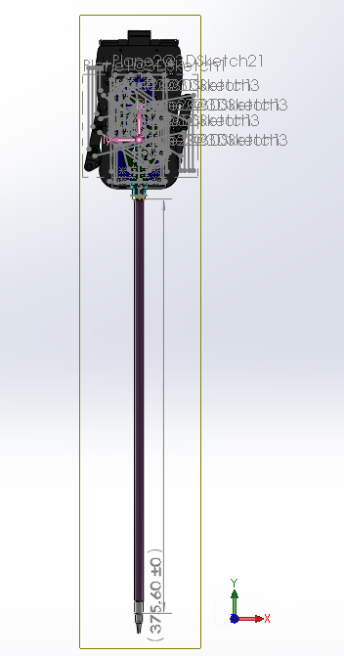

Figure 3: Cad model of link 3.

Link3:

Actual Mass= 406.58 g

CoM= (20.01, 0.19, 12.97) mm

I= [2908131, -1085, -66027,

     -1085, 3009048, -8871,

     -66027, -8871, 355197] g*mm^2