**Response Prediction**

David Havrilla

Andrew Rendler

Justin Teufel

**PROBLEM STATEMENT/MOTIVATION**

How do we identify an emotional state like stress preemptively, as to alert a user that they may be approaching a stressed state, and corrective action should be taken? This type of technology could be applied in the area of workplace ergonomics, for example in high stress environments like police work.

How do we describe emotional states like amusement, with a quantitative approach? With an understanding of how stress manifests itself in our biological systems, we can use this information to make better design decisions. This could be applied to A/B testing in environmental or UX design; Think, designing a dentist or doctor’s office to optimize neutral emotional states.

Is temperature a good predictor for stress? What is a better predictor of stress?

Since laugher/amusement are generally associated with better health, what sensor modalities are predictors of amusement?

How effective of an indicator can respiration, and/or body temperature be in order in roughly classifying levels of anxiety, nervousness, and other similar feelings, and is there a strong enough correlation to develop a predictive classification model? If a model can be developed, what level of precision can be achieved, and what is an ideal classification scale (ie. rating anxiety levels on a scale of 1-5, or 1-10).

**LITERATURE SURVEY**

Alberdi, A., Aztiria, A., & Basarab, A. (2015, November 28). Towards an automatic early stress recognition system for office environments based on multimodal measurements: A review. Retrieved July 8, 2020, from <https://www.sciencedirect.com/science/article/pii/S1532046415002750>

In this study a framework for office stress monitoring was developed using contextual, physiological, and psychological signals – as well as providing evidence to support that, out of all signals captured, which were the most indicative of stress states. Additionally, with the incorporation of contextual and psychological data, distinctions are made between cognitive stimulation and stress.

Dawans, B., Kirschbaum, C., & Heinrichs, M. (2010, September 16). The Trier Social Stress Test for Groups (TSST-G): A new research tool for controlled simultaneous social stress exposure in a group format. Retrieved July 9, 2020, from https://www.sciencedirect.com/science/article/abs/pii/S0306453010002088?via=ihub

This study focused on group behavior, taking groups of 6 out of a total pool of 25 participants to apply the Trier Social Stress Test – involving public speaking and mental math recitation scenarios. The test collected physiological data including ECG, respiration, heartrate, and cortisol level measurements. This study provides a valuable foundation for future experiments involving group based physiological response stress research.

Ruensuk M. (2018, October 8-12). Detecting Emotions using Smartphone Sensors: Technique to Raise Self-Awareness for Social Media Users. UbiComp/ISWC ’18. ACM 978-981. <https://doi.org/10.1145/3267305.3277825>

The study proposal suggests research is needed in investigating emotional self-awareness. The author shares her feelings on the importance of transferring of emotions over social media platforms. Her proposal is to use smartphone commodity sensors to detect physiological responses of social media users. The goal of completing such research would provide social media users with greater emotional self-awareness from the physiological data collected. This emotional self-awareness would improve human interaction between social media users.

H. Vögel et al., "Emotion-Awareness for Intelligent Vehicle Assistants: A Research Agenda," 2018 IEEE/ACM 1st International Workshop on Software Engineering for AI in Autonomous Systems (SEFAIAS), Gothenburg, 2018, pp. 11-15.

Emotion-aware Vehicle Assistant (EVA) is a design to be used as personal assistance within autonomous vehicles. The design idea is to interact on a contextual basis by utilizing environmental information including: “sights and objects, sound, car sensor input, intonation voice and sentiment of language, direction of gaze, and gestures” and other forms of sensory input. The purpose is to allow a user to make more emotionally aware decision utilizing EVA’s interpretation of contextual information.

<https://www.ncbi.nlm.nih.gov/pmc/articles/PMC6468793/>

The following paper titled *Assessing Anxiety Disorders Using Wearable Devices: Challenges and Future Directions* explores the reliability of using wearable devices (specifically those that measure electrocardiogram signals (ECG) to predict anxiety levels. The paper analyzes a collection of past studies and uses these to establish a set of criteria for future studies to adhere do in order to be effective.

<https://www.sciencedirect.com/science/article/abs/pii/S1532046419300693>

The following study titled *Predicting anxiety state using smartphone-based passive sensing* aims to use “behavioral features” (usage statistics, brightness, holding angle) from cellphone logs to predict stress/anxiety levels.

**PROPOSED WORK**

Our project will require no additional data collection, we are using the WESAD dataset, described later in our summary. The dataset fully describes the system that we are working to analyze, so there is no need to enrich our information or integrate any additional features.

First, we have read the source files (.pkl ‘pickle’) into the defined data structure or class. We will include the subject ID along with the ECG, EDA, EMG, respiration, and temperature measurements. Our team has decided to eliminate the use of the data collected from the accelerometers, as the analysis would require more time than available for this activity.

The data is collected at disparate rates – some at a rate of 70 per second, down to 1 every 2 seconds. We will want to summarize some of the readings to several per second, as the collection rates likely are high enough to support this reduction. We will make this determination during the initial EDA process.

During the EDA process we will try to identify correlation between the sensor outputs and the emotional response, **this is our primary objective for this project**. An interesting python library was highlighted during research; Neurokit. This package can be used to read or analyze variables such as ECG and EDA, that may return more valuable features that can be applied to our predictive model.

Another approach that could be valuable would be time series. If a generally correlated feature is identified, some window of historical data could be transposed onto each incoming ‘new’ record, where the sequence of states for the given variable all become useful features.

Once we have identified the highest quality features generated during the process, we will attempt to build a predictive model. Though our overarching objective is to identify features that are correlated to emotional state, our stretch goal is to build a model that could ingest incoming data and provide a user a response of their predicted emotional state (amusement, neutral, or stress).

**DATA SET**

The data being used is the Wearable Stress and Affect Detection (WESAD) Data Set by Schmidt et al (<https://ubicomp.eti.uni-siegen.de/home/datasets/icmi18/>). The data set is publicly available and features sensor data measured from both a chest and wrist-worn device.

The dataset contains information for 15 different subjects.

The devices used measured: blood volume pulse, electrocardiogram, electrodermal activity, electromyogram, respiration, body temperature, and three-axis acceleration.

From this dataset, we plan to focus on respirations and body temperature. Once some data analysis is established, we plan to broaden our predictive search to other measured biometric data in ability to predict various emotions.

The emotions being studied within this data set were neutral, stress, and amusement.

**EVALUATION METHODS**

We will apply the following evaluation methods:

Chi Square or 2 Way ANOVA during our exploratory data analysis. This can help us generalize the relationship between some selected explanatory variable and our response to evaluate which features should be allowed further consideration.

During the model development phase of the project we will apply a cross validation cross validation approach, there is a scikit learn workflow that was identified during our research that can be easily integrated into our process. We will use the cross-validation score to evaluate our success.

We will use a confusion matrix to understand the performance of our models as we test various configurations. With this analysis we can generate the standard metrics of precision, recall, and accuracy. And as suggested by one of our classmates during the feedback session, we will also incorporate the F1 metric.

**TOOLS**

As our primary programming language, we will use Python 3.7.x. We chose Python as our programming language for this project based on each group member’s familiarity with the language, as well as comfort using Python. We plan to use additional packages in Python that are commonly used in data science, including: pandas, numpy, matplotlib, and sklearn.

Pandas (source: <https://pandas.pydata.org/>) is an open source package for statistical analysis of data sets. The package allows the user a much more efficient way of manipulating data structures. Another benefit of panadas is the ability to work with multiple data formats. We plan to use pickle files, which can be imported with pandas.

Numpy (https://numpy.org/) is a package that makes Python computation much more user-friendly. What makes it so valuable is the ability to perform more complex mathematic computations and its use in building multi-dimensional arrays. Numpy is often used in fields of study such as: bioinformatics, mathematical analysis, multi-variate analysis, and more.

Matplotlib (<https://matplotlib.org/>) is a library used for plotting graphs within Python. Again, it can utilize numpy as an extension. We plan to use it as one of a few different ways to plot data points from our dataset.

Sklearn (<https://scikit-learn.org/stable/>), or more formally known as scikit-learn, is a machine learning library used within Python. To best optimize sklearn, it is used congruently with numpy for complex calculations and operations with arrays. One of the benefits of using sklearn is the fact that it is also an open source package.

Tableau (<https://www.tableau.com/>) is an additional tool we may use based on its ease of use and ability to generate complete and customizable visualizations. Granted, it is not nearly as customizable as other options. The primary benefit is the ease of importing datasets, while having general control over the visualizations created.

**MILESTONES**

As a group, we plan to meet once a week, currently every Sunday, to discuss work to be completed and make any necessary changes to milestones or other portions of the group project. We plan to meet via video conference and will continue to collaborate between meetings via e-mail or text message.

We plan to have the remaining portions of our project, parts 4-6, completed by Sunday, August 3rd. Setting an earlier due date will allow us to complete the project with enough time to make last minute changes. Additionally, a Sunday due date will allow us to meet via video conference and review last minute edits as a group.

Since Part 7 is an individual piece for peer evaluation, it will be a separately determined milestone for each group member.

**PROGRESS - CODE**

Up to this point our focus has been on data cleaning/analysis prep and preliminary exploratory analysis. In preparation for our exploratory analysis, we’ve developed a python class that interacts with the raw data - the .pkl files associated with each subject.

Our class has a series of methods that we developed to visualize and ‘smooth’ the data where necessary. Our methods include several graphing functions - some of which focus on a single sensor attribute, and some for correlation studies. Some functions have optional arguments which allow the user to smooth the data where necessary.

**PROGRESS - EDA**

Our exploratory data analysis at this point includes time series visualizations of the raw data (with some smoothing), just to get an understanding of how the sensor data is changing over the duration of the study, and how it relates to the subjects ‘protcal condition’.

For this submission we’ve included exploratory graphs from 3 subjects (1,4,8), with 4 time series graphs for each subject. The first graph shows the subjects entries for the protocol condition (0 = not defined / transient, 1 = baseline, 2 = stress, 3 = amusement, 4 = meditation, 5/6/7 = should be ignored). The next three graphs show sensor readings for respiration, temperature, and electrodermal activity respectively - these graphs ‘smoothed’ the raw data which was sampled at 700Hz, by averaging every 100 entries. As you’ll see below, the electrodermal and temperature time series graphs are more legible in the sense that you can easily identify a sensor reading at a particular time during the study, where the variation in the raw respiration data doesn’t allow for that legibility. The visualization is telling though, because the increased variability indicates greater displacement from the subject’s inhaling and exhaling.

**Subject 1:**

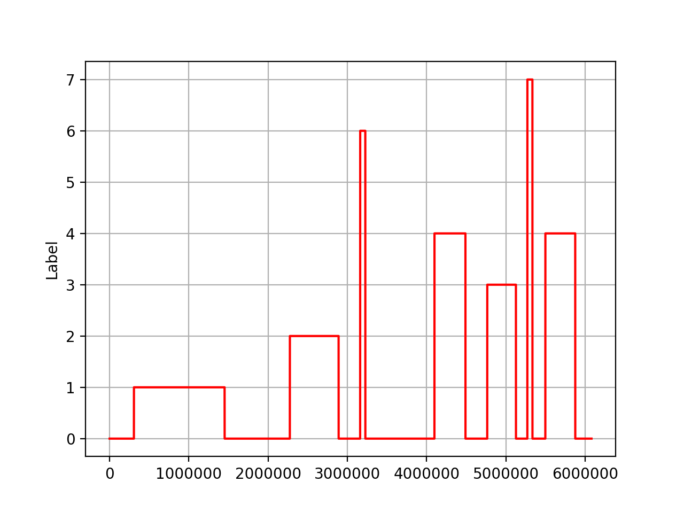

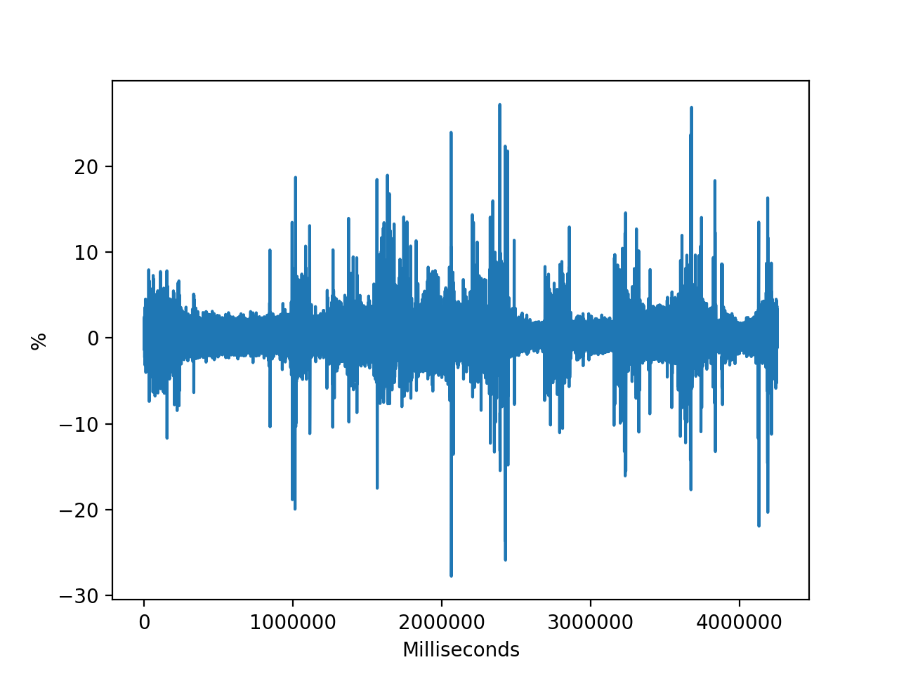

**Respiration - Subject 1**

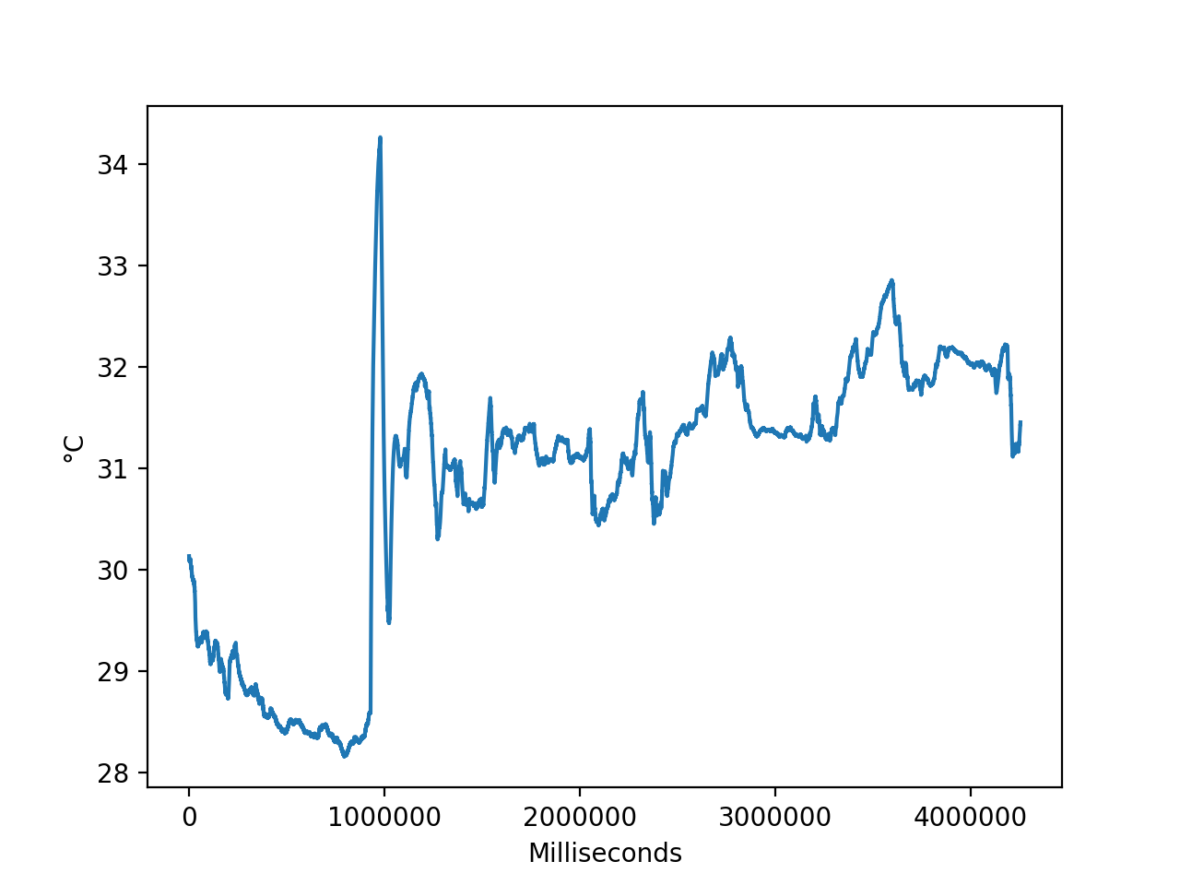

**Tempurature - Subject 1**



**EDA - Subject 1**

**Subject 4:**



**Protocals - Subject 4**



**Respiration - Subject 1**



**Tempurature - Subject 4**

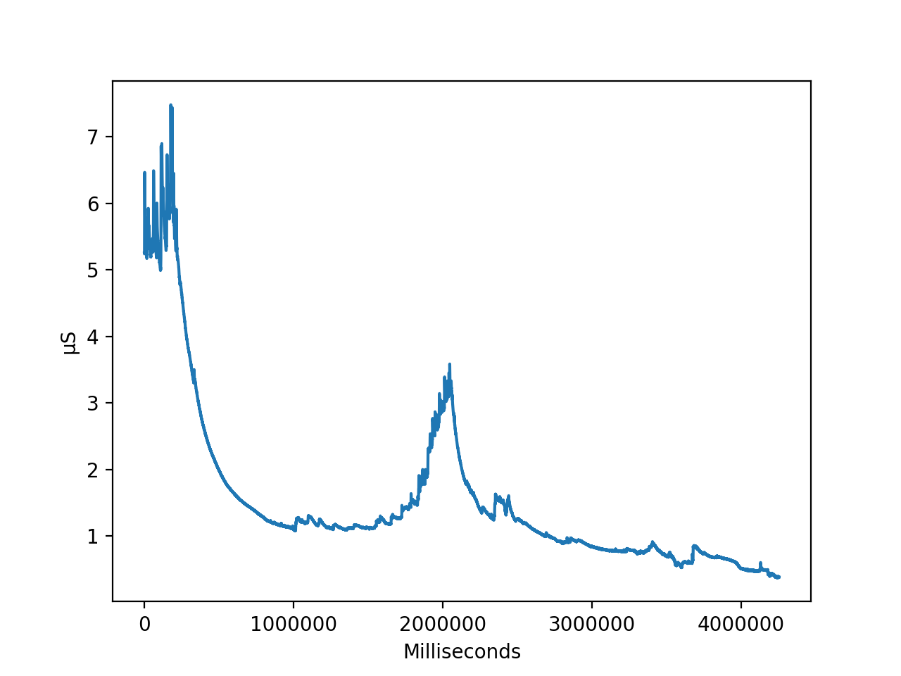

**EDA - Subject 4**

**Subject 8:**

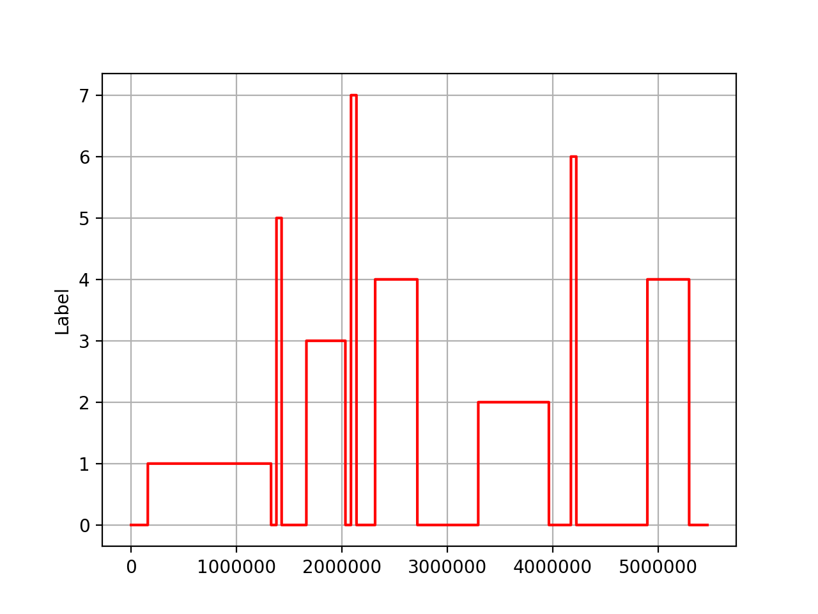

**Protocals - Subject 8**

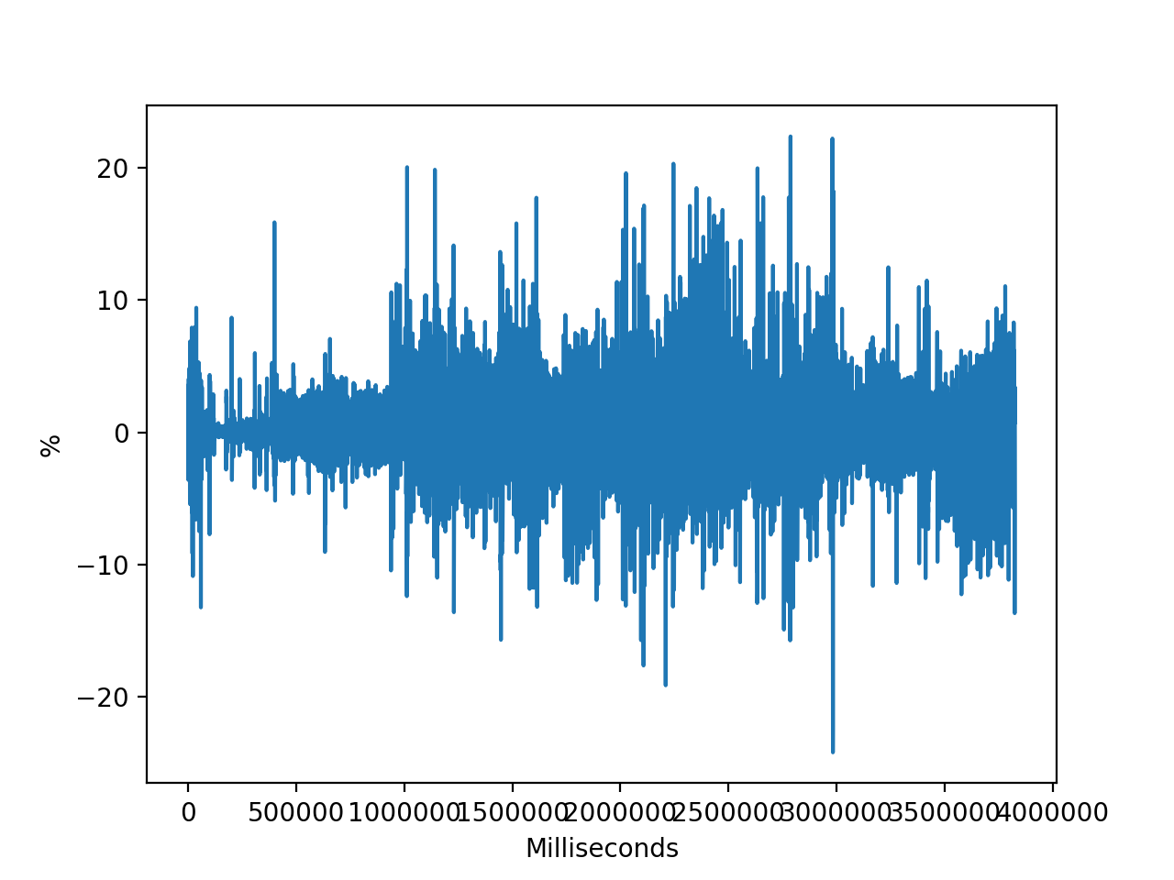

**Respiration - Subject 8**

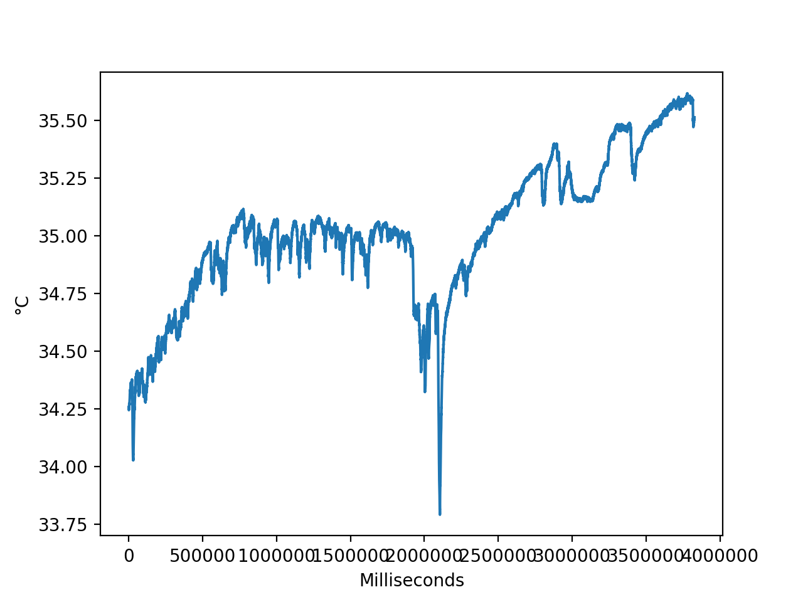

**Tempurature - Subject 8**

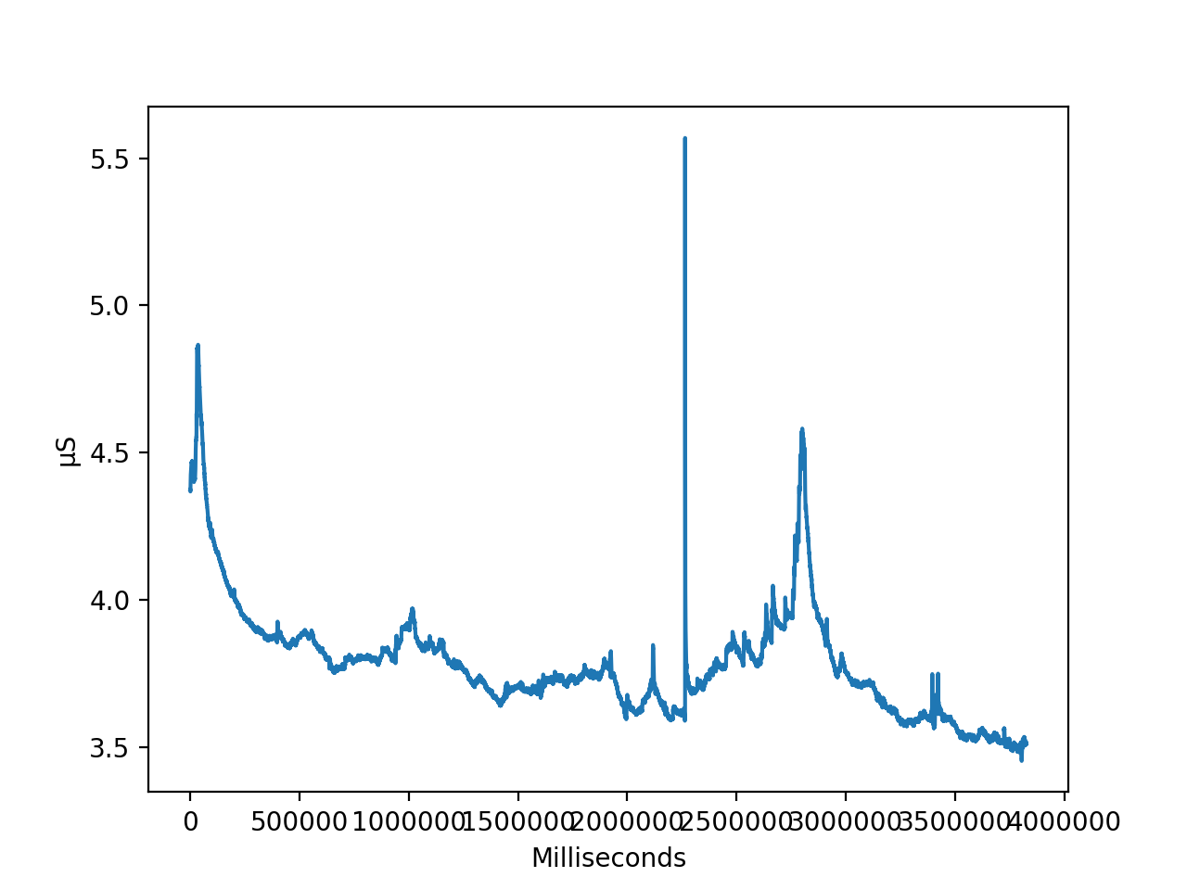

**EDA - Subject 8**

**NEXT STEPS - EDA**

To further refine our analysis, we will take additional steps to clean the data - which will involve removal of outliers, possibly deriving additional statistics from the raw data, and excluding irrelevant data (such as protcals 5,6 and 7). Additionally we will work on developing correlation graphs to identify any relationships between sensor readings and the protcals.