Analysis Report

Identification Results
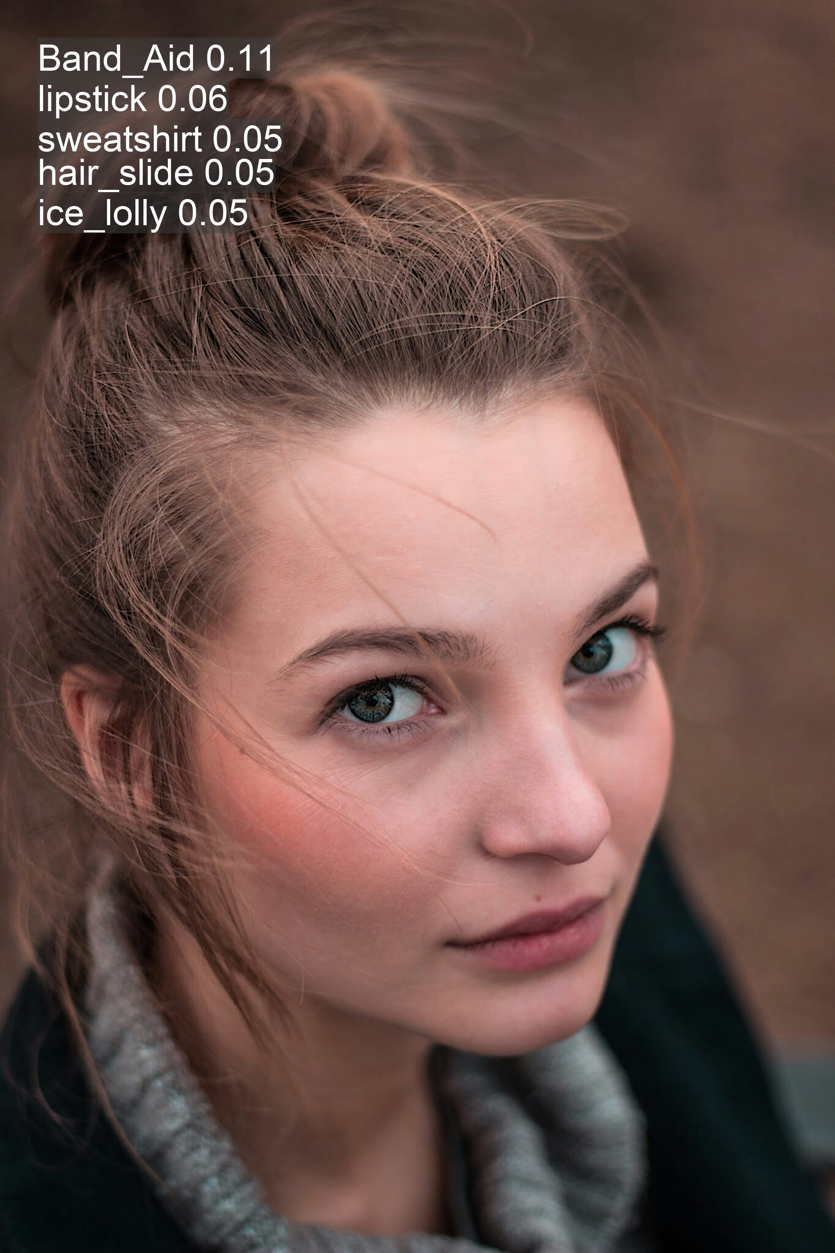

Classification Results
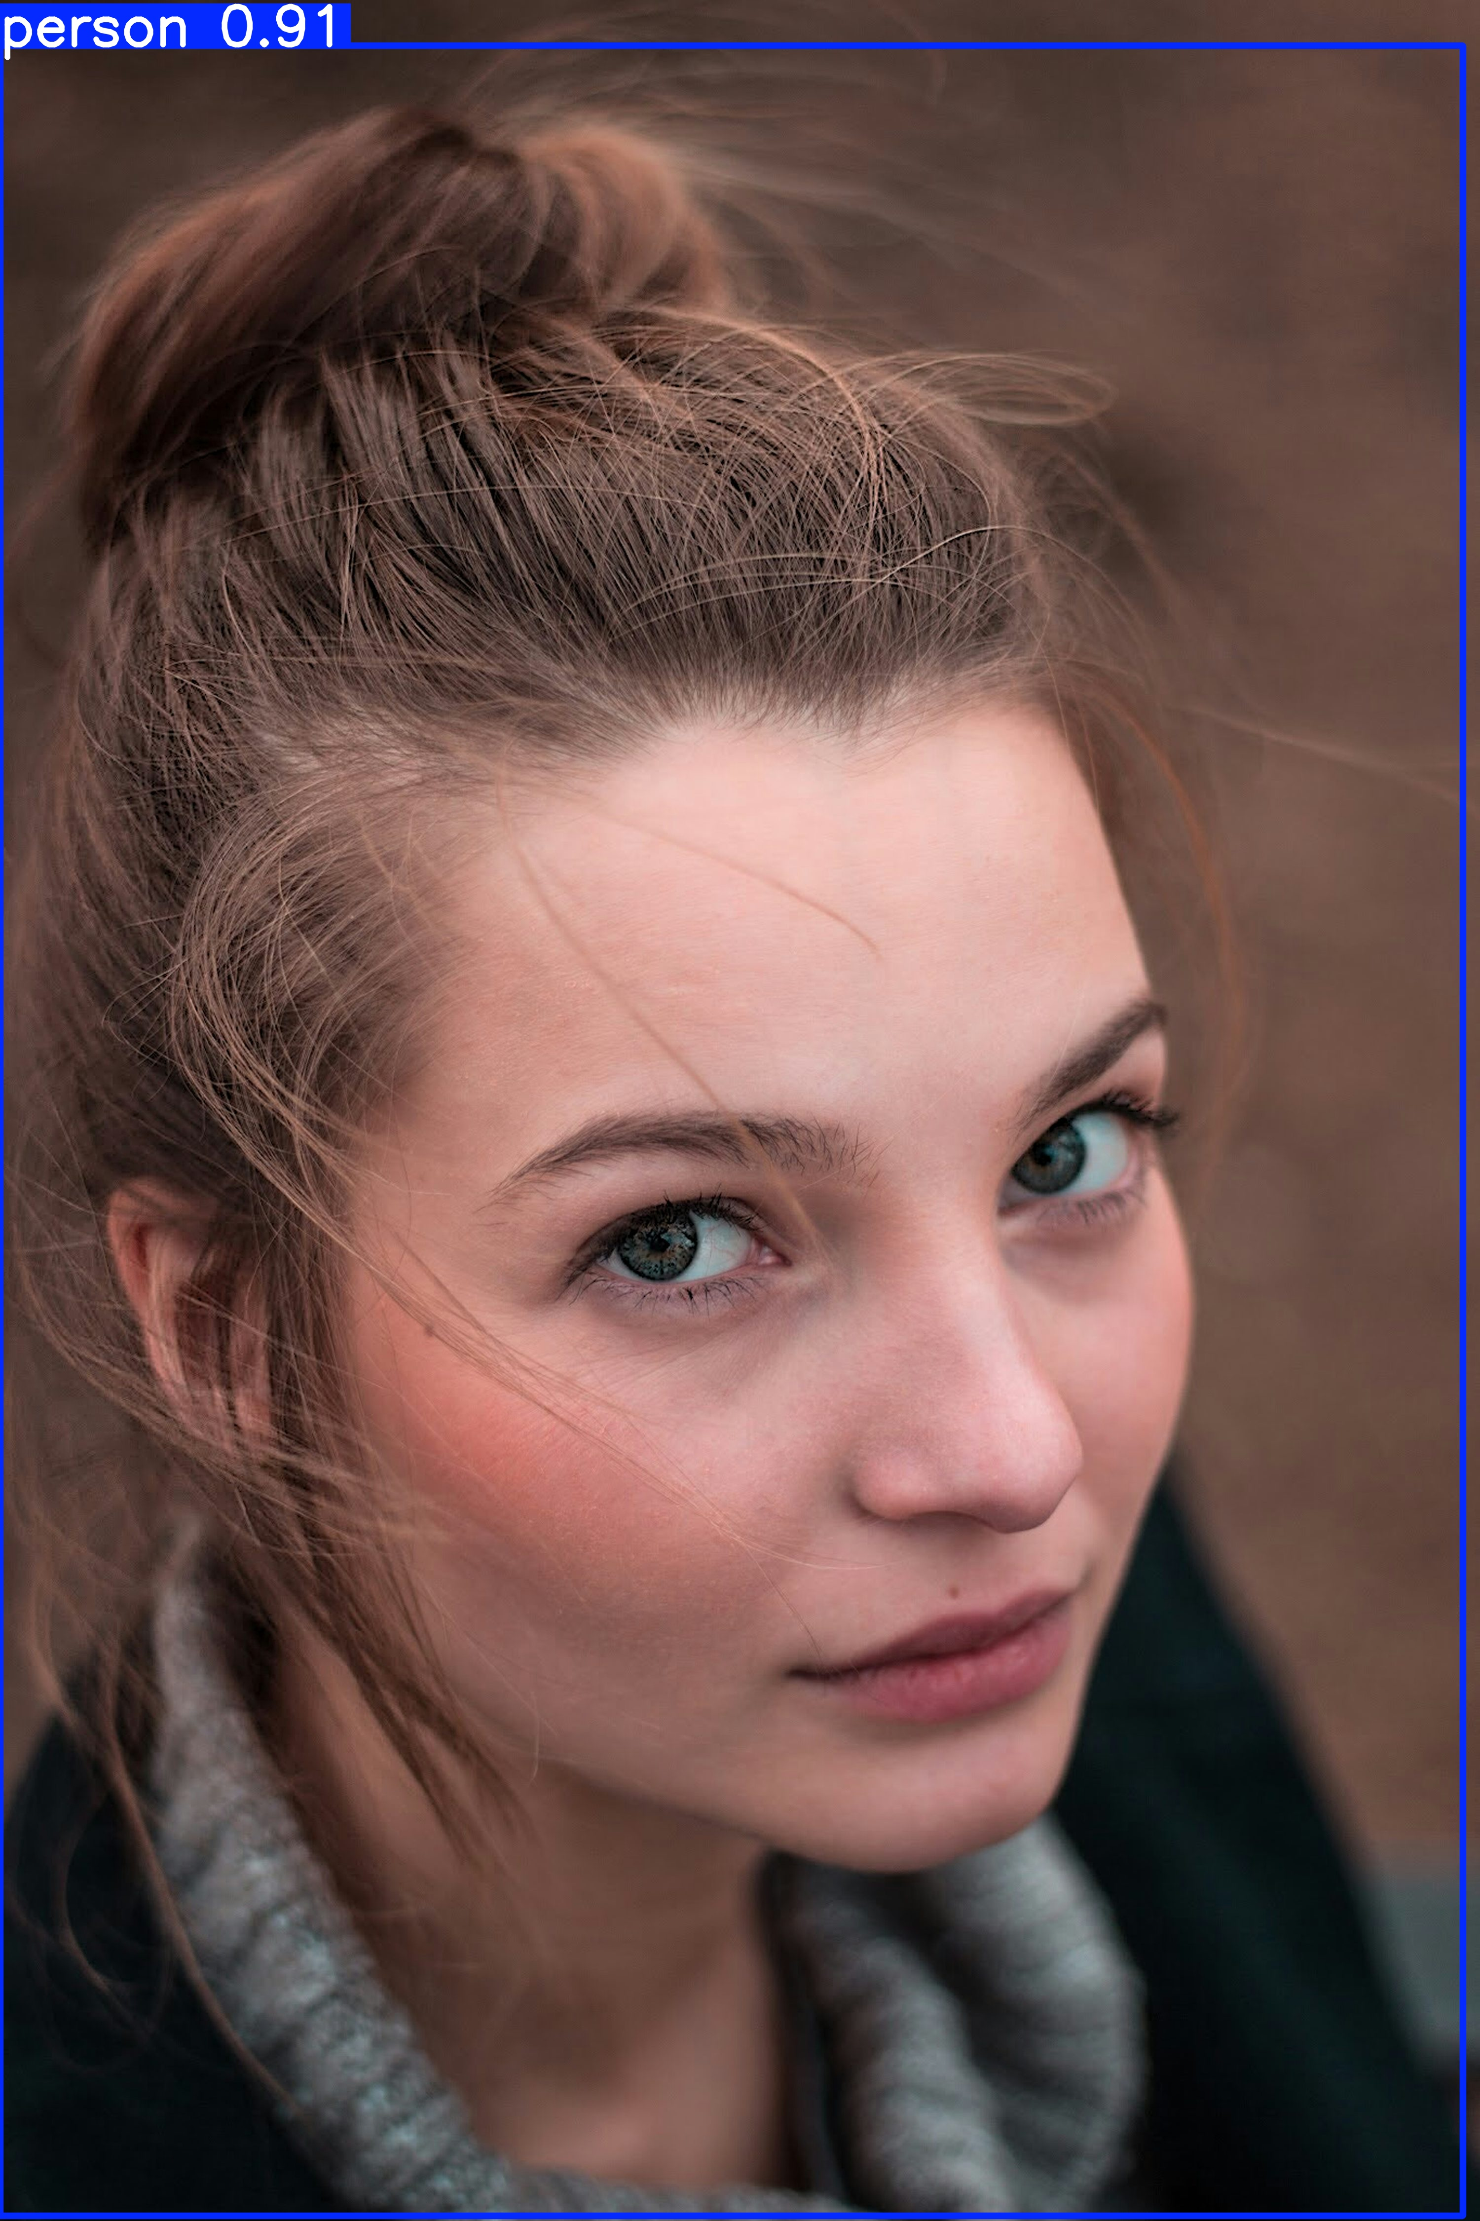

Analysis Results
31,Woman,white,happy

Logger Results
image 1/1 1.jpg: 224x224 Band_Aid 0.11, lipstick 0.06, sweatshirt 0.05, hair_slide 0.05, ice_lolly 0.05, 76.8ms
Speed: 77.2ms preprocess, 76.8ms inference, 0.1ms postprocess per image at shape (1, 3, 224, 224)
image 1/1 1.jpg: 640x448 1 person, 550.1ms
Speed: 2.8ms preprocess, 550.1ms inference, 1.2ms postprocess per image at shape (1, 3, 640, 448)

