|  |  |  |
| --- | --- | --- |
| **Problem Chosen** C | **2023 MCM/ICM Summary Sheet** | **Team Control Number** 2313119 |

**The Analysis of Wordle on Prediction and Classification**

**Abstract**

When the epidemic was raging, Wordle became a popular game on the Internet due to its extremely low operation complexity, high game fun and unique sharing mechanism. In order to help the New York Times carry out better development planning, game optimization and management, we respectively established the ARIMA model, BPNN model and K-means algorithm base model to help the New York Times carry out data prediction and analysis.

As for Problem 1, we built two models. In order to predict the number interval of future report results, we established the ARIMA model by analyzing the overall fluctuation trend of the data given for 359 days. The data of the first 328 days were used as the training set of the model to predict the data of the next 31 days. After comparing the predicted results with the real data, it was found that there was a very high degree of coincidence between them. We used all 359 data as the training set and predicted that the number of reported results of 2023/3/1 was within the range of 16735~17238. In order to find the relationship between word attributes and the ratio of the number of hard mode reports to the total number of reports, we took three factors as parameters: letter frequency, combined sound frequency and word frequency (processed by sigmoid function) of words and compared their occurrence frequency in hard mode respectively. Finally, it is found that there is no direct correlation between the word attributes and the ratio of difficulty patterns.

As for Problem 2, we use BP neural network model to predict the distribution of reported data. On the basis of known input parameter 7 and output result 7, the predicted value and the real value under different overfitting times and different hidden layers were compared, and the accuracy of the model was evaluated with RMSE as the measurement standard. The results show that the prediction results are better when the number of overfitting is 100 and the number of hidden layers is 10. The model is used to predict the data of the word "EERIE" (Table 5), and the distribution of its report results is shown in Table 6.

As for Problem 3, The K-mean model was used to divide the difficulty of words into four categories and evaluate them with seven parameters. For visualization purposes, the seven parameters were converted into two parameters, which are displayed in the rectangular coordinate system (Figure 11). For the example of "eerie", the correlation analysis is shown in Figure 12

Some other interesting observations we make during the meta-analysis of the data are that the number of results reported skyrocketed to a peak in the first 25 days of the data set and then declined daily; there was an abrupt low in the December 25 results report; the proportion of results of choosing difficult mode keeps increasing.

To sum up, we establish ARIMA model to predict the number of reported results in the future, BP Neural Network model to predict percentage distribution and K-means model to classify solution words by difficulty. Through analysis and case test, the results show that our model has high accuracy.

**Keywords:** ARIMA; Word Frequency; BP Neural Network; K-means

**Contents**

1 Introduction3

1.1 Background3

1.2 Restatement of the Problem3

2 General Assumptions3

3 Model Preparation3

3.1 Notations3

3.2 Data Cleaning4

4 Model I: Reported Results Number Prediction Model5

4.1 Overview5

4.2 Autoregressive Integrated Moving Average (ARIMA) model 5

4.3 Model Building 6

4.4 Results7

5 Model II: Relativity Between Word Attributes and Hard Mode Percentage 8

5.1 Overview8

5.2 Single Letter Frequency9

5.3 Double Letter Frequency9

5.4 Word Frequency and Letter Frequency10

5.5 Results11

6 Model III: Percentage Distribution Prediction Model 11

6.1 Overview11

6.2 Back Propagation Neural Network Model 11

6.3 Model Building 12

6.4 Results 14

7 Model IV: Word Difficulty Classification Model 14

7.1 K-means Model14

7.2Model Building and Results15

8 Some Interesting Features of the Data Set 16

9 Strengths and Possible Improvements17

References17

The Letter to the Puzzle Editor 18

1. **Introduction**

**1.1 Background**

In 2022, when the novel coronavirus pandemic was rampant, a puzzle game called Wordle, which was run on the platform of Twitter, attracted a lot of attention in a short time and then became popular all over the world. By January 2023, more than 300,000 people were taking part daily, according to the New York Times.

The rules of the game are pretty simple: You try to solve a puzzle by guessing a five-letter word six or fewer times, and you get feedback for each guess: if you have the right letter in the right spot, it shows up green. A correct letter in the wrong spot shows up yellow. A letter that isn't in the word in any spot shows up gray. For this version, each guess must be an actual English word, and guesses that are not recognized as words by the contest are not allowed.

For the New York Times staff overseeing the game, they desperately needed a way to do statistical analysis of the data from past puzzles, and a way to assess the difficulty of the puzzles chosen that day.

**1.2 Restatement of the Problem**

To optimize The Times' evaluation system, MCM produced a daily results file from Jan. 7 to Dec. 31, 2022. We will complete the following tasks according to the given data:

* Develop a model to account for daily variations in the number of reported results and explain whether word attributes affect the percentage of reported scores.
* Build a model to predict the relevant percentage of one day in the future (1, 2, 3, 4, 5, 6, X), and then evaluate the model by analyzing the performance of the training set.
* Establish a model that can distinguish the difficulty of words and analyze the accuracy of the model.
* Perform descriptive analysis or other statistical analysis on the data set.

**2 General Assumptions**

**Assumption 1:** We assume that the data given by the problem can represent the statistics of the daily game accurately.

**Assumption 2:** We assume that the distribution of the reported results can reflect the difficulty of the word.

**3 Model Preparation**

**3.1 Notations**

Table 1: Notations

|  |  |
| --- | --- |
| Symbol | Description |
|  | Frequency of single letter |
|  | Frequency of double letter |
|  | Word frequency with Sigmoid function |
|  | Percentage of Hard Mode |
|  | the sum of letter frequency of its letters |

**3.2 Data Cleaning**

**A. Number**

We made a line chart of the data in the Data File to facilitate our search for the wrong data. By looking at the broken line statistics of the number of reported results, we find a cliff drop at 2022/11/30 reported results, as known in Figure 1.

Figure 1: The Trend of the Number of Reported Results

Considering the data error is relatively serious, which may cause great interference to our following analysis results, we replaced the data through the method of data fitting before and after. The data used fitting before and after and the replacement results are shown in Table 1.

Table 2: Reported Number Errors in the Data File

|  |  |  |
| --- | --- | --- |
| Date | Contest Number | Reported Number |
| … | … | … |
| 2022/12/2 | 532 | 24646 |
| 2022/12/1 | 531 | 22628 |
| 2022/11/30 | 530 | ~~2569~~ (25295) |
| 2022/11/29 | 529 | 23735 |
| 2022/11/28 | 528 | 26051 |
| … | … | … |

**B. word**

According to the actual rules of Wordle, the target word to be guessed must be composed of 5 English letters. However, in the process of data cleaning, we find through observation that there are letters missing, letters wrong or the number of letters exceeded the limit of 5 in some word data. For example, the word data with contest number#525, #545, and #314 have errors in the word column. By inquiring relevant information published on the official website of the New York Times, we have corrected the wrong word, as shown in the following table.

Table 3: Word Errors in the Data File

|  |  |  |  |
| --- | --- | --- | --- |
| Date | Contest Number | Word (Errors) | Word (Corrections) |
| 2022/12/16 | 545 | rprobe | probe |
| … | … | … | … |
| 2022/12/11 | 540 | naïve | naive |
| … | … | … | … |
| 2022/11/26 | 525 | clen | clean |
| … | … | … | … |
| 2022/4/29 | 314 | tash | trash |
| … | … | … | … |

**4 Model I: Reported Results Number Prediction Model**

**4.1 Overview**

After data cleaning, we re-generate the line figure for the number of reported results.

Figure 2: The Trend of the Number of Reported Results (after data cleaning)

According to the observation and analysis of the new line figure, the data fluctuate greatly in the early period, and gradually tend to be stable and show a slow decline in the later period.

Generally speaking, the data of the number of reported results is still in a state of fluctuation over time, which belong to the non-stationary time series. Based on the above analysis, we decide to build the ARIMA model to solve the problem.

**4.2 Autoregressive Integrated Moving Average (ARIMA) model**

The basic idea of ARIMA model is to treat the data sequence formed by the prediction object over time as a random sequence, which is approximated by a certain mathematical model. Once it identified, the model can predict future values from past and present values of the time series.

The model can be divided into three parts. The bottom layer is the AR model, which uses the same variable such as the previous periods of x, namelyto, to predict the performance ofin the current period and assumes that they are linear relationships. The formula is:

Where is a constant term; is assumed to be the random error of the mean equal to 0 and the standard deviation equal to σ (zero mean white noise sequence); Sigma is assumed to be invariant for any .

On this basis, we add MA model to optimize AR model. MA model focuses on the accumulation of error terms in the autoregressive model, which can effectively eliminate random fluctuations in the prediction. Its formula is defined as

However, due to the limitation that AR model requires time series to have stationarity, we still need to continue to optimize it.

For a non-stationary time series, after the elimination of its local level or trend, it will show a certain homogeneity, in other words, some parts of the series are very similar to others. This kind of non-stationary time series can be transformed into stationary time series after difference processing, which is called homogeneous non-stationary time series, in which the degree of difference is the order of homogeneity.

If I take ∇ as the difference operator, then we have:

For the delay operator B, there is:

Therefore, it can be concluded that:

Given a homogeneous non-stationary time series of order d, then given that is a stationary time series, it can be called the ARMA (p, q) model, that is:

In it:

Are respectively autoregressive coefficient polynomial and moving average coefficient polynomial. is zero mean white noise sequence. The proposed model can be called the autoregressive summation moving average model, denoted as **ARIMA (p, d, q)**.

**4.3 Model Building**

We group the 359 data sets we had (the data as of November 30 had been cleaned up) and use the data before November 30 as the training set and the rest as the test set.

IBM SPSS Statistic 20 are used to establish the ARIMA model, and the following results are obtained:

Table 4: Specific Data of the ARIMA Model

|  |  |  |  |  |  |  |
| --- | --- | --- | --- | --- | --- | --- |
| Fitting Statistics | Stationary |  |  |  |  | normalized BIC |
| Mean Value | 0.277 | 0.981 | 12846.088 | 5.929 | 6775.711 | 19.029 |

We take 328 pieces of data before November 30 as the training set to test our model, and the test results are shown in the Figure 3.

Figure 3: The Training Data of the Number of Reported Results

The images of the real data are generated and compared with the images of the training set and zoom in at the end of the image where the testing set is made.

The results are shown in the figure above. We can obviously see that the results of the predicted value of the training set coincide with the real data to a high degree, which indicates that our model has high reliability and accuracy.

**4.4 Results**

Apply the model to the problem we need to solve, and after importing all the data sets, forecast the data after December 31, 2022, until March 1, 2023. Based on our model projections, we conclude that the range of the number of reported results for March 1, 2023 is 16735-17238.

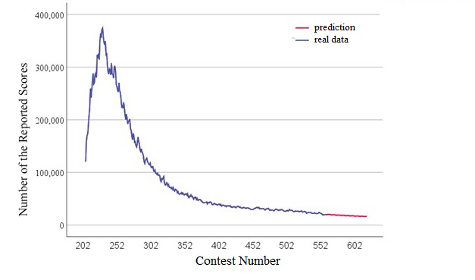

Figure 4: The Prediction of the Number of Reported Results

**5 Model II: Relativity Between Word Attributes and Hard Mode Percentage**

**5.1 Overview**

In order to study the relationship between word attributes and the proportion of Hard Mode in report scores, after searching and learning relevant materials, we define word attributes and divided them into 3 criteria, respectively.

1. Letter frequency, that is, the proportion of the number of times that each letter in the word appears in the sum of all letters in the word data to the total number of letters. The calculation formula is

(For example, if the letter "e" appears 15 times in a total of 25 words which all have 5 letters, its letter frequency is ).

1. Frequency of combined sounds, similar to letter frequency, that is, the proportion of the number of combined sounds in all word data contained in this word to the total number of words, the calculation formula is
2. Word frequency. The data mainly comes from wolfram [1], a professional word frequency statistics website, which records the usage frequency of each word worldwide. The frequency of the word can be expressed as .

Since there is a large gap between some words, it is not good for comparison, we use sigmoid function for data processing. The functional relation is

Its domain of definition is limited to. The processed values are sorted, and the value of the 180th word in the word frequency sorting of 359 words is processed as . The image of the specific result is shown in Table 4.

Table 5: Word Frequency and Data Processing

|  |  |  |  |
| --- | --- | --- | --- |
| Contest Number | Word |  |  |
| 286 | their | 0.001799 | 0.924142 |
| 314 | other | 0.001396 | 0.923157 |
| … | … | … | … |
| 204 | goose |  | 0.503492 |
| 240 | badge |  | 0.5 |
| 144 | cling |  | 0.496508 |
| … | … | … | … |
| 84 | howdy | 3.74E-08 | 0.076843 |
| 107 | parer | 1.84E-08 | 0.075858 |

**5.2 Single Letter Frequency**

We first count the letter frequency of each letter in the data set and select the nine letters with a higher letter frequency. Then, we divide words in the data set into three categories according to the percentage of Hard Mode, namely high percent, medium percent, and low percent respectively, to study the relationship of individual letter frequency with the percentage of Hard Mode.

As can be seen from Figure 6, the frequency of words fluctuates slightly in the three categories of Hard Mode percentage, but there is no significant overall change and tends to be average. As a result, it can be concluded that the single letter frequency has no significant effect on the percentage of Hard Mode.

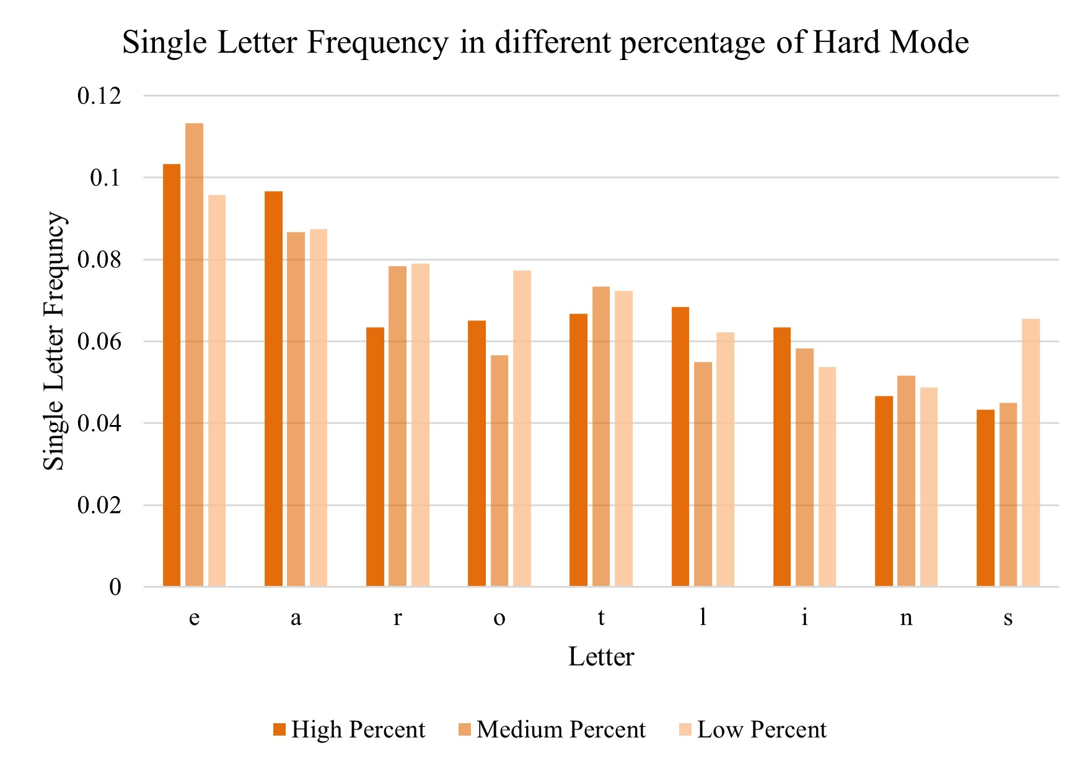

Figure 5: Single Frequency in Different Percentage of Hard Mode

**5.3 Double Letter Frequency**

After considering the single letter frequency, we also consider the double letter frequency. Similar to the idea when considering the single letter frequency, we first count the frequency of all double letter combinations in the data set and select 6 two letter combinations with higher frequency. Then, we divide words in the data set into three categories according to the percentage of Hard Mode, namely high percent, medium percent, and low percent respectively, to study the relationship of double letter frequency with the percentage of Hard Mode.

As can be seen from Figure 7, most of the double letter frequency do not change much, and a few have huge ups and downs, but there is no regularity. As a result, it can be concluded that the double letter frequency has no significant effect on the percentage of Hard Mode.

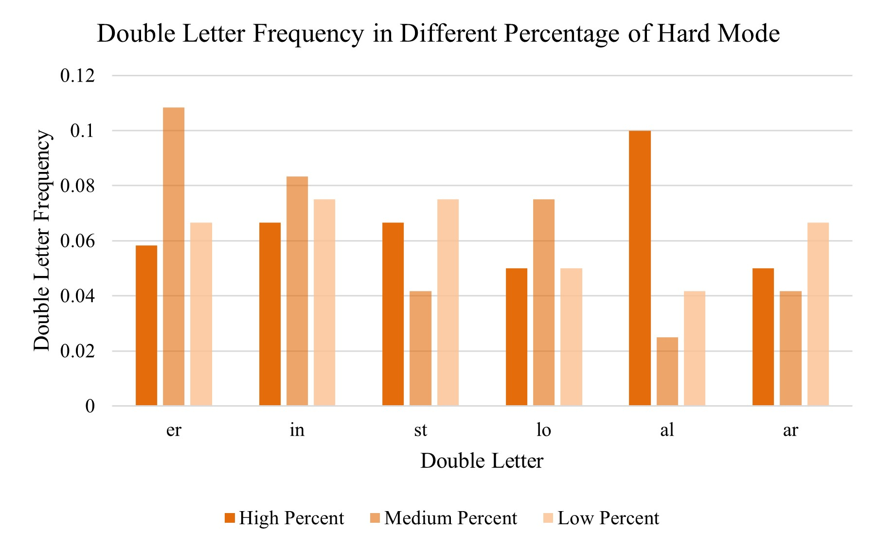

Figure 6: Double Letter Frequency in Different Percentage of Hard Mode

**5.4 Word Frequency and Letter Frequency**

Furthermore, we draw a 3-dimensional figure of the Hard mode percentage, word frequency and letter frequency. Among them, the percentage of hard mode is defined as

The word frequency is transformed by the sigmoid function.

The letter frequency of the word is the sum of letter frequency of its letters.

The X axis is , the Y axis is , and the Z axis is .

As can be seen from Figure 8, the data points are scattered and have no obvious regularity. As a result, it can be concluded that the word frequency has no significant effect on the percentage of Hard Mode.

Figure 7: Relativity of Hard Mode Percentage and Word and Letter Frequency

**5.5 Results**

In this section, we discuss the relativity of Hard Mode percentage and the word attributes from 3 aspects: single letter frequency, double letter frequency and the word frequency. All of them shows that the attributes of the word **do not** affect the percentage of scores reported that were played in Hard Mode.

**6 Model III: Percentage Distribution Prediction Model**

**6.1 Overview**

For the distribution of the report of the attempt times of a word, we divide the factors which are affecting it into three types: letter frequency, word frequency and letter repetition times, a total of seven parameters (the letter frequency of each letter should be taken into account), and the target output results are also seven (1,2,3,4,5,6, X). On this basis, we set up BP neural network, optimized by error feedback, and predict the distribution of future report results.

**6.2 Back Propagation Neural Network Model**

BP neural network is a multi-layer feedforward neural network trained according to the error backward propagation algorithm. The propagation process can be divided into forward propagation process and back propagation process. In the forward propagation process, BP neural network processes data through hidden layer neurons to output corresponding results. In the back propagation process, BP neural network constantly adjusts the parameter values of neurons in each layer by comparing the error between the real result and the predicted result. Thus, the error can be reduced to achieve the ideal effect of the model. The principle of adjustment is that the error is decreasing, so the weight adjustment should be proportional to the error gradient.

Figure 8: Schematic Diagram of the BP Neural Network Principle

Assume that the number of nodes in the input layer is, the number of nodes in the hidden layer is , and the number of nodes in the output layer is . The weight from input layer to hidden layer is, the weight from hidden layer to output layer is , the bias from input layer to hidden layer is , the bias from hidden layer to output layer is , the learning rate is and the excitation function is takes the Sigmoid function, of the form as

As shown in the BP network above, the output of the hidden layer is:

The output of the output layer is

In view of the error, we still need to set out the equation to take the error:

Where is the expected output. If we call , the error can be denoted as:

In the above formula,

The updated formula of weight is:

The updating formula of bias is:

Finally, determine whether the iteration is over.

**6.3 Model Building**

BP neural network system is applied to our study, and its structure is as follows:

* Input layer -- Each input layer of prediction data contains 7 neurons, each representing a parameter describing the attributes of the data (frequency of the first, second, third, fourth, and fifth letters, number of letter repeats, or word frequency).
* Hidden Layer -- This layer has one neuron for each case in the training dataset. The neuron stores the values of the predictor variables for the case along with the target value. In this case, there are 10 neurons in this layer.
* Output layer -- Through the calculation and fitting of the data, the calculated (1,2,3,4,5,6, X) is derived as the prediction result.

A new consideration in this model is the number of letters repeated as a parameter. Through our own experience and searching for relevant strategy data, we've noticed that, unless we can't recall another word or are absolutely certain, when considering possible words, players tend to choose words with fewer repetitions (or even zero) in order to eliminate more misinformation. As a result, it often takes more attempts to find the answer when the letter is repeated.

We select 70% of the data as the training set, 15% as overfitting validation and 15% as the test set, and then obtain the prediction and real values .

To evaluate the accuracy of the model, we can use RMSE (Root Mean Squared Error):

In the process of establishing the model, we adjust two parameters: the number of overfitting and the number of hidden layer neurons. We build a 3-dimension figure that reflects the RMSE of our model when the number of overfitting and hidden layer neurons change.

Figure 9: The Variation Trend of RMSE with the Number of Overfitting and Hidden Layer Neurons

It can be found that RMSE of the model is lower when the number of overfitting is set to 100 and the number of hidden layer neurons is set to 10, which means the prediction results are better. Since the RMSE is less than 0.5, we can think that the BP Neural Network Model is accurate.

**6.4 Results**

The word that need to be predicted is “EERIE”, and the data of the word can be seen in Table 5.

Table 6: Parameters of the word “EERIE”

|  |  |  |  |  |  |  |  |
| --- | --- | --- | --- | --- | --- | --- | --- |
| Parameter |  |  |  |  |  |  | Repeat Letter |
| Value | 0.13 | 0.13 | 0.06 | 0.07 | 0.13 | 0.283 | 3 |

After training the BP Neural Network Model, we get the output below, which is the prediction of the distribution of the reported results.

Table 7: Prediction of “EERIE”

|  |  |  |  |  |  |  |  |
| --- | --- | --- | --- | --- | --- | --- | --- |
| Tries | 1 try | 2 tries | 3 tries | 4 tries | 5tries | 6tries | 7 or more tries (X) |
| Percentage | 0 | 4 | 20 | 30 | 23 | 17 | 6 |

**7 Model IV: Words Difficulty Classification Model**

**7.1 K-means Model**

K-means clustering algorithm is a clustering analysis algorithm with iterative solution. It divides the sample set into k subsets, constituting k classes, and divides samples into classes. The distance between the center of each sample and its class is minimum, and each sample belongs to only one class (which is the characteristic of hard clustering algorithm).

Its specific construction process is as follows:

**Step 1:** Initialization. The sample of is randomly selected as the center of the initial clustering.

**Step 2:** Cluster the samples. For the clustering center selected during initialization, the distance between all samples and each center is calculated, the default Euclidean distance, and each sample is aggregated into the class of its nearest center to form the clustering result.

**Step 3:** Calculate the class center after clustering, and calculate the centroid of each class, namely the mean value of samples in each class, as the new class center.

**Step 4:** Then perform steps (2) and (3) again until the clustering results no longer change.

Figure 10: Schematic Diagram of the K-means Model

**7.2 Results**

The data we use for the K-means Model has a total of 7 parameters, as the percentage distribution, which can be expressed as . We use SPSS to build the K-means Model and get the classification of each word.

After obtaining the classification of word difficulty, to facilitate visualization, we simplify the 7 parameters to 2 parameters by linear combination.

Next, it is represented in the rectangular coordinate system, and the data points of the same classification are given the same color to distinguish them from the other classification.

Figure 11: The Classification of Word Difficulty

The Figure 13 shows the classification of word by difficulty directly. We can divide the word difficulty into four categories, and the magnitude of word difficulty is Green > Red > Blue > Orange.

Take the percentage distribution of the word “eerie” into the dataset and get Figure 14. The red triangle shown in the figure represents the position of the word “eerie”. We can find that the position of the word is in the red area, so the difficulty is the second level of difficulty.

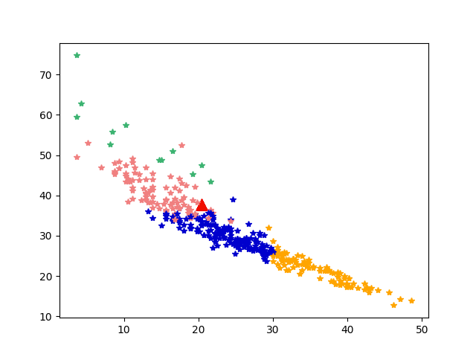

Figure 12: The position of Word “EERIE”

**8 Some Interesting Features of the Data Set**

* Since January 10, the number of reported results has shown an overall trend of crazy growth, tripling in just 23 days.
* While the number of reported results remained stable at around 20000 for several days before and after, the number of reported results dropped sharply to 15,554 on 2022/12/25 (the contest number is 554). Combined with real life, we speculated that it might be because of the influence of Christmas.

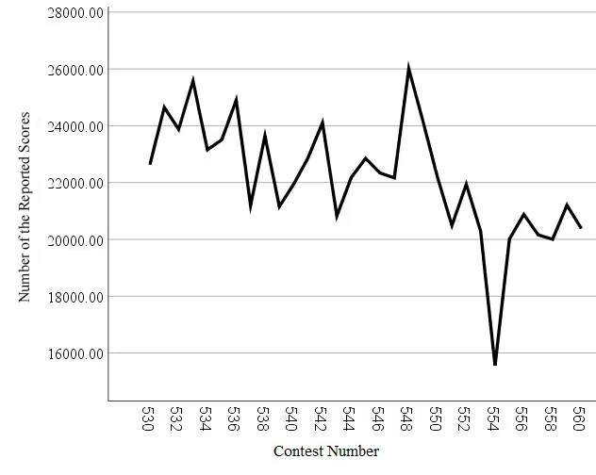

Figure 13: The Trend of Number of Reported Results From 12/1-1­2/31

* The proportion of hard mode report results in the total number of report results continues to increase, and finally, as the total number of reported results tends to stabilize, it is roughly stable around 10%. Combined with our statistical analysis of the total reported result data, we conclude that the likely reason for this change is that the number of "elite" players who choose hard mode is relatively stable compared to the number of regular players who churn out. And as some interested players become more familiar with the game, they are willing to play it in hard mode.

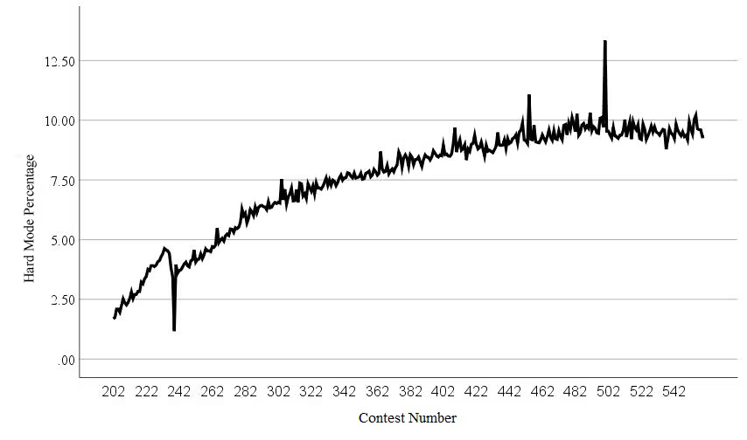

Figure 14: The Trend of Hard Mode Percentage

**9 Strengths and Possible Improvements**

1. **Strengths**

* The ARMA Model is simple, which requires only endogenous variables without recourse to other exogenous variables.
* In order to overcome the inaccuracy of clustering a small number of samples, the K-means Model has the function of optimization iteration, which iteratively corrects the obtained clustering to determine the clustering of some samples and optimizes the place where the classification of initial supervised learning samples is unreasonable.

1. **Weaknesses**

* When we consider about the attributes of the word, we only discuss mainly on letter frequency, letter frequency and repeated letters. There may be other attributes of the word that affects the percentage of Hard Mode and the percentage distribution.
* Since BP Neural Network Model sometimes has overfitting problem and the size of the dataset is not large, the prediction of percentage distribution may be not very accurate, even though the test set performs well.

**References**

[1] https://reference.wolfram.com/language/ref/WordFrequencyData.html

**The Letter to the Puzzle Editor**

Dear Puzzle Editor of the New York Times:

Your Wordle is a hugely successful game, with great numbers of participants and discussion around the world. We have built a series of models to analyze the published data for the period 2022/1/7 to 2022/12/31 of this game, hoping to help your company make full use of the resulting data, which will be helpful for the optimization and future planning of this game.

* According to the analysis of the number of report results, we found that wordle had a period of sharp increase in the number of report results from 2022/1/10 to 2022/2/2, but the heat did not last for a long time. After that, the number of report continued to decline, and by 2022/12/31, the decline has been more than 90%. According to our model forecast analysis, the data will continue to fall, and the number of reported results is expected to be between 16735 and 17328 on 2023/3/1.
* As for the word attributes and the ratio of reports about the hard mode in choosing the pattern to the total number, which you are concerned about. After we built a model and analyzed several word attributes and relevant data ( Refer to the above article for details ), we found that there was no direct correlation between the two.
* We built a model to predict the distribution of report results, and optimized the two important parameters in the model through the detection and comparison of multiple data results. According to this model, we predicted the distribution of report results of the word "EERIE" (as shown in Table 6), and we are confident of the accuracy of its prediction results.
* In the end, we divided the difficulty of words through model construction. There were 7 criteria for classification, including word frequency, letter repetition times and other dimensions, so as to ensure the scientific and accurate classification results. For visualization purposes, the seven parameters were converted into two parameters, which were displayed in the rectangular coordinate system (Figure 13). For the example of "eerie", the correlation analysis is shown in Figure 14

We also found something else in our analysis of the charts: On Christmas Day, for example, there was a surprisingly low number of results reported, which we believe is indicative of the casual puzzle nature of Wordle's game -- a genre that often lacks an addictive point for players and is simply used as a common pastime in life, like a board game. This is probably one of the reasons why the game continues to lose regular players; For example, the rate of playing "hard mode" is going up and up, and while there is a reason for the rapid loss of regular players, we think the more important reason is that the base of" elite players "or" expert players "is relatively stable, and as players become more proficient, they are more likely to keep playing and play hard mode. This can be used as a reference point to strengthen wordle's player base, for example by increasing advertising to increase the frequency of engagement with the game.

We sincerely hope that the above data and analysis can help your company to optimize and plan the game Thanks for taking the time out of your busy schedule to read our letter.

MCM Team #2313119