|  |  |  |
| --- | --- | --- |
| **Problem Chosen** ABCDEF | **2024 MCM/ICM Summary Sheet** | **Team Control Number** 2410605 |

Summary Sheet

**Contents**

1 Introduction1

1.1 Problem Background2

1.2 Restatement of the Problem2

1.3 Literature Review2

1.4 Our work2

2 Assumptions and Justification1

3 Notations1

键入章标题(第 1 级)4

键入章标题(第 2 级)5

键入章标题(第 3 级)6

1. **Introduction**
   1. **Problem Background**
   2. **Restatement of the Problem**
   3. **Our work**
2. **Assumptions and Justification**
3. **Notations**
4. **Model I: Submersible Location Prediction Model**
   1. **Submersible configuration**

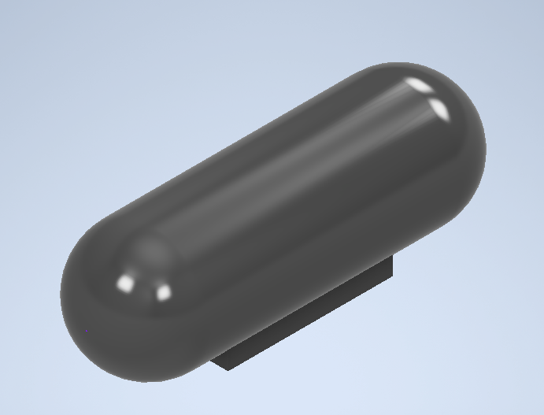

* 1. **State of the Ionian Sea**

Data 收集 三线表

Currents（方向&大小 0.008）

Sea Water Density

Density Measurement by Miller [1],



为关于温度的函数，

* Temperature主要描述温度随海水深度的变化Thermocline
* 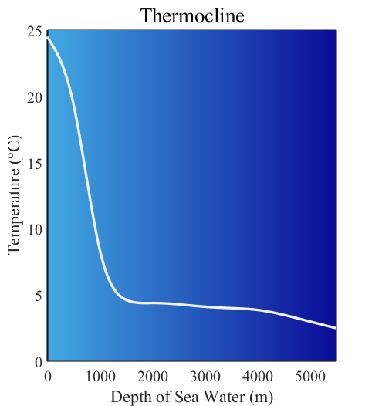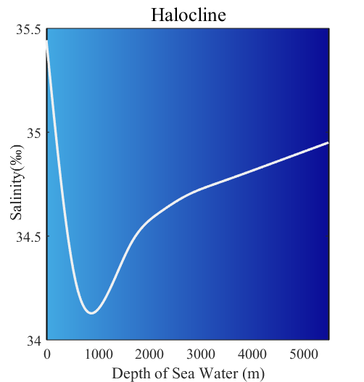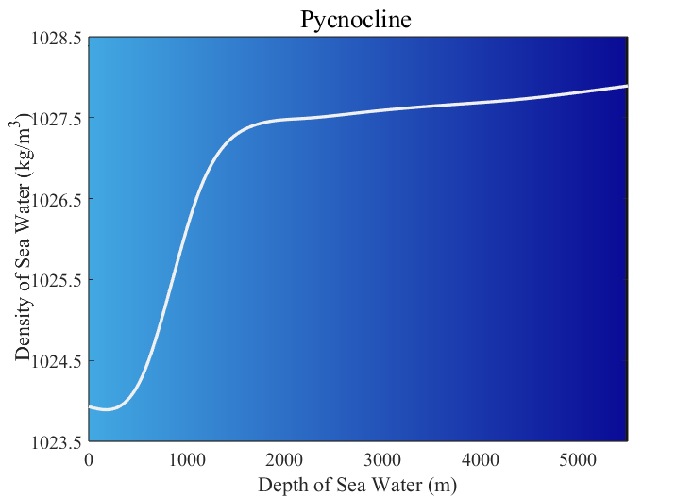Salinity Halocline主要描述盐度随海水深度的变化Halocline

Geography of the Sea Floor（今晚出）

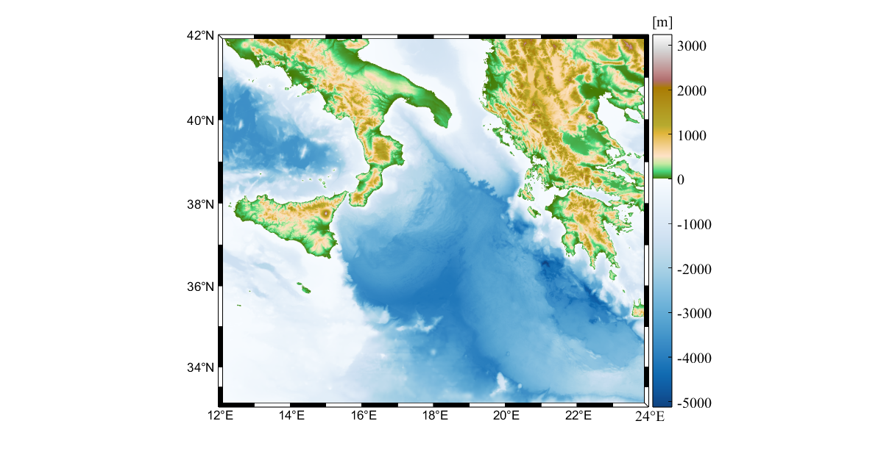

* 1. **Dynamic analysis of submersibles**

假设失事时位置

Weight

Floatage

FrictionC=0.03 类比鱼





* 1. Model Evaluation of Uncertainty

1. 1

Reference

密度[1] Frank J. Millero, Alain Poisson, International one-atmosphere equation of state of seawater, Deep Sea Research Part A. Oceanographic Research Papers, Volume 28, Issue 6,

1981, Pages 625-629

[2]