|  |  |  |
| --- | --- | --- |
| **Problem Chosen** ABCDEF | **2024 MCM/ICM Summary Sheet** | **Team Control Number** 2410605 |

Summary Sheet

**Contents**

1 Introduction1

1.1 Problem Background2

1.2 Restatement of the Problem2

1.3 Literature Review2

1.4 Our work2

2 Assumptions and Justification1

3 Notations1

键入章标题(第 1 级)4

键入章标题(第 2 级)5

键入章标题(第 3 级)6

1. **Introduction**
   1. **Problem Background**

Modern people's understanding of the ocean, especially the deep sea, is far less than that of the land. Deep-sea exploration is to comprehensively study the mysteries of the ocean and the earth, exploring the natural conditions of the deep ocean, such as the appearance of the seabed, ocean currents, as well as the biological and economic resources contained in the seabed. The deep-sea space has complex and special environmental characteristics, its sea surface Marine meteorology and sea water movement are changeable, and the sea bottom has no light, high pressure, low temperature and no oxygen. The severe Marine environment, equipment failure, human factors and other factors make the deep sea major sudden safety accidents hover at a high level for a long time. In order to reduce the loss of deep-sea accident and find out the cause of the accident, it is necessary to carry out rescue and search and salvage the accident equipment at the first time.

* 1. **Restatement of the Problem**

According to the requirements of MCMS, we are supposed to support their submersible safety system in the following aspects.

* Develop a model to predict the position of the submersible over time. Through the analysis of uncertain factors, consider the auxiliary positioning information and the corresponding acquisition equipment.
* Under the premise of considering economy and practicality, adding additional search equipment to the main vessel and the rescue vessel.
* By using the information in the positioning model, recommend the initial deployment point and search mode of the equipment in order to minimize the search time, and determine the probability of finding the submersible based on the time and cumulative search results.
* Extend the model to different marine environment and the environment with identified disturbances.
  1. **Our work**

1. **Assumptions and Justification**
2. **Notations**
3. **Model I: Submersible Location Prediction Model**
   1. **Submersible configuration**

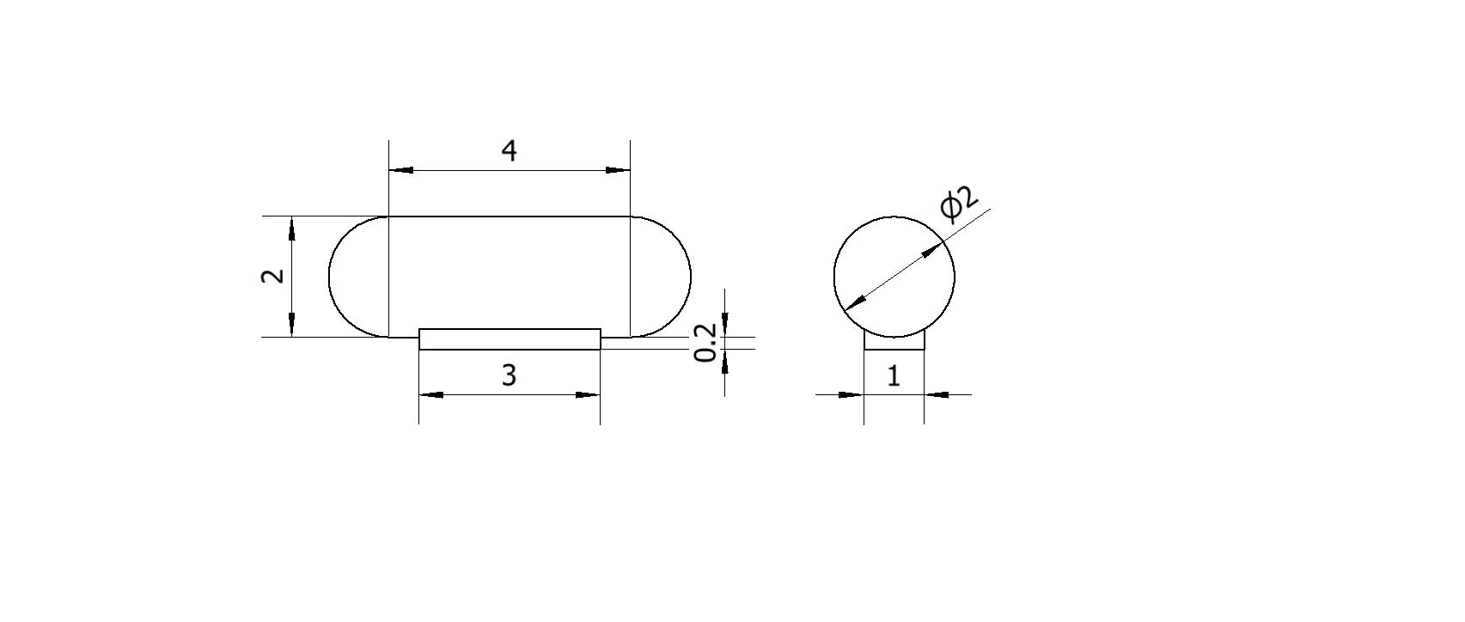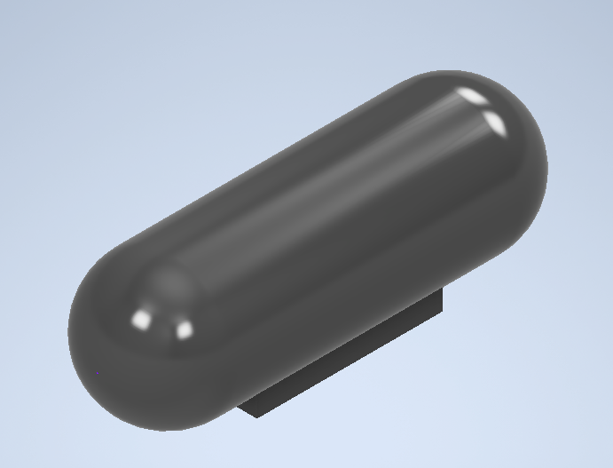In order to simplify the model, through data search and comparison, we set the submersible as a capsule-like shape, and the specific structure and size are shown in the figure below (in meters).

You can see that the structure of the submersible consists of two parts, the main body of the capsule, and a piece of ballast iron suspended below the body. On this basis, we make further assumptions as follows

|  |  |  |  |  |  |  |  |
| --- | --- | --- | --- | --- | --- | --- | --- |
| Length | Width | Height | Full load displacement | Weight of the ballast iron | | Empty Weight | Water Storage Place |
|  |  |  | 16.7552 |  |  | |  |

As a result, the total weight of the submersible can be expressed as follows：



Where Empty is the weight of the empty ship, Iron is the weight of the ballast iron, others is the weight of other weights, such as personnel and equipment, and water is the weight of water contained in the water storage tank.

* 1. **State of the Ionian Sea**

Data 收集 三线表

Currents（方向&大小 0.008）

Ocean current is a force that can not be ignored in the ocean, which refers to the regular horizontal flow of sea water in a certain direction at a relatively stable speed, and is the main form of sea water movement. There are three main influencing factors, namely wind, density and compensation. Given the operating area of the submersible, wind and compensation effects have less effect on ocean currents, and density differences in layers of similar or the same depth are not enough to have large effects. Therefore, we believe that the current data at a certain point tend to be stable as a whole and do not affect the change of seasons over time. On the basis of the above cognition, we obtained the ocean current data at the depth of 3000 meters in the Ionian Sea, and plotted the flow field and velocity characteristic pattern of the ocean current at this depth

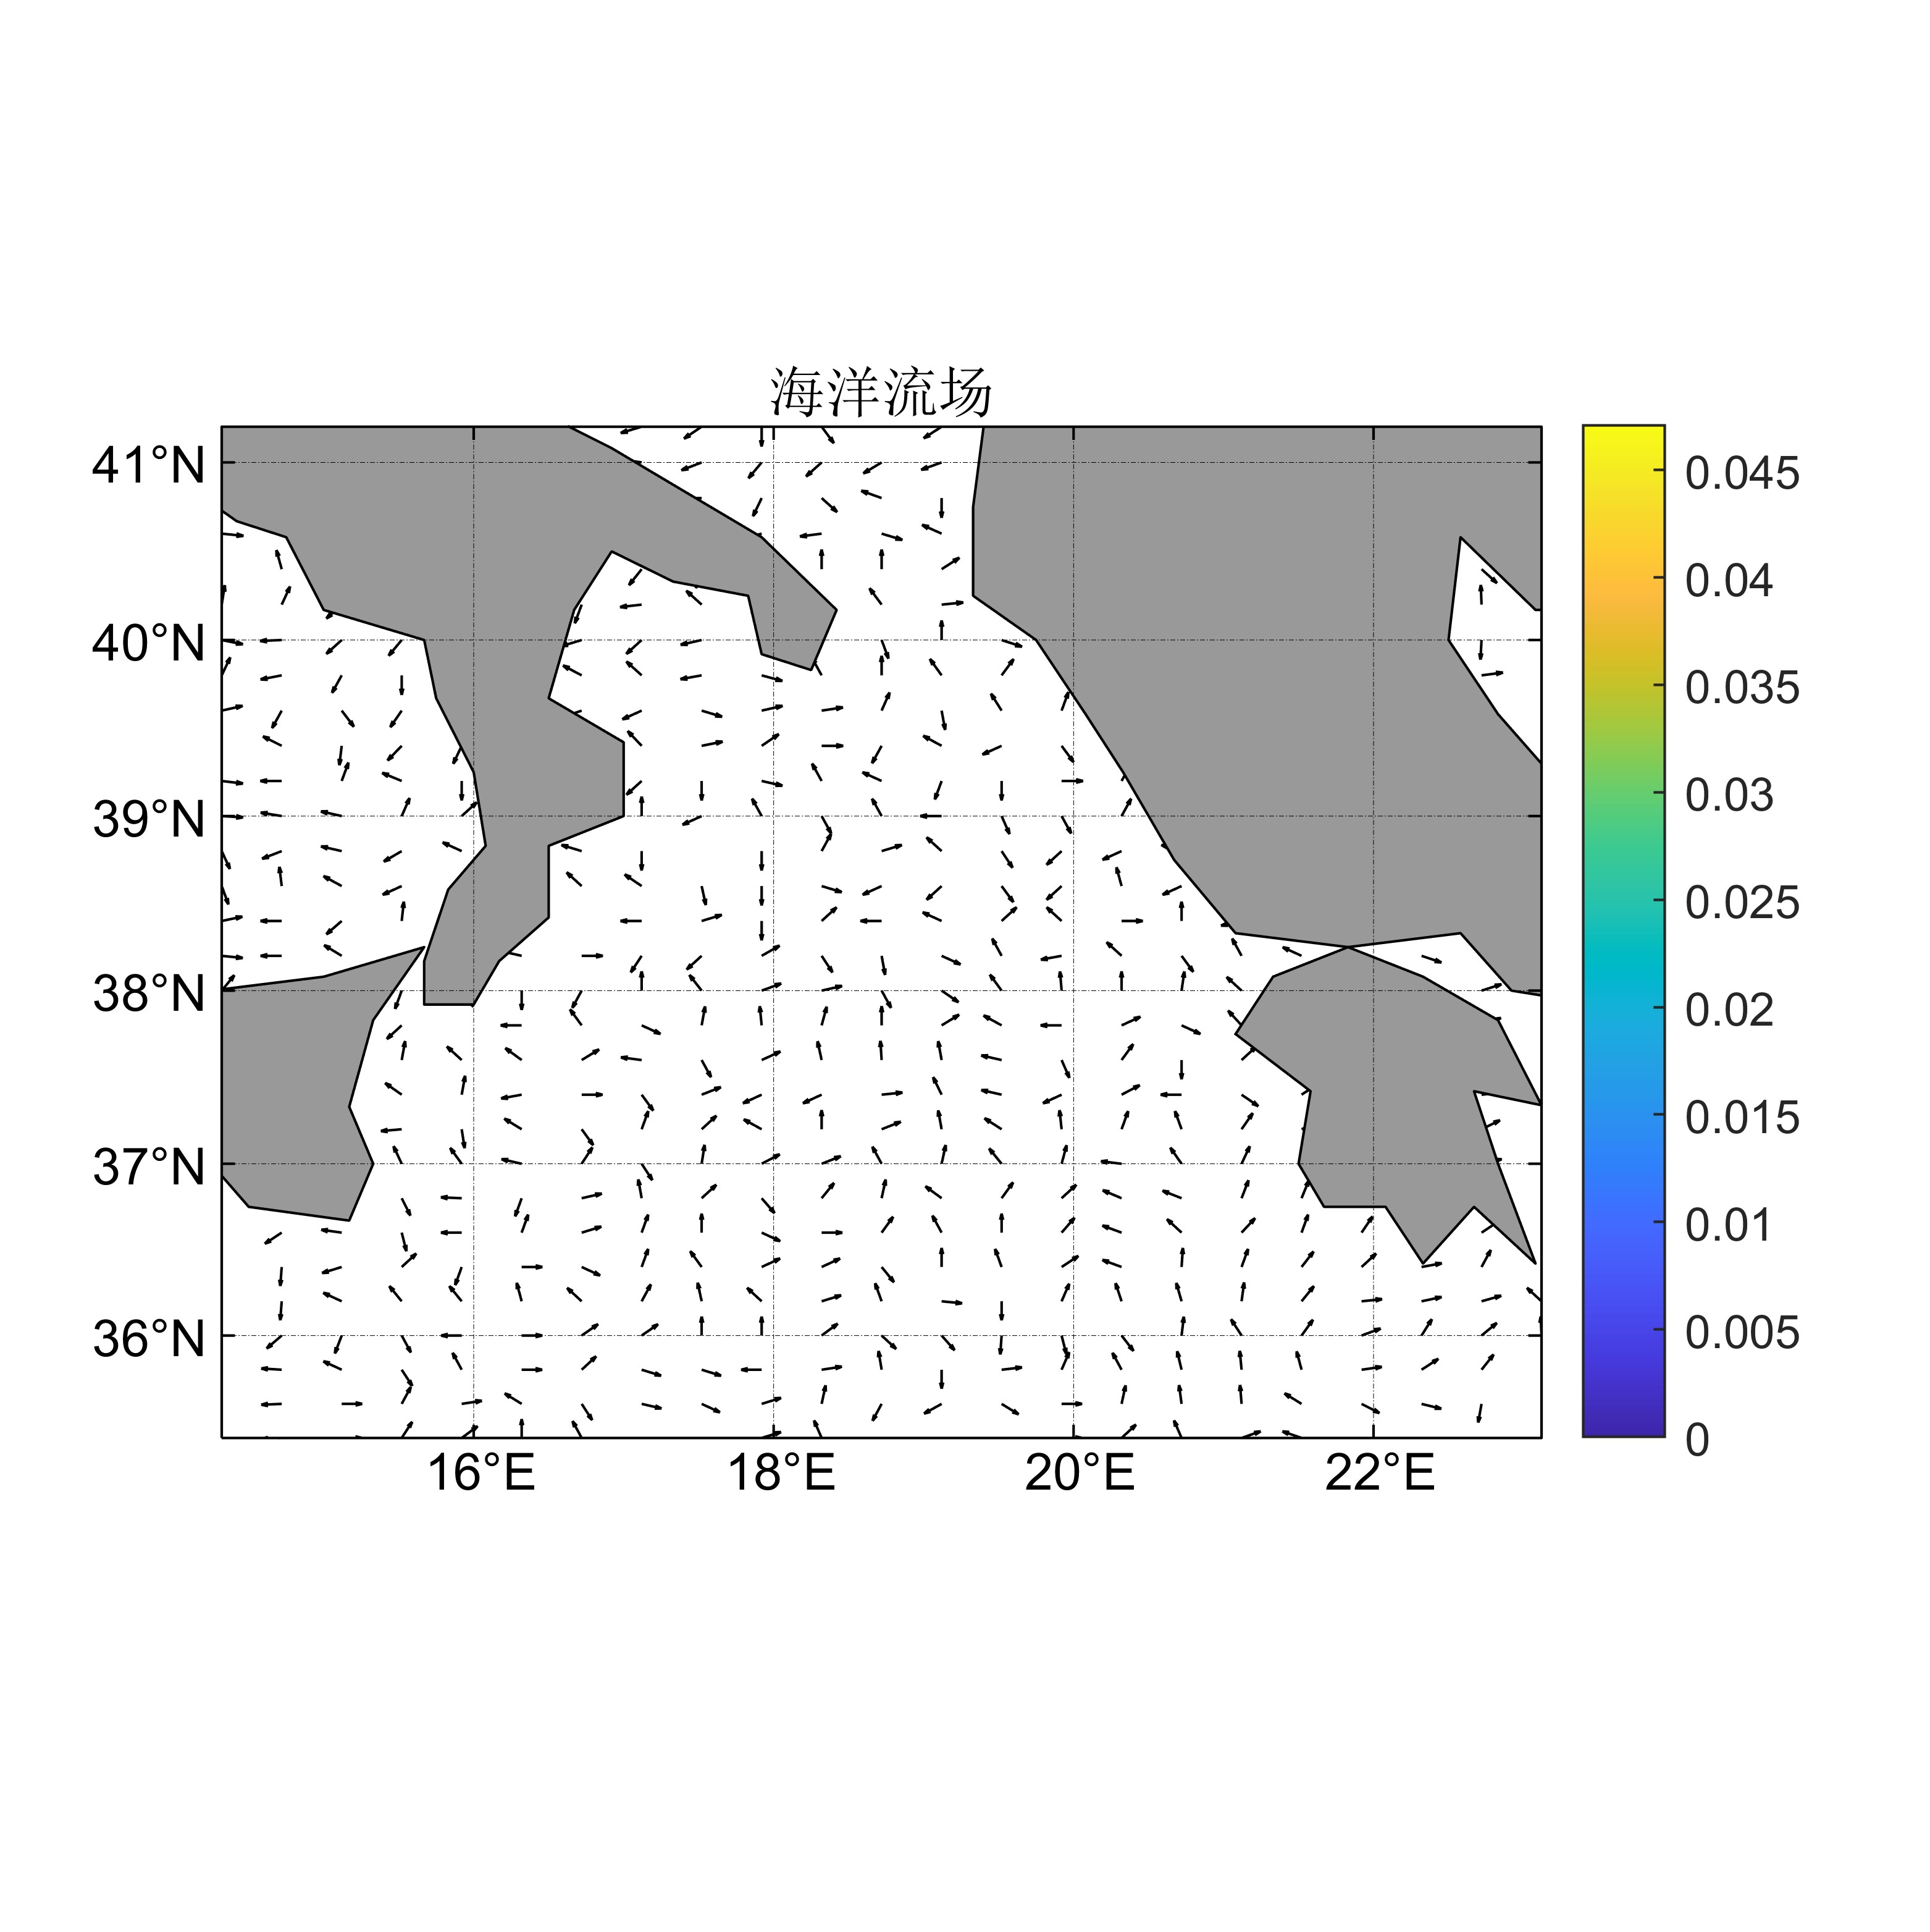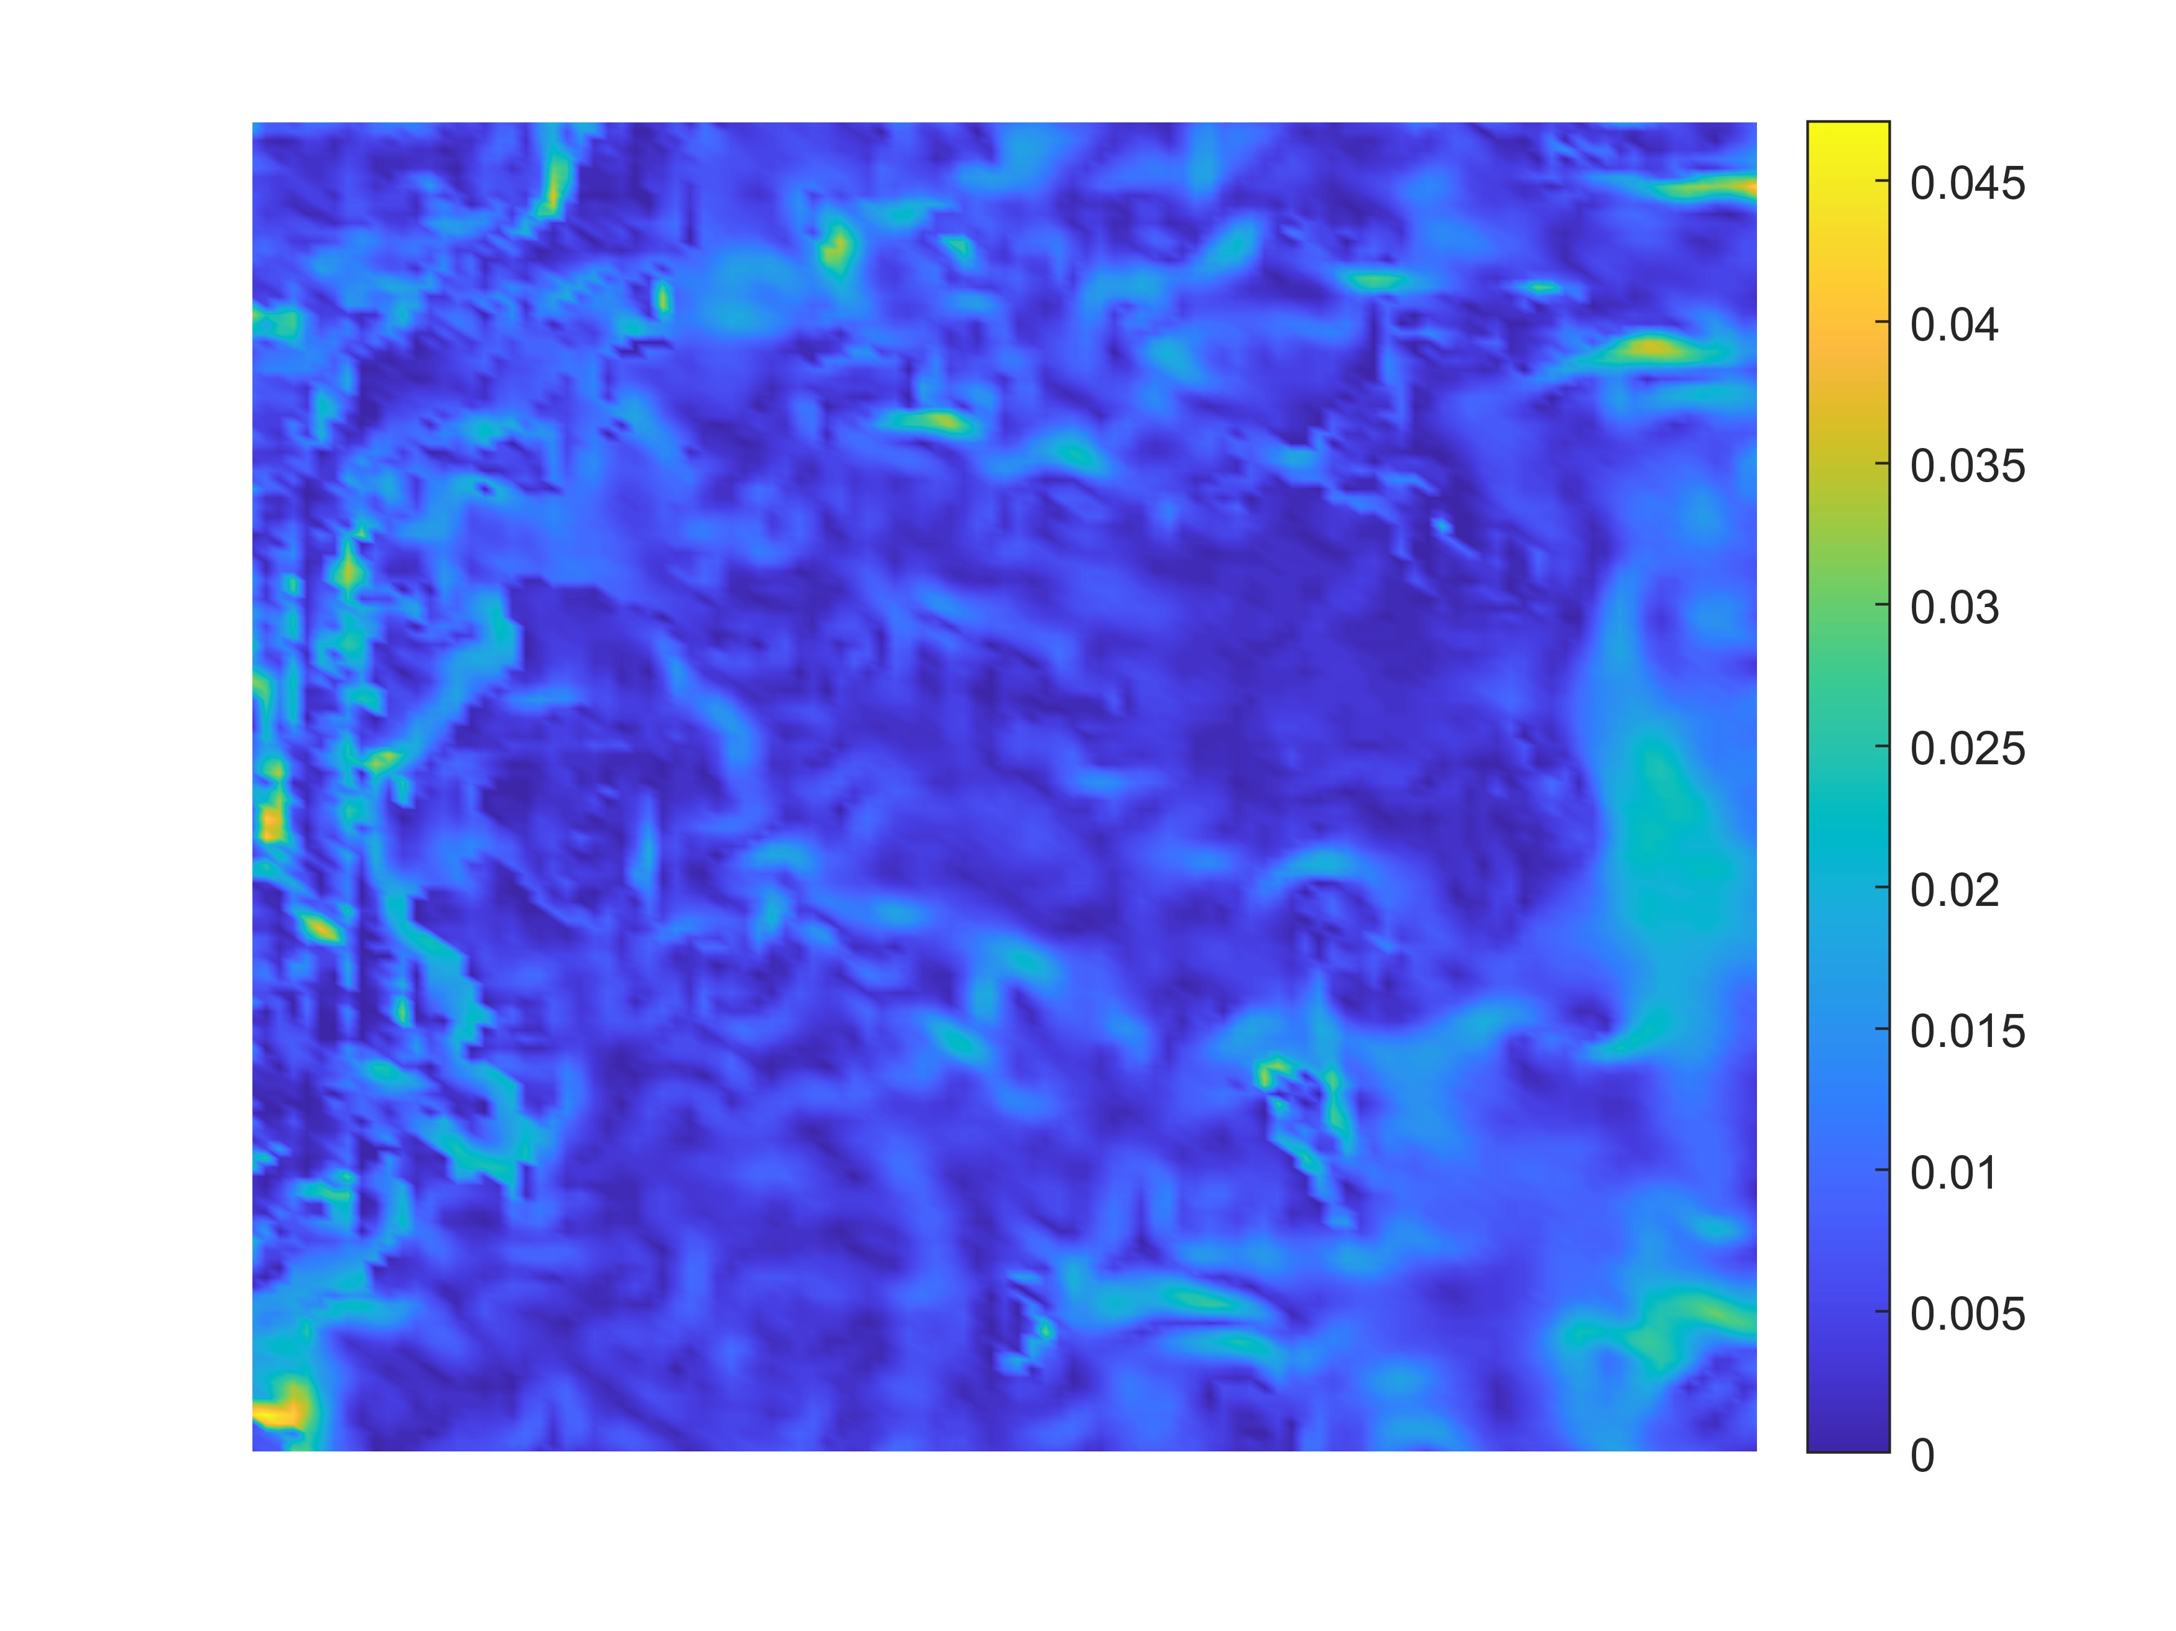

It can be analyzed from the figure that the ocean current field in the Ionian Sea is basically disordered in direction, and the remote region still maintains a certain degree of overall direction, while the direction of the ocean current around the land plate is relatively chaotic and does not have overall directivity. And also, it can be seen that the ocean current velocity is basically constant at at a depth of .

Considering that the search location is in the deep sea, since the ocean current velocity varies with depth and the degree of change is large, the surface current velocity may reach several meters per second, and the deep sea current velocity is only a few centimeters per second, we use an exponential function to describe the change of ocean current velocity with depth

Where , is the current depth, is the ocean current velocity data of 3000m depth in the Ionian Sea obtained above, and the constant k can be determined by the sea level current velocity (that is, when )

Since ocean currents are not completely invariable, for the sake of accurate modeling, we determine a velocity magnitude deviation in the range of to ，so the equation can be further refined as

Assuming that the Angle between the ocean current direction and the Y-axis is α, and considering the directional deviation θ of magnitude -20 to 20 degrees, the value range of the ocean current direction can be expressed as



Temperature is also an important consideration in the state of the deep-sea environment, and by finding and fitting the data, it is possible to plot the temperature with the depth of the water.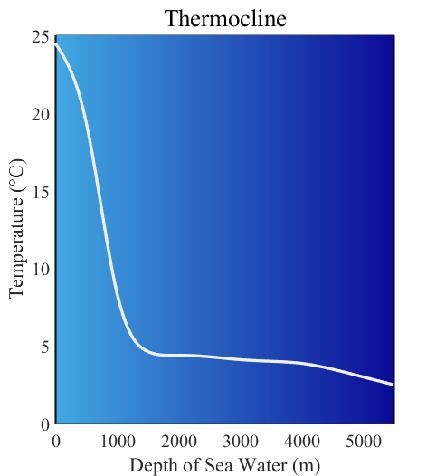

It can be clearly seen from the figure that the initial temperature decreases significantly with the increase of depth, and then turns to a steady and slow decrease and continues after it drops to 5℃.

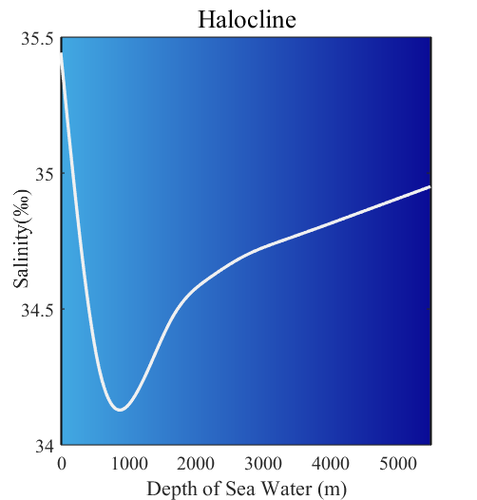Similar to temperature, we perform a similar analysis on seawater salinity to find data for a dataset where a graph of changes can be plotted below.

It can be analyzed from the figure that the salinity initially decreases significantly with increasing depth, but after reaching a critical value of about 34.2%, it continues to rise at a lower rate of change than before.

Through the International one-atmosphere equation of state of seawater (Frank J. Millero, Alain Poisson, 1981, Oceanographic Research Papers, 625-629), we can determine the density of seawater at the target location, and the equation form is



Where s is the salinity of seawater is the density of water, expressed as

，

A, B, and C are all functions of temperature

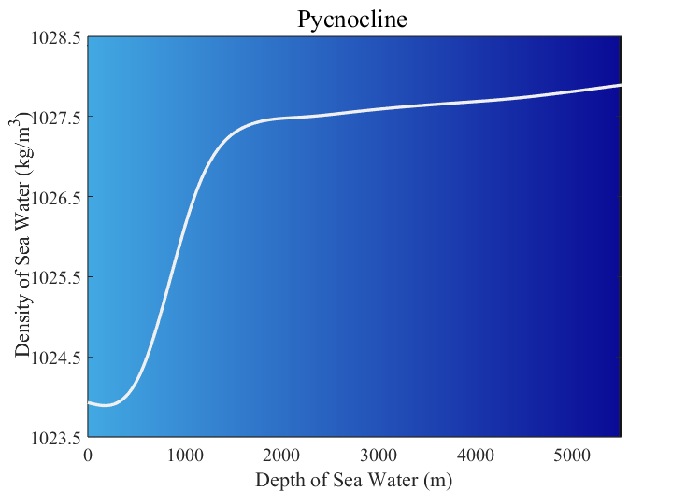Since salinity and temperature are both known, the corresponding density values can be obtained by calculation, and the data can be fitted to plot the density of seawater with depth.

According to the analysis of the curve trend in the above figure, except for a small decrease near the sea surface, the density increases as a whole with the increase of depth, and the increase rate is large at the shallow layer, and the rate slows down at about 2000 meters.

The shape of the sea floor is also an important consideration, with fluctuations in the shape of the sea floor determining that the deepest depth can vary from region to region, which in turn can produce different Marine environments. Based on the search data fitting, we have mapped the sea floor characteristic pattern of the Ionian Sea

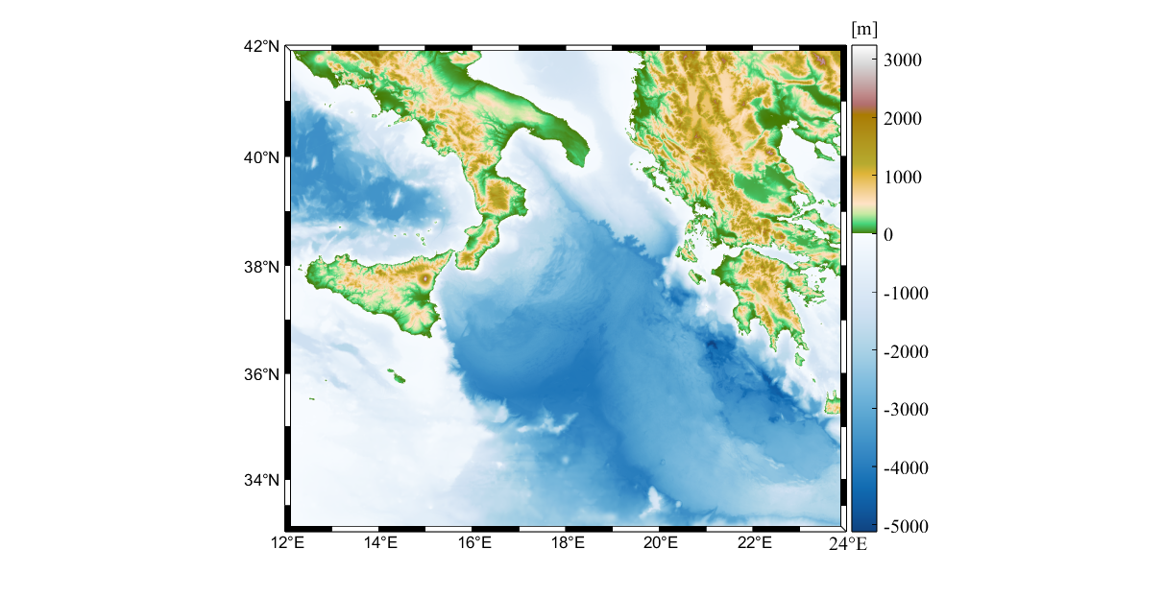

Through the analysis of the above figure, it can be seen that the overall depth of the Ionian Sea is basically more than 3000m, and the deepest depth can reach about 5000m. On the whole, compared with other regions, the eastern south region of the Ionian Sea has a deeper seabed, and the deepest is also in this region

* 1. **Dynamic analysis of submersibles**

假设失事时位置

Weight

Floatage

FrictionC=0.03 类比鱼





* 1. Model Evaluation of Uncertainty

1. 1

Reference

密度[1] Frank J. Millero, Alain Poisson, International one-atmosphere equation of state of seawater, Deep Sea Research Part A. Oceanographic Research Papers, Volume 28, Issue 6,

1981, Pages 625-629

[2]