|  |  |  |
| --- | --- | --- |
| **Problem Chosen** ABCDEF | **2024 MCM/ICM Summary Sheet** | **Team Control Number** 2410605 |

Summary Sheet

**Contents**

1 Introduction1

1.1 Problem Background2

1.2 Restatement of the Problem2

1.3 Literature Review2

1.4 Our work2

2 Assumptions and Justification1

3 Notations1

键入章标题(第 1 级)4

键入章标题(第 2 级)5

键入章标题(第 3 级)6

1. **Introduction**
   1. **Problem Background**

Modern people's understanding of the ocean, especially the deep sea, is far less than that of the land. Deep-sea exploration is to comprehensively study the mysteries of the ocean and the earth, exploring the natural conditions of the deep ocean, such as the appearance of the seabed, ocean currents, as well as the biological and economic resources contained in the seabed. The deep-sea space has complex and special environmental characteristics, its sea surface Marine meteorology and sea water movement are changeable, and the sea bottom has no light, high pressure, low temperature and no oxygen. The severe Marine environment, equipment failure, human factors and other factors make the deep sea major sudden safety accidents hover at a high level for a long time. In order to reduce the loss of deep-sea accident and find out the cause of the accident, it is necessary to carry out rescue and search and salvage the accident equipment at the first time.

* 1. **Restatement of the Problem**

According to the requirements of MCMS, we are supposed to support their submersible safety system in the following aspects.

* Develop a model to predict the position of the submersible over time. Through the analysis of uncertain factors, consider the auxiliary positioning information and the corresponding acquisition equipment.
* Under the premise of considering economy and practicality, adding additional search equipment to the main vessel and the rescue vessel.
* By using the information in the positioning model, recommend the initial deployment point and search mode of the equipment in order to minimize the search time, and determine the probability of finding the submersible based on the time and cumulative search results.
* Extend the model to different marine environment and the environment with identified disturbances.
  1. **Our work**

1. **Assumptions and Justification**
2. **Notations**

1

1

1. **Model I: Submersible Location Prediction Model**
   1. **Submersible configuration**

圆柱4m高半径1m+两半球半径1m+压载铁长方体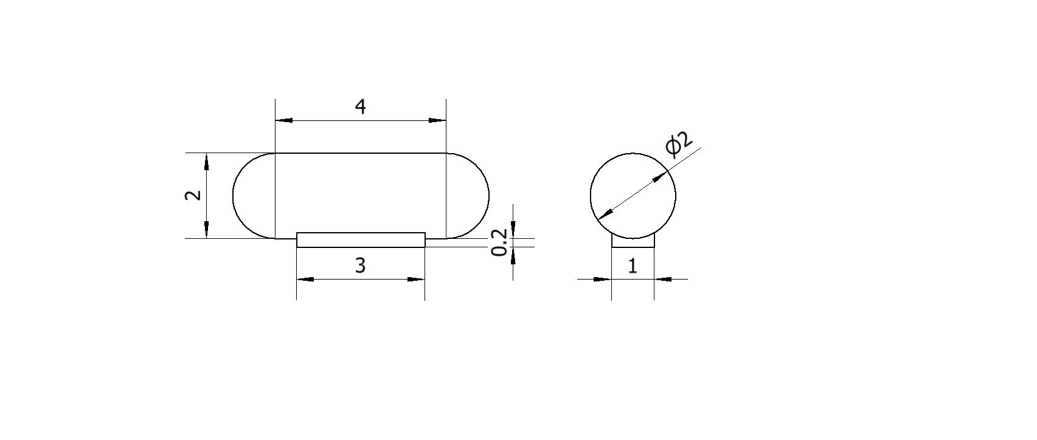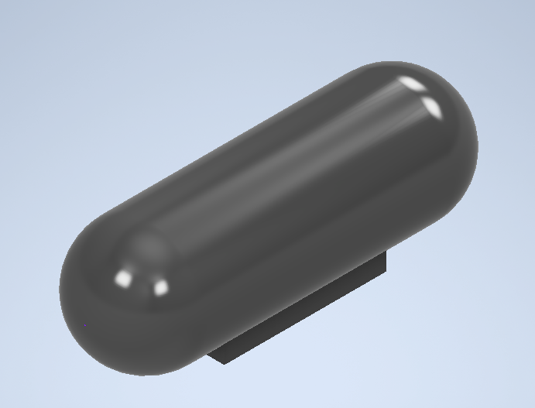3m*1m*0.2m，大概为4.8*10^3kg

|  |  |  |  |  |  |
| --- | --- | --- | --- | --- | --- |
| Length | Width | Height | Full load displacement | Empty Weight | Water Storage Place |
| 6m | 2m | 2.2m | 16.7552 |  |  |



Empty为空船质量10t，Iron表示压载铁重量，others为其他重量，例如人员和装备，water为储水仓含有的水的重量

* 1. **State of the Ionian Sea**

Data 收集 三线表

Geography of the Sea Floor

海水深度

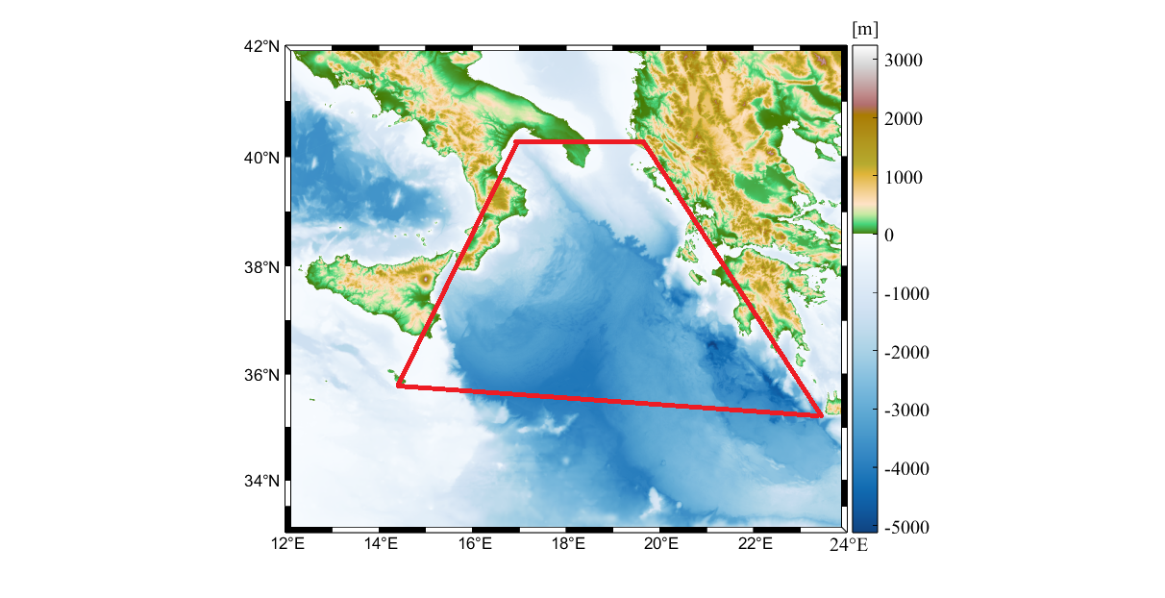 

Currents（方向&大小 0.008）

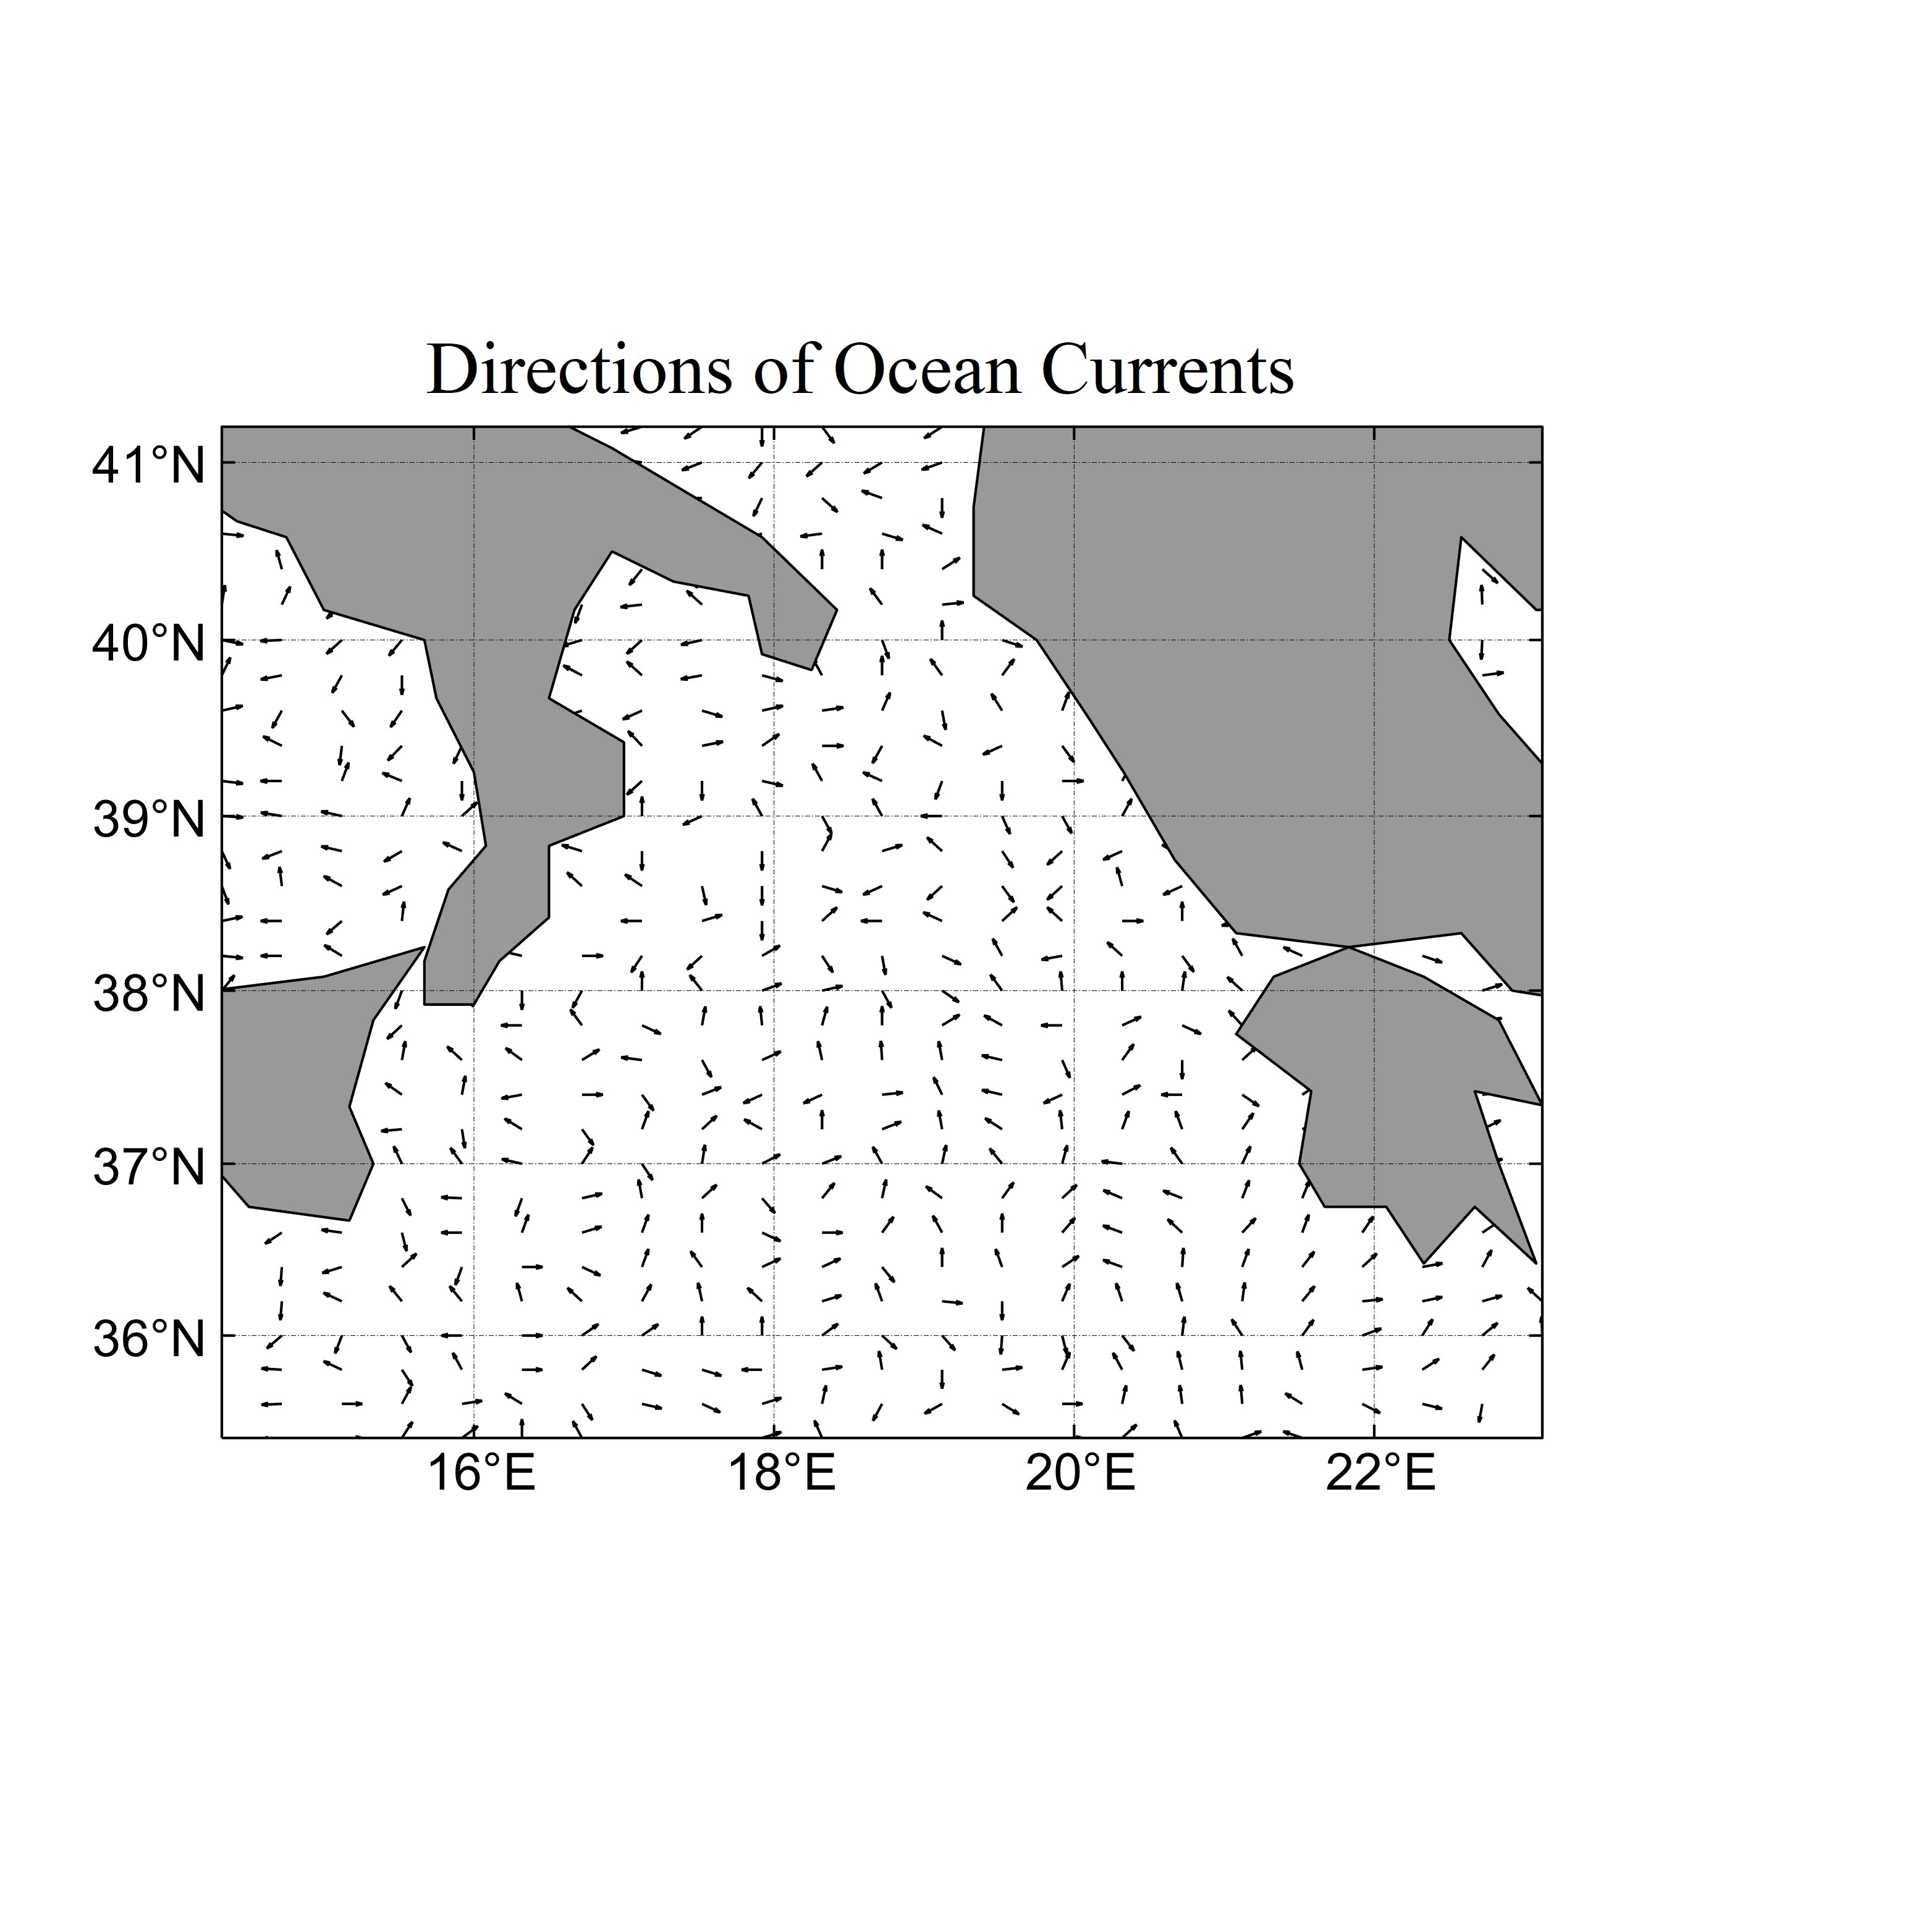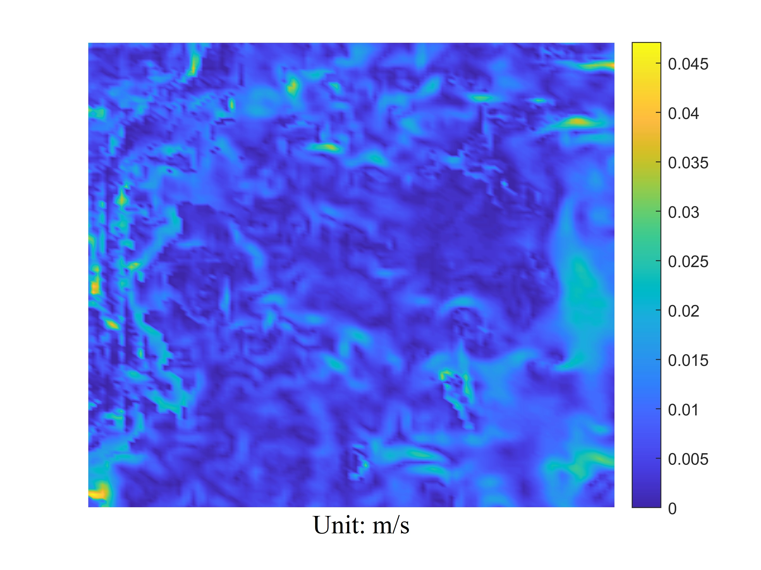

洋流数据库得到H0的速度为



洋流速度随深度变化，表面流速达几米每秒，深海速度仅有几厘米每秒 用指数函数来描述洋流速度随深度的变化H0=4000m,v_normal



加上大小的偏差sigma为-0.3~0.3



方向假设与y轴夹角为alpha，则考虑到偏差theta-20度-20度的方向为



Sea Water Density

Density Measurement by Miller [1],



为关于温度的函数，

* Temperature主要描述温度随海水深度的变化Thermocline
* 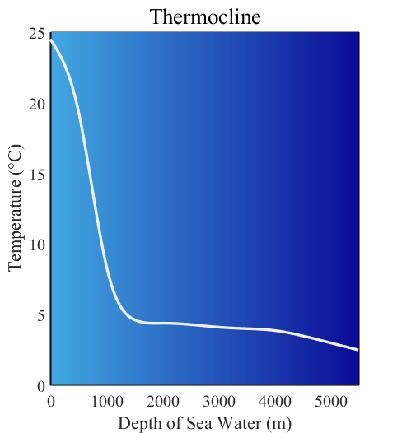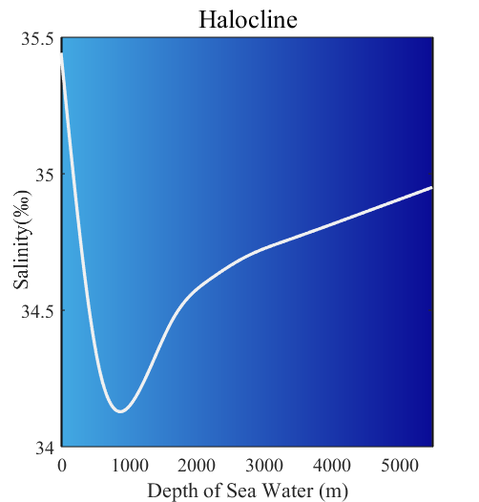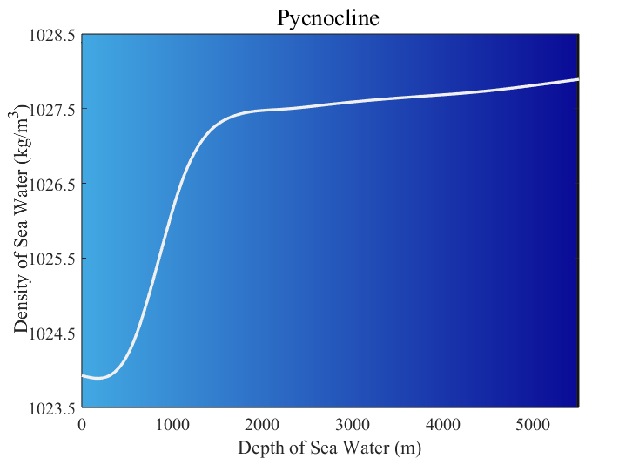Salinity Halocline主要描述盐度随海水深度的变化Halocline
  1. **Dynamic analysis of submersibles**

动力学分析

第一步说明失事时位置（x,y,h），说明失事时速度0，0，0，船头朝北

受力分析 三维+2个2维 一个竖直方向、一个水平方向（俯视）

竖直方向上：一个重力、一个浮力、阻力和运动方向相反，开始的时候重力大于浮力

水平方向上：阻力

最后说明：重量、洋流方向和大小的随机性都会对潜水器的位置造成影响

Weight



Floatage



FrictionC=0.03 类比鱼













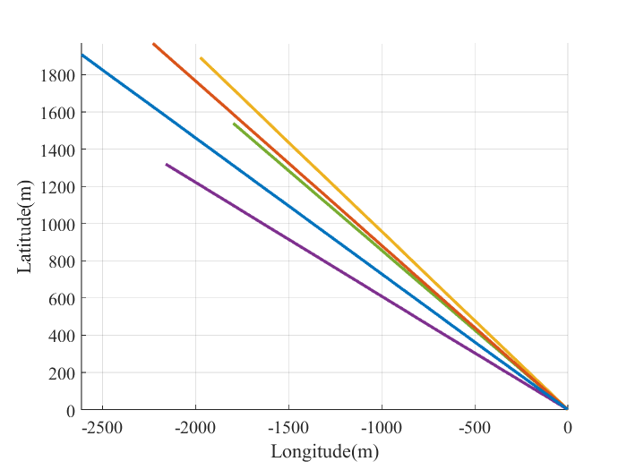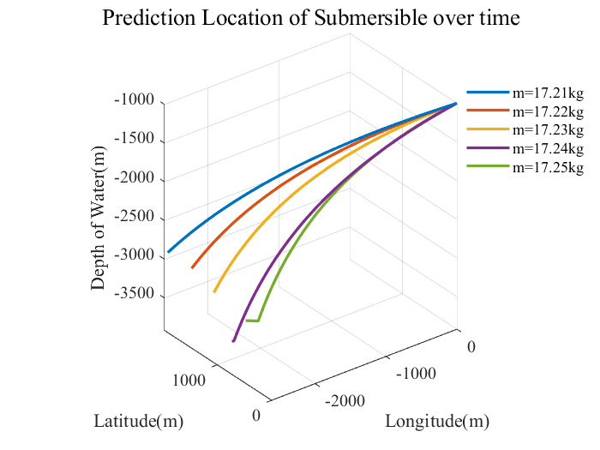

* 1. Model Evaluation of Uncertainty

蒙特卡洛方法

1. 1

AUV自主式：6000m

* 1名 AUV 操作员：负责计划、执行和监控 AUV 任务。
* 1名科学家或研究员：负责分析和解释从 AUV 传感器中获得的科学数据。
* 1名技术支持人员：负责解决 AUV 系统问题，确保设备正常运行

占用体积：3m^3, 质量2000kg

价格：800,000美元

ROV遥控式：4500m

* 2 名 ROV 操作员：负责 ROV 的操控和任务执行。
* 1名 ROV 技术支持：负责 ROV 设备的维护和问题解决。
* 1名船上技术支持：包括电气工程师和机械工程师，确保 ROV 设备和系统正常运行。
* 1名科学家或研究员：负责分析 ROV 收集的数据。

体积：2m^3,质量1300kg

价格：400,000美元

声呐

实时操控：ROV>AUV说明越到后面，越需要实时操纵，主船<救援船，重量权重：主船<救援船

Reference

密度[1] Frank J. Millero, Alain Poisson, International one-atmosphere equation of state of seawater, Deep Sea Research Part A. Oceanographic Research Papers, Volume 28, Issue 6,

1981, Pages 625-629

[2]