|  |  |  |
| --- | --- | --- |
| **Problem Chosen** ABCDEF | **2024 MCM/ICM Summary Sheet** | **Team Control Number** 2410605 |

Summary Sheet

**Contents**

1 Introduction1

1.1 Problem Background2

1.2 Restatement of the Problem2

1.3 Literature Review2

1.4 Our work2

2 Assumptions and Justification1

3 Notations1

键入章标题(第 1 级)4

键入章标题(第 2 级)5

键入章标题(第 3 级)6

1. **Introduction**
   1. **Problem Background**

Modern people's understanding of the ocean, especially the deep sea, is far less than that of the land. Deep-sea exploration is to comprehensively study the mysteries of the ocean and the earth, exploring the natural conditions of the deep ocean, such as the appearance of the seabed, ocean currents, as well as the biological and economic resources contained in the seabed. The deep-sea space has complex and special environmental characteristics, its sea surface Marine meteorology and sea water movement are changeable, and the sea bottom has no light, high pressure, low temperature and no oxygen. The severe Marine environment, equipment failure, human factors and other factors make the deep sea major sudden safety accidents hover at a high level for a long time. In order to reduce the loss of deep-sea accident and find out the cause of the accident, it is necessary to carry out rescue and search and salvage the accident equipment at the first time.

* 1. **Restatement of the Problem**

According to the requirements of MCMS, we are supposed to support their submersible safety system in the following aspects.

* Develop a model to predict the position of the submersible over time. Through the analysis of uncertain factors, consider the auxiliary positioning information and the corresponding acquisition equipment.
* Under the premise of considering economy and practicality, adding additional search equipment to the main vessel and the rescue vessel.
* By using the information in the positioning model, recommend the initial deployment point and search mode of the equipment in order to minimize the search time, and determine the probability of finding the submersible based on the time and cumulative search results.
* Extend the model to different marine environment and the environment with identified disturbances.
  1. **Our work**

1. **Assumptions and Justification**
2. **Notations**

1

1

1. **Model I: Submersible Location Prediction Model**
   1. **Submersible configuration**

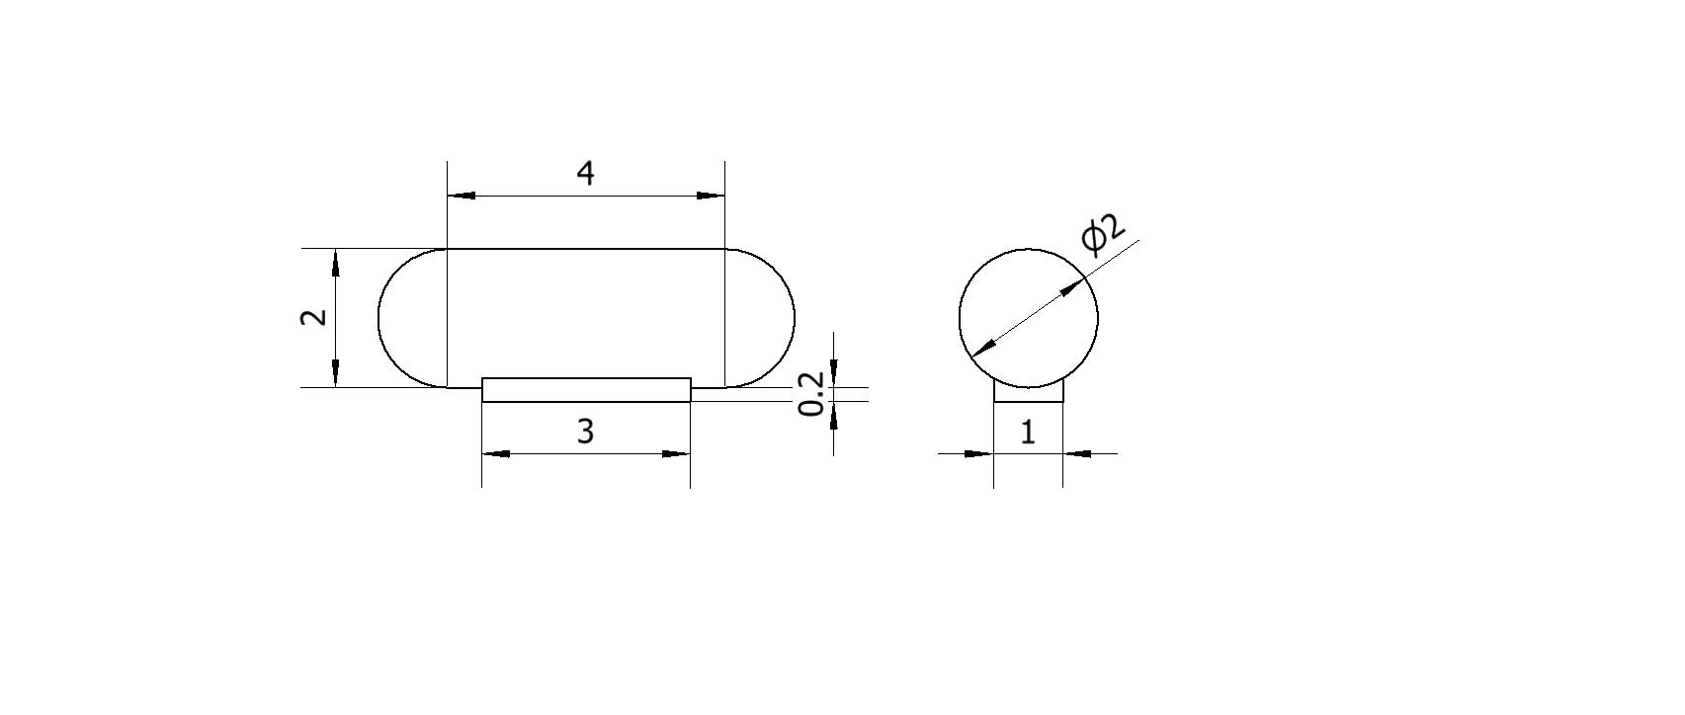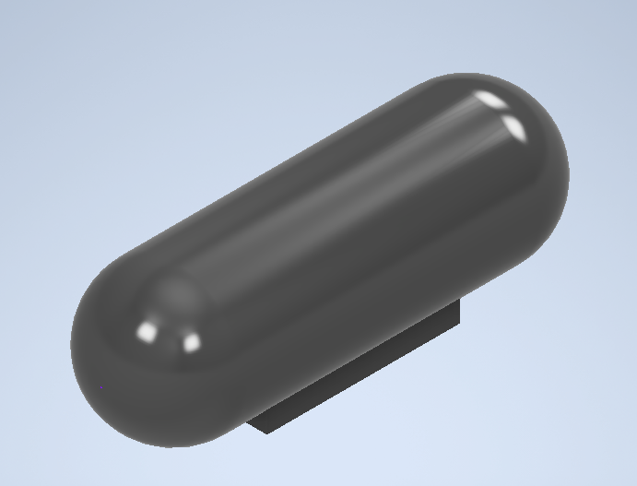In order to simplify the model, through data search and comparison, we set the submersible as a capsule-like shape, and the specific structure and size are shown in the figure below (in meters).

Figure 2 Schematic Diagram of Submarine Model

We can see that the structure of the submersible consists of two parts, the main body of the capsule, and a piece of ballast iron suspended below the body. 压载铁的作用On this basis, we make further assumptions as follows:

Table 2 Detailed Parameters of Submarine

|  |  |  |  |  |  |
| --- | --- | --- | --- | --- | --- |
| Length | Width | Height | Full load displacement | Empty Weight | Water Storage Place |
| 6m | 2m | 2.2m | 16.7552 |  |  |

As a result, the total weight of the submersible m can be expressed as follows：



Where  is the weight of the empty ship,  is the weight of the ballast iron,  is the weight of other weights such as personnel and equipment, and  is the weight of water contained in the water storage tank.

* 1. **State of the Ionian Sea**

The data we use to describe the state of Ionian Sea include historical ocean currents data, density of sea water and the depth of Ionian Sea. The data sources are summarized in Table 3.

Table 3 Data Source Collocation

|  |  |  |
| --- | --- | --- |
| Database Names | Database Websites | Data Type |
| HYCOM | https://www.hycom.org/dataserver/gofs-3pt1/analysis | Currents |
| HURRICAN | https://hurricanescience.org/science/basic/water/index.html | Density |
| GBECO | https://www.gebco.net/data_and_products | Depth |

* + 1. **Currents**

Ocean current is a force that cannot be ignored in the ocean, which refers to the regular horizontal flow of sea water in a certain direction at a relatively stable speed, and is the main form of sea water movement. There are three main influencing factors, namely wind, density and compensation. Given the operating area of the submersible, wind and compensation effects have less effect on ocean currents, and density differences in layers of similar or the same depth are not enough to have large effects. Therefore, we believe that the current data at a certain point tend to be stable as a whole and do not affect the change of seasons over time. On the basis of the 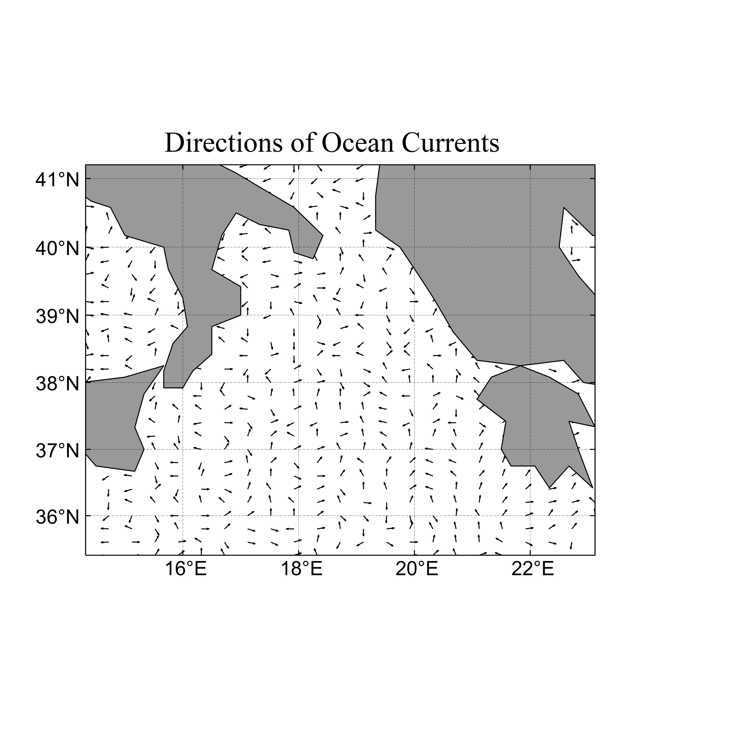above cognition, we obtained the ocean current data at the depth of 4000 meters in the Ionian Sea, 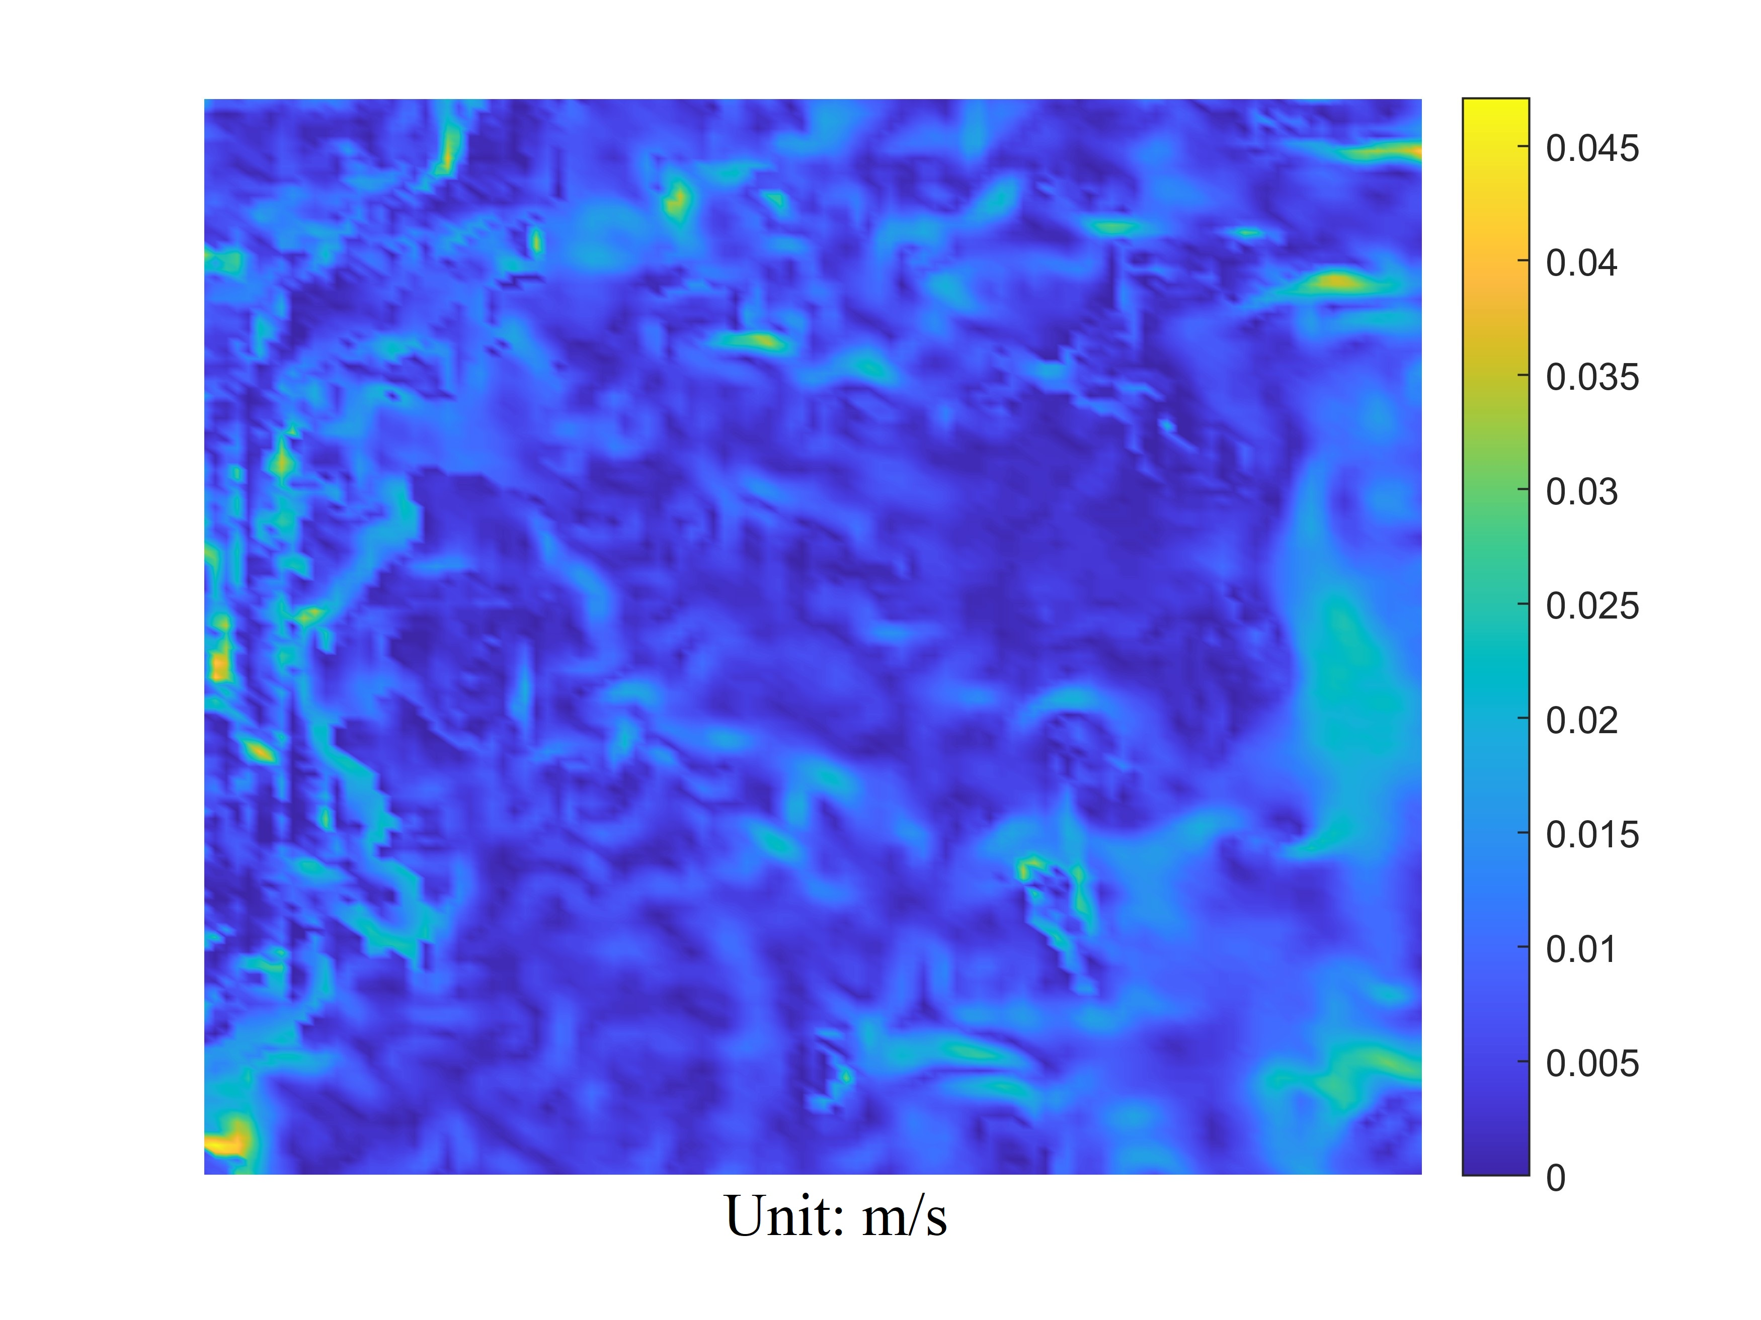and plotted the flow field and velocity characteristic pattern of the ocean current at this depth.

Figure 3 Direction and Value of Ocean Currents in Ionian Sea at 

From Figure 3, ocean current field in the Ionian Sea is basically disordered in direction, and the remote region still maintains a certain degree of overall direction, while the direction of the ocean current around the land plate is relatively chaotic and does not have overall directivity.

Considering that the search location is in the deep sea, since the ocean current velocity varies with depth and the degree of change is large, the surface current velocity may reach several meters per second, and the deep-sea current velocity is only a few centimeters per second, we use an exponential function to describe the change of ocean current velocity with depth:



where , is the current depth, and the constant  can be determined by the sea level current velocity (that is, when ).

Since ocean currents are not completely invariable, for the sake of accurate modeling, we determine a velocity magnitude deviation in the range of ，so the equation can be further refined as



Assuming that the Angle between the ocean current direction and the Y-axis is α, and considering the directional deviation θ of magnitude , the value range of the ocean current direction can be expressed as .

* + 1. **Density of Sea Water**

Through the International one-atmosphere equation of state of seawater (Frank J. Millero, Alain Poisson, 1981) [1], we can determine the density of seawater at the target location, and the equation form is



where  is salinity of water,  is density of water, and  are functions of temperature.

* Temperature

Temperature is an important consideration in the state of the deep-sea environment, and by finding and fitting the data, it is possible to plot the temperature with the depth of the water, which is also known as thermocline. It can be clearly seen from Figure 4 that the initial temperature decreases significantly with the increase of depth, and then turns to a steady and slow decrease and continues after it drops to 5℃.

* Salinity

Similar to temperature, we perform a similar analysis on seawater salinity to find data for a dataset where a graph of changes can be plotted, which is also known as Halocline. It can be analyzed from the figure that the salinity initially decreases significantly with increasing depth, but after reaching a critical value of about 34.2%, it continues to rise at a lower rate of change than before.

Since salinity and temperature are both known, the corresponding density values can be obtained by calculation, and the data can be fitted to plot the density of seawater with depth.

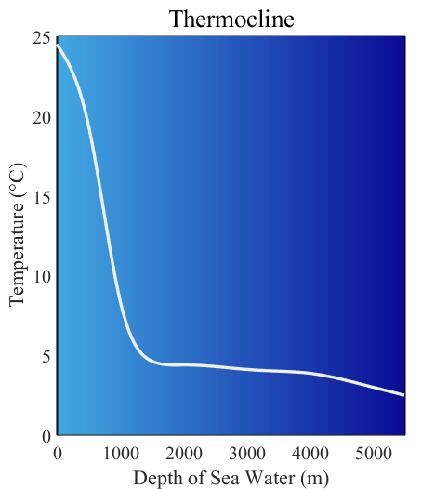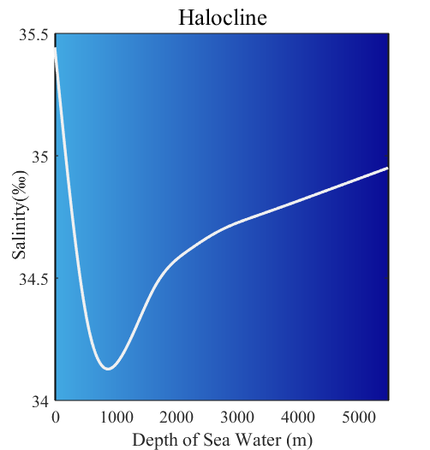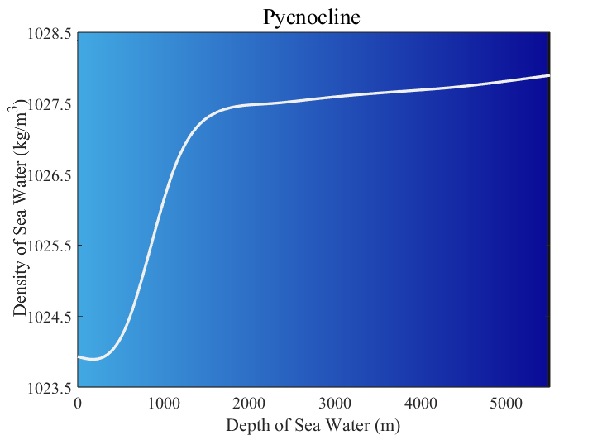According to the analysis of the curve trend in the above figure, except for a small decrease near the sea surface, the density increases as a whole with the increase of depth, and the increase rate is large at the shallow layer, and the rate slows down at about 2000 meters.

Figure 4 Changes in Seawater Temperature, Salinity, and Density with Depth

* + 1. **Geography of the Sea Floor**

The shape of the sea floor is also an important consideration, with fluctuations in the shape of the sea floor determining that the deepest depth can vary from region to region, which in turn can produce different Marine environments. Based on the search data fitting, we have mapped the sea floor characteristic pattern of the Ionian Sea in Figure 5.

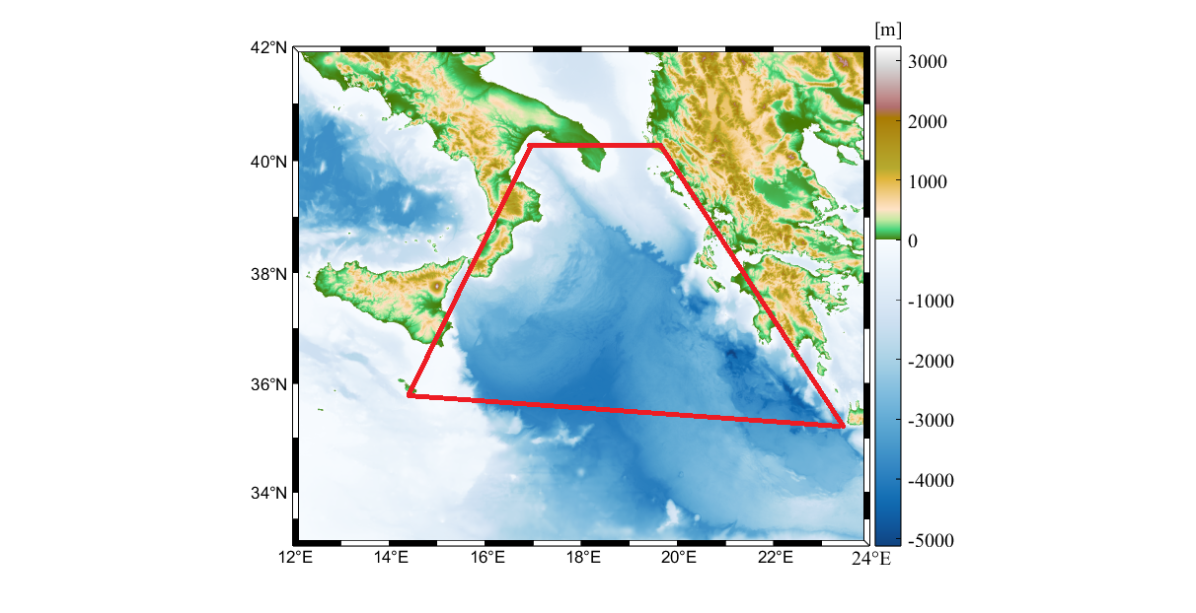Through the analysis of the above figure, it can be seen that the overall depth of the Ionian Sea is basically more than 3000m, and the deepest depth can reach about 5000m. On the whole, compared with other regions, the eastern south region of the Ionian Sea has a deeper seabed.

Figure 5 Topographic Map of Ionian Sea

* 1. **Dynamic analysis of submersibles**

In order to predict the trajectory of the submersible after losing contact and determine the position of the submersible, the dynamics analysis of the submersible is necessary. In order to simplify the model, we assume that the position coordinates of the submersible at the time of crash are and the bow is facing due north.

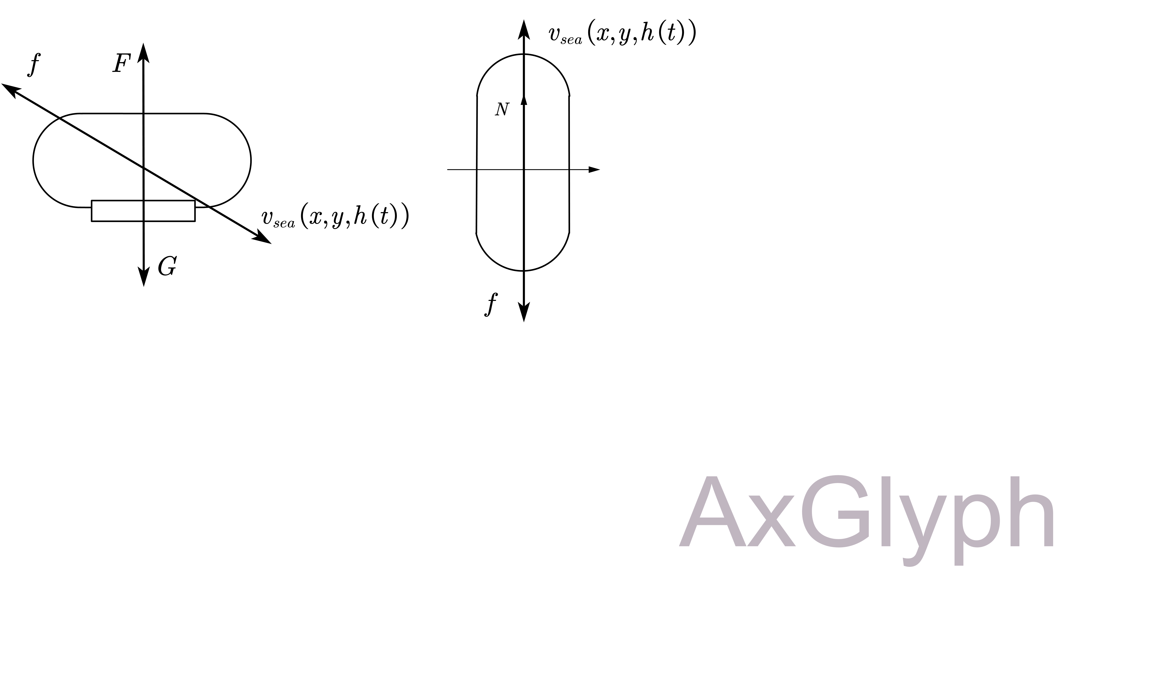The force analysis of the submersible is carried out: in the vertical direction, the submersible is mainly subjected to the vertical upward buoyancy, the vertical downward gravity , and the resistance  which is opposite to the direction of the submersible's movement relative to the sea water. In the horizontal direction, the submersible is affected only by the resistance. The diagram is as follows

Figure 6 Force Analysis of Submersible

* **Weight:**



where  is the mass of the submersible and 

* **Floatage:**



where  is the density of sea water at this depth, and  is the volume of submersible.

* **Friction:**

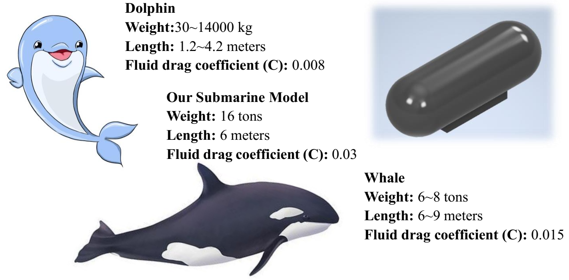 

is the resistance coefficient of seawater, is the area of the characteristic surface along the axis, is the density of seawater, v = . 通过类比，得到潜水器的阻力系数For the convenience of analysis, the resistance is orthogonal decomposed into the x - and y-axis directions.

Figure 7

By combining the above three equations, the state equation of the submersible under stress balance can be listed. The considerations and limitations of error in 4.2 are brought into it and can be obtained by comprehensive sorting



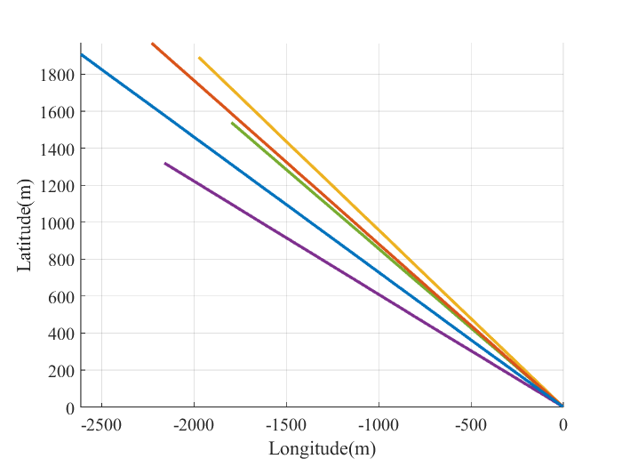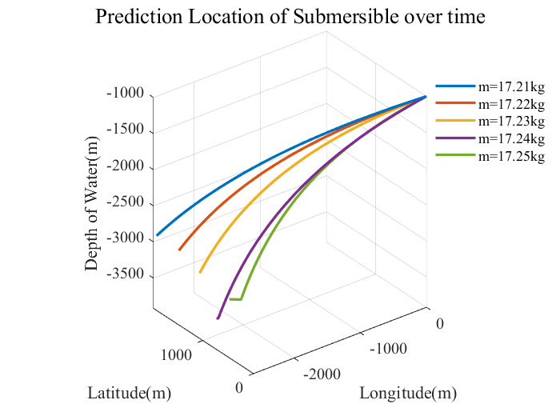It can be obtained by analyzing the relationship between the elements expressed in the equation that the randomness of submersible weight, direction and size of ocean currents all affect the position of submersibles. For practical and simplified models, we believe that the submersible will have a completely elastic collision with the seabed when falling to the seabed. In order to verify the rationality of this conclusion, five groups of submersibles with different masses were taken as steps of 0.01kg to simulate the trajectory after the crash. The results are shown in the figure below.

Figure 8 Prediction Location of Submersible over time

From the analysis of the above two figures, it can be seen that even though the mass of the submersible changes only in a subtle range and the deviation between the front and back is very small, the impact on the movement trajectory of the submersible after the crash is indeed significant, which is reflected in the trajectory deviation in the horizontal direction and the distance from the origin, as well as the difference in the falling rate in the vertical direction. In general, when the mass is lighter, the vertical fall rate is slower, which means that the final travel distance in the corresponding horizontal direction may be larger. When the mass is heavier, the vertical fall of the submersible is faster, and the submersible sinks to the sea bottom faster, which means that its displacement in the horizontal direction may be shorter.

* 1. **Model Evaluation of Uncertainty**

According to the inference in 4.3, the mass of submersible, the direction and size of ocean current are main factors affecting the trajectory of submersible after the wreck, and the uncertainties of the three factors bring more troubles to the position prediction. In order to evaluate the uncertainty, we use Monte Carlo method to simulate the possible position of the submersible.

Monte Carlo method is a method of numerical calculation through a large number of repeated random experiments. Because of its versatility and flexibility, Monte Carlo ideas are often used to solve the following problems: probability distribution statistics, optimization of geometric structures and numerical integration operations. The underwater motion of the wrecked submersible is a stochastic problem, so solving it based on Monte Carlo idea can greatly simplify the calculation model and improve the calculation efficiency and accuracy.

We simulate the possible positions of the submersible at six time points after the accident, and observed the probability distribution of the position of the submersible at that time. The simulation diagram is shown below.

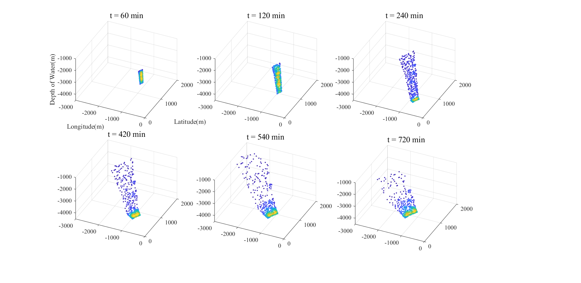

Figure 9 Possible Position of Submersible in Simulation

Through the analysis of the above figure, it can be concluded that with the passage of time, due to the uncertainty of the above three factors at the time of the crash, the probability distribution of the possible position of the submersible has been continuously dispersed over time. In particular, the displacement deviation range in the horizontal direction is too large, which undoubtedly greatly increases the success rate and search and rescue time.

* 1. **Ways to Reduce Uncertainty**

According to the requirements, the submersible is now considered to periodically transmit some data back to the main ship, in order to reduce uncertainty, help the main ship to conduct more accurate positioning, and facilitate the search and rescue work.

Referring to the inference in 4.3, the uncertainty is mainly concentrated in three aspects: the weight of the submersible, the speed and direction of the ocean current. The instability of the weight mainly comes from the weight of the personnel and equipment carried by the submersible and the weight of the ballast water in the ballast water tank. Therefore, if we can determine the relevant data before the submersible crash, the accuracy of the position judgment of the submersible will be greatly improved. And the following are the equipment and necessary means that we consider suitable for deploying on the submersible.

* Unified weighing before launching to evaluate the **instability of the weight**
* Deploying the instrument monitoring the water quantity in the tank in real time
* Using the water tracking mode of Doppler log DVL to measure the convection velocity, combined with the high-precision navigation parameters provided by SINS self-assisted navigation, using the least squares estimation algorithm RLS to **estimate the ocean current velocity and direction**.

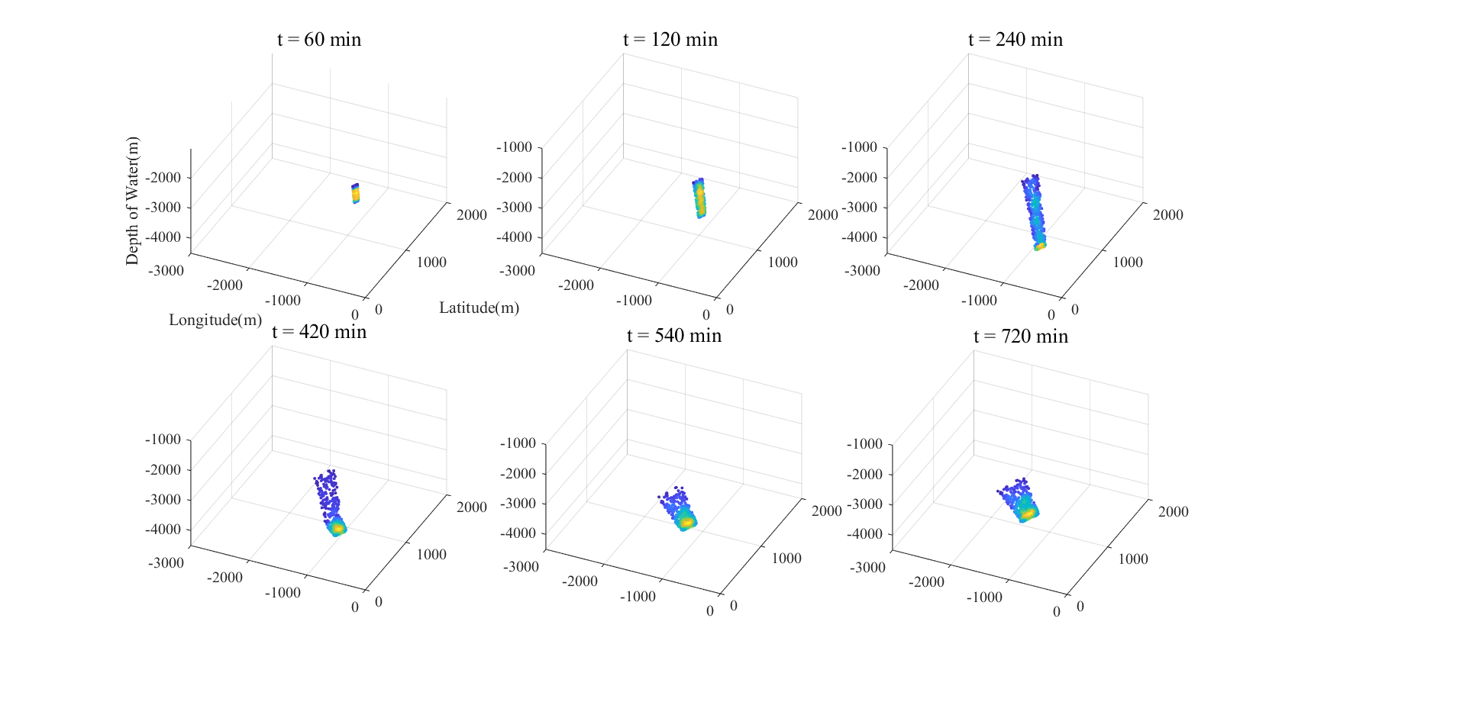After taking the above measures, the uncertainty about the weight of the submersible and the magnitude and direction of ocean current speeds will decrease. Then, we use 4.4 to build a model to simulate the probability distribution of positions at several time points after the submersible crash.

Figure 10 Possible Positions of Submersible with Ways to Reduce Uncertainty

Through comparison and analysis between the above figure and the distribution figure in 4.4, it can be concluded that the probability distribution area for predicting the location of submersible will shrink significantly, and the distribution of random points will be more convergent, which means that the search and rescue area can shrink. **Search time and rescue success rate will be greatly improved.**

1. **Evaluation Model for Equipment Preparation**
   1. **Evaluation Based on TOPSIS**

Table 4: Possible Additional Search Equipment

|  |  |  |
| --- | --- | --- |
| **Equipment** | **AUV** | **ROV** |
| **Effects** | Ocean survey, seabed geological research and manned submersible salvage | Remote control operation, seabed survey and deep-sea exploration |
| **Advantages** | Autonomous operation, high precision and wide range of action | Multi-functional and continuous working for a long time |
| **Disadvantages** | High price, large weight and size | Reliance on cables, limited flexibility, high maintenance costs |

|  |  |  |
| --- | --- | --- |
| **Echo Sounder** | **Side Scan Sonar** | **Magnetometer** |
| Marine mapping and topographic exploration | Providing a side view of underwater terrain | Find metal objects and locate electronic devices |
| High precision and efficiency | High definition, wide coverage and strong functionality | No dependence on light, suitable for many environments |
| Energy Dependence and susceptible to terrain effect | Depth limitation, high investment cost | Low accuracy and may be affected by other metals |

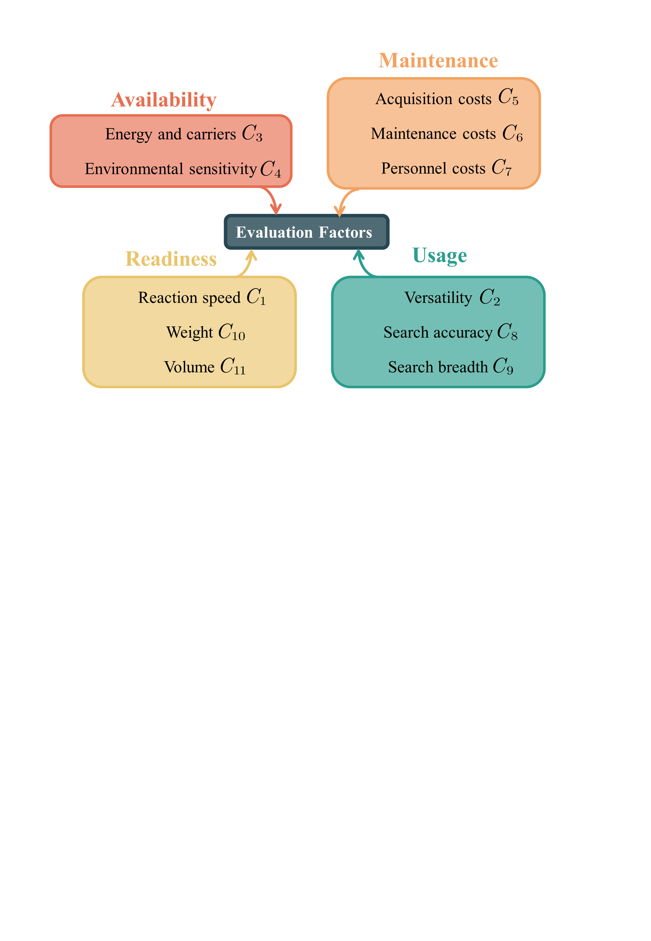

先说明搜救装置 5种中型/大型 **画一张三线表**2+3 文字说明

文字说明→4大类11个因素（思维导图） 需要过渡

11个因素→打分/数据→**归一化**、极大化 极小化max-

11个特征因素 5×11的表格（**归一化之后的分数**）**heatmap**

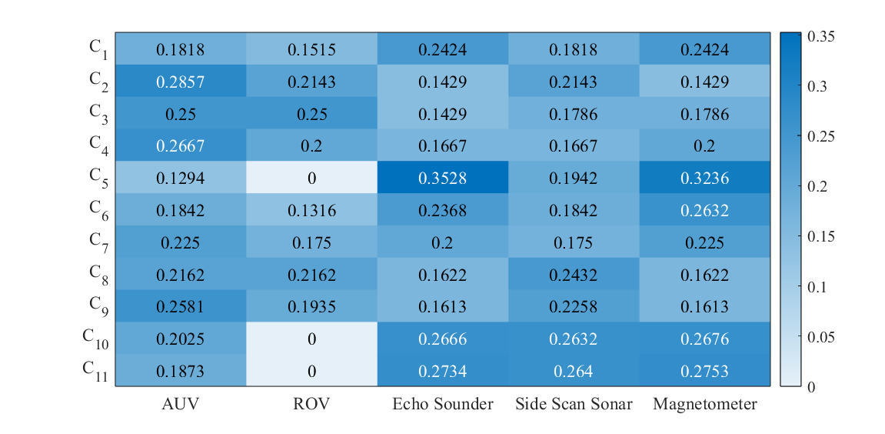

每个因素的权重不一样，故需要AHP

* 1. **Weight Selection Based on AHP**

主观上1-9打分表示重要性

A_ij 1-9 1-1/9

**主船和救援船 说明不同**

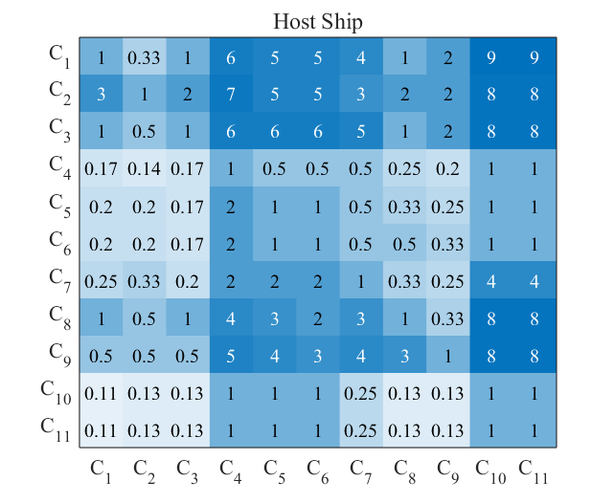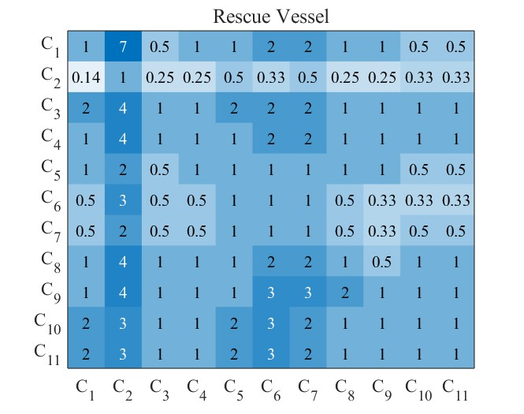一致性检验p<0.1

说明主船和救援船的不同，从而有不同的权重

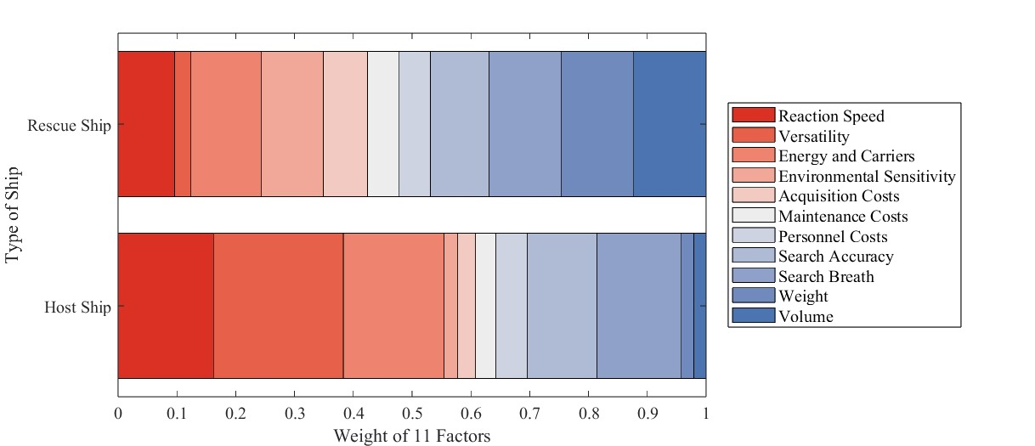生成两张雷达图关于权重

* 1. **Conclusion**

基于5.2的权重计算最后各个装备在两种不同的船上的分数，

主船和救援船分别携带3种最高分数的

实时操控：ROV>AUV说明越到后面，越需要实时操纵，主船<救援船，重量权重：主船<救援船

Reference

密度[1] Frank J. Millero, Alain Poisson, International one-atmosphere equation of state of seawater, Deep Sea Research Part A. Oceanographic Research Papers, Volume 28, Issue 6,

1981, Pages 625-629

[2]