|  |  |  |
| --- | --- | --- |
| **Problem Chosen** A | **2024 MCM/ICM Summary Sheet** | **Team Control Number** 24M039 |

**Calculation And Optimization of Reflection Light Convergence**

**Summary**

Converging light is an important basic means of light utilization. In this paper, **an arcuate reflection system** consisted of line segments is established, and **optimization measures** are given under certain conditions.

For problem 1, establishing the equation according to reflection law, normal vector of straight-line segment and vector of incident light, coordinates of intersection point of reflected light and Y-axis are obtained. After clustering the traversal results, it is found that the intersection points of reflected rays are concentrated in the range [-200, -150] and converge around point -196. In the interval of length 20, the initial target [-200, -180] contains **82 points**, and **the maximum number 294** is collected in interval [-170, -150]. In order to optimize the ray convergence, the base circle is changed into parabola. Maximum and average radial deviation are taken as the evaluation criteria. The optimal optimization scheme is obtained as a parabola .

For problem 2, change the incident light direction vector according to the problem and repeat the above step. Two special cases of reflected light not passing through the y axis and secondary reflection in the system are found. After incorporating them into the evaluation system and fitting the traversal results, it can be obtained that interval [-200, -180] under the new model contains **125 points**, and the interval [-193, -173] contains the most points of **224**. Continue to optimize the system, change the base circle to a parabola, and rotate the parabola so that its axis is parallel to the incident light. Through the analysis of the mean radial deviation and the similar steps above to determine the focus, midpoint and normal, it is solved that all the intersection points are basically concentrated within the point -197.

For problem 3, for precision consideration, the incident light range is **discretized into 100,000 rays**, and the intersection points are obtained in turn. After traversal, fitting analysis shows that the proportion of reflected rays in interval [-170, -150] reaches **48.91%**. The base circle is transformed into a parabola, which can make the concentrated reflected rays in the target interval reach **98.8%**.

For problem 4, the unit direction vector of incident light is changed and repeat the steps in problem 3. The analysis of fitting results find that the two special cases found in the second question still existed, the intersection points are scattered, and the proportion of reflected light in the target interval was only **6.474%**. Transform the base circle is into a parabola within limits and discretize the incident light. Analysis shows that the proportion in interval reaches **98.79%.**

For problem 5, based on the previous model analysis, through simulation comparison, it is concluded that: when curve shape is parabolic, line segment shape fits the off-axis parabola, and parabola symmetry axis is parallel to incident light through **rotation transformation**, the mirror surface can have higher convergence ratio.

Finally, we make **sensitivity analysis** with angel deviation from -3% to 3% to verify the rationality and robustness of the model, and use RMSE metric to evaluate the error generated by the stretch contraction of the line segment to verify the rationality of the model hypothesis. The advantages and disadvantages of the model are summarized, and the possible improvement scheme of the model is proposed.

**Keywords:** Reflection Light Convergency; Rotation Transformation; Spherical and Parabolic Mirror; Light Ray Discretization

**Contents**

1 Introduction4

1.1 Problem Background4

1.2 Restatement of the Problem4

1.3 Our Approach5

2 General Assumptions5

3 Notations6

4 Model I: Calculation and Optimization of Reflection Light Ray on Midpoint7

4.1 Model Overview7

4.2 Establishment of the Circle7

4.3 Model Building8

4.4 Results of Problem 19

4.5 Model Optimization9

5 Generalization of Model I When Incident Angle Changes12

5.1 Model Overview12

5.2 Re-discussion of Base Circle Shape Surface12

5.3 Model I Optimization with Rotation Matrix and Transformation 14

6 Model II: Calculation and Optimization of Reflection Light Ray on Straight-line segments16

6.1 Model Overview16

6.2 Discretization and Description of Light Ray 16

6.3 Model Solving 18

6.4 Model Optimization 18

7 Generalization of Model II When Incident Angle Changes20

7.1 Model Overview20

7.2 Re-discussion of Base Circle Shape Surface20

7.3 Model II Optimization with Rotation Matrix and Transformation 21

8 Model Generalization of Curve Segments23

9 Test the Model23

9.1 Sensitivity Analysis23

9.2 Robustness Analysis24

10 Evaluation and Promotion25

10.1 Strengths25

10.2 Weaknesses25

10.3 Promotion 25

Reference25

1. **Introduction**
   1. **Problem Background**

As an important fundamental component of nature, light is an important energy source for our daily lives, and humans have never stopped studying its utilization. Converging light is a very basic concept in the use of light. From the lighting of the Olympic flame in ancient Greece to the vigorous development of solar photovoltaic and photothermal power generation technology, converging light has occupied an important position in the history of light use. Its principle is to use the geometric characteristics of light, such as reflection, refraction, etc., to collect the low-heat flux energy carried by light that is difficult to use and form a high heat flux, so as to achieve the purpose of effective use.

Take large-diameter astronomical telescopes as an example. The adjustment of the mirror has always been the core issue of large optical telescopes. The concentration of light after adjustment directly affects the imaging of the observation object. The amount of deviation during mirror adjustment determines the observation efficiency and quality of the telescope.

* 1. **Restatement of the Problem**

Using the proportion of the amount of reflected light falling in a specific position interval as a reference criterion, evaluate and optimize the light convergence system which is consisted of 600 straight segments of unit length with endpoints successively distributed on a circle with a radius of 300 is.

* The light that strikes the midpoint of each line segment in the reverse direction of the Y-axis is reflected into the interval of length 20 on the Y-axis [-200m, -180m]. Calculate the number of rays that satisfy the condition. Moving this interval of length 20 along the Y-axis to make the corresponding number of reflected rays satisfying the condition is maximum. It is also discussed whether it is possible to adjust the circle to an appropriate curve while keeping the position of the two highest endpoints unchanged, so that the light reflected by the midpoint of the 600 straight-line segments on the adjusted curve falls near a certain point on the Y-axis. If possible, give the corresponding plan
* Rediscuss the first issues on the premise of changing the incident light angle.
* Discuss whether it is possible to invert the Y-axis to the midpoint of each line segment by adjusting the curve without changing the two highest endpoints so that the greatest number of reflected rays fall in the 20-meter-length interval [-170m, -150m] on the y axis. If possible, give the corresponding plan
* Rediscuss the third issues on the premise of changing the incident light angle.
* Change the straight-line segment with a length of 1 meter to some curve segments, and change the circle with radius 300 meters to an appropriate curve. When the endpoints of these curve segments of length 1 fall on this modified curve in sequence, can the proportion of light convergence be increased? For different angles of incident light, please provide an adjustment plan for a circle with a radius of 300 meters.
  1. **Our Approach**

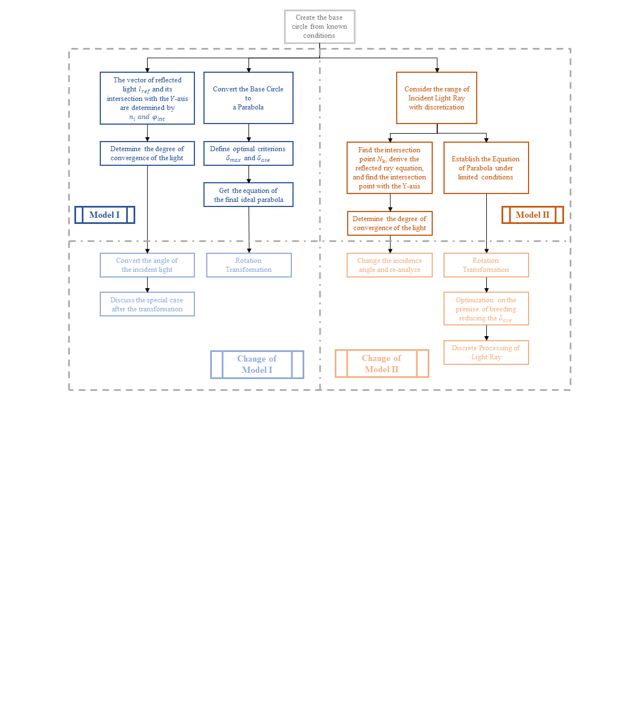

Figure 1: Our Approach

1. **General Assumptions**

To simplify the problem, we make the following basic assumptions, each of which is properly justified.

* **Assumption 1:** Light travels in a straight line, regardless of deflection caused by factors such as air density.

**Justification:** The study of the model mainly focuses on the problems of specular reflection and light convergence, so we can ignore the influence of other factors.

* **Assumption 2:** We only consider the geometric properties of the straight-line segment and do not consider the influence of mechanical factors.

**Justification:** Some mechanical factors, such as the gravity of the straight-line segment and the tension at both ends, will make the model more complex. In addition, combined with the knowledge of mechanics, it can be seen that when the two ends of a rope without elasticity are fixed and hang naturally, the resulting curve is a catenary, while the curve given in the question is a circle. If we need to consider it, we also need to consider the constraints of each endpoint.

* **Assumption 3**: Straight segments can stretch and shrink to a certain extent.

**Justification**: When discussing this assumption, we need to discuss it in the actual situation. Large-diameter circular mirrors similar to those in the question are usually used in astronomical telescopes and other fields. When the telescope is working, it usually uses cables to adjust the nodes so that the reference sphere changes into a working paraboloid. If the straight segment is completely rigid and there is no space between nodes for adjustment, it will increase the difficulty of adjusting the mirror.

1. **Notations**

Important notations used in this paper are listed in Table 1.

Table 1: Notations

|  |  |  |
| --- | --- | --- |
| Symbol | Description | Unit |
|  | Length of each straight-line segment |  |
|  | Radius of the base circle |  |
|  | The central angle of each straight-line segment |  |
|  | The angle of the base circle |  |
|  | Coordinate of the endpoints of each straight-line segment |  |
|  | Coordinate of the midpoints of each straight-line segment |  |
|  | Unit direction vector of incident light ray | Vector |
|  | Unit normal vector of each straight-line segments | Vector |
|  | The angle of the incident light ray |  |
|  | Unit direction vector of reflection light ray | Vector |
|  | Rational distance difference before and after adjustment |  |
|  | The maximum radial deviation difference |  |
|  | The average radial deviation difference |  |
|  | Angle between incident light ray and y-axis |  |
|  | Total number of light ray | / |
|  | Distance between each light ray |  |
|  | Intersection point of light ray and the segments | Coordinate |

1. 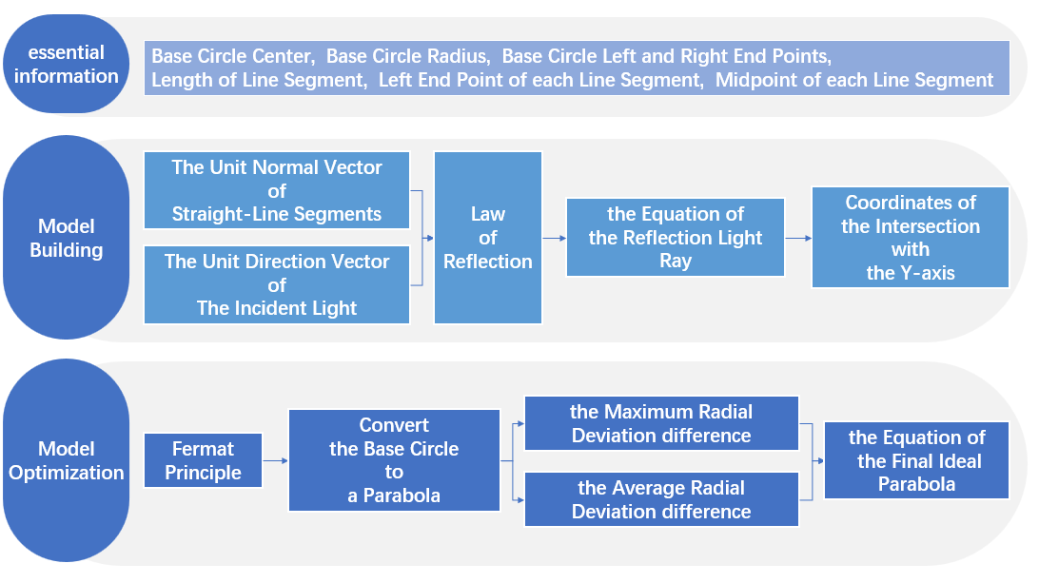**Model I: Calculation and Optimization of Reflection Ray on Midpoint**
   1. **Model Overview**
   2. **Establishment of the Base Circle**

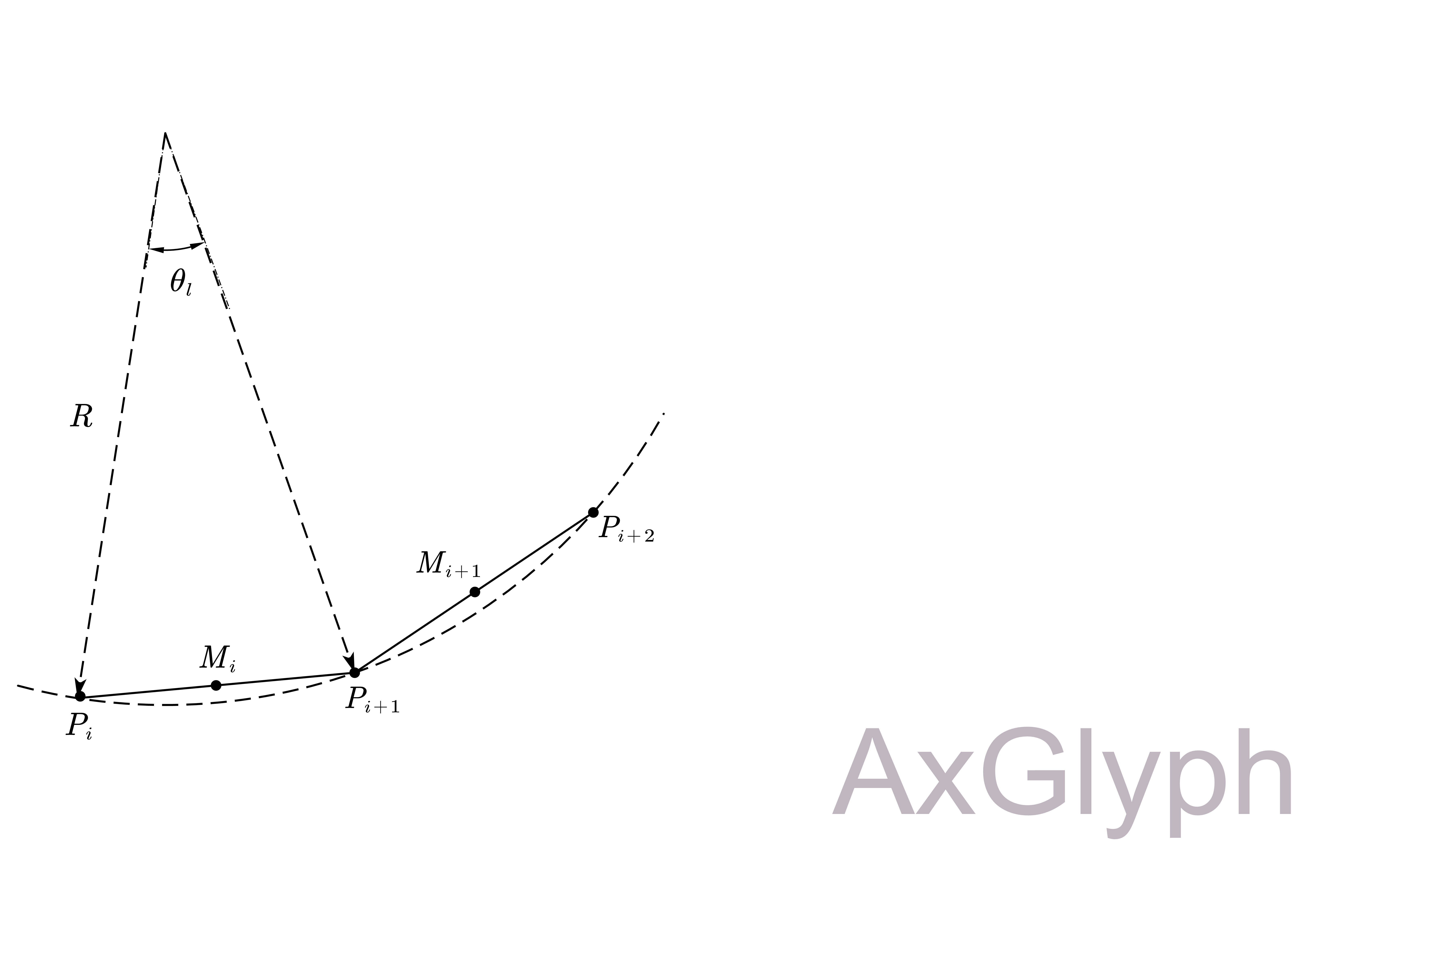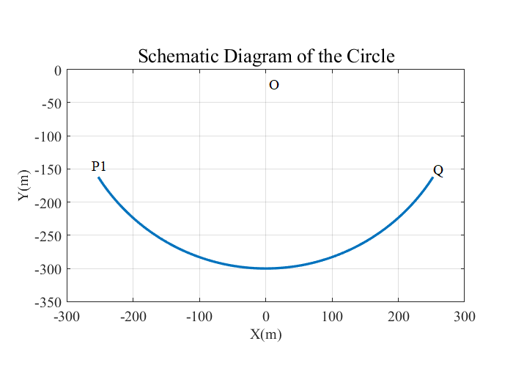As required in the problem, the endpoints of 600 straight-line segments with a length of  are sequentially distributed on a circle with a radius of . Assume that the center of the circle is , and the right endpoint of the arc is . The left endpoint of each straight-line segments can be denoted as , and the midpoint of each straight-line segments can be denoted as . The schematic diagram of the circle is shown in Figure 2, and the connection relationship of the straight-line segments is shown in Figure 3.

Figure 3 Connection Relationship

Figure 2 Schematic Diagram of the Base Circle

From Figure 2, we can find that the central angle  corresponding to the straight-line segment can be expressed as



Therefore, the angle of the base circle can be obtained as



The coordinate of  is  .

The coordinates of  can be expressed as



The coordinates of the midpoint  can be expressed as



* 1. **Model Building**

In problem 1, we need to consider about the light ray that shoot on midpoint of each straight-line segments. As shown in Figure 4, the incident light ray is parallel to y-axis, so its unit direction vector can be expressed as

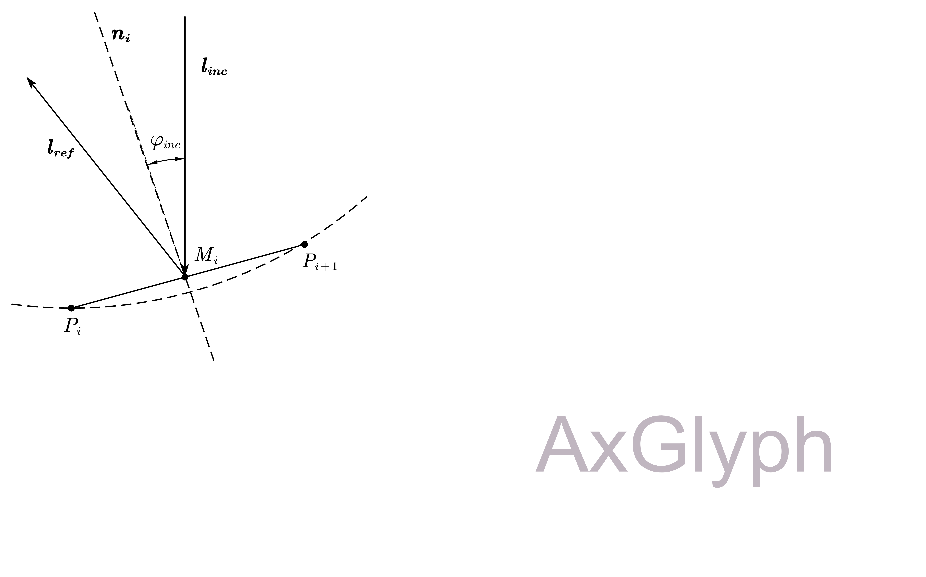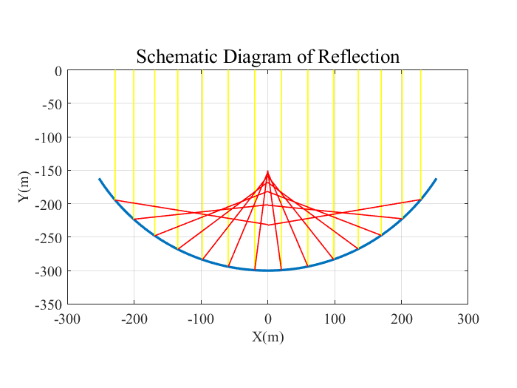 

Figure 5 Incident and Reflection Ray

Figure 4 Schematic Diagram of Reflection

As shown in Figure 5, the normal vector of the reflective panel is perpendicular to the straight-line segments, so the unit normal vector of each straight-line segments can be expressed as



According to the law of reflection, on reflection from a smooth surface, the angle of the reflected ray is equal to the angle of the incident ray. The angle of the incident ray can be obtained as



The unit reflection vector of each straight-line segments can be obtained as



Thus, equation of the reflection light ray can be expressed as



The intersection point of the reflection light ray and the y-axis can be obtained as



* 1. **Results of Problem 1**

There are 600 straight-line segments, which means that the total number of the light ray is . Following the steps in section 4.3, we can calculate each intersection point of the reflection light ray with the help of MATLAB.

Figure 6 shows the distribution and density of the intersection point on y-axis. Red points indicate that there are more intersection points nearby, while yellow points indicate that there are fewer intersection points nearby. All points range from -290m to -150m, and mainly concentrate on -200m to -150m

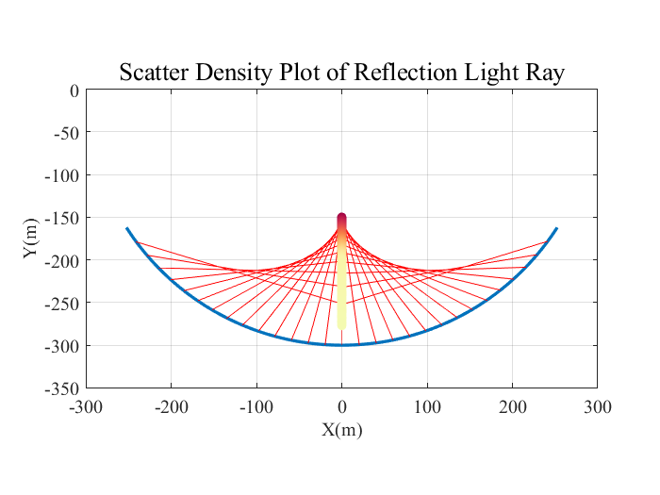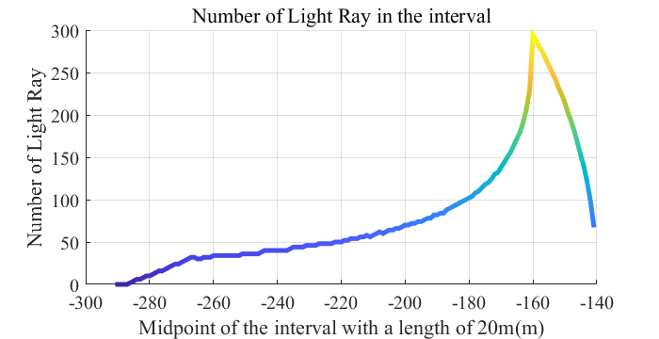Figure 7 shows the trend of number of light ray in the interval. **When the interval is [-200m, -180m], the number of light ray is 82.** We can find that when the midpoint of the interval is -160m, the interval contains the most reflection light ray. **Thus, the best interval is [-170m, -150m], and the number is 294.**

Figure 7 Number of Light Ray in the Interval

Figure 6 Scatter Density Plot of Reflection Ray

* 1. **Model Optimization**

In order to make the light reflected from the midpoints of these 600 straight-line segments whose endpoints are located on the adjusted curve all fall near a certain point on the y-axis, we need to adjust the circle with a radius of 300 meters to the appropriate curve.

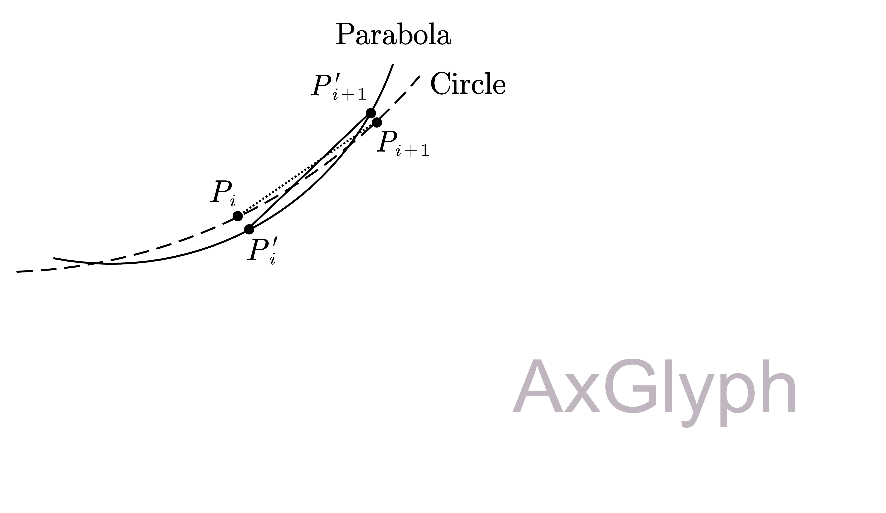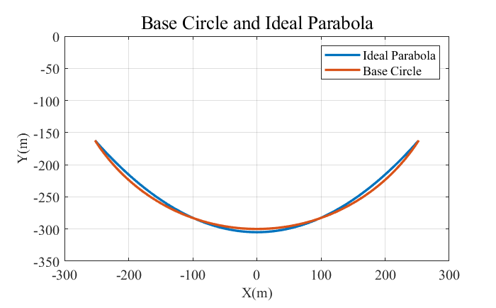According to the Fermat’s principle, when the shape of the reflecting surface is a parabola and the axis of rotation is parallel to the incident light, the reflected light can be converged at the focus of the parabola. Thus, our task is to optimize the curve as a parabola, as shown in Figure 8.

Figure 9 Movement of the Endpoints

Figure 8 Base Circle and Ideal Parabola

It is easy to know that  is a point on the y-axis, and we can assume that the vertex of the ideal parabola is , then  is the movement amount of . Therefore, the equation of the parabola can be expressed as



where  is the focal length of the parabola.

Since the positions of the two highest endpoints of this curve are fixed after adjustment, endpoint  satisfy the above equation. Thus, for a given , the focal length can be obtained as



As shown in Figure 9, the movement amount of each straight-line segment can be denoted as , where  is the endpoint on the parabola. Combine the equations of the straight line  and the parabola, there is



Therefore, the coordinate of  can be expressed as



We can approximate the amount of movement as the distance difference between the center of the circle and the base circle or parabola .



The maximum radial deviation difference obtained by traversing  is



The average radial deviation difference obtained by traversing  is



Taking the minimum movement of the endpoint as the optimal criterion for the ideal parabola,  and  can be used as evaluation indicators for the total movement of the endpoint. Select two ideal parabolas with minimum  and minimum , which are called parabolas of the first kind and parabolas of the second kind respectively.

Taking into account the changes in the mirror surface, we select the range of  from -20 meters to 20 meters, and take a step size of 0.1 meter to traverse.

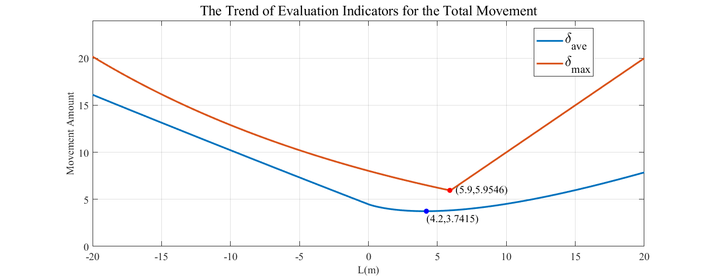As shown in Figure 10, when ,  has a minimum value of . The parabola in this case is the first kind parabola. Its equation can be expressed as

Figure 10 The Trend of Elvaluation Indicators for the Total Movement



When ,  has a minimum value of . The parabola in this case is the second kind parabola. Its equation can be expressed as

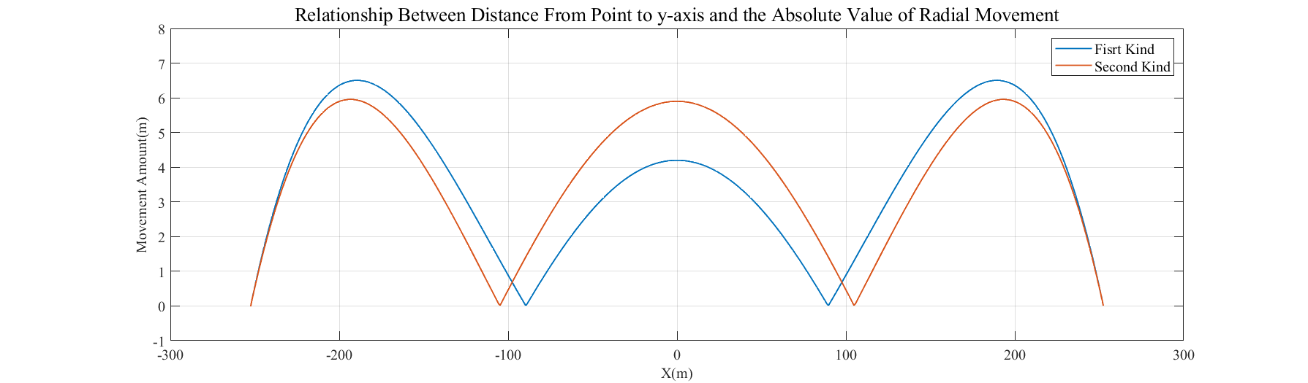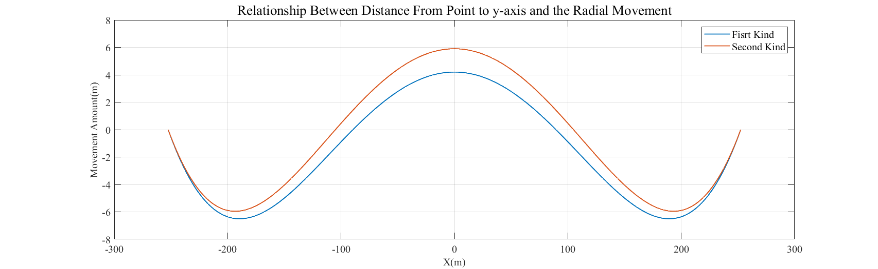 

Figure 12 Relationship Bewteen Distance From Point to y-axus and the Abosolute Value of Radial Movement

Figure11 Relationship Between Distance From Point to y-axis and the Radial Movement

From Figure11 and Figure12, we can conclude that although the maximum radial deviation of the second type of parabola is large, the parts with large deviations are mostly concentrated at the center. The number of endpoints at the center is small, so the average deviation  of the second type of curved surface is small. We conjecture that  reflects the movement level of the endpoint, and believe that the optimal ideal parabola is the second type of parabola. **Therefore, the equation of the final ideal parabola is**



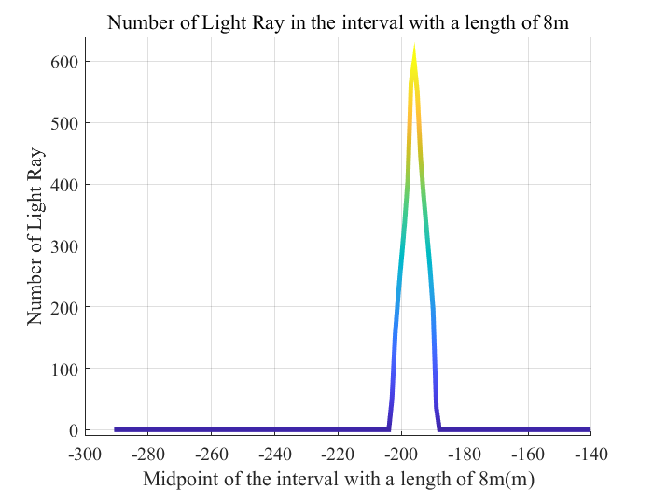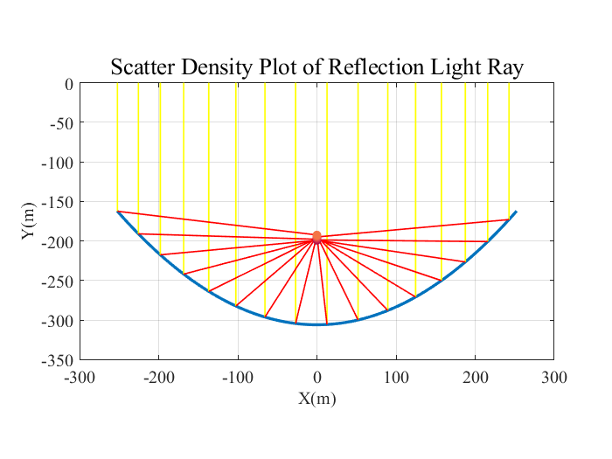Similar to the steps in section 4.2 and 4.3, we can know the midpoint  and the normal vector  after adjustment. Then, we can calculate the distribution and density of the intersection point on y-axis.

Figure 13 Scatter Denstiy Plot

Figure 14 Number of Light Ray in the Interval

Figure 13 shows that the parabola successfully brings all rays together near a point. Figure 14 gives more detailed information about the convergence point. It is shown that the interval  has contained all of the points, which means that the distance between all intersection points and point  is no more than 4m.

1. **Generalization of Model I When the Incident Angle Changes**
   1. **Model Overview**

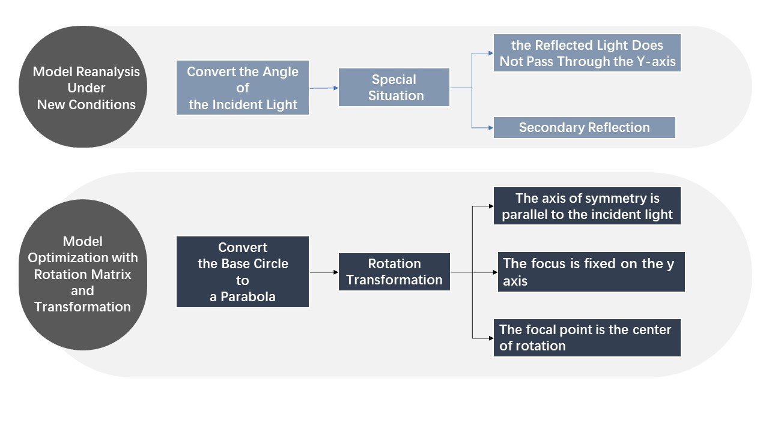

* 1. **Re-discussion of Base Circle Shape Surface**

The angle between the incident light ray and the y-axis is 10 degrees, so its incident unit vector can be expressed as



Following the calculation method above, we can get the convergence of reflection light ray.

When the angle between the incident light and the y-axis is 10 degrees, the reflection situation is similar to that in Problem 1, but there are two special situations that need further consideration.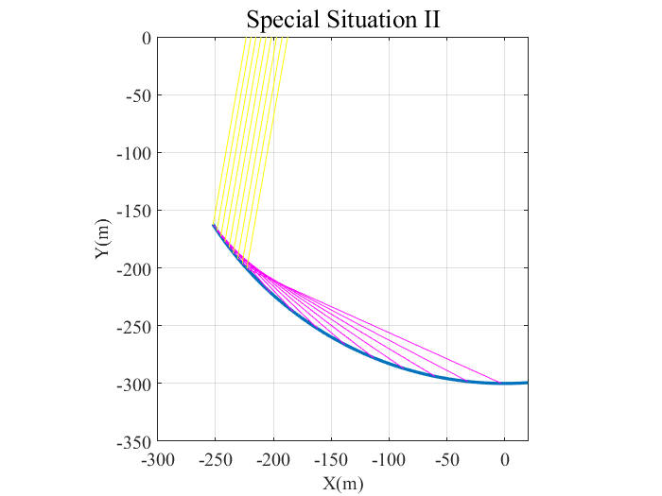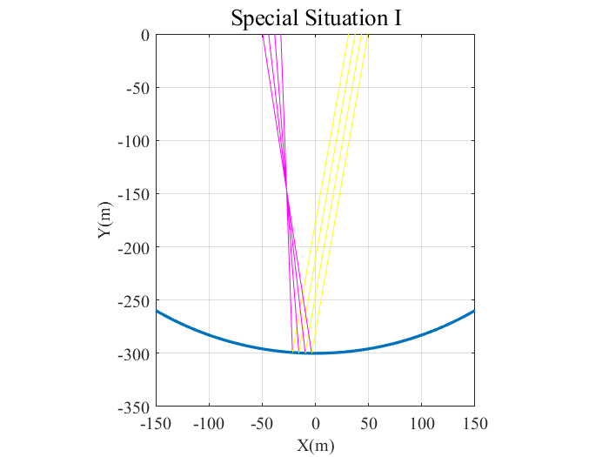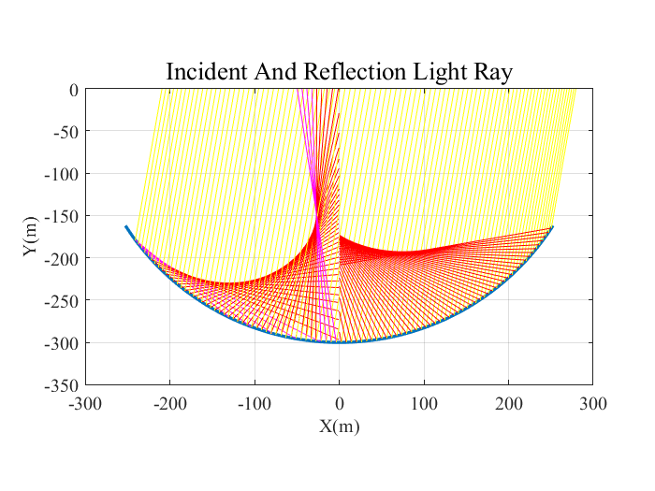

Figure 16 Two Special Situation

Figure 15 Incident And Reflection Light Ray

* **Special Situation I**: Since the change of the incident light ray, some reflection light ray near the symmetry axis may not cross the y-axis, but will converge at a point to the left of the symmetry axis.
* **Special Situation II**: Since the incident angle is too large, some reflection light ray will shoot on the mirror surface again, causing secondary reflection. Such secondary reflection will make the problem more complicated and difficult to deal with. At the same time, according to actual conditions, the light intensity will decrease significantly after multiple reflections. Therefore, in this model, we do not consider secondary reflection, but consider that the reflection light ray is absorbed by the surface.

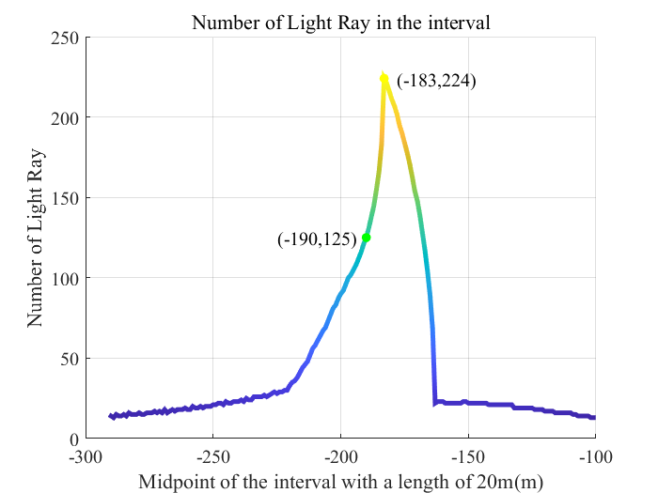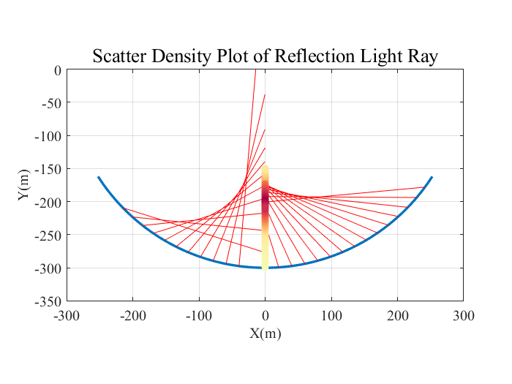After handling these two special situations, we can get the distribution and density of light convergence.

Figure 17 Scatter Density Plot of Reflection Ray

Figure 18 Number of Light Ray in the Interval

It can be seen from Figure 17 that most of the intersection points range from -250m to -150m. Figure 18 shows the trend of the number of light ray in the interval with a length of 20 meters. **When the interval is [-200m, -180m], the total number of light ray is 125, which accounts for 20.8% of the total amount of light ray.** We can find that when the midpoint of the interval is -183m, the interval contains the most reflection light ray. **Thus, the best interval is [-193m, -173m], and the number is 224, which accounts for 37.2% of the amount of light ray.**

* 1. **Model Optimization with Rotation Matrix and Transformation**

Similar to section 4.5, we need to optimize the curve as a parabola, but the biggest difference is that this parabola requires a certain angle of rotation. Assume that the angle between incident light ray and y-axis can be denoted as . Then, we need to rotate the parabola  counterclockwise so that the symmetry axis of the parabola is parallel to the incident light, and the reflected light will have the best convergence effect.

On a two-dimensional plane, assuming there is a point ,  obtained by rotating counterclockwise  around the satisfies



Its inverse transformation is



The equation of the parabola before rotation is



The focus point of the parabola is



In order to make the light reflected from the midpoints of these 600 straight-line segments whose endpoints are located on the adjusted curve all fall near a certain point on the y-axis, we need to ensure that the focus is on the y-axis and rotate the parabola in a certain angle around the focus. There is



Substitute  into the equation, and we can get



According to Problem 1, the values of which describes the parabola satisfy



Thus, for a given , we can calculate the corresponding , then the focus point of the parabola, which is also the central point of rotation, is determined.

Similar to the steps in section 4.5, the movement amount of each straight-line segment can be denoted as , where  is the endpoint on the parabola. Combine the equations of the straight line  and the parabola, there is



Therefore, the coordinate of  can be expressed as



We can approximate the amount of movement as the distance difference between the center of the circle and the base circle or parabola .



The average radial deviation difference obtained by traversing  is



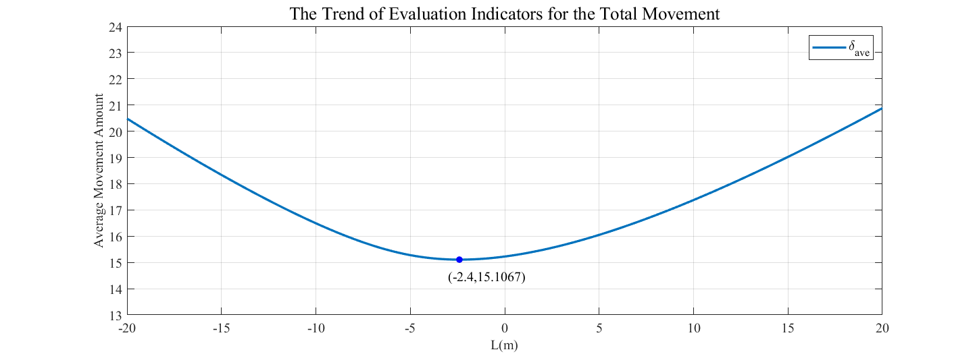Taking into account the changes in the mirror surface, we select the range of from -20 meters to 20 meters, and take a step size of 0.1 meter to traverse.

Figure 19 Trend of Evaluaiton Factors for the Total Movement

As shown in Figure 19, when ,  has a minimum value of . Comparing it with the result in Problem 1, we can find that the average deviation has increased significantly. This is caused by rotating the parabola and cannot be avoided if we want to converge the light ray at the focus point of the parabola on the y-axis.

The equation of the parabola in this case can be expressed as



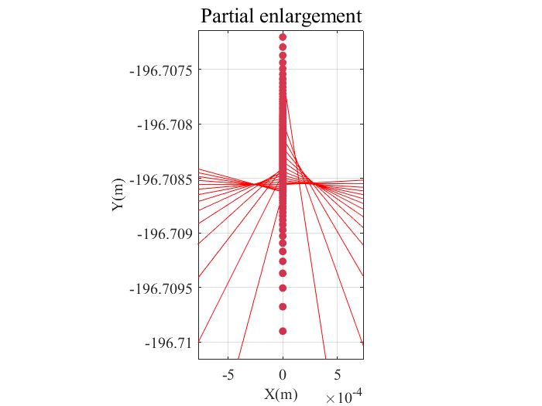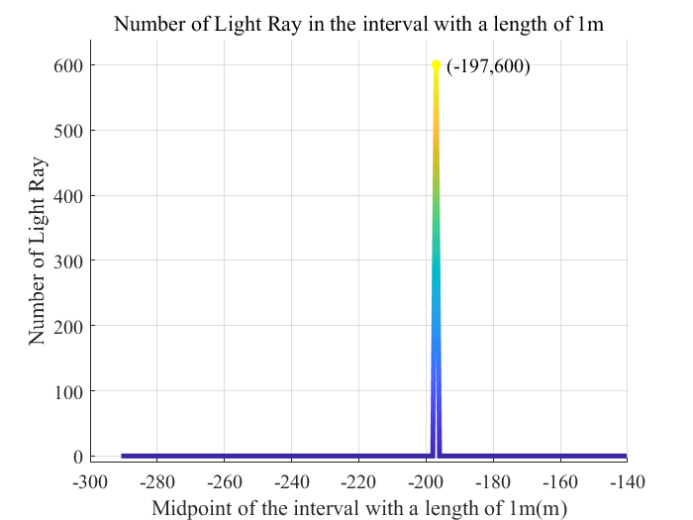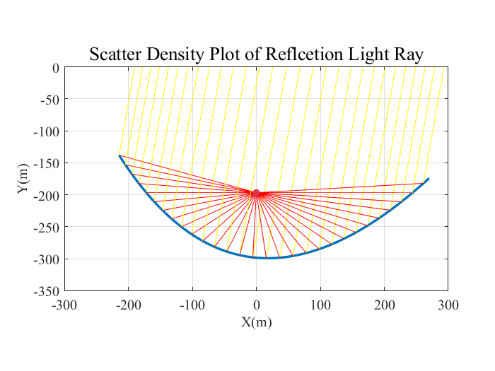Similar to the steps in section 4.2 and 4.3, we can know the midpoint  and the normal vector  after adjustment. Then, we can calculate the distribution and density of the intersection point on y-axis.

Figure 21 Number of Points in the Interval

Figure 20 Scatter Density Plot of Refleciton Light Ray

Figure 20 shows that the parabola after rotation around the focus point successfully brings all rays together near a point. The partial enlargement gives more detailed information about the convergence point. Figure 21 shows that the interval [-197.5m, -196.5m] has contained all of the points, which means that the distance between all intersection points and point (0, -197) is no more than 1 meter.

1. **Model II: Calculation and Optimization of Reflection Light Ray on Straight-line segments**
   1. **Model Overview**

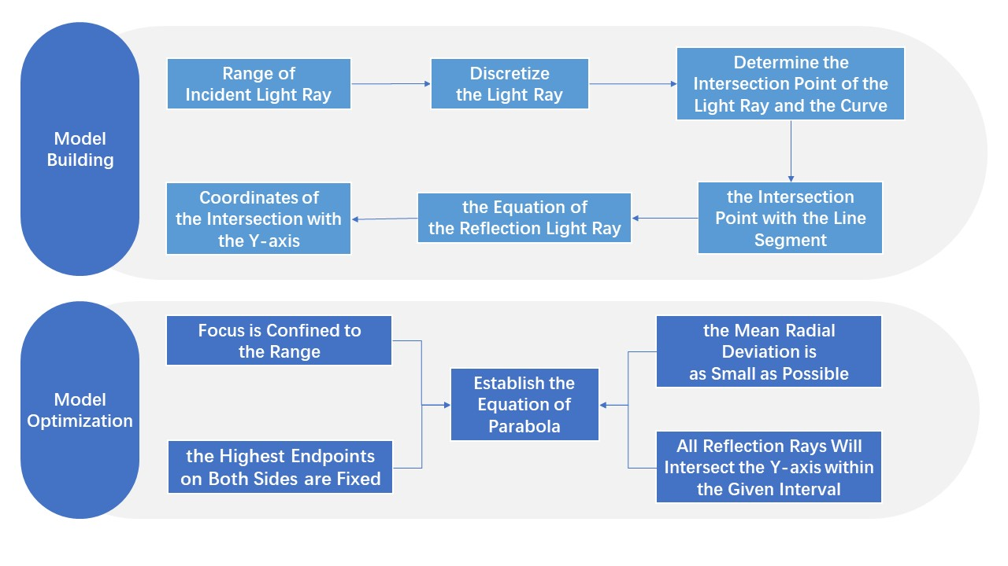

* 1. **Discretization and Description of Light Ray**

In Problem 3, we need to consider about the incident light ray that hits on each point of the straight-line segments. Thus, it is necessary to find a proper way to express the equation of the light ray. As Figure 22 shows, the range of the incident light ray is from point  to point . Assume that the angle between y-axis and the incident light ray is . The coordinates of point  satisfy the equations below



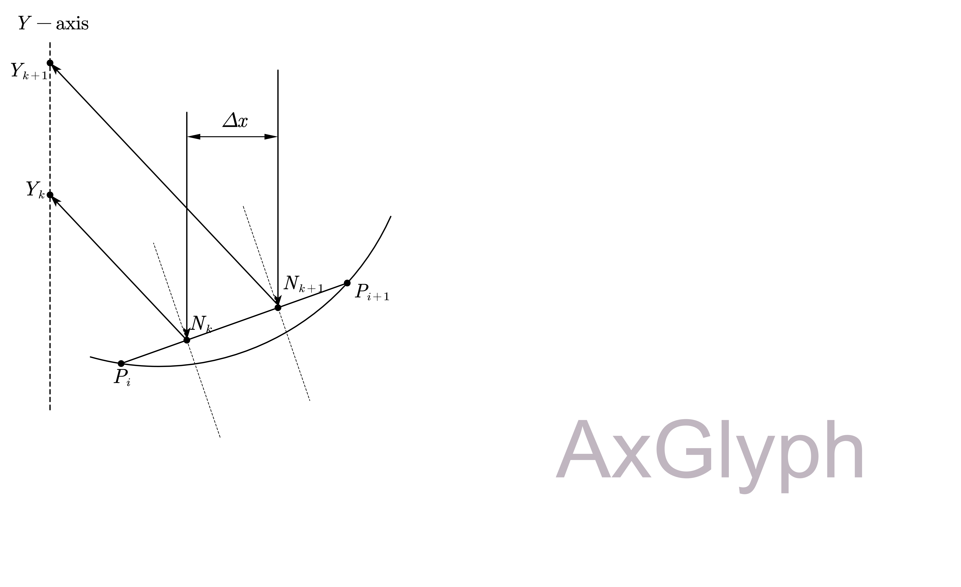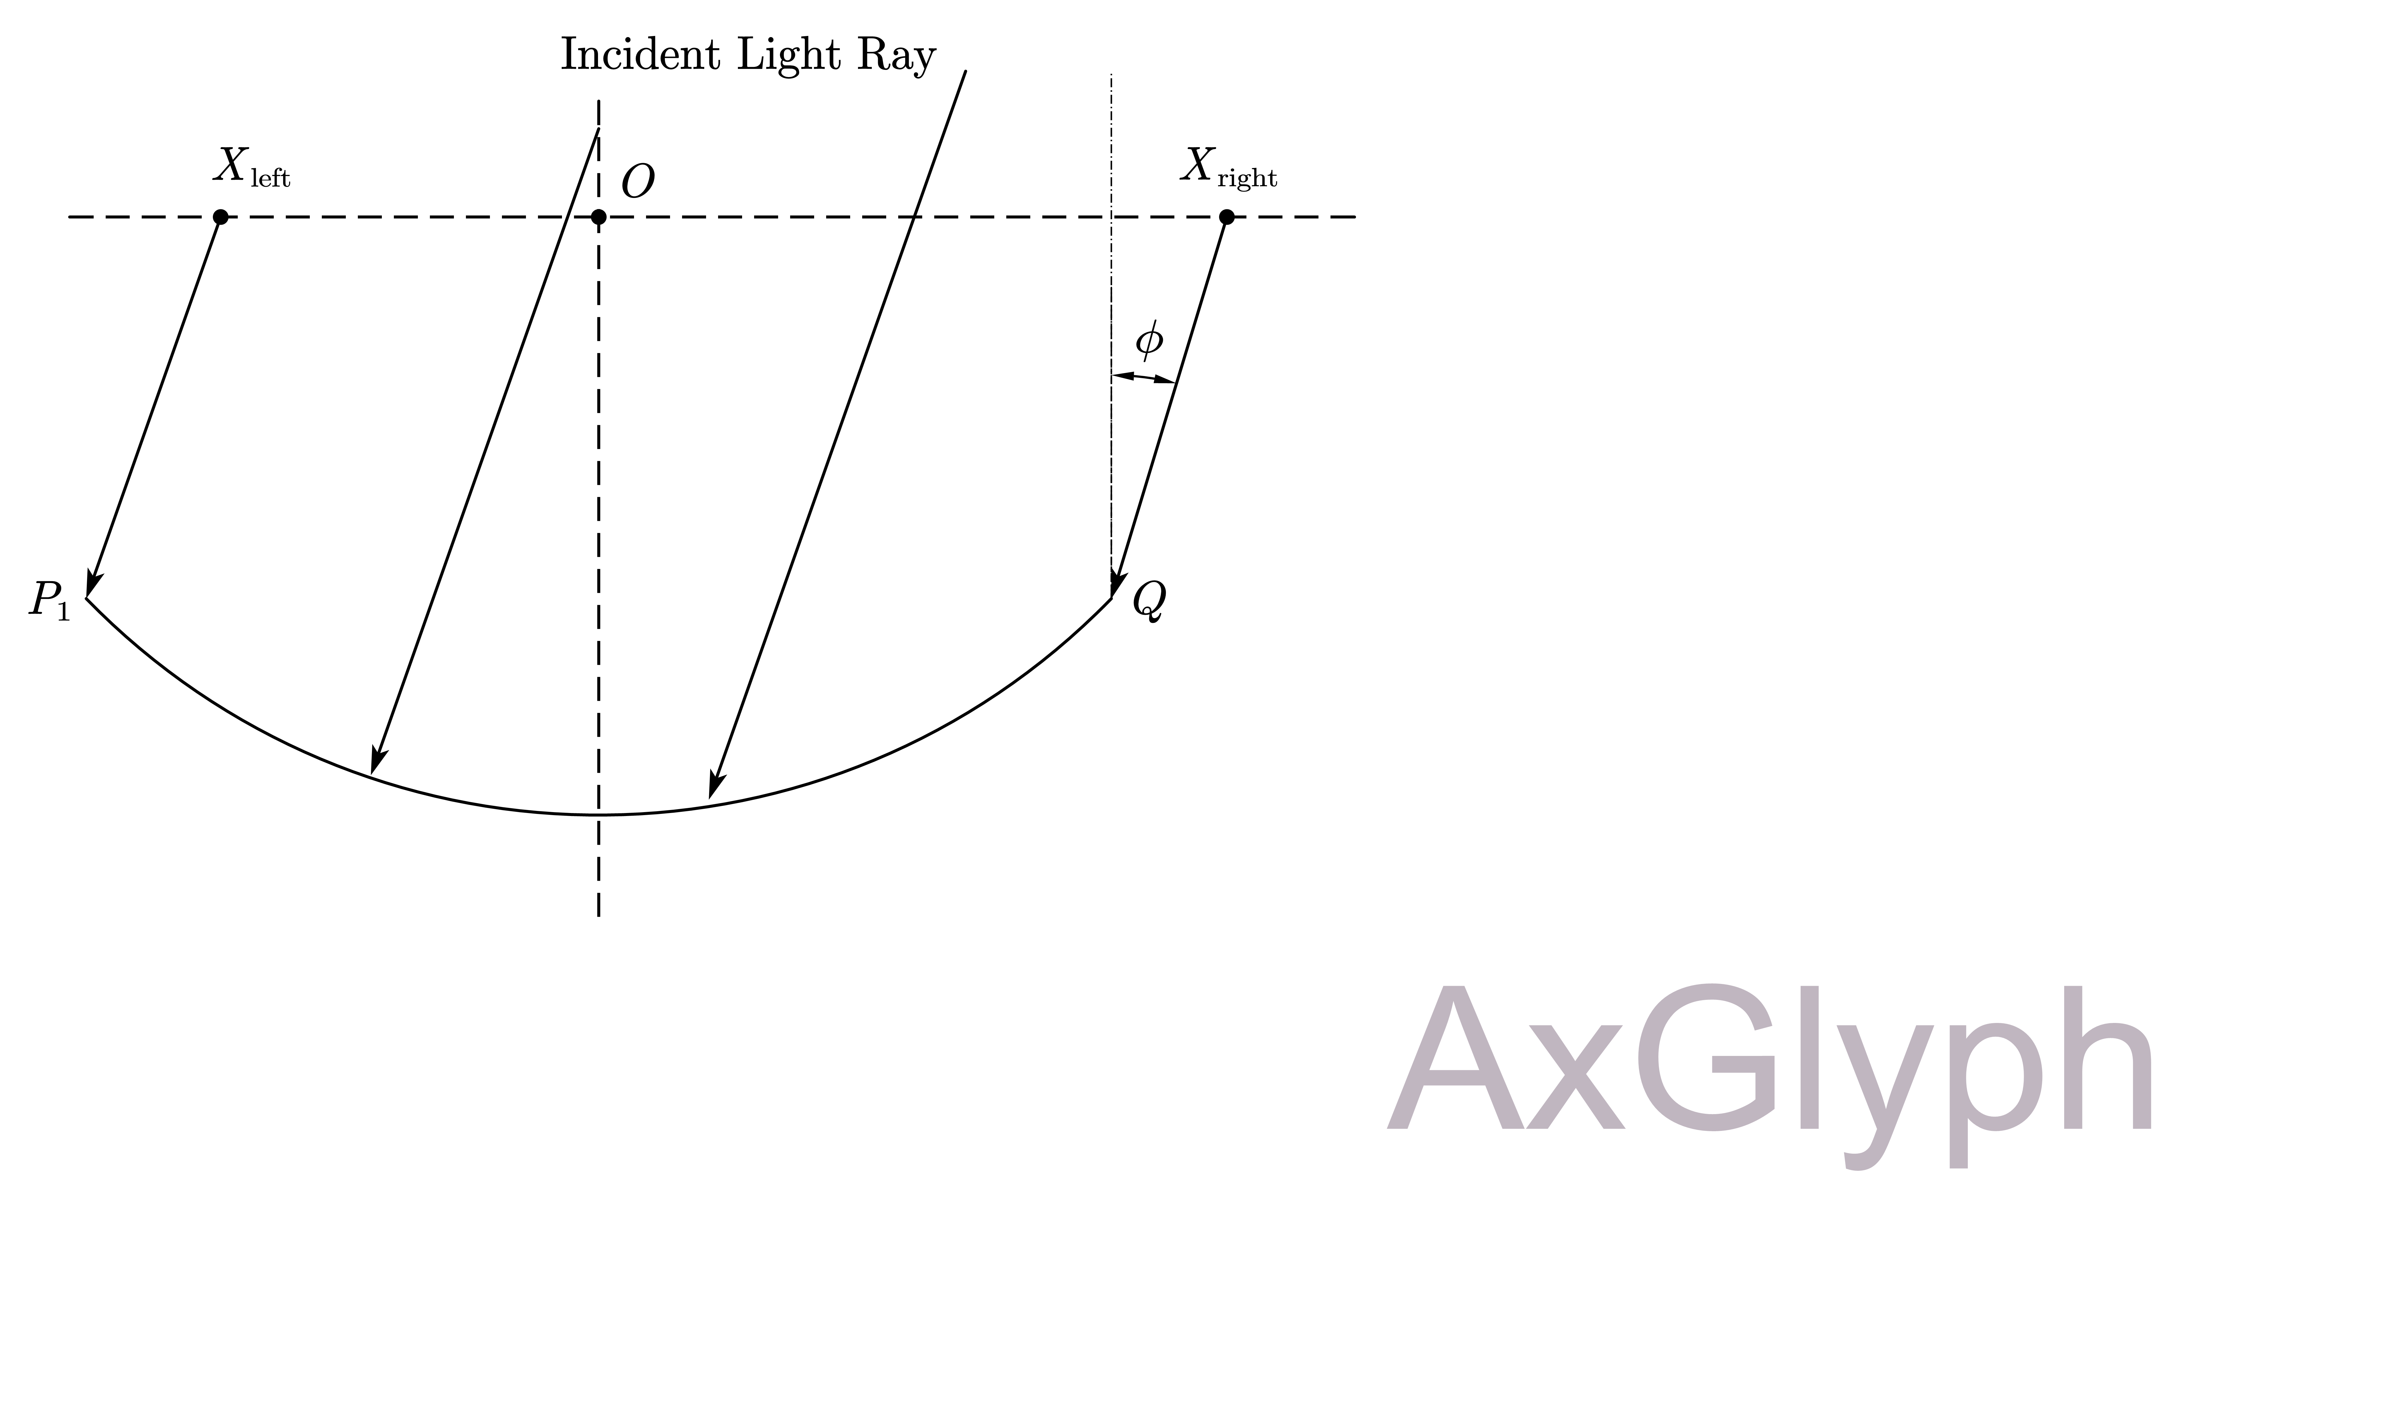Thus, point  can be expressed as

Figure 22 Range of Incident Light Ray

Figure 23 Light Ray Reflection on Each Point



In Problem 3, the incident light ray is parallel to y-axis, so the coordinate can be obtained as



In order to simplify the calculation, we need to discretize the light ray. Assume that the total number of light ray is , then the distance between each light ray can be expressed as



Thus, the equation of each light ray can be obtained as



Combine the equation of the light ray and the circle, and we can know the intersection point of the light ray and the curve is



Then, there must be a number of  can be found out that satisfy



which means that the intersection point of incident light ray  and the straight-line segment  is on the straight-line segment , as shown in Figure 23. Combine the equation of incident light ray and the straight-line segment, and the coordinate of  can be obtained as



Thus, the equation of the reflection light ray can be expressed as



The intersection point with y-axis can be obtained as



* 1. **Model Solving**

In our model, we take the value of  as , so the distance between each incident light ray can be obtained as



which can ensure that the result is accurate enough.

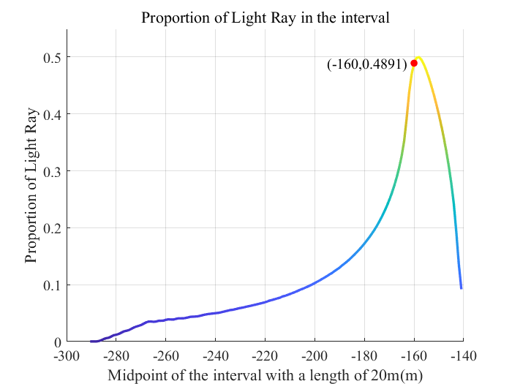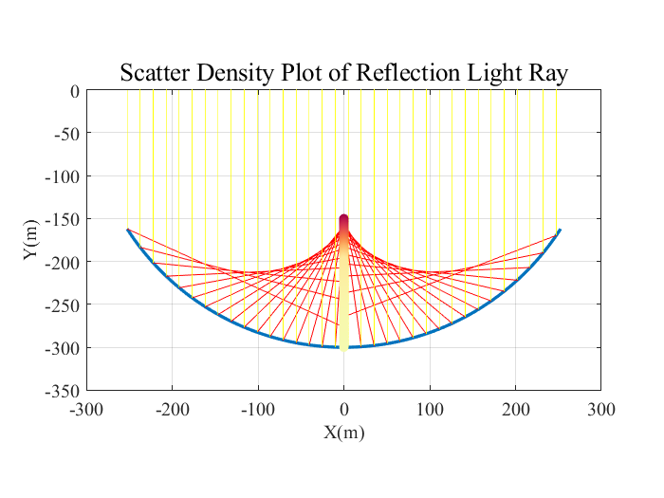Figure 24 qualitatively shows the distribution density of the intersection of reflection light and the y-axis. From -300 meters to -150 meters, the number of intersections gradually increases, and most of the intersections are concentrated in the range from -200 meters to -150 meters. Figure 25 quantitatively analyzes the proportion of the intersection of the reflection light and the y-axis in each interval. It is shown that **when the midpoint of the interval with a length of 20 meters is -160m, which means the interval is [-170m, -150m], the proportion of reflection light ray reaches 48.91%.**

Figure 25 Proportion of Light Ray in the Interval

Figure 24 Scatter Density Plot of Reflection Light Ray

* 1. **Model Optimization**

Similar to Section 4.5, we need to optimize the base circle as a parabola to ensure that the light reflected by these 600 straight line segments which endpoints are on the adjusted curve all fall in the interval with a length of 20 meters on the y-axis [-170m, -150m].

From Section 4.5, we can know the equation of the parabola and determine the relational expressions of relevant parameters like  if the positions of the two highest endpoints are fixed.



Point  is the focus point of the parabola, and the reflection light ray will converge on it. Thus, the range of  is [-170m, -150m]. For a given , we can combine the relational expressions above. There is



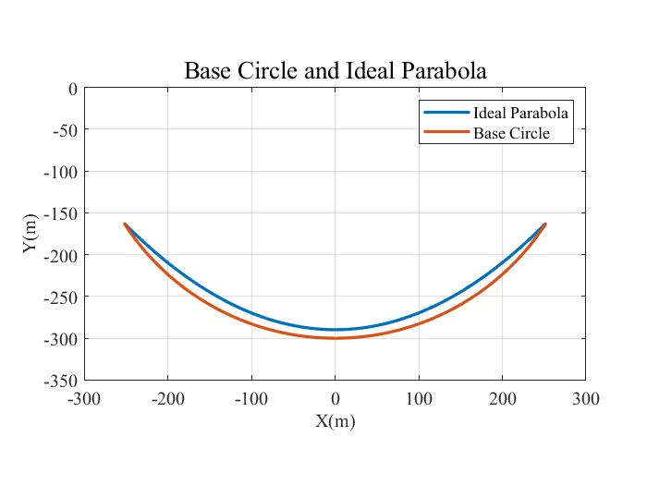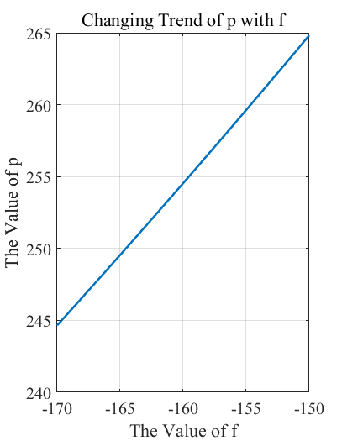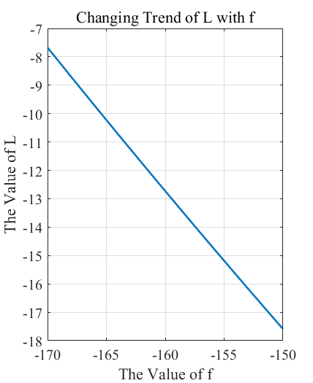Figure 26 shows the trend of  when  changes from -170m to -150m. The value of decreases as  increases, and the value of  increases as  increases. Combined with the conclusion in Figure 10, when the value of is less than 4.2, the average radial deviation of the straight-line segment decreases as the value of  increases. At the same time, we also need to ensure that all reflection rays will intersect the y-axis within the given interval.

Figure 27 Base Circle and Ideal Parabola

Figure 26 Changing Trend of L and p with f

Therefore, after careful consideration in many aspects, we selected the value of  as -10.2256 and the value of  as 249.5488, and in this case , as shown in Figure 26. Thus, the equation of the parabola is



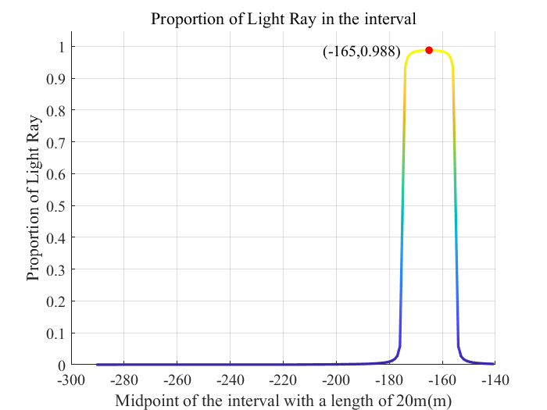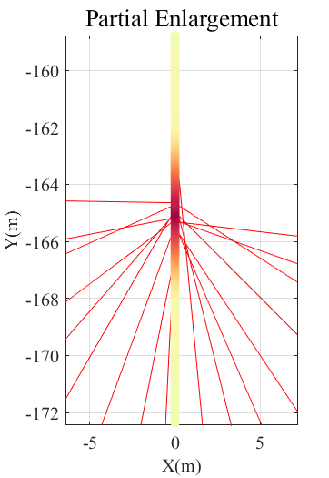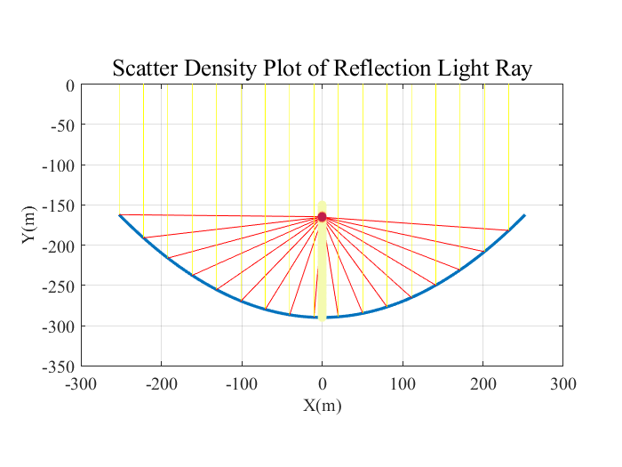Similar to the steps in section 4.2 and 4.3, we can know the midpoint  and the normal vector  after adjustment. Then, we can calculate the distribution and density of the intersection point on y-axis.

Figure 28 Scatter Density Plot of Reflection Light Ray

Figure 29 Proportion of Ray in the Interval

Figure 27 shows that the parabola successfully brings all rays together near the focus point. The partial enlargement gives more detailed information about the convergence and scatter density situation in the interval. It is shown that almost all intersection points fall in the interval [-168m, -163m] and meet the requirement of the problem. Figure 28 quantitatively analyzes the proportion of the intersection of the reflection light and the y-axis in each interval. It is shown that **when the midpoint of the interval with a length of 20 meters is -160m, which means the interval is [-170m, -150m], the proportion of reflection light ray reaches 98.8%.** Therefore, considering the influence of part of the error, we can think that **all intersection points fall within the interval required by the problem**. What’s more, further analysis shows that the obtained curve has good ability of light convergence: when the midpoint of the interval changes in the range of [-156 m, -174 m], the interval with a length of 20 meters can always include almost all points.

1. **Generalization of Model II When the Incident Angle Changes**
   1. **Model Overview**

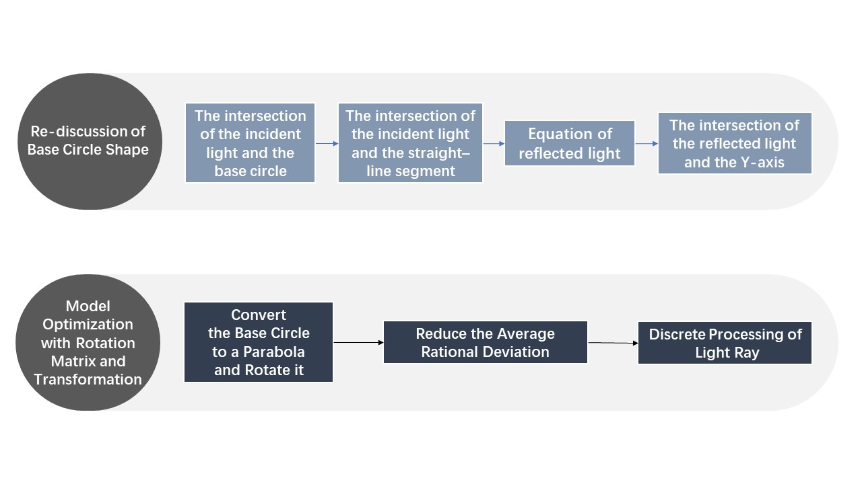



* 1. **Re-discussion of Base Circle Shape**

From Section 6.2, we can know that the equation of incident light ray can be expressed as



where .

Combine the equation of the incident light ray and the circle, there is



Then, the x-coordinate of the intersection can be obtained as



Following the steps in section 6.2, the intersection point of the incident light ray and the straight-line segments can be obtained as



Thus, the equation of the reflection light ray can be expressed as



The intersection point with y-axis can be obtained as



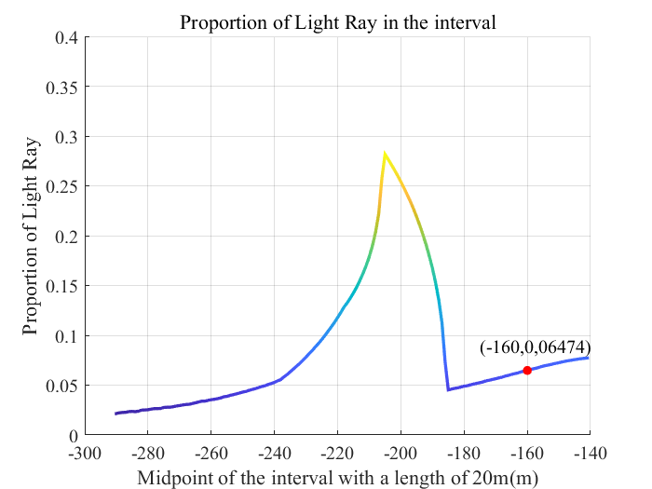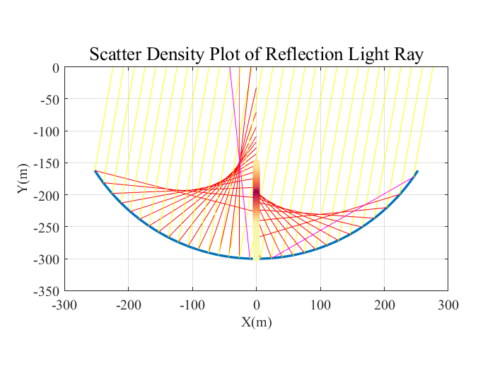Like section 6.3, we take the value of  to simulate light reflection. Figure 30 qualitatively shows the distribution density of the intersection of reflection light and the y-axis. From -300 meters to -200 meters, the proportion of intersections gradually increases. From -200 meters to -150 meters, the proportion of intersection points gradually decreases. Most of the intersections are concentrated in the range from -210 meters to -190 meters. What’s more, it is shown that the two special situations that the reflection light ray don’t cross y-axis still exist. Figure 31 quantitatively analyzes the proportion of the intersection of the reflection light and the y-axis in each interval. It is shown that **when the midpoint of the interval with a length of 20 meters is -160m, which means the interval is [-170m, -150m], the proportion of reflection light ray reaches 6.474%.** Moreover, Figure 30 shows that the distribution of intersection points is not dense, and only 30% of the points are included in the densest interval, indicating that the light convergence ability of the original curve is not good and we need to optimize it.

Figure 31 Propertion of Light Ray in the Interval

Figure 30 Scatter Density Plot of Reflection Ray

* 1. **Model Optimization with Matrix Rotation and Transformation**

To ensure that the intersection points all fall on the interval given by the problem, we need to optimize the curve as parabola and rotate it around its focus point. From section 5.3, the parabola after rotation can be expressed as



What’s more, there are relational expressions of 



Thus, for a given , we can calculate out the value of  and evaluate the average rational deviation. As Figure 32 shows, Under the condition of ensuring that the light intersection meets the requirement of the problem, we select  to reduce the average deviation caused by curve movement and rotation. The obtained parabola is shown in Figure 33, and its equation is

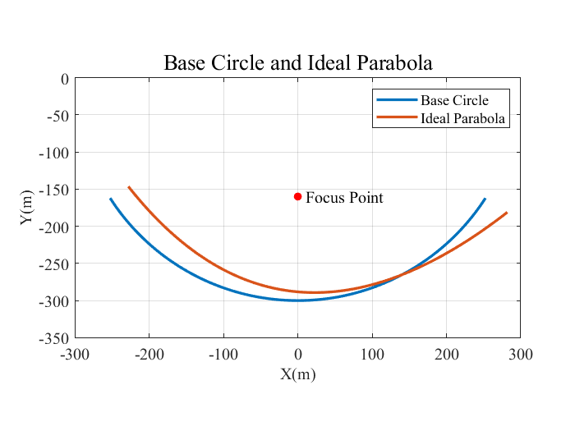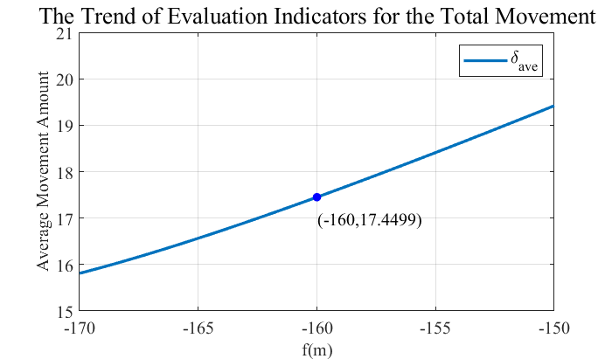 

Figure 33 Base Circle and Ideal Parabola

Figure 32 Trend of Evaluation Indicators for Movement

Like section 7.2, we need to discretize the light ray. The equation of incident light ray can be expressed as



where .

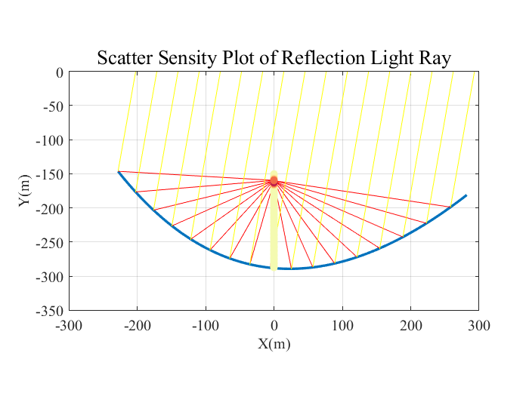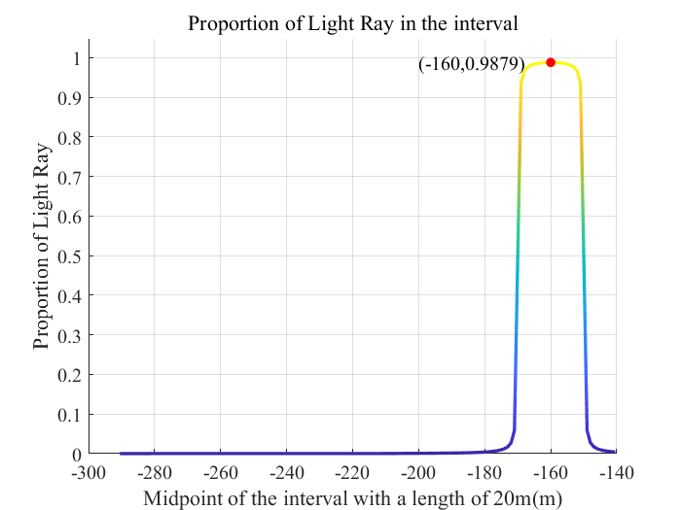We take the value of  to ensure that the result is accurate. Figure 34 shows that the parabola successfully brings all rays together near the focus point. Figure 35 quantitatively analyzes the proportion of the intersection of the reflection light and the y-axis in each interval. It is shown that **when the midpoint of the interval with a length of 20 meters is -160m, which means the interval is [-170m, -150m], the proportion of reflection light ray reaches 98.79%.** Therefore, considering the influence of part of the error, we can think that **all intersection points fall within the interval required by the problem**.

Figure 35 Proportion of Light Ray in the Interval

Figure 34 Scatter Sensity Plot of Reflection

1. **Model Generalization of Curve Segments**

In problem 5, we need to determine how to optimize straight line segments into appropriate curve segments and select appropriate curves to achieve the best light convergence effect. Based on the previous model, we will analyze the following **four influencing factors** and give our adjustment plan.

* **Curve Shape**

The initial shape of the curve given in the problem is a circle. In Sections 4-7, we conduct a detailed analysis, combine with the simulation of reflection light ray, and finally conclude that a circle has a better effect on converging paraxial light, but when the light deviates from the axis a lot, it cannot converge well. In the optimization of each problem, we optimize the circle into a parabola. The advantage of a parabola is that when the incident ray is parallel to the axis of symmetry of the parabola, the reflected rays will converge at the focus of the parabola. Therefore, we choose the **parabola as the basic curve**. The equation can be expressed as



* **Segments Shape**

The shape of the curve segment will indirectly affect the convergence of reflection light. Under initial conditions, the line segment is a straight segment. At this time, when parallel incident light rays illuminate each point on the straight-line segment, they will be reflected in parallel at the same angle, which cannot improve the concentration ratio of the light. The focusing effect on light is provided entirely by the interrelationship between straight line segments. Therefore, we can optimize it to a suitable curve. Combined with the optimization of the previous factor, we can set the curve segment to be **a small part of the parabola, also known as an off-axis parabola**. When light strikes at just the right angle, the reflected rays converge into a focal point.

* **Change of Incident Light Ray Angle**

When the incident angle changes, the incident light is no longer parallel to the symmetry axis of the parabola, causing the parabola to be unable to produce a good convergence effect on the light. Therefore, we can learn from the methods in Sections 5 and 7 and use **rotation matrices and transformations** to rotate the parabola around the focus by a certain angle so that the symmetry axis is parallel to the incident light ray. The rotation transformation can be expressed as



In summary, by appropriately adjusting the above three influencing factors, we can formulate a suitable plan to increase the proportion of light convergence. But in practical applications, we also need to consider the impact of errors.

1. **Test the Model**
   1. **Sensitivity Analysis**

In the generalization of Model I and II, we consider about the change of the incident light angle and take the value of . However, in actual situations, there may be slight deviations in the angle. Thus, we choose the percentage of angular deviation to be  and rediscuss the situation of light reflection on straight-line segments.

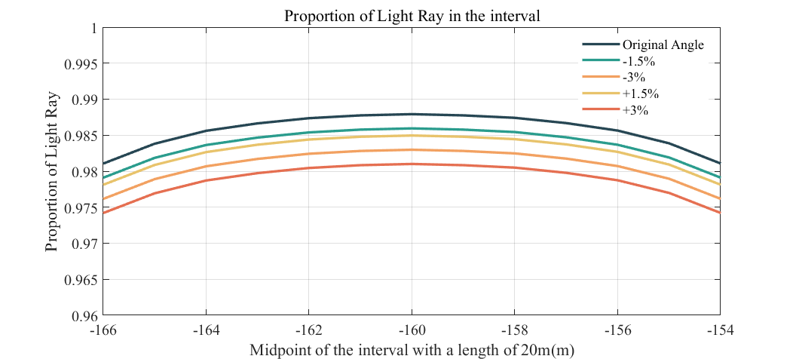Figure 36 shows the change of proportion when the angle of incident light deviates from . The percentage of ray intersections within the interval remains at 97-99%, which proves **the rationality and robustness of the rotation parabola model**.

Figure 36 Sensitivity Analysis of Angle Deviation

* 1. **Robustness Analysis**

In the assumptions of the model, we assume that straight segments can stretch and shrink to a certain extent. Now, we need to test the optimized parabolic model to verify the reasonableness of the hypothesis, and use the RMSE metric to evaluate the error. RMSE can be expressed as



where  represents the number of straight-line segments, and  represents the amount of stretching or shrinking of the straight-line segment after curve adjustment. After calculation, we can get the data in Table 2.

Table 2: RMSE of the Parabola in Each Section

|  |  |  |  |  |
| --- | --- | --- | --- | --- |
| Parabola | Section 4 | Section 5 | Section 6 | Section 7 |
| RMSE | 0.3268 | 0.7730 | 0.4857 | 0.9455 |

It can be seen from Table 2 that the RMSE of the parabola obtained in Section 4 and 6 are low, while the RMSE of the results in Section 5 and 7 are higher. Analysis shows that this is because in Section 5 and 7, the curves also involve rotation, thus increasing the deviation. **In summary, the results are acceptable and the model assumptions are reasonable.**

1. **Evaluation And Promotion**
   1. **Strengths**

* When considering the offset of the straight-line segment, we introduce the assumptions of stretching and shrinkage, which improves the stability and applicability of the model. In addition, we also consider the maximum radial deviation and the average radial deviation to evaluate the endpoint offset.
* When considering changes in the angle of incident rays, we use rotation transformations to simplify operations and use appropriate evaluation factors to determine the specific equation of the curve.
* When considering the situation when light hits on each point of a straight line, we discretize the light to simplify the calculation and improve the calculation efficiency.
  1. **Weaknesses**
* We did not fully consider the impact of the stretch and shrinkage of the straight-line segment when we optimized the curve.
* When optimizing the curve shape, we only perform the analysis for parabolas and do not consider other curves with similar optical properties.
  1. **Possible Improvements**
* We can incorporate the stretching and shrinkage of the straight-line segment into the objective function to establish a multi-objective optimization model.
* When optimizing the model, we can analyze more types of curves, such as irregular curves, or approach the problem from different views.
* We can further generalize the applicability of the model. For example, when the incident angle changes with time, how to establish a continuous curve adjustment model to obtain the best convergence effect.

**Reference**

This paper does not refer to any literature.