<https://pic.ntimg.cn/file/20220331/31306436_152125108101_2.jpg>

<https://img.redocn.com/sheji/20210406/yuanchuangshouhuixiaoqingxinxieshikatongburuleishengwuhujingchahua_11428933.jpg.400.jpg>

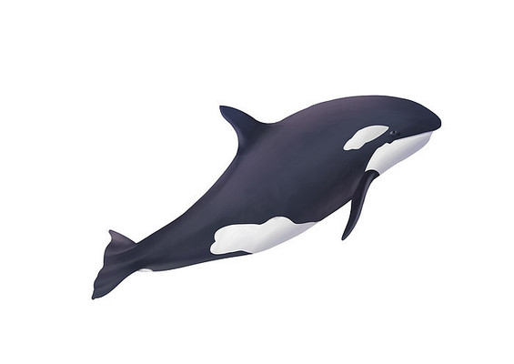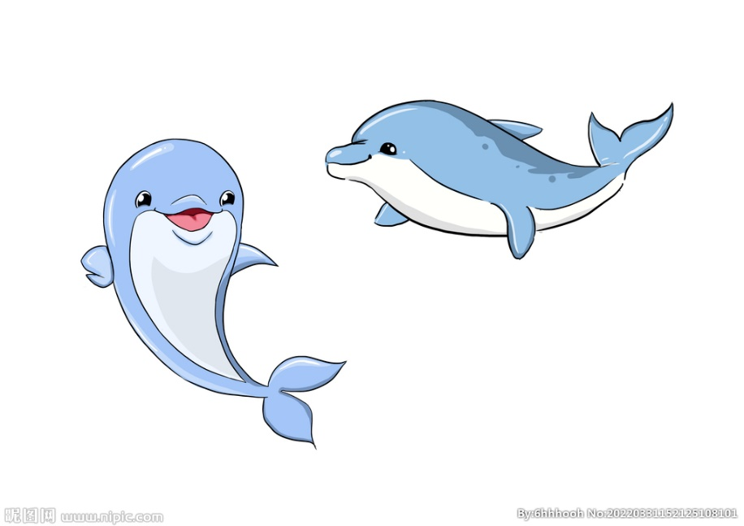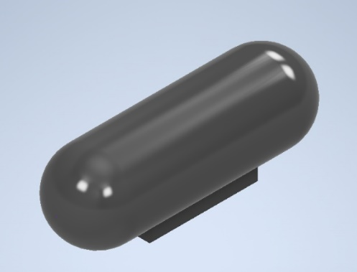

**Whale[j2]**

**Weight:** 6~8 tons

**Length:** 6~9 meters

**Fluid drag coefficient (C):** 0.015

**Our Submarine Model**

**Weight:** 16 tons

**Length:** 6 meters

**Fluid drag coefficient (C):** 0.03

**Dolphin[j1]**

**Weight:**30~14000 kg

**Length:** 1.2~4.2 meters

**Fluid drag coefficient (C):** 0.008