CIDA CONSULTING CENTER: STyles document

Project title:  
Submitted to: Client names, department, school or organization  
Report prepared by: Biostatistician’s names, CIDA information  
Date:

# Introduction

Provides concise description of the key elements of the objectives, design, methods and analysis

## Level Two Header

here is a table

|  |  |  |
| --- | --- | --- |
| Variable | Description.Values | Type |
| Primary Outcome |  |  |
| FEV1 | Pre-bronchodilator Forced Expiratory Volume at 1 second. There are many observations for each individual ranging from 1 – 18. Some individuals have observations extending to 10 years of follow-up. Outcome will be FEV measurements at 72 months (6 year mark), or the last measurement for those with less than 6 years of follow-up. Those with only baseline measurements will be excluded. | Continuous, repeated |

### Level 3 Header

here is a plot

## `geom_smooth()` using method = 'gam' and formula 'y ~ s(x, bs = "cs")'

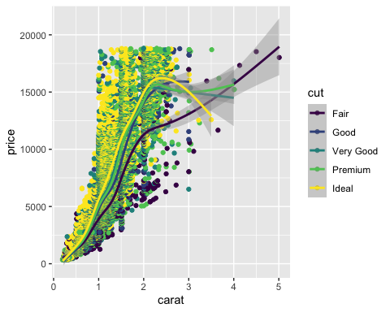

#### Level 4

blah blah blah

##### Level 5

Here is a list

* thing one
* and another
  + and an indent
* third thing
  + indent
    - indented indent

# Appedix

here is some more *Different Types* of **Text**