Report

**Project**:  
**Analyst**:  
**Investigator**(s):  
**Date**: August 11, 2020

# Project Summary

# Introduction

Introduction text, here is a reference: [1].

# Methods

Methods text

# Results

## Descriptive Statistics

Tables/Figures/Results section

*Figure 1* 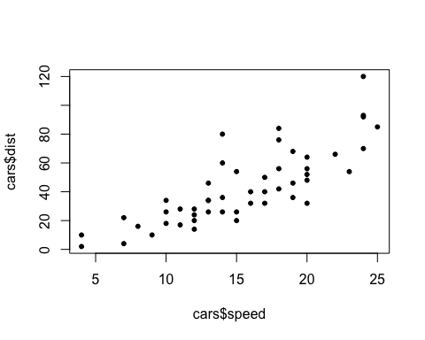

*Table 1*

|  |  |  |  |  |
| --- | --- | --- | --- | --- |
|  | Group 1 (N=25) | Group 2 (N=25) | Total (N=50) | p value |
| **speed** |  |  |  | 0.752 |
| Mean (SD) | 15.160 (5.289) | 15.640 (5.384) | 15.400 (5.288) |  |
| Range | 4.000 - 24.000 | 4.000 - 25.000 | 4.000 - 25.000 |  |
| **dist** |  |  |  | 0.901 |
| Mean (SD) | 43.440 (27.878) | 42.520 (24.045) | 42.980 (25.769) |  |
| Range | 2.000 - 120.000 | 10.000 - 93.000 | 2.000 - 120.000 |  |

## Main Analysis

# Conclusions

Interpretations, discussion

# References

# Appendix

[1] Buuren, S. van and Groothuis-Oudshoorn, K. (2010). Mice: Multivariate imputation by chained equations in r. *Journal of statistical software* 1–68.