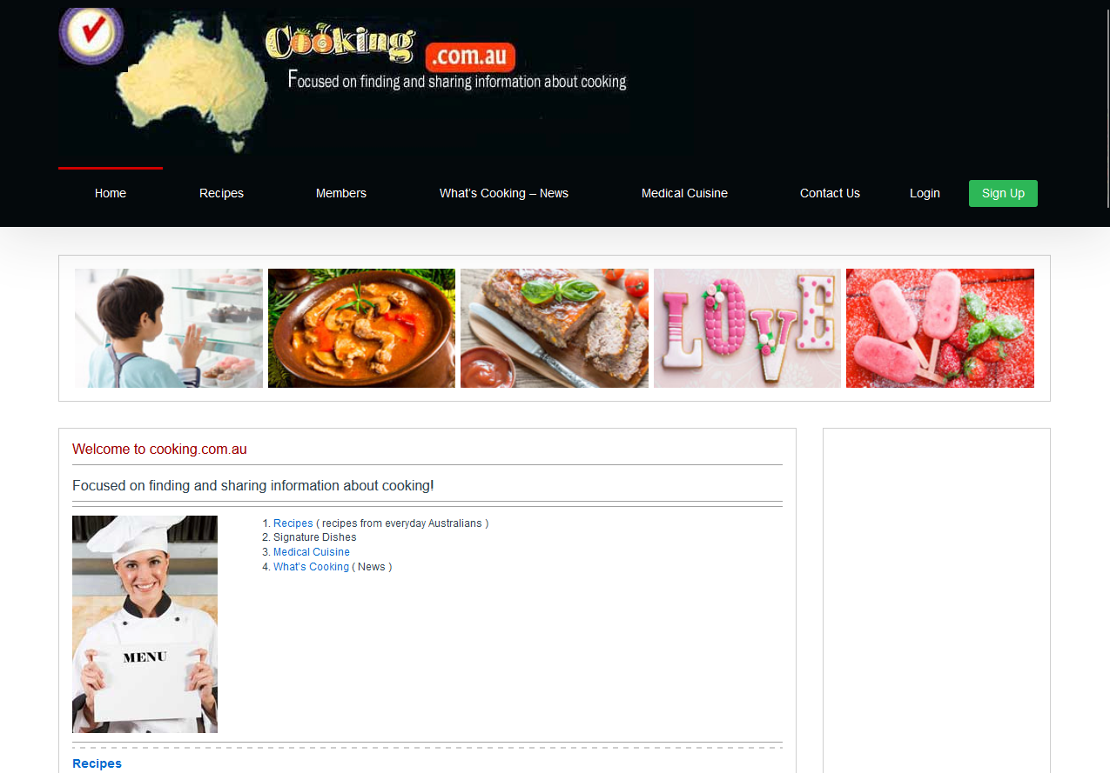

I like the simplicity of the website and it's easy to navigate around. I will be making some changes once I finalise the login and signup pages.

