Student Result Management System Using Python

STUDENT NAME:
Andrew Deen Will

COURSE:
Scientific Programming

DEPARTMENT:
(B.Sc. Computer Science)

INSTITUTION:
(Njala University, Njala Campus)

LECTURER:
(MR. WARRITAY)

DATE:
26/06/2026

ABSTRACT

This project presents the development of a Student Result Management System using Python programming language and SQLite database. The traditional method of managing student results manually is often associated with errors, delays, and inefficiency. The aim of this project is to design and implement a computerized system that automates the process of managing student academic records.

The system allows users to add, search, update, delete, and view student records. It also automatically calculates total marks, average scores, and assigns grades based on performance. Python was chosen due to its simplicity and flexibility, while SQLite was used for efficient data storage.

The system improves accuracy, reduces workload, and enhances data management in academic institutions. The project demonstrates how programming can be applied in solving real-world educational problems.

Table of Contents
CHAPTER ONE: INTRODUCTION 4
1.1 Background of the Study 4
1.2 Problem Statement 4
1.3 Aim of the Study 4
1.4 Objectives of the Study 4
1.5 Significance of the Study 4
1.6 Scope of the Study 5
CHAPTER TWO: LITERATURE REVIEW 6
CHAPTER THREE: METHODOLOGY 7
3.1 System Design 7
3.2 Tools Used 7
3.3 System Flow 7
CHAPTER FOUR: IMPLEMENTATION 8
Figure 4.1: Main Menu Interface 1 8
Figure 4.2: Add Student Module 1 8
Figure 4.3: Search Student Interface 1 8
Figure 4.4: View All Students Interface 1 8
CHAPTER FIVE: CONCLUSION AND RECOMMENDATIONS 10
5.1 Conclusion 10
5.2 Recommendations 10

CHAPTER ONE: INTRODUCTION

1.1 Background of the Study

Student result management is an essential part of academic institutions. Traditionally, results are managed manually, which leads to errors, delays, and data loss. With the advancement of technology, computerized systems have been introduced to improve accuracy and efficiency.

This project focuses on developing a Student Result Management System using Python and SQLite.

1.2 Problem Statement

Manual result management has several challenges:
* Errors in calculation
* Difficulty in updating records
* Data loss
* Slow processing of results

1.3 Aim of the Study

To develop a computerized system for managing student results efficiently.

1.4 Objectives of the Study

* To design a student result system
* To automate grade calculation
* To store student data using a database
* To allow searching, updating, and deleting records

1.5 Significance of the Study

This system helps schools and institutions to:

* Reduce workload
* Improve accuracy
* Save time
* Manage student data efficiently

1.6 Scope of the Study

The system covers:

* Student registration
* Result entry
* Grade calculation
* Data storage and retrieval

CHAPTER TWO: LITERATURE REVIEW

Student result management systems are widely used in educational institutions. They improve efficiency by replacing manual processes with automated systems.

Python is widely used in system development because of its simplicity and flexibility. SQLite is used as a lightweight database for storing records.

CHAPTER THREE: METHODOLOGY

3.1 System Design

The system is developed using Python programming language and SQLite database.

3.2 Tools Used

* Python programming language
* SQLite database
* VS Code or IDLE

3.3 System Flow

1. Enter student details
2. Calculate total and average
3. Assign grade
4. Store data in database
5. Display or manage records

CHAPTER FOUR: IMPLEMENTATION

The system allows users to:

* Add student records
* Search students by ID
* Update student data
* Delete student records
* View all students

Figure 4.1: Main Menu Interface 1
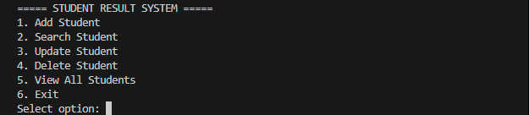

Figure 4.2: Add Student Module 1
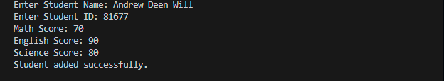

Figure 4.3: Search Student Interface 1
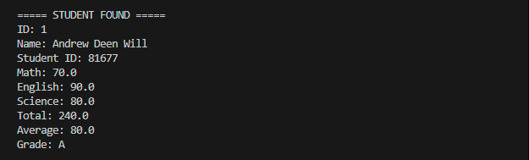

Figure 4.4: View All Students Interface 1

Features:

* Menu-driven system
* Database storage
* Automatic grade calculation

CHAPTER FIVE: CONCLUSION AND RECOMMENDATIONS

5.1 Conclusion

The Student Result Management System successfully improves the process of managing student records by automating calculations and storing data efficiently.

5.2 Recommendations

* Future systems should include web-based interfaces
* Mobile access should be added
* Security features should be improved

