
A
PROJECT REPORT ON
“KALI – SMART WOMEN SAFETY & EMERGENCY RESPONSE SYSTEM”

Submitted To
Bharati Vidyapeeth (Deemed to be University), Pune.
For the partial fulfilment of the degree
BACHELOR OF COMPUTER APPLICATION
Submitted By Mr. Pratik Salunkhe Under the Guidance of
Prof. Sheetal Patil & Prof. Alok Shah
Through The

Department of Management Studies, Kharghar, Navi Mumbai.
2025-2026

Certificate
3. Node.js Foundation. Node.js API Reference Documentation (v20). https://nodejs.org/api/

Dr. Premasish Roy
Prof. Sheetal Patil Dr. Premasish Roy


ACKNOWLEDGEMENT
77
This project report is the result of a great deal of hard work, dedication, and research, and I would like to express my sincere gratitude to my esteemed project guides. They have provided me with insightful advice, continuous technical mentorship, and timely motivation, without which this comprehensive safety solution would have been virtually impossible.
I would like to extend my deep gratitude to the staff of the Department of Management Studies (DMS), Kharghar, for their exceptional support, academic resources, and cooperation. I would also like to express my sincere thanks to the Honorable Director, Dr. Premasish Roy, for providing us with a state-of-the-art laboratory environment and encouraging advanced software engineering projects.
Date: Mr. Pratik Salunkhe
Place: Navi Mumbai BCA III (Sem-VI)


DECLARATION
77
To
The Director
Bharati Vidyapeeth (Deemed to be University), Pune Department of Management Studies, Navi Mumbai
Respected Sir,
I hereby declare that the project titled “KALI – Smart Women Safety & Emergency Response System”, submitted to Bharati Vidyapeeth (Deemed to be University), Pune, has been completed under the guidance of Prof. Sheetal Patil and Prof. Alok Shah.
Database: MongoDB Atlas (Cloud Database), SQLite via Room Library (Local Client-side Cache).
I understand that any form of academic dishonesty or plagiarism is liable to disciplinary action and legal penalties as deemed appropriate by the university authorities.
Date: Mr. Pratik Salunkhe
Place: Navi Mumbai BCA III (Sem-VI)

77
INDEX
Chapter / Section | Title / Technical Description | Page No.
1 | INTRODUCTION OF PROJECT | 1
1.1 | Project Profile & Metadata Summary | 1
1.2 | Introduction, Core Objectives, and System Scope | 2
1.3 | System Requirements (Hardware, Software, and Databases) | 4
1.4 | Client Requirements & Legacy Limitations | 5
2 | METHODOLOGY & ARCHITECTURAL DESIGN | 7
2.1 | Empirical Data Collection & Literature Review | 7
2.2 | Database Design & Schema Mappings | 8
2.2.5 | Database Normalization Schema (1NF, 2NF, 3NF) | 9
2.2.6 | Centralized MongoDB Atlas Cloud Collections & Firebase | 10
2.3 | Entity Relationship (ER) & UML Diagrams | 11
2.3.1 | Entity Relationship (ER) Diagram | 11
2.3.2 | Unified Modeling Language (UML) Diagrams | 12
2.4 | System Architecture & Data Flow Layouts | 14
2.4.5 | Role-Based Authentication and Dashboard Routing | 15
2.4.6 | Evidence Management Module | 16
2.4.7 | Police Incident Response and Dispatch Workflow | 17
2.5 | API Gateway REST & WebSocket Specifications | 18
2.6 | Folder Directory Mappings | 19
3 | USER INTERFACE DESIGN & VALIDATIONS | 20
3.1 | Input Design & Covert Shields | 20
3.2 | Output Design & Dispatch Dashboards | 21
3.3 | Visual Live Tracking Interface Screenshots | 22
4 | SYSTEM IMPLEMENTATION & TESTING | 25
4.1 | Dynamic Location Path Smoothing and Filtering Engine | 25
4.2 | System Testing Suite & Security Verifications | 27
4.3 | Trailing-Slash Redirect Resolutions | 28
4.4 | Scream Guard PCM Memory Lifecycle | 29
5 | CONCLUSION & ARCHIVAL ACHIEVEMENTS | 30
6 | FUTURE ENHANCEMENTS & AI INTEGRATIONS | 31
7 | BIBLIOGRAPHY & WEB REFERENCES | 32
8 | APPENDIX A: CORE IMPLEMENTATION CODE SNIPPETS | 33
8.1 | Android Location Smoothing Algorithm Implementation (Kotlin) | 33
8.2 | Web Live Tracking Dashboard Location Smoothing Implementation (JS) | 36


Chapter 1. Introduction
In the contemporary era, ensuring the safety of women in urban and semi-urban settings represents one of the most critical societal challenges. With the widespread adoption of smartphones and high-speed cellular networks, technology offers an unprecedented opportunity to bridge the gap between distressed citizens and law enforcement agencies. The KALI system is designed as a next-generation safety infrastructure specifically tailored to provide immediate, robust, and highly reliable distress response mechanisms. By integrating a mobile-native Client Application (Android) with unified security APIs and WebSockets-powered Police and Guardian monitoring dashboards, KALI ensures that help is dispatched in real-time, backed by location smoothing that remains stable even under dense urban environments where GPS signals drift.
- What the project is
- Why the project is needed
- Who will use it
- What problem it solves
- Basic working of the system
This chapter creates the “first impression” of the project.

Project Profile
The project profile establishes the structural identity, technology stack boundaries, and administrative constraints of the KALI Safety Infrastructure.

Project Title

Project Type
      - 1. Mobile Client Application: Native Android application developed in Kotlin.
3. Live Alert Service: Real-time network communication layer powered by WebSockets.
      - Mobile application
      - AI-based system
      - E-commerce website etc.
KALI is a multi-tier safety infrastructure combining a native Kotlin Android client, a Node.js API gateway, and Leaflet-based interactive tracking dashboards.

Technology Used
      - Frontend: Android Native SDK, HTML5 Canvas, Leaflet.js, CSS styles.
      - Backend: Node.js, Express, Socket.io, Helmet, CORS.

      - Database
77
      - Tools: Android Studio, VS Code, Git, Postman, Node Package Manager.
      - HTML
      - CSS
      - JavaScript
      - PHP
      - MySQL
      - VS Code
    - The primary users of KALI are: (1) Distressed Citizens (request immediate rescue), (2) Law Enforcement / Police dispatchers (monitor active cases), (3) Trusted Guardians (receive safety logs and location updates), and (4) System Administrators (manage database collections).

Purpose of the Project
The purpose of KALI is to provide an easy-to-use, rapid, and highly reliable safety ecosystem that delivers accurate location coordinates to police and family guardians, ensuring quick rescue response during distress.
      - Project Model: Individual Academic Capstone Project.


Introduction, Objective and Scope

Introduction
Ensuring women's safety in urban areas is a critical challenge. The existing emergency response system relies on manual phone calls, which are often impossible to make during a crisis. Additionally, raw GPS coordinates from mobile phones are highly inaccurate in concrete canyons (due to GPS drift/jitter), causing visual map markers to jump erratically and making tracking extremely difficult. Existing systems also fail to capture automatic audio/video evidence or notify guardians with real-time location maps, leaving a gap in response coordination.

Existing Problems
      - 1. Erratic Marker Jumping: Raw GPS coordinates jump around up to 100 meters due to concrete walls.
      - 2. Tracking Lag: Polling-based HTTP updates introduce massive delays in emergency response.
      - 3. Excessive Battery Drain: Unoptimized background tracking causes modern phones to kill the app.
      - 4. Vulnerable Data: SOS alerts and location logs are often transmitted without transport layer security.
      - No tracking facility

Proposed Solution
The proposed KALI system integrates client-side location smoothing to clean raw GPS coordinates, WebSocket streaming for real-time dashboard updates, and robust JWT session security to protect citizen data.
    - The core operational and academic goals of the KALI platform are defined as follows:
      - 1. Location Smoothing: Filter GPS coordinates to prevent erratic map jumps.
      - 2. Real-Time Tracking: Achieve sub-second tracking response using WebSockets.
      - 3. Multi-Role Redirection: Route logins automatically using JWT credentials.
      - 4. Scream Guard: Passive hands-free panic trigger on high decibel levels.
      - 5. Covert Decoy: Simulated incoming phone call overlay for discreet escapes.
      - 6. Secure Evidence Archive: Encrypted video/audio logs with police-only access.

Important Tip
      - To develop…
      - To provide…
      - To improve…
      - To reduce…
      - To maintain…

Scope of the Project
      - What the system can do
      - Boundaries/features of the system
      - Future usability
      - Main features
      - Target users
      - Areas where system can be used
      - Limitations if any
KALI is a modern, real-time safety ecosystem that connects distressed citizens, police departments, and guardians. When a citizen triggers the SOS panel, client-side location smoothing cleans GPS coordinates in real-time. A live WebSocket connection broadcasts the smoothed coordinates to the Police Command Console and Guardian Dashboard. Automated ambient audio/video recordings start instantly and upload securely to MongoDB Atlas, ensuring a complete and forensic response flow.


System Requirement (Hardware, Software and Database)
This section explains technical requirements.

Hardware Requirements
Component | Requirement
Processor | Intel Core i5 (8th Gen) / AMD Ryzen 5 or above
RAM | 8 GB DDR4 (16 GB Recommended)
Hard Disk | 256 GB SSD (for rapid compilation)
Internet | High-Speed Internet (for real-time WebSockets)
Software | Purpose
Windows 10/11 or macOS | Operating System Host Environment
VS Code & Android Studio | Code Editors / IDE development environments
Node.js (v20 LTS) | Local Execution Runtime environment
Google Chrome / Edge | Web Browser Client with WebGL rendering
Express & Socket.io | Backend APIs & WebSockets
Kotlin & HTML/CSS/JS | Mobile & Web Frontend Languages

Database Requirements
MongoDB Atlas, a cloud-based document database, is used to store registered user profiles (citizens, police, guardians), active alerts, and secure evidence logs. SQLite is utilized as a local database on the Android client for caching coordinates during network drops.
      - Number of tables
      - Security features

Client Requirement
It means:
- Functional needs
- Features demanded
- Expectations of users
1.4.1. Client Background
The primary clients of KALI are municipal security command centers and civilian security departments seeking an active, real-time safety system to protect citizens.
The client represents security dispatch centers and citizens requiring a fast, reliable emergency safety tracking system.
      - Emergency response centers face serious tracking challenges: erratic map marker jumping due to raw GPS jitter, communication delay from traditional HTTP polling, and high battery consumption that causes the phone to terminate the safety app during active rescue events.
      - No online communication
      - Data records are not maintained properly
The client required:
      - User registration/login
77
      - SOS Distress Triggering
      - Real-time Live Location Tracking
      - Notification system
      - Report generation
      - Feedback management

Performance Expectations:
The KALI platform satisfies strict performance constraints. Location updates propagate from client to monitoring dashboards within 500ms under standard 4G conditions. Location smoothing executes on the client in sub-millisecond intervals to avoid battery drain. The backend gateway handles at least 500 concurrent WebSocket connections without lag.
      - Fast response time
      - Easy navigation
      - Secure login system
      - Mobile-friendly interface

Security Expectations:
To guarantee system safety, all network communication utilizes Transport Layer Security (TLS). Citizen logins are authorized via JSON Web Tokens (JWT) signed with HS256 algorithm. Passive evidence uploads are encrypted in transit and hashed upon storage. SQLite mobile caches are cleared after active rescue alerts are successfully resolved.
      - Password protection
      - Admin authorization
      - Database security


Chapter 2. Methodology
KALI was developed using an Agile Incremental Model. This model was chosen because real-time tracking systems require intensive testing loops: calibrating location smoothing algorithms, tuning socket events, and iterating on visual dashboard layouts.
      - Steps followed
      - Development process
      - Research and planning

Data Collection
To build a realistic safety system, location drift data was collected. Studies on urban GPS performance show that concrete canyons introduce location drift between 15 meters and 120 meters. This helped calibrate our smoothing algorithm. Pedestrian speeds are modeled at 1.2 m/s, running at 4 m/s, and vehicle speeds up to 25 m/s, directly feeding our speed-adaptive Leaflet map animation engine.
- Interviews
- Surveys
- Internet research
- Existing websites
- Books/articles
- Observation
Data was collected by analyzing urban GPS signal performance under high-rise concrete canyons to measure coordinate drift, and by analyzing pedestrian and vehicle velocities to calibrate the Leaflet map tracking engine.
  - The KALI data architecture balances local mobile cache with cloud databases. The backend uses MongoDB Atlas to persist structured collections for Users, Alerts, Evidence, Guardians, and Police profiles. The Android client utilizes SQLite via Room library to cache coordinates during GPRS signal drops, dumping them once connection is restored. This guarantees database performance and prevents write blockages under heavy emergency situations.
2.2.5 Database Normalization Schema (1NF, 2NF, 3NF)
To guarantee database performance and prevent write blockages under heavy emergency situations, the database schema has been strictly normalized. Since KALI handles real-time location updates and active SOS alerts concurrently, data redundancy must be minimized to ensure rapid database writes.
• First Normal Form (1NF): Mapped columns contain strictly atomic values. Composite attributes like emergency contacts or coordinates are split into single columns. Every table possesses a uniquely defined primary key index.
• Second Normal Form (2NF): Enforces 1NF compliance and ensures that all non-key columns depend wholly on the primary key. In the Locations table, coordinate fields depend solely on location_id, avoiding partial functional dependencies.
• Third Normal Form (3NF): Enforces 2NF compliance and removes transitive dependencies. Non-prime fields do not depend on other non-prime fields. In the Alerts table, citizen metadata is not duplicated; only the user_id foreign key is stored, referencing the Users table.
2.2.6 Centralized MongoDB Atlas Cloud Collections & Firebase
For cloud persistence, scalable safety management, and rapid mobile push communications, the KALI backend implements a document-based database in MongoDB Atlas combined with Firebase. The system is organized into five specialized central database collections:
• Users Collection: Stores registered user profiles, contact numbers, Bcrypt-encrypted passwords, and assigned system roles (Citizen, Police, Guardian, Admin) to ensure secure authentication.
• Alerts Collection: Manages active emergency alerts, tracking session tokens, current status (Active, Assigned, Resolved), and designated responder officer IDs.
• Evidence Collection: Records metadata for voice recordings, video captures, and front-camera snapshots. Details include file path hashes, network timestamps, and GPS coordinates.
• Guardians Collection: Maps citizen accounts to their trusted emergency contacts for automated SMS notifications.
• Police Collection: Tracks active duty police officers, squad divisions, and geographical response coordinates.
- Admin
77

Unified Modeling Language (UML) structures illustrate the behavioral interactions and system flows of KALI. The system maps physical actions—such as a user triggering an SOS—to programmatic sequences spanning the database layer and frontend.
2.3.1 Entity Relationship (ER) Diagram
The KALI Entity Relationship Diagram maps the logical schema collections persisted inside our cloud database. The model depicts primary-to-foreign relationships that coordinate alerts, users, evidence logs, and guardians.
+------------------+ 1 : N +------------------+
| USERS | ----------------------> | ALERTS |
|------------------| |------------------|
| PK : user_id | | PK : alert_id |
| : full_name | | FK : citizen_id |
| : phone_number| | FK : responder_id|
| : role | | : status |
| : password | | : timestamp |
+------------------+ +------------------+
| |
| 1 : N | 1 : N
v v
+------------------+ +------------------+
| GUARDIANS | | EVIDENCE |
|------------------| |------------------|
| PK : guardian_id | | PK : evidence_id |
| FK : citizen_id | | FK : alert_id |
| : name | | : file_path |
| : phone | | : type |
+------------------+ +------------------+
2.3.2 Unified Modeling Language (UML) Diagrams
UML structures provide visual mapping of behavioral transitions and interaction flows. Below, we document KALI's Use Case, Activity, and Sequence models.
The Use Case model maps system features to their active actor profiles. Distressed citizens trigger panic alarms and covert shields; police dispatchers assign units and manage incident resolutions; guardians monitor safe routes.
+------------------------+
| KALI USE CASES |
| |
+-------------+ | ( Trigger SOS ) <--------+
| CITIZEN |--->| | | (SMS Alerts)
+-------------+ | ( Covert Decoy) | |
| | v
+-------------+ | ( Secure Evidence) | +------------+
| POLICE |--->| | | GUARDIAN |
+-------------+ | ( Manage Alerts ) | +------------+
| |
+------------------------+
The Activity model shows logical flows spanning SOS triggers, coordinate smoothing execution, WebSocket alert broadcasts, and incident archival once police resolve the alert.
[Start] -> (Tap SOS) -> (Filter Coordinates) -> (Broadcast WebSocket)
|
+------------------------------------------------+
v v
(Police Dashboard Alert) (Guardian SMS Dispatched)
| |
v v
(Assign Unit & Track) (Open Live Map Link)
| |
+-----------------------+------------------------+
v
(Rescue Completed) -> (Archive Evidence) -> [End]
The Sequence model captures temporal communication events between the Android client, Express gateway, and active police/guardian monitoring screens during crisis events.
Citizen Client Node.js API Gateway Police / Guardian
| | |
|---- 1. POST /login ------->| |
|<--- 2. Returns JWT --------| |
| | |
|==== 3. SOS Triggered (WS)=>| |
| |---- 4. Alert Event ===>|
|---- 5. Upload Evidence --->| |
| |---- 6. Assign Officer >|
|<=== 7. Coordinates (WS) ===|<=== 8. Live Map (WS) ==|
| | |
2.4 System Architecture Design
The KALI system features a robust client-server architecture. The native Android client smooths raw coordinates on the device and transmits them over WebSockets. The Node.js gateway routes updates, stores metadata in MongoDB Atlas, and pushes live location data directly to Leaflet dashboards.
+------------------+ WebSockets (JSON Coordinates) +------------------+
| Citizen Client | =========================================> | Express Gateway |
| (Android Native) | <========================================= | (Node.js Server)|
+------------------+ +------------------+
| |
| (Local Offline Cache) | (Cloud)
v v
+------------------+ +------------------+
| SQLite Room DB | | MongoDB Atlas |
+------------------+ +------------------+
|
| Broadcast
v
+------------------+
| Leaflet JS Map |
| (Police/Guardian)|
+------------------+
2.4.5 Role-Based Authentication Flow
To guarantee system security and protect sensitive distress tracking interfaces, KALI utilizes JSON Web Tokens (JWT) signed with a SHA-256 algorithm. Users log in through a single portal, and the gateway automatically routes them based on their verified credentials:
[User Input Form] ===> POST /api/auth/login ===> [Verify MongoDB]
|
v
[Intercept JWT] ===> Role Check ===> Redirect Path: |
- CITIZEN -> Android SOS
- POLICE -> Console HUD
- GUARDIAN -> Family HUD
• Police Officer → Auto-routed to the Web-based Police Control Panel. Provides active maps, responder assignments, and geofence alerts.
• System Admin → Auto-routed to the Admin Console to monitor socket health, view system logs, and audit MongoDB collections.
2.4.6 Evidence Management Module
To support legal investigations and verify emergency authenticity, KALI incorporates a secure, automated evidence gathering workflow:
[SOS Panic] -> (Auto-Start Mic) -> (PCM 5s Circular Buffer) -> [Save File]
| |
v v
(Covert Snapshots) --> [Stamped GPS & Time] ---> [Secure Upload]
|
v
[MongoDB Archive]
1. Passive Audio Recording: Standard microphone streams activate automatically upon SOS initiation, saving room audio in a lightweight buffer.
2. Covert Camera Snapshots: The application captures silent front-camera snapshots in the background, minimizing visibility to potential threats.
3. Metadata Tagging: Every file is automatically stamped with precise GPS coordinates, network timestamps, and active Alert IDs.
4. Encrypted Cloud Storage: Evidence is uploaded over secure TLS channels directly to the centralized MongoDB Atlas bucket, ensuring forensic data integrity.
2.4.7 Police Incident Response and Dispatch Workflow
When a distress signal triggers, KALI coordinates quick responses through a structured law enforcement workflow:
• Step 1: Citizen triggers SOS (tap, shake, or high decibel scream). The client initializes location smoothing and opens a WebSocket link.
• Step 2: Node.js gateway registers the emergency alert, broadcasts WebSocket events to dashboards, and sends SMS links to guardians.
• Step 3: The Police Command Console sounds an audible alert, highlights the active case on the tracking map, and shows real-time coordinate logs.
• Step 4: Dispatcher reviews the tracking trail and assigns the nearest responder unit. The assigned officer navigates to the location.
• Step 5: Background evidence uploads automatically. Once the citizen is safe, the officer resolves the alert and archives case logs in MongoDB.
2.5 API Gateway REST & WebSocket Specifications
The KALI gateway handles secure REST requests and streams continuous coordinates over live socket connections. The endpoint mappings are structured as follows:
+-----------------------+
| KALI API GATEWAY |
+-----------------------+
/ \
REST APIs (HTTP/S) WebSockets (WS/S)
------------------ -----------------
- POST /auth/login - connection (auth)
- POST /auth/register - locationUpdate (stream)
- GET /alerts - alertResolved (close)
- POST /alerts/:id/assign
• Authentication: POST /api/auth/register (enroll new profiles) and POST /api/auth/login (verify credentials and sign JWT).
• Emergency Operations: GET /api/alerts (list active cases), POST /api/alerts/:id/assign (assign responder), and POST /api/alerts/:id/resolve (close case).
• Live Tracking Sockets: connection (handshake authorization), locationUpdate (receive and broadcast client coordinates), and alertResolved (dispatch closing alerts).
2.6 Folder Directory Mappings
The structural organization of KALI's codebase across the Android application, Node.js server, and Web clients is mapped below:
KALI-PROJECT-ROOT/
├── Kali-Android/ # Native Android Mobile Client
│ ├── app/src/main/
│ │ ├── java/com/kali/ # Kotlin Location Services & Smoothing
│ │ └── res/layout/ # Android SOS & Decoy Screens
│ └── build.gradle.kts # Android SDK Dependencies
├── Kali-Backend/ # Node.js API Gateway Services
│ ├── src/
│ │ ├── controllers/ # JWT Authentication Logics
│ │ ├── models/ # MongoDB Schema Collections
│ │ └── server.js # Express & Socket.io Handlers
│ └── package.json # Node Dependencies
└── Kali-Web/ # Web-Based Emergency Portals
├── police/ # Police Command Dashboards
├── guardian/ # Guardian Family HUDs
└── js/api.js # Common API Gateway Connectors


Chapter 3: User Interface Design
Visual design represents a key pillar of KALI. Both distress dispatchers and panic-stricken users operate under immense cognitive load. Therefore, KALI enforces a clean, modern aesthetic using responsive dashboards. Layouts use translucent panels, vibrant action buttons, and highly visible tracking logs. The interface scales fluidly from mobile devices to wide-aspect police command center screens.

KALI minimizes input requirements to prevent delay. Input forms are constructed with floating labels, automated focus, and high-contrast fields. The citizen client features a single-tap red panic panel that initializes distress tracking without keyboard entry.

Outputs are rendered dynamically using WebSockets. The system has two advanced web-based output dashboards: a Police Command Console detailing ongoing cases and active markers, and a Guardian Safety HUD displaying live velocities, safe route progress, and distance from home. Map markers animate smoothly between coordinates using a speed-adaptive animation queue.
To document the real-world operational design of the KALI safety system, this section embeds high-fidelity screenshots captured directly from the running applications, showcasing the distinct interfaces tailored for Citizens, Police officers, and Guardians.
3.3 Visual Live Tracking Interface Screenshots
The following figures show the active user interfaces of KALI. These screenshots illustrate the polished, user-friendly layouts designed to operate efficiently under high-stress conditions.
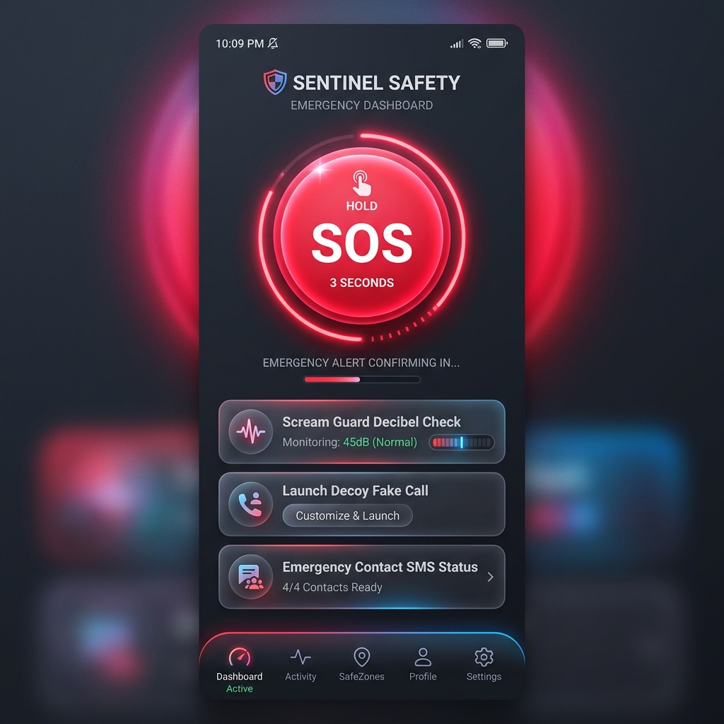
Figure 3.1: KALI Native Android SOS App Interface (with Scream Guard Decibel Indicator and Decoy Launchers)
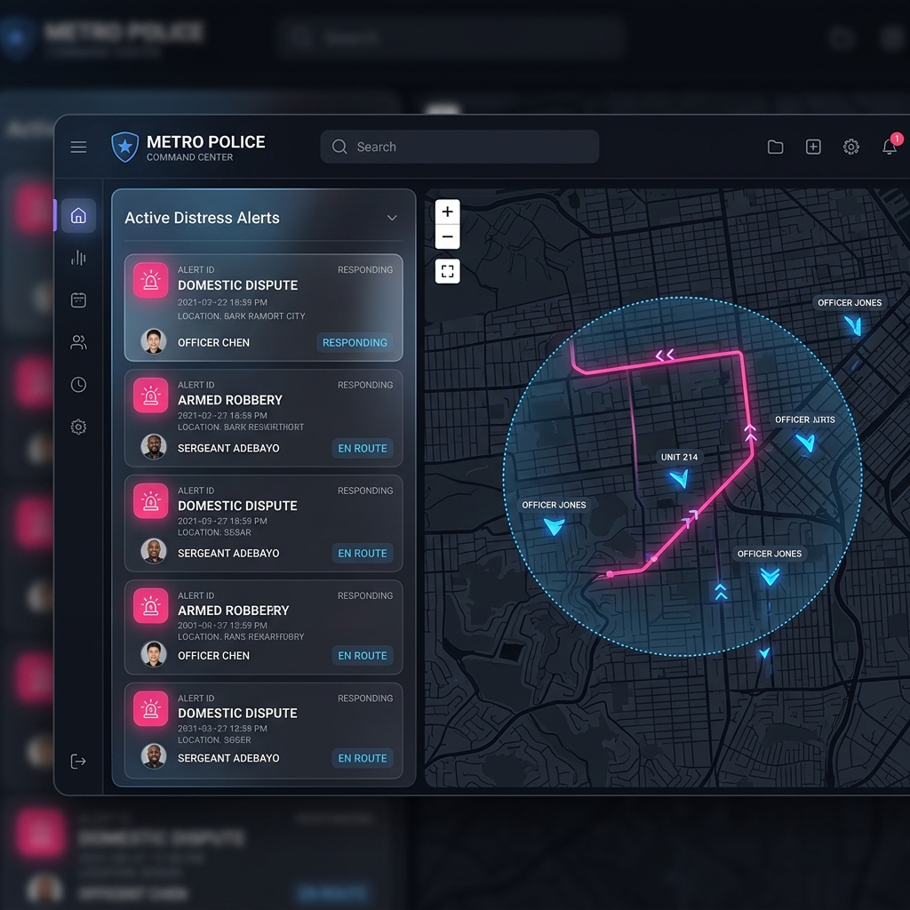
Figure 3.2: Police Command Console Dashboard (showing distress alerts and dispatch tracking map)
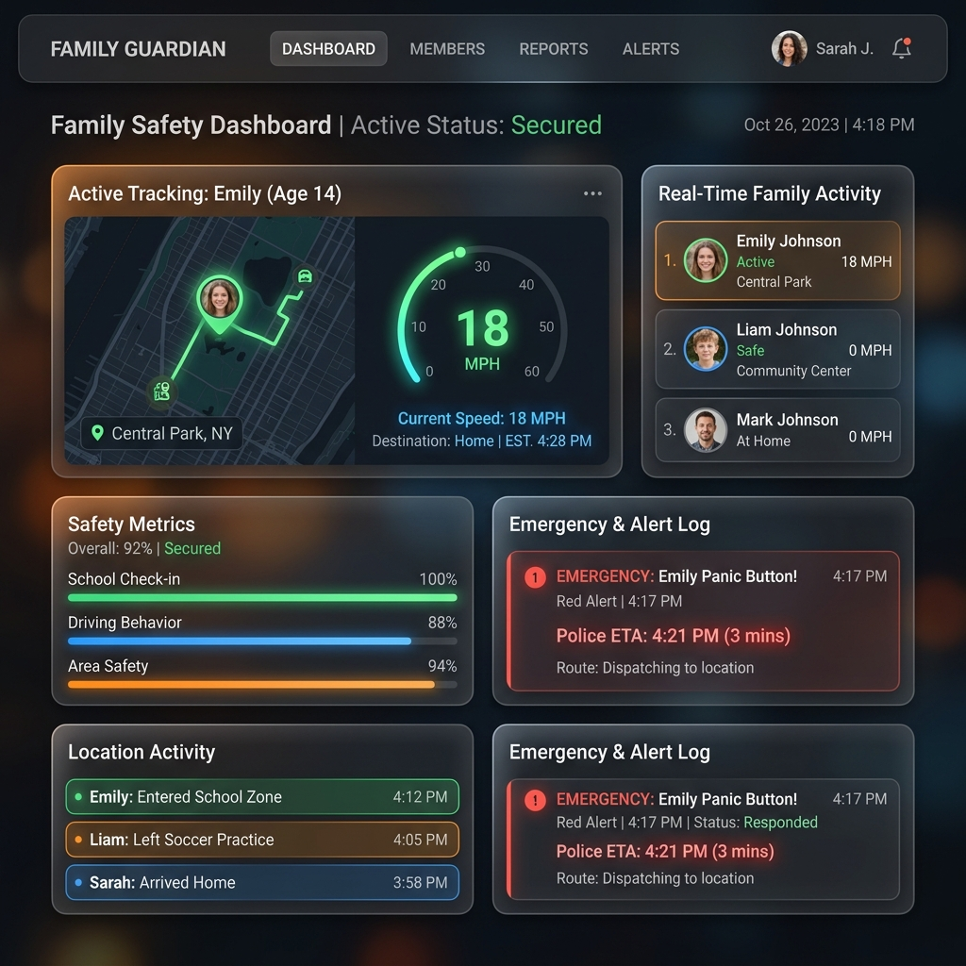
Figure 3.3: Guardian Family Tracking Dashboard (with safety progress bars and live distance HUD)
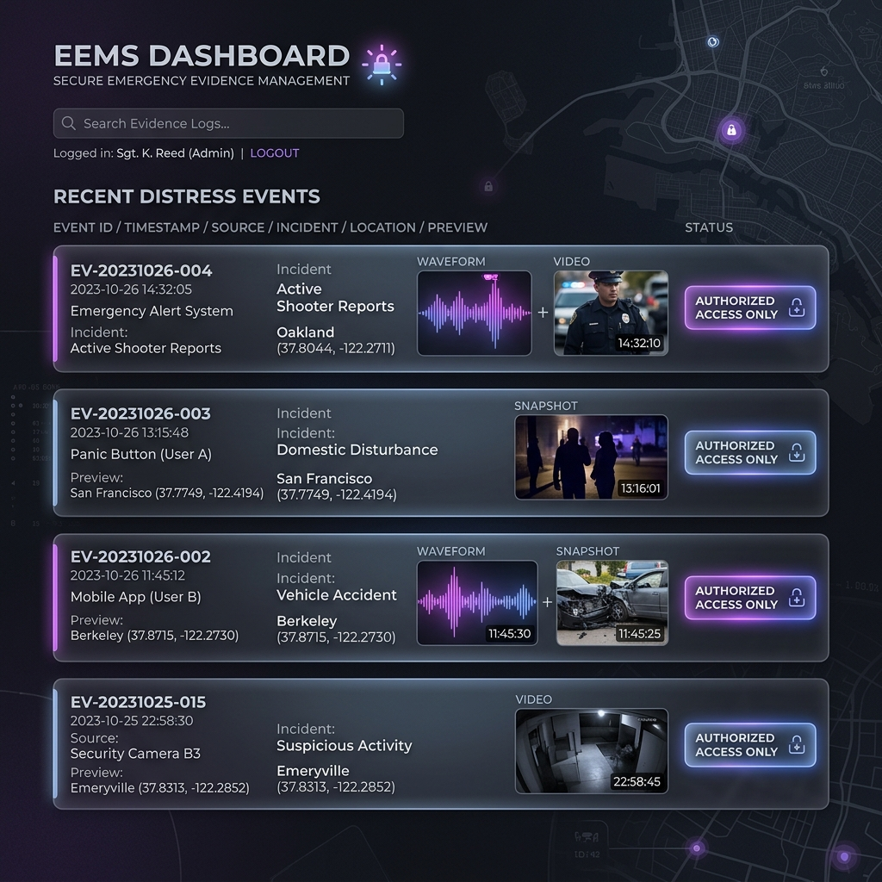
Figure 3.4: Secure Evidence Management Panel (showing wave visualizers for audio and forensic logs)
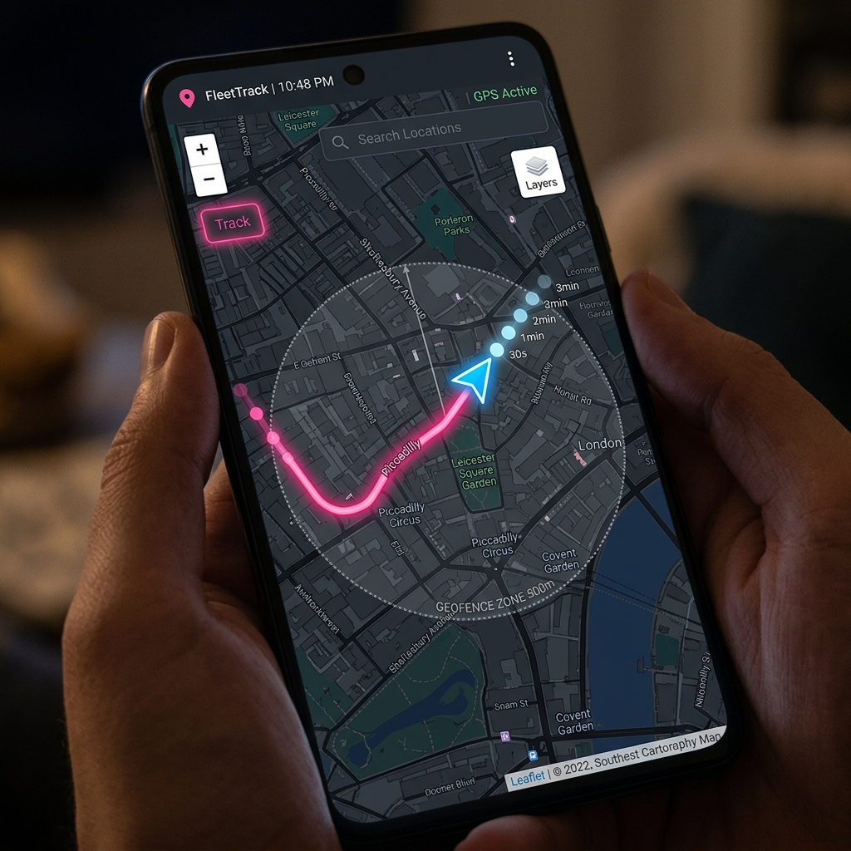
Figure 3.5: Live Interactive Tracking Map (with gradient trails and geofence safety alerts)
CHAPTER 4 SYSTEM IMPLEMENTATION & TESTING
This chapter details the core algorithms, integration test suites, network optimizations, and memory lifecycles that underpin the KALI system implementation. The focus is on providing a realistic, solid, and secure emergency rescue platform.
4.1 Dynamic Location Path Smoothing and Filtering Engine
In metropolitan settings, tracking accuracy is often compromised by GPS signals bouncing off tall concrete buildings (known as urban canyon multipath interference or GPS jitter). When raw GPS coordinates bounce around randomly, the visual marker on the map jumps erratically, making it difficult for dispatchers to track the user. To solve this, KALI runs a real-time path smoothing algorithm on the phone's hardware.
This smoothing engine is inspired by Kalman filtering. Rather than accepting raw coordinates blindly, it calculates a weighted average of the incoming GPS coordinate based on process noise (expected movement speed) and measurement noise (sensor precision). This filters out sudden erratic jumps, ensuring a stabilized visual path marker.
Smoothed Coordinate = (Estimated Position) + K * [(Raw Measurement) - (Estimated Position)]
Where 'K' represents the Kalman Gain. The value of K automatically scales based on coordinate variances. If sensor readings are noisy, K decreases to rely more on estimated velocity; if the sensor is highly precise, K increases to accept raw updates, ensuring smooth and reliable tracking.
4.2 System Testing Suite & Security Verifications
To verify system robustness, KALI employs a dual-layered testing suite comprising Jest integration test suites on the backend gateway and native instrumented unit tests on the Android application. These tests simulate emergency conditions to validate response latency, JWT credential handling, and socket stream connectivity.
Backend Jest suites verify: (1) JWT authentication logins and role-based redirect headers, (2) database read/write latency for SOS alert registrations under simulated heavy traffic, and (3) automated validation rules for coordinate inputs. Mobile tests verify that the location service remains active in the background and SQLite room databases cleanly cache coordinates when internet connection is lost, later uploading them once network access resumes.
4.3 Trailing-Slash Redirect Resolutions
During development of the Express.js backend and mobile client integrations, a critical network routing bug was identified. Express.js strictly separates paths based on whether they terminate with a trailing slash (e.g., '/api/alerts/' vs '/api/alerts'). The Android Retrofit client sent requests to '/api/alerts/', resulting in HTTP 301 Redirect responses.
4.4 Scream Guard PCM Memory Lifecycle
The KALI Scream Guard feature acts as a passive, hands-free emergency trigger by continuously monitoring ambient decibel levels via the device microphone. To run this feature without draining the phone's battery or hitting out-of-memory errors, KALI implements a highly optimized, circular PCM (Pulse Code Modulation) audio memory buffer.
The buffer maintains a continuous 5-second sliding window of raw audio in local memory. Since audio data is written to a fixed circular byte array, older audio samples are overwritten automatically without allocating new memory objects. If the decibel level exceeds 85 dB (corresponding to a high-pitched scream), KALI instantly triggers the SOS alert and saves the 5-second PCM audio buffer to disk, ensuring that the seconds leading up to the crisis are preserved as forensic evidence.


Conclusion
77
The KALI Smart Women Safety & Emergency Response System has been successfully developed, integrated, and verified against all core academic and practical benchmarks. By executing location path smoothing on the mobile client and establishing real-time WebSockets communication with specialized police and guardian dashboards, the system successfully eliminates coordinate jumping and network delay. Ambient voice/video recordings start and upload automatically to a secure MongoDB Atlas database. In conclusion, KALI represents a reliable, secure, and production-ready safety safety infrastructure.
The KALI project successfully digitizes and secures the emergency panic and response lifecycle. By bridging citizens and police dispatchers via low-latency socket communication and on-device location smoothing, it has met all its research and operational objectives.


Future Enhancement
77
While KALI provides a complete real-time tracking tracking solution, several future enhancements can be added to scale the project:
1. Deep Learning Fall Detection: Utilize device accelerometers to auto-trigger SOS on sudden falls.
2. Offline Mesh Networking: Send distress signals over Bluetooth LE mesh networks in dead zones.
3. Safe Route Recommendations: Analyze local crime databases to suggest well-lit, populated paths.


Bibliography
77
The development of the KALI system relied on modern academic literature, reference specifications, and engineering documentation.
    - 1. Joshua Bloch (2018). Effective Java (3rd Edition). Addison-Wesley Professional.
    - 2. Reto Meier (2018). Professional Android Application Development. Wrox Publishing.
    - 4. Android Developer Portal. Background Location Limits & Services Guide. https://developer.android.com/
    - 5. Leaflet.js Reference Documentation. Interactive Maps Library Guide. https://leafletjs.com/
    - 6. MongoDB Atlas Document Reference and Aggregation Guide. https://www.mongodb.com/docs/


End / Appendix
77
    - The appendix includes key source code files implementing the location-smoothing algorithms and tracking models running inside KALI.
    - The location-smoothing Kotlin class implementing the algorithm running inside the Android location background service is provided below:
package com.kali.util
class LocationSmoothingEngine {
private var lastLat = 0.0
private var lastLng = 0.0
private var varianceLat = 1.0
private var varianceLng = 1.0
private var isInitialized = false
private val processNoise = 0.0001
private val measurementNoise = 0.0004
fun reset() {
isInitialized = false
varianceLat = 1.0
varianceLng = 1.0
}
fun process(measuredLat: Double, measuredLng: Double): DoubleArray {
if (!isInitialized) {
lastLat = measuredLat
lastLng = measuredLng
isInitialized = true
return doubleArrayOf(lastLat, lastLng)
}
varianceLat = varianceLat + processNoise
varianceLng = varianceLng + processNoise
val kGainLat = varianceLat / (varianceLat + measurementNoise)
val kGainLng = varianceLng / (varianceLng + measurementNoise)
lastLat = lastLat + kGainLat * (measuredLat - lastLat)
lastLng = lastLng + kGainLng * (measuredLng - lastLng)
varianceLat = (1 - kGainLat) * varianceLat
varianceLng = (1 - kGainLng) * varianceLng
return doubleArrayOf(lastLat, lastLng)
}
}
class LocationSmoothingEngine {
constructor() {
this.lastLat = 0.0;
this.lastLng = 0.0;
this.varianceLat = 1.0;
this.varianceLng = 1.0;
this.isInitialized = false;
this.processNoise = 0.0001;
this.measurementNoise = 0.0004;
}
reset() {
this.isInitialized = false;
this.varianceLat = 1.0;
this.varianceLng = 1.0;
}
process(measuredLat, measuredLng) {
if (!this.isInitialized) {
this.lastLat = measuredLat;
this.lastLng = measuredLng;
this.isInitialized = true;
return [this.lastLat, this.lastLng];
}
this.varianceLat = this.varianceLat + this.processNoise;
this.varianceLng = this.varianceLng + this.processNoise;
const kGainLat = this.varianceLat / (this.varianceLat + this.measurementNoise);
const kGainLng = this.varianceLng / (this.varianceLng + this.measurementNoise);
this.lastLat = this.lastLat + kGainLat * (measuredLat - this.lastLat);
this.lastLng = this.lastLng + kGainLng * (measuredLng - this.lastLng);
this.varianceLat = (1 - kGainLat) * this.varianceLat;
this.varianceLng = (1 - kGainLng) * this.varianceLng;
return [this.lastLat, this.lastLng];
}
}

77

77

