**Name:**  Karene Antoine Nassif Guirguis **Name:** Andrew Ashraf

**ID:** 21010969 **ID:** 21010313

**Game Description:**

Our Connect 4 program is a two-players game in which the players alternately drop their different colored shapes into a grid by choosing the column’s number. The shapes occupy the next available space within the column. The objective of the game is to connect-four of one’s own same color shape next to each other vertically, horizontally, or diagonally. The two players keep playing until the board is full. The winner is the player having greater number of connected-fours.

**Features:**

* **Board User Interface:** The board may be of any size, the player can change the board’s height and width by editing in the XML file choosing the number of rows and columns.
* **Drop shape in grid:** The player inputs his colored shape by choosing the column number desired and if there is an available space in that column, this shape appears in the bottom or above the last displayed one.
* **Game Mode:** Our Connect 4 program allows the player to choose the game mode: either vs another human player or vs computer.
* **Save and Load:** The game can be saved at any time to be loaded and continued whenever needed.
* **Undo and Redo:** In his turn, the player has the right to undo all played moves and make new ones OR redo them.
* **Top Players:** High Scores are updated at the end of each game and the player has access to view the number of top players he chooses.
* **Winning Announcement:** Once the board is full, the player having higher score is announced to be Winner and is asked if he wants to play again or to return to the main menu.
* **Draw Announcement:** Once the board is full and the two players’ scores are equal, Draw is announced and the players are asked if they want to play again or to return to the main menu.

**Assumptions:**

-To let the user be able to undo and redo, we assumed that he won’t enter in the XML file more than 100 rows and 100 columns.

-If the player’s new score is less than his high score, this new score will be neglected. But if it is higher than his high score, then the high score will be updated to the new greater score.

-In case of new player his score will not be considered as a new personal high score, so the new high score list won’t be printed.

**User Manual:**

This game consists of a board with horizontal rows and vertical columns. You have access to choose the height and width of the board by editing in the XML file.

One player’s pieces are ‘x’ shaped red colored, the other’s are ‘o’ shaped yellow colored. You can input your colored shape by choosing the column’s number desired and if there is an available space in that column, your shape appears in the bottom or above the last displayed one. In this way the columns start to fill up.

The objective of the game is to connect-four of one’s own same color shape next to each other vertically, horizontally, or diagonally. The two players keep playing until the board is full. The winner is the player having greater number of connected-fours.

Press 1 to Start a new game then Press 1 to choose one player or Press 2 to choose two players or Press 3 to go back.

Press 2 to Continue a previous saved game

Press 3 to View the top players

Press 4 to Quit the game

**Data Structure:**

**Structures used in the program:**

**-**Player struct: to store the data of the players

-Time struct: to store all data related to time

-State struct: to store the updates after each move

**Arrays used in the program:**

-board array:

-array array:

**Sample runs:**

* While Playing:

* Winning: Text

  Description automatically generated
* Player vs Player:

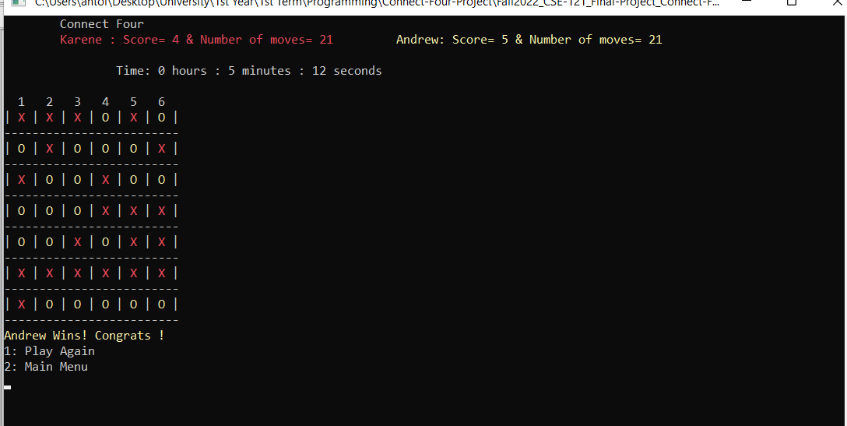

* Loosing:

* Draw:

