**Co-registration Ames Stereo Pipeline Gotcha Optimised (CASP-GO) User Guide**

*Yu Tao, Divya M. Persaud, Jan-Peter Muller, UCL/MSSL*

[*yu.tao@ucl.ac.uk*](mailto:yu.tao@ucl.ac.uk)

**Table of Contents**

INTRODUCTION 3

Pre-Installation 5

General Processing Workflow 6

CTX Processing 10

HiRISE Processing 11

Additional Notes 12

Publications 16

Acknowledgments 18

REFERENCES 19

# INTRODUCTION

The Co-registration ASP-Gotcha Optimised (CASP-GO) is a C++ wrapper of the independent NASA Ames Stereo Pipeline with additional UCL developed components for image co-registration, Gotcha disparity densification, ML disparity refinement, and co-kriging DTM interpolation software suites.

CASP-GO can be used to produce HiRISE and CTX DTMs straightaway. USGS-ISIS is the only required additional installation. For HRSC DTMs, CASP-GO needs some specific set-up; please contact the developer ([yu.tao@ucl.ac.uk](mailto:yu.tao@ucl.ac.uk)) for more information. Work is underway for CaSSIS for Mars and to extend its use to very high-resolution EO platforms, such as Carbonite-2 and Planet Skysat, and lunar stereo data, such as LROC-NAC.

## Architecture

The CASP-GO processing chain was developed by the Imaging Group at UCL/Mullard Space Science Laboratory for DTM construction (Tao et al. 2018). CASP-GO is based on the NASA Ames Stereo Pipeline (ASP), a workflow for image processing (including DTM construction) for planetary bodies, and optimised using a tie-point-based image co-registration process and the Gruen-Otto-Chau (Gotcha) region-growing algorithm (Moratto et al. 2010; Sidiropoulos and Muller 2015; Shin and Muller 2012).

The ASP DTM pipeline begins with pre-processing using least-squares bundle adjustment, left/right image alignment, map projection, normalisation of the image pair, and image filtering. A disparity map is next produced using integer-based cross-correlation, followed by sub-pixel refinement, triangulation using camera models via the US Geological Survey Integrated Software for Imagers and Spectrometers (ISIS), ending with the production of the final DTM and ORI and associated products.

Figure 1 is a flowchart of the CASP-GO processing chain with ASP and ISIS functions denoted. The CASP-GO modification to ASP includes the following steps. Firstly, CASP-GO utilises a maximum-likelihood sub-pixel refinement method to build a floating-point encoded initial disparity map, which tries to address the “quilting” artefact from ASP. Outlier rejection and erosion address un-matched areas and mis-matches, using a larger correlation kernel and smaller search range to minimise each, respectively, leaving un-matched areas for Gotcha densification and co-kriging interpolation.

The ALSC and Gotcha algorithm attempt to match un-matched/mis-matched areas. Gotcha operates iteratively and achieves better completeness, especially at the edges, than ASP. Co-kriging grid-point interpolation generates the DTM and determines height uncertainties for each point. Finally, co-kriging uses weighted average neighbour values of elevation, based on distance, direction, and orientation, with a fixed search radius.

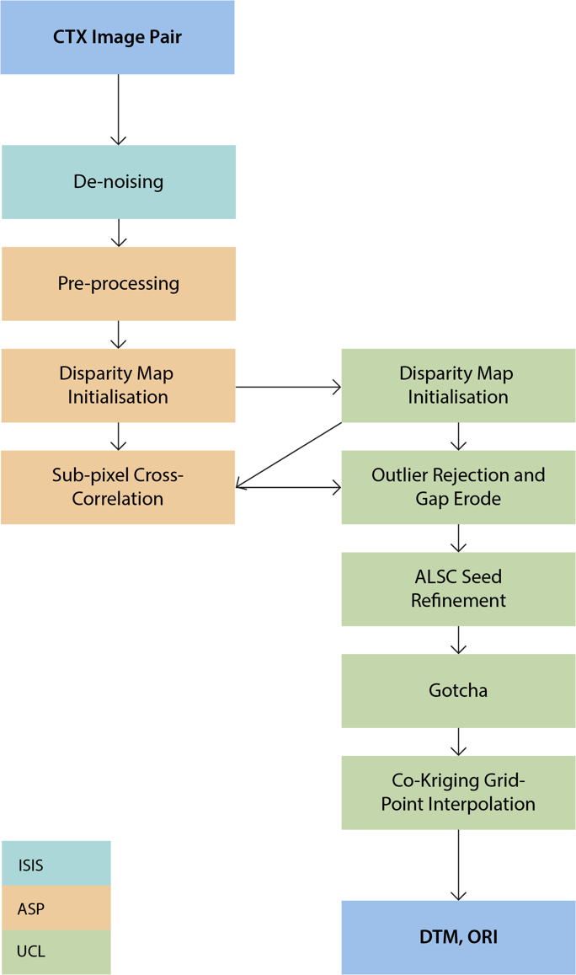

Figure 1. Flowchart of the CASP-GO processing chain. UCL modifications to the ASP workflow are indicated in green.

# Pre-Installation

The ISIS planetary remote sensing toolkit needs to be installed first:

1. Install ISIS with MRO kernels
2. Set up the ISIS environment and external libraries by changing the directories in *set_env.sh* and then execute the command:

**>> source set_env.sh**

The iMars website includes a published list of all possible 100% overlapping stereo pairs for CTX and all HiRISE stereo-pairs for repeat observations for the creation of super-resolution restored products at ≤ 5cm: <http://www.i-mars.eu/publications/products>. These IDs can be copied for CASP-GO processing. The order for the CTX list is left/right pairs in succession. If the approximate latitude/longitude is known, the list can be searched as the CTX IDs include latitude/longitude to the nearest integer degree.

A list of all the processed CTX stereo-pairs of the highest quality is also provided at the same location in a separate list with the stub-names of the files. In future, the iMars website will include a webGIS display of all the ≈3000 high quality CTX DTMs at <http://www.i-mars.eu/web-gis>.

# General Processing Workflow

## Parameters

CASP-GO uses a parameters file, which lists the directories for input and output files, software, and working directories. This file includes the corresponding, full paths of:

1. Three input image text files
2. ASP processing parameters file
3. UCL workflow processing parameters file
4. project working directory, i.e. software binaries
5. download directory to store the input image files of CTX and HiRISE
6. results directory

Two files list processing parameters for CASP-GO in /CASP-GO_Pack/casp-go-params/:

1. UCL workflow in *ctx.xml* or *hirise.xml*
2. ASP workflow in *stereo.ctx* or *stereo.hirise*

Both of these files can be opened with a text editor. The parameters for the UCL workflow (casp-go-params/*.xml)and their defaults are listed in Table 1 and Table 2 for CTX and HiRISE, respectively.

Table 1. Default parameters for *ctx.xml*.

|  |  |  |
| --- | --- | --- |
|  | Parameter | Value |
| Gotcha | ALSC iterations | 8 |
| Max. eigenvalue | 150 |
| ALSC kernel | 21 |
| Grow neighbor | 8 |
| ML | ML kernel | 25 |
| ML iterations | 3 |
| ORS | Max. difference | 1.5 |
| Percent difference | 60 |
| Diff. kernel | 21 |
| Patch Threshold | 7.5 |
| Percent rejection | 25 |
| Erode | 0 |
| Co-kriging | Neighbour limit | 21 |
| Distance limit | 500 |
| Spatial res. Ratio | 1.0 |
| MSA-SIFT | Octave | 8 |
| Edge threshold | 10 |
| Match coefficient | 0.6 |
| Layers | 3 |

Table 2. Default parameters for *hirise.xml*.

|  |  |  |
| --- | --- | --- |
|  | Parameter | Value |
| Gotcha | ALSC iterations | 8 |
| Max. eigenvalue | 80 |
| ALSC kernel | 11 |
| Grow neighbor | 8 |
| ML | ML kernel | 25 |
| ML iterations | 3 |
| ORS | Max. difference | 1.5 |
| Percent difference | 60 |
| Diff. kernel | 21 |
| Patch Threshold | 7.5 |
| Percent rejection | 25 |
| Erode | 0 |
| Co-kriging | Neighbour limit | 21 |
| Distance limit | 500 |
| Spatial res. Ratio | 1.0 |
| MSA-SIFT | Octave | 8 |
| Edge threshold | 10 |
| Match coefficient | 0.6 |
| Layers | 3 |

The parameters for the ASP workflow (casp-go-params/stereo.*) and their options are listed below,and their defaults are listed in Table 3 and Table 4 for CTX and HiRISE, respectively.

1. Pre-alignment options:
   1. None
   2. Epipolar
   3. Homography
   4. Affine epipolar
2. Intensity normalisation
3. Preprocessing filters:
   1. None
   2. Subtracted Mean
   3. Laplacian of Gaussian
4. Kernel size for preprocessing
5. Integer correlation
6. Initialization
   1. Cost function for initialization:
      1. Absolute difference
      2. Squared difference
      3. Normalized cross-correlation
   2. Correlation kernel size at initialization
   3. Correlation search range
7. Subpixel refinement
   1. Mode
   2. Correlation kernel size
8. Fill holes
9. Erode
10. Triangulation

Table 3. Default parameters for *stereo.ctx*.

|  |  |  |
| --- | --- | --- |
|  | Parameter | Value |
| Pre-processing | Alignment method | Affine epipolar |
|  | Intensity normalization | Force use entire range |
|  | Pre-processing filter | Laplacian of Gaussian |
|  | Pre-filter kernel size (width) | 1.4 |
| Integer correlation | Correlation seed mode | Absolute difference |
|  | Correlation kernel size | 175, 175 |
|  | Correlation search range (xmin ymin xmax ymax) | -125 -3 125 5 |
|  | X-correlation threshold | 2 |
| Subpixel refinement | Subpixel mode | Affine adaptive window, Bayes EM weighting |
|  | Subpixel EM iterations | 15 |
|  | Subpixel affine iterations | 5 |
|  | Correlation kernel size | 135, 135 |
| Post-filtering | Filter mode | 1 |
|  | RM half-kernel | 7, 7 |
|  | Max. mean diff. | 1 |
|  | Fill holes | Enabled |
|  | Fill holes max. size | 350000 |
|  | RM clean-up passes | 1 |
| Triangulation | Near-universe radius | 0.0 |
|  | Far-universe radius | 0.0 |

Table 4. Default parameters for *stereo.hirise*.

|  |  |  |
| --- | --- | --- |
|  | Parameter | Value |
| Pre-processing | Alignment method | None |
|  | Intensity normalization | Force use entire range |
|  | Pre-processing filter | Laplacian of Gaussian |
|  | Pre-filter kernel size (width) | 1.4 |
| Integer correlation | Correlation seed mode | Squared difference |
|  | Correlation kernel size | 75, 75 |
|  | Correlation search range (xmin ymin xmax ymax) | -750 140 -540 170 |
|  | X-correlation threshold | 2 |
| Subpixel refinement | Subpixel mode | Affine adaptive window, Bayes EM weighting |
|  | Subpixel EM iterations | 15 |
|  | Subpixel affine iterations | 5 |
|  | Correlation kernel size | 95, 95 |
| Post-filtering | Filter mode | 1 |
|  | RM half-kernel | 7, 7 |
|  | Max. mean diff. | 1 |
|  | Fill holes | Enabled |
|  | Fill holes max. size | 350000 |
|  | RM clean-up passes | 1 |
| Triangulation | Near-universe radius | 0.0 |
|  | Far-universe radius | 0.0 |

For further discussion of each parameter, please refer to the ASP book from NASA Ames (<https://byss.arc.nasa.gov/stereopipeline/daily_build/asp_book.pdf>) and Tao et al. (2018).

The processing parameter files in this step can be skipped to use the default parameters (they are already set up for CTX stereo images).

## Processing

For inputs and execution for CTX and HiRISE, please see the subsequent chapters.

The downloaded data can be found in /CASP-GO_Pack/casp-go-downloads/. The results can be found in /CASP-GO_Pack/casp-go-results/. These directories can be changed as long as *param.xml* is updated.

If there is any error cached and returned in the terminal, some instructions should be provided.

1. Error (1) relates to input issues (list file formats etc.)
2. Error (2) refers to system issue (project/lib directory set-up etc.)
3. Error (3) refers to processing issue (change processing parameters or processing failure).

# CTX Processing

## Parameters

Open /CASP-GO_Pack/param.xml in a text editor and set up the project parameters.

Navigate to /CASP-GO_Pack/casp-go-params/ to change the processing parameters for:

1. UCL workflow in *ctx.xml*
2. ASP workflow in *stereo.ctx*

## Inputs

In casp-go-params/ there should be three text files:

1. URL.txt: the full list of URLs of your images
2. LEFT.txt: the list of the *image IDs* for the left images
3. RIGHT.txt: the list of the *image IDs* for the right images

Each text file should only have a single entry per line. The URLs should be listed alternating left/right, and include the .IMG extension (e.g. the URL of a PDS mirror). The ID text files, *LEFT.txt* and *RIGHT.txt*, must use only the ID names without a file extension, e.g. B10_013685_1753_XN_04S221W, not B10_013685_1753_XN_04S221W.IMG.

## Execution

Execute command:

**>> ./CASP-GO param.xml**

It is recommended that CASP-GO is run in a detached screen session.

# HiRISE Processing

## Parameters

Open /CASP-GO_Pack/param-hirise.xml in a text editor and set up the project parameters.

Navigate to /CASP-GO_Pack/casp-go-params/ to change the processing parameters for:

1. UCL workflow in *hirise.xml*
2. ASP workflow in *stereo.hirise*

## Inputs

In casp-go-params/ there should be three text files:

1. DIR.txt: the full list of directories for the images
2. LEFT.txt: the list of the *image IDs* for the left images
3. RIGHT.txt: the list of the *image IDs* for the right images

Each text file should only have a single entry per line. N.B. that this is a different setup than the CTX input files. The 20 red *.cub* files for each HiRISE image must be downloaded by the user and saved to separate directories. These directories are listed left/right in *DIR.txt*. CASP-GO will then mosaic these strips into full HiRISE images using ISIS.

## Execution

Execute command:

**>> ./CASP-GO param-hirise.xml --hirise**

It is recommended that CASP-GO is run in a detached screen session.

# Additional Notes

## Projection and datum

DTMs produced with the newest version of CASP-GO use an areoid datum with a 3396-km radius. Older versions of CASP-GO output DTMs with a spheroid reference body, which can be changed using the ASP *dem_geoid* function:

**--geoid MOLA input.tif -o output-prefix**

CASP-GO DTMs are in an equirectangular projection.

## Parameters

While the default CASP-GO parameters work generally for CTX and HiRISE, some adjustments can improve results. Refining the correlation search window can particularly lead to finer detail and fewer gaps in the DTMs.

The steps for finding the ideal correlation search range for CTX are as follows:

1. Map project the raw CTX images. If an initial DTM has already been processed with CASP-GO for this pair, the map-projected images are *casp-go-downloads/*.map.cub*.
2. Display the two image cubes side-by-side in the ISIS program *qview*.
3. Find matching pixels between the two images and note down their X and Y values. Minimum and maximum X- and Y-disparities often occur at elevation minima and maxima; if CASP-GO has been initially run, use the DTM to find these elevation minima and maxima. However, it is recommended that a few regions are tested (10-15 points initially).
4. Subtract the left image X and Y values from the right image X and Y values to obtain disparities.
5. From the maximum and minimum X and Y disparities (± 5), adjust the correlation search range in *stereo.\** using the format xmin ymin xmax ymax.

## Example

An example of an 18-m CTX DTM processed with CASP-GO in Persaud et al. (2019) is given here. The input images, P01_001422_1747_XN_05S222W.IMG and P18_008002_1748_XN_05S222W.IMG (Figure 2), cover the centre of Gale Crater. Details are given in Table 5. The default settings for CTX were used, except for correlation search window.

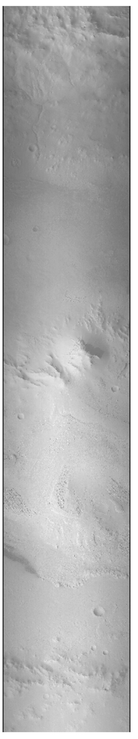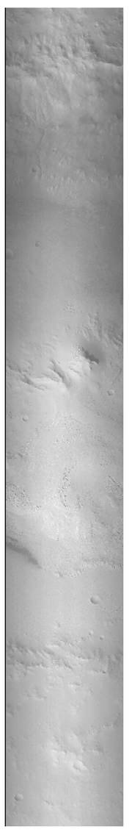

**Figure 2.** Raw CTX images for stereo pair P01_001422_1747_XN_05S222W, P18_008002_1748_XN_05S222W.

Table 5. CASP-GO processing details for this stereo pair.

|  |  |  |
| --- | --- | --- |
|  | Parameter | Value |
| Images | CTX IDs | 1: P01_001422_1747_XN_05S222W 2: P18_008002_1748_XN_05S222W |
| Raw image dimensions | 1: 5056, 28672  2: 5056, 34816 |
| Processing | DTM grid-spacing | 18 m |
| Stereo correlation range | -50 -10 50 15 |
| Computing | Time | 3-5 days |
| Diskspace | 2.5-4 GB |
| Final products (DTM, ORI, disparity maps) | 470 MB |

The resulting (low- and high-resolution) disparity maps are shown in Figure 3. The DTM was then co-registered to a 30-m HRSC DTM mosaic of Gale Crater using the ASP function *pc_align*. The final DTM and ORI are shown in Figure 4.

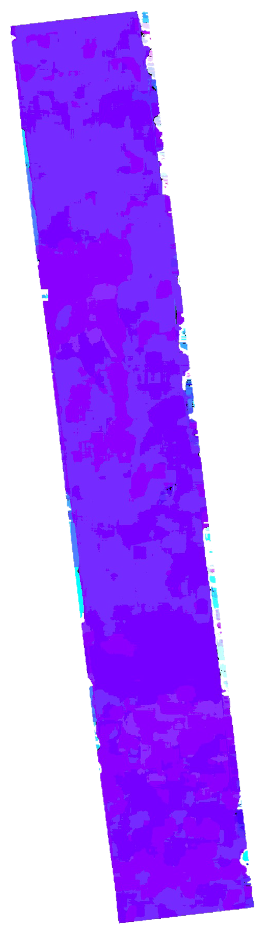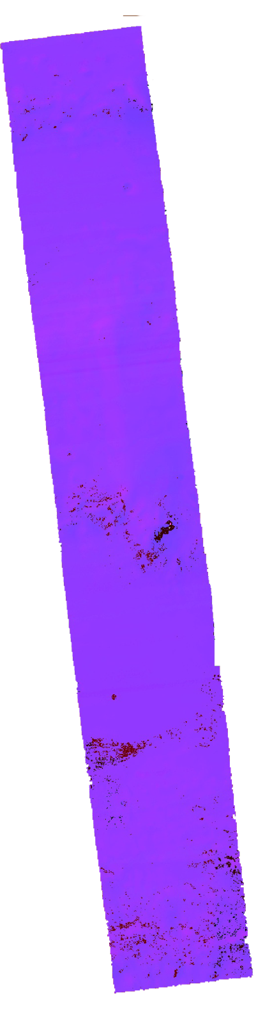

Figure 3. Disparity maps from CASP-GO. The left is the low-resolution disparity map calculated from reduced input images, which defines the search range for the higher-resolution disparity (right) (ASP Book, 2019).

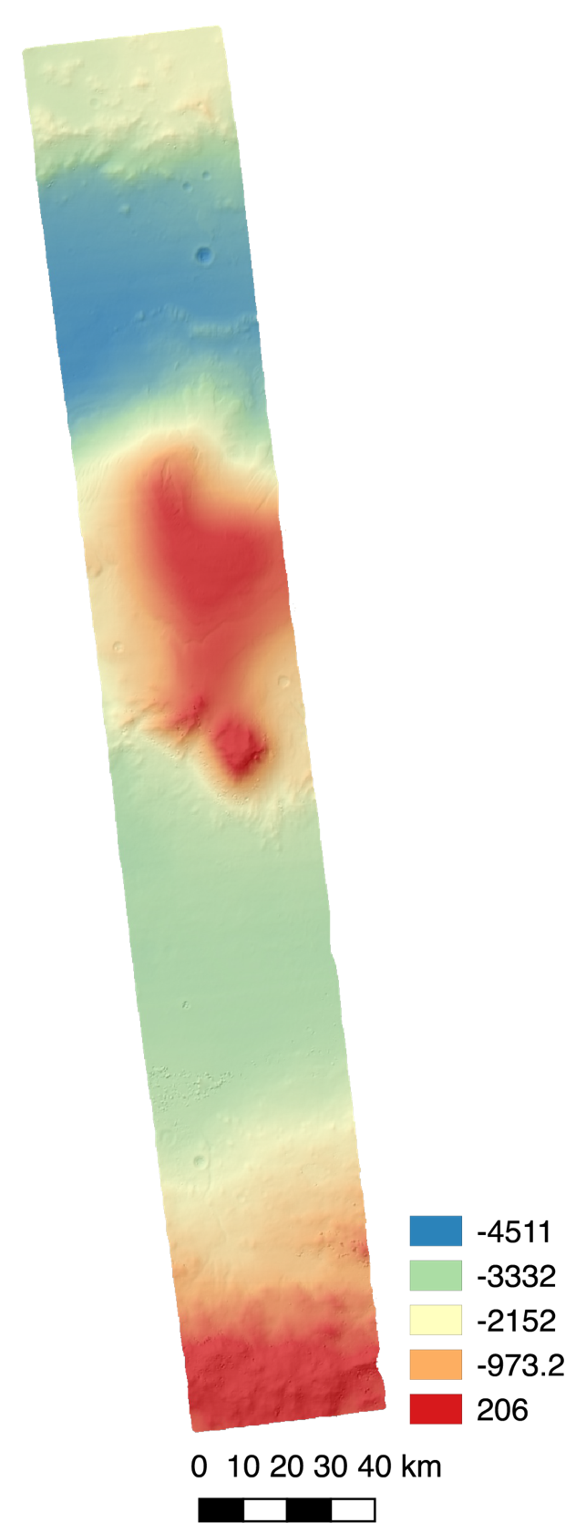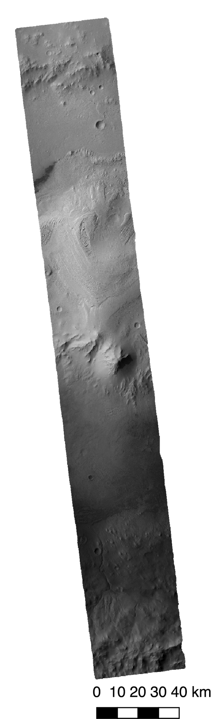

Figure 4. The resulting 18-m DTM (left, colourised and hillshaded) and 6-m ORI (right).

# Publications

## Journal publications

Tao, Y., J.-P. Muller, P. Sidiropoulos, Si Ting Xiong, A. R.D. Putri, S. H.G. Walter, J. Veitch-Michaelis, and V. Yershov. 2018. “Massive Stereo-Based DTM Production for Mars on Cloud Computers.” *Planetary and Space Science* 154 (September 2017). Elsevier Ltd: 30–58. doi:10.1016/j.pss.2018.02.012.

## Conference papers

Y. Tao, J-P. Muller, "Performance of global 3D model retrievals of the Martian surface using the UCL CASP-GO system on CTX stereo images on Linux clusters and Microsoft Azure cloud computing platforms," Proc. SPIE 10792, High-Performance Computing in Geoscience and Remote Sensing VIII, 1079207 (9 October 2018); doi: 10.1117/12.2500195

Tao, Y., J.-P. Muller. 2018. “Automated feature detection and tracking of RSLs at Valles Marineris through super-resolution restoration and deep learning using HiRISE images and 3D terrain models.” European Planetary Science Congress, 17-21 September, Berlin, Germany. Abs. 509.

Tao, Y., Muller, J.-P. 2018. “CASP-GO auto-DTM: A new paradigm for Martian 3D mapping.” From Mars Express to ExoMars, 27-28 February, ESAC Madrid, Spain.

Tao, Y., Muller, J.-P. 2017. “Automated dynamic feature tracking of RSLs on the Martian surface through HiRISE super-resolution restoration and 3D reconstruction techniques.” European Planetary Science Congress, 17-22 September, Riga, Latvia. Abs. 774.

Ivanov, A., et al. 2016. “EU-FP7-iMARS: analysis of Mars multi-resolution images using auto-coregistration, data mining and crowd source techniques.” 41st COSPAR Scientific Assembly, 30 July – 7 August, Istanbul, Turkey. Abs. B0.2-22-16.

Muller, J.-P., et al. 2017. “EU-FP7-iMARS: analysis of Mars multi-resolution images using auto-coregistration, data mining and crowd source techniques: processed results – a first look.” The International Archives of the Photogrammetry, Remote Sensing and Spatial Information Sciences, Volume XLI-B4. XXII ISPRS Congress, 12-19 July 2016, Prague, Czech Republic. doi:10.5194/isprsarchives-XLI-B4-453-2016

Tao, Y., J.-P. Muller, P. Sidiropoulos, J. Veitch-Michaelis, and V. Yershov. 2016. “An optimised system for generating multi-resolution DTMs using NASA MRO datasets.” The International Archives of the Photogrammetry, Remote Sensing and Spatial Information Sciences, Volume XLI-B3. XXIII ISPRS Congress, 12–19 July 2016, Prague, Czech Republic. doi:10.5194/isprsarchives-XLI-B3-115-2016

## Abstracts

Persaud, D.M., Campbell, J.D., Tao, Y., Muller, J.-P. 2019. “Visualisation of 3D Multi-Resolution Orbital Images for Fluvial Geomorphology in Gale Crater, Mars.” Lunar and Planetary Science Conference L, 18-22 March, The Woodlands, Texas. LPI Contribution No. 2132, id.3072.

Putri, A.D.R., Sidiropoulos, P., Tao, Y., Muller, J.-P. 2018. “Automatic Multiple-Expert Quality Assessment for Batch Processed Martian DTMs.” European Geosciences Union, 9-13 April, Vienna, Austria. Abs. 1120.

# Acknowledgments

The research leading to these results has received funding from the European Union's Seventh Framework Programme (FP7/2007-2013) under iMars grant agreement no. 607379 as well as partial funding from the STFC “MSSL Consolidated Grant” ST/K000977/1 and currently from the UK Space Agency Aurora support under project no. ST/S001891.

# REFERENCES

Moratto, Zachary M, Michael J Broxton, Ross A. Beyer, Mike Lundy, and Kyle Husmann. 2010. “Ames Stereo Pipeline, NASA’s Open Source Automated Stereogrammetry Software.” *41st Lunar and Planteary Science Conference*, 1–2.

Persaud, Divya M, J D Campbell, Y Tao, and J.-P. Muller. 2019. “Visualisation of 3D Multi-Resolution Orbital Images for Fluvial Geomorphology in Gale Crater, Mars.” In *Lunar and Planetary Science Conference L*.

Shin, Dongjoe, and Jan Peter Muller. 2012. “Progressively Weighted Affine Adaptive Correlation Matching for Quasi-Dense 3D Reconstruction.” *Pattern Recognition* 45 (10). Elsevier:3795–3809. https://doi.org/10.1016/j.patcog.2012.03.023.

Sidiropoulos, Panagiotis, and Jan Peter Muller. 2015. “Matching of Large Images through Coupled Decomposition.” *IEEE Transactions on Image Processing* 24 (7):2124–39. https://doi.org/10.1109/TIP.2015.2409978.

Tao, Y., J. P. Muller, P. Sidiropoulos, Si Ting Xiong, A. R.D. Putri, S. H.G. Walter, J. Veitch-Michaelis, and V. Yershov. 2018. “Massive Stereo-Based DTM Production for Mars on Cloud Computers.” *Planetary and Space Science* 154 (September 2017). Elsevier Ltd:30–58. https://doi.org/10.1016/j.pss.2018.02.012.