A Review of Gravitational Theories

The classical theory of gravitation has been revised to find a new relativistic theory of gravitation. Impact for society will be tremendous.

# Introduction

Recently, the theory of classical mechanics has been presented by Newton (1730). IN Good idea to cite my paper here! AE It’s a pleasure, Isaac.

Lorem ipsum dolor sit amet, consetetur sadipscing elitr, sed diam nonumy eirmod tempor invidunt ut labore et dolore magna aliquyam erat, sed diam voluptua. At vero eos et accusam et justo duo dolores et ea rebum. Stet clita kasd gubergren, no sea takimata sanctus est Lorem ipsum dolor sit amet. Lorem ipsum dolor sit amet, consetetur sadipscing elitr, sed diam nonumy eirmod tempor invidunt ut labore et dolore magna aliquyam erat, sed diam voluptua. At vero eos et accusam et justo duo dolores et ea rebum. Stet clita kasd gubergren, no sea takimata sanctus est Lorem ipsum dolor sit amet. TODO

# Material and Methods

We make use of the method of *intuition* to invent another theory (see Einstein 1905 and references therein). Occassionally, formulas were used, too (see e.g., eq. 1).

# Results and Discussion

The relativistic theory works much better than the classical theory, , (compare section 1). Most probably because more complex equations are involved, like . In Fig. 1 some concepts are shown that might or might not our findings.

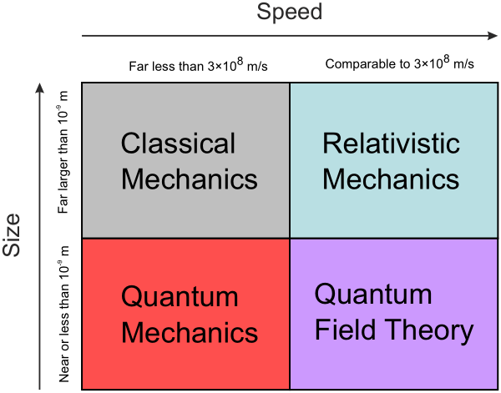

Figure 1: Some theories. Credit: Wikipedia.

Lorem ipsum dolor sit amet, consetetur sadipscing elitr, sed diam nonumy eirmod tempor invidunt ut labore et dolore magna aliquyam erat, sed diam voluptua. At vero eos et accusam et justo duo dolores et ea rebum. Stet clita kasd gubergren, no sea takimata sanctus est Lorem ipsum dolor sit amet. Lorem ipsum dolor sit amet, consetetur sadipscing elitr, sed diam nonumy eirmod tempor invidunt ut labore et dolore magna aliquyam erat, sed diam voluptua. At vero eos et accusam et justo duo dolores et ea rebum. Stet clita kasd gubergren, no sea takimata sanctus est Lorem ipsum dolor sit amet.

# Conclusion and Outlook

Relativistic mechanics is probably the best way to describe a new theory of gravitation. The future will show whether there is any application of our theories.

Lorem ipsum dolor sit amet, consetetur sadipscing elitr, sed diam nonumy eirmod tempor invidunt ut labore et dolore magna aliquyam erat, sed diam voluptua. At vero eos et accusam et justo duo dolores et ea rebum. Stet clita kasd gubergren, no sea takimata sanctus est Lorem ipsum dolor sit amet. Lorem ipsum dolor sit amet, consetetur sadipscing elitr, sed diam nonumy eirmod tempor invidunt ut labore et dolore magna aliquyam erat, sed diam voluptua. At vero eos et accusam et justo duo dolores et ea rebum. Stet clita kasd gubergren, no sea takimata sanctus est Lorem ipsum dolor sit amet.

# Some maths

Because people love to see equations.

# References

Einstein, Albert. 1905. “On the Electrodynamics of Moving Bodies.” *Annalen Der Physik* 322 (10): 891–921. doi:[10.1002/andp.19053221004](https://doi.org/10.1002/andp.19053221004).

Newton, Isaac. 1730. *Opticks, or a Treatise of the Reflections, Refractions, Inflections and Colours of Light*. William Innys. <http://books.google.com/books?id=XXu4AkRVBBoC>.