Comparing Gravitational Theories

The classical theory of gravitation has been revised to find a new relativistic theory of gravitation. Impact for society will be tremendous.

# Introduction

Recently, the theory of classical mechanics has been presented by Newton (1730).

# Material and Methods

We are using the method of *intuition* to invent another theory (see Einstein 1905 and references therein). Occassionally, formulas were used, too (see e.g., eq. 1).

# Results and Discussion

The relativistic theory works much better than the classical theory (compare section 1). In Fig. 1 some concepts are shown that might or might not our findings.

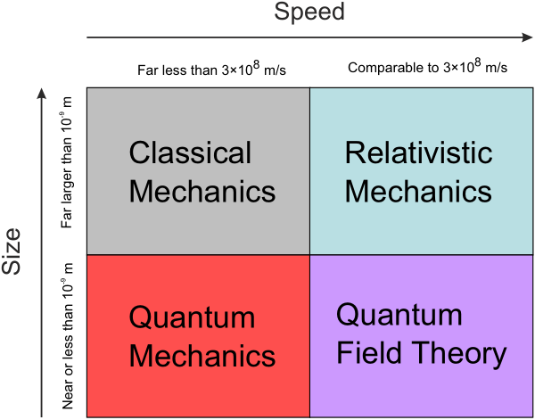

Figure 1: Some theories.

# Conclusion and Outlook

Relativistic mechanics is probably the best way to describe a new theory of gravitation. The future will show whether there is any application of our theories.

# Some maths

$$E=m⋅c^{2} , (1)$$

Because people love to see equations.

# References

Einstein, Albert. 1905. “[On the Electrodynamics of Moving Bodies.” *Annalen Der Physik* 322 (10): 891–921. doi:[10.1002/andp.19053221004](https://doi.org/10.1002/andp.19053221004).

Newton, Isaac. 1730. *Opticks, or a Treatise of the Reflections, Refractions, Inflections and Colours of Light*. William Innys. <http://books.google.com/books?id=XXu4AkRVBBoC>.