Name: Please put Last name (Lastname, Firstname)__Apollo, Andrew_____________________________

Practice Exercise 5 Assignment box PE05

Download this Word file, edit it, upload this document with answers typed in this document. I like PDF files the best, but if you have problems with creating PDF’s then submit a Word Document to the assignment box.

Notice the functional dependencies are provided for you in each question. Study the functional dependencies provided before you attempt your answer for each question.

For each problem below, normalize the relations into the second Normal Form 2nf.
Be sure to use proper relational notation (relational scema):
RELATION(pkattr, attribute1, attribute2, attribute3, fkattr)
Include reference statements for foreign keys (Must Exist In or M.E.I.) statements

Problem #1
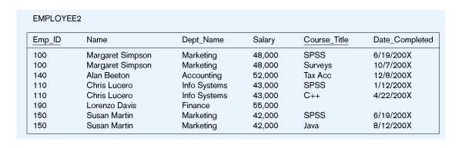
EMPLOYEE2(Emp_ID, Name, Dept_Name, Salary, Course_Title, Date_Completed)
Functional Dependencies:
Emp_ID, Course_Title è Name, Dept_Name, Salary, Date_Completed
EmpID è Name, Dept_Name, Salary
YOUR ANSWER (in relational schema format) is? What is your M.E.I. statement ?
Employee(Emp ID, name, Dept_Name, Salary)
Course(Emp ID, Course Title, Date_Completed)
Course (Emp ID) M.E.I. Employee (Emp_ID)
Problem #2
ENGINEER-SERVICE(empID, firstname, lastname, email, serviceID, servicename)

Functional Dependencies:
empID, serviceID è firstname, lastname, email, servicename
empID è firstname, lastname, email
email è empID, firstname, lastname
serviceID è servicename

YOUR ANSWER (in relational schema format) is? What is your M.E.I. statement

Engineer (empID, firstName, lastName, email)

Service(serviceID, serviceName)

Engineer-Service (empID, serviceID )

Engineer-Service (empID) M.E.I. Engineer (empID)

Engineer-Service(serviceID) M.E.I Service(serviceID)

Problem #3
Movie
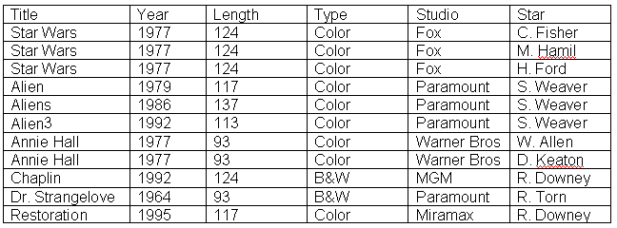

MOVIE(Title, Year, Length, Type, Studio, Star)

Functional Dependencies:
Title, Star è Year, Length, Type Studio
Title è Year, Length, Type, Studio

YOUR ANSWER (in relational schema format) is? What is your M.E.I. statement?

Movie (Title, Year, Length, Type, Studio)

Star (Title, Star)

Star(Title) M.E.I. Movie(Title)

Problem #4
Is This a relation?_______YES OR NO_______________
What is/are the Primary key? __________________________ It appears to have 2 fields (COMPOSTE KEY)
Normalize the following table. Use Relational Schema! Please include a proper M.E.I. 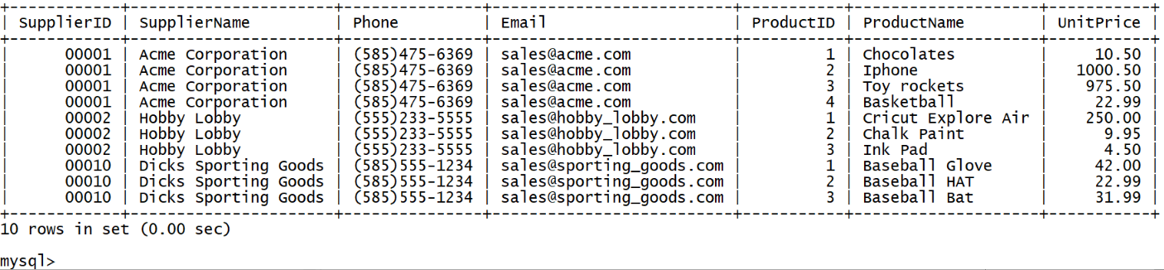

Supplier(SupplierID, SuplierName, Phone, Email)
Product (ProductID, SupplierID, ProductName, UnitPrice)

Product(SupplierID) M.E.I. Supplier(SupplierID)

