User Manual


Caroline Krouse
Aaron Cesar
AJ Atkins
Megan Morton

Capstone Project, Spring 2020
The University of West Florida

April 24th, 2020

Capstone Systems Project CIS4595
Dr. Ownsnicki-Klewe

Abstract
This report is meant to walk users through the process of installing Game Geo. One method of installation that will be covered is downloading from GitHub to an Android device. Another installation method is that will be shown is downloading from GitHub to a computer, then from the computer to an Android Device.

Table of Contents
Abstract 2
Table of Contents 3
List of Figures 4
1 Downloading Game Geo 5
1.1 Downloading directly to Device …5
1.2 Downloading to Computer and Importing to Device 5
2 Enable Installation 6
3 Installing with APK 7
4 Finding Game Geo on your Device 8

List of Figures
1. GitHub Repository 5
2. GitHub APK Location 5
3. Devices 6
4. Settings 6
5. Security 6
6. Storage 7
7. Internal Storage 7
7. Downloads Folder 7
7. Apps Launcher 8
7. App Location 8

1 Downloading Game Geo

1.1 Downloading directly to Device
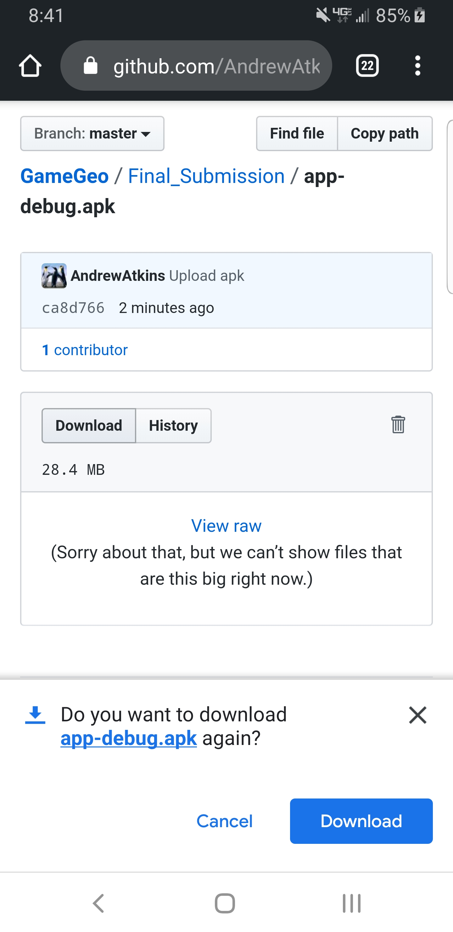
To download Game Geo directly to your Android device, open a web browser on the device and open the Game Geo GitHub repository. Click on View code to access the repository file structure, then select the Final_Submission folder. Inside this folder you will find a file titled app-debug.apk, click this file and select download. Disregard any warnings that the file may harm your device. This is the phone’s way of telling you that you are downloading third party software that is not on the Google Play Store.
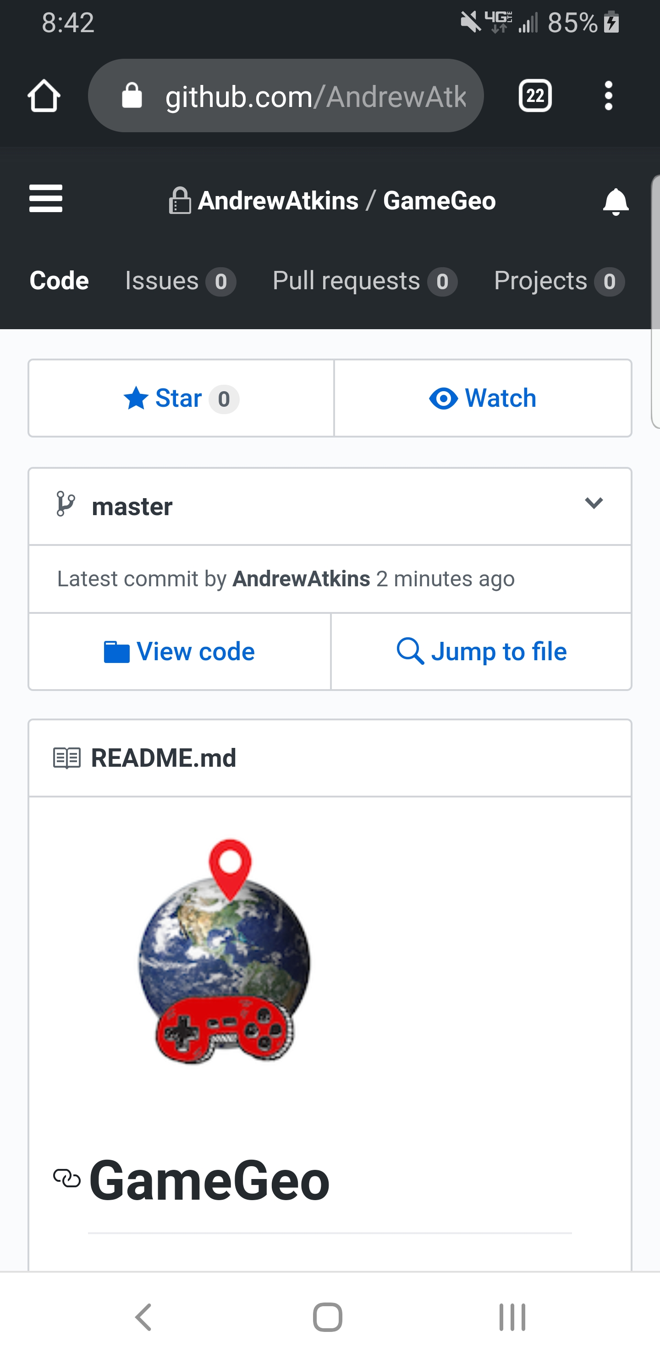

1.2 Downloading to Computer and Importing to Device
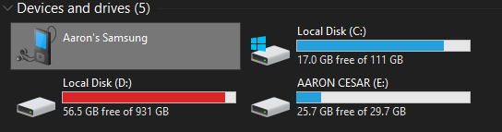
To download Game Geo to your computer and then manually import onto your Android Device you must first open the Game Geo GitHub repository on your computer. Select the Final_Submission folder. Inside this folder you will find a file titled app-debug.apk, click this file and select download. Then you will need to plug in your android device into your computer. Once your device appears open the device in a file explorer. Copy the app-debug.apk you downloaded earlier and paste it onto your device.

2 Enable Installation
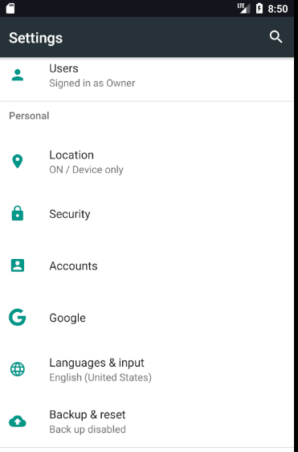
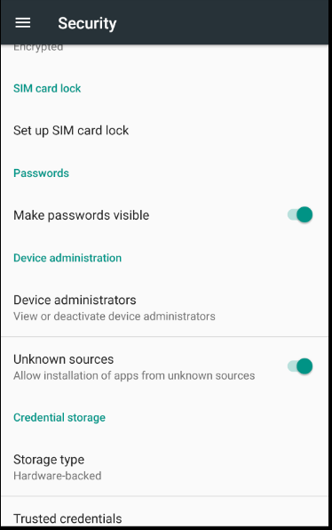
Once the app-debug.apk is on your device you will have to enable third party software to be installed. Open the Settings on your device and look for the section titled Security. Open Security and find the setting titled Unknown Sources. The setting must be enabled in order to install Game Geo.

3 Installing with APK
After you have enabled installation of software from unknown sources locate the app-debug.apk on your device. You can do this by going to Settings then Storage. Once in Storage click on either Internal Storage or your portable storage depending on where you stored the app-debug.apk. If you downloaded the app-debug.apk directly to your device then it is likely stored in the Internal Storage. Once you select the storage device look for an option that says explore. From there you should be able to navigate to your download folder, this is where the app-debug.apk should be. If you have trouble locating app-debug.apk try looking for a search option in the file explorer and searching app-debug.apk. Once you have located the app-debug.apk click on it and the installation process should begin. Here the device may warn you about installing third party software. If the device will not allow you to install than refer back to the Enable Installation section of this manual as you may not have changed the proper settings.
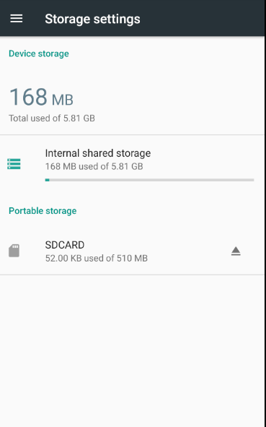
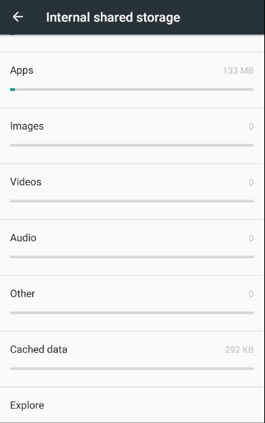
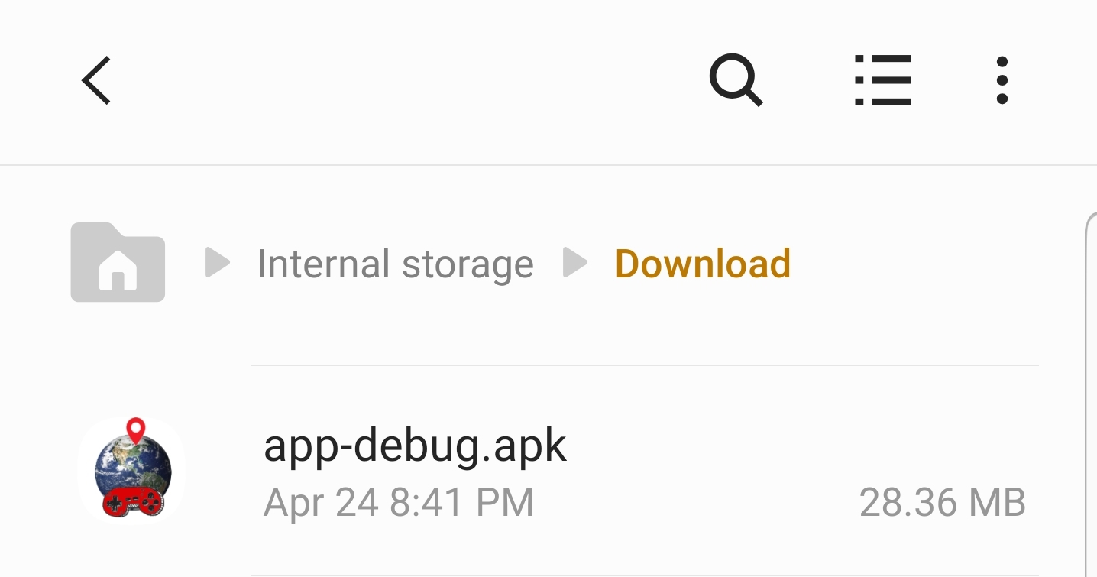

4 Finding Game Geo on your Device
After the app-debug.apk has installed then should see the Game Geo app appear on your home screen. If it does not appear, try opening your Apps launcher located by default at the bottom of the screen. In there you should be able to locate the Game Geo app.
