User Manual


Caroline Krouse
Aaron Cesar
AJ Atkins
Megan Morton

Capstone Project, Spring 2020
The University of West Florida

April 24th, 2020

Capstone Systems Project CIS4595
Dr. Ownsnicki-Klewe

Abstract
This report is meant to walk users through the different functionality of our application. We will be covering how to login into the application and play Game Geo. Each step of how to leave challenges for other players and view other players challenges will be covered.

Table of Contents
Abstract 2
Table of Contents 3
List of Figures 4
1 Getting Started 5
2 Logging In 5
3 Map Screen 5
3.1 Interacting with Pictionary Challenges 5
3.1.1 Guessing a Pictionary Challenge 6
3.2 Creating a Pictionary Challenge 6
3.2.1 Drawing a Pictionary Challenge 6

List of Figures
1. Launcher 6
2. Logging In 6
3. Location permission 6
4. View challenges on map 6
5. View Pictionary challenge 7
6. Begin a challenge button 7
7. Draw a challenge 7

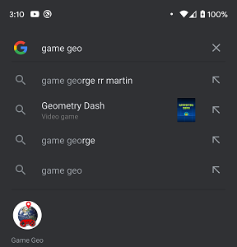
1 Getting Started
Once Game Geo has been installed, the user should click on the game geo application icon. This will direct them to a log in screen where they can enter their credentials.

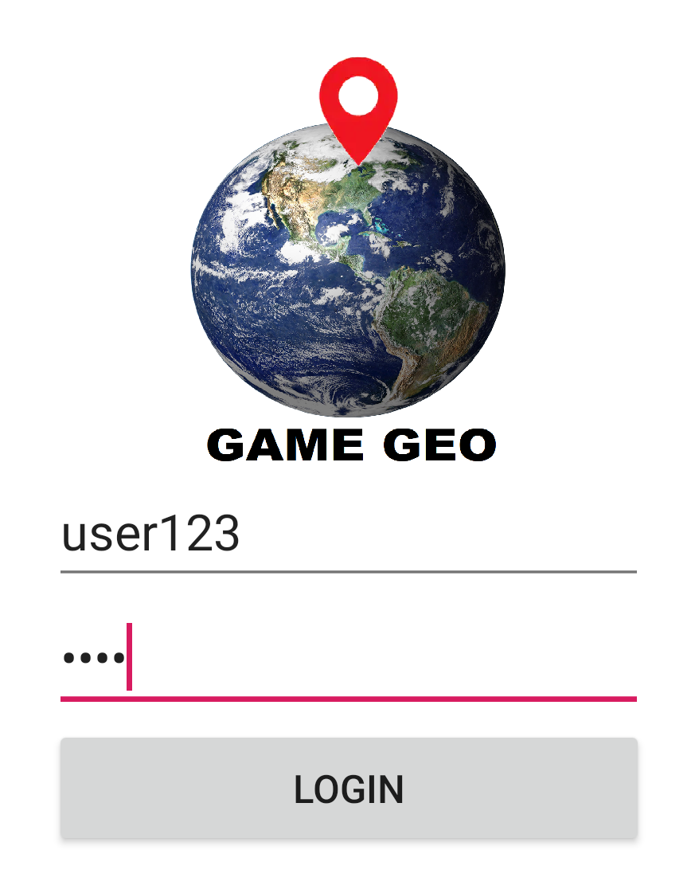
2 Logging In
From the login page, users should enter their username and password. At this time, the username and password can be bypassed by just clicking login. Users will login anonymously and any challenges they leave for other players will not be associated with a username.

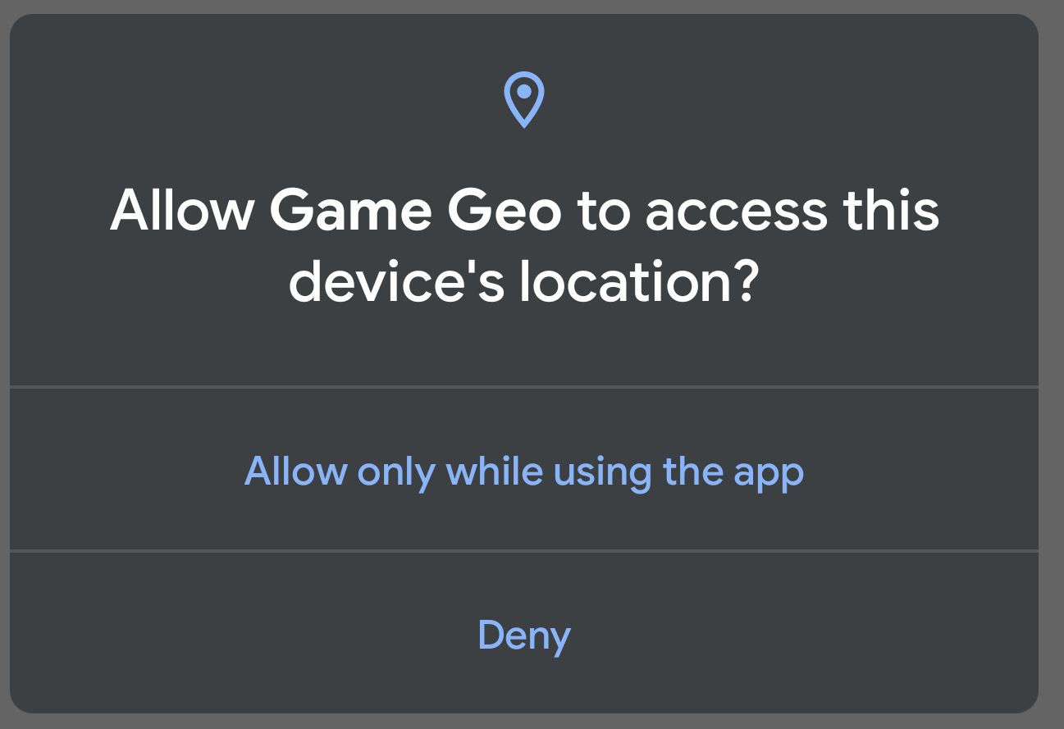
3 Map Screen
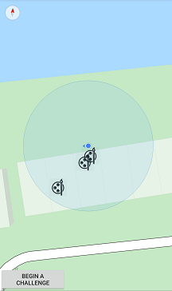
Once logged in, users will be able to view the map. Before being able to view it, however, users must grant Game Geo permissions to view their location. If the user denies this permission, then he or she will be unable to view and interact with the map.

3.1 Interacting with Pictionary Challenges
Once users have given Game Geo access to their device location, he or she may view any challenges players have left around them. Pictionary challenges will appear as easels on the map and can be interacted with by tapping on their icon.

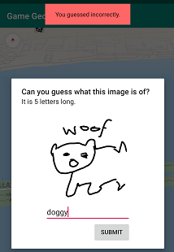
3.1.1 Guessing a Pictionary Challenge
Once a user has tapped on a challenge, the image that was left in the challenge will be pulled up. In the window that appears, users will be informed how many letters the word that describes the image is. In the text box, users can enter their guess. If they guess correctly, a green box appears informing them their answer was correct, otherwise a red dialog box appears informing them they were incorrect.

3.2 Creating a Pictionary Challenge

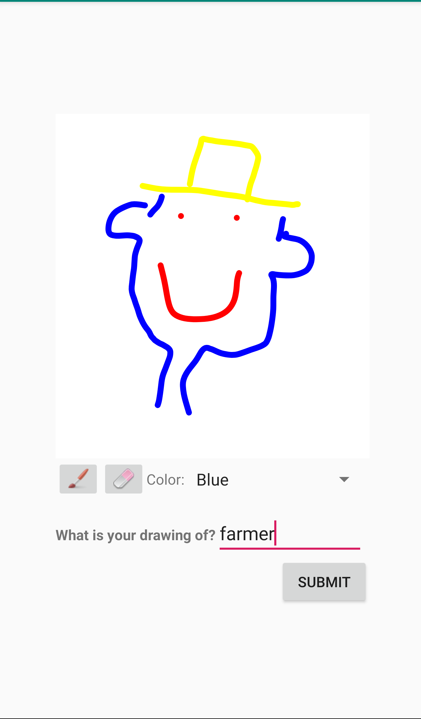
From the map screen, users can click the “Begin a Challenge” button to begin a Pictionary challenge. Once this button has been clicked, a dialog box will appear asking if they would like to start a Pictionary or trivia challenge. Currently the Pictionary challenge is the only type of challenge implemented.

3.2.1 Drawing a Pictionary Challenge
Once a Pictionary challenge has been launched, users will be greeted with a space to draw an image and enter what the image is of. The user can select from a pencil or eraser tool and can select from five colors to draw with: red, blue, green, yellow, and black. Before pressing the submit button, the user must ensure that he or she has drawn a picture and entered a word in the text box. Once submitted, the image will be available in the location that the user drew it at and will be visible for other players.

