Document for all screenshots related to the lab 2 and assignment 2
Screenshot 1

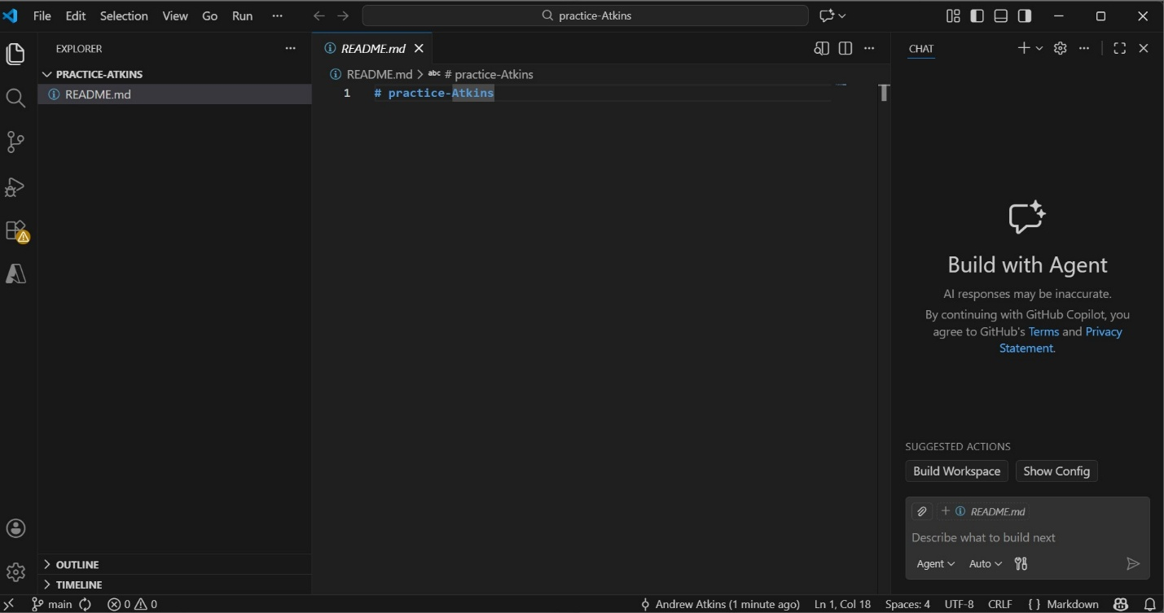

Screenshot 2
