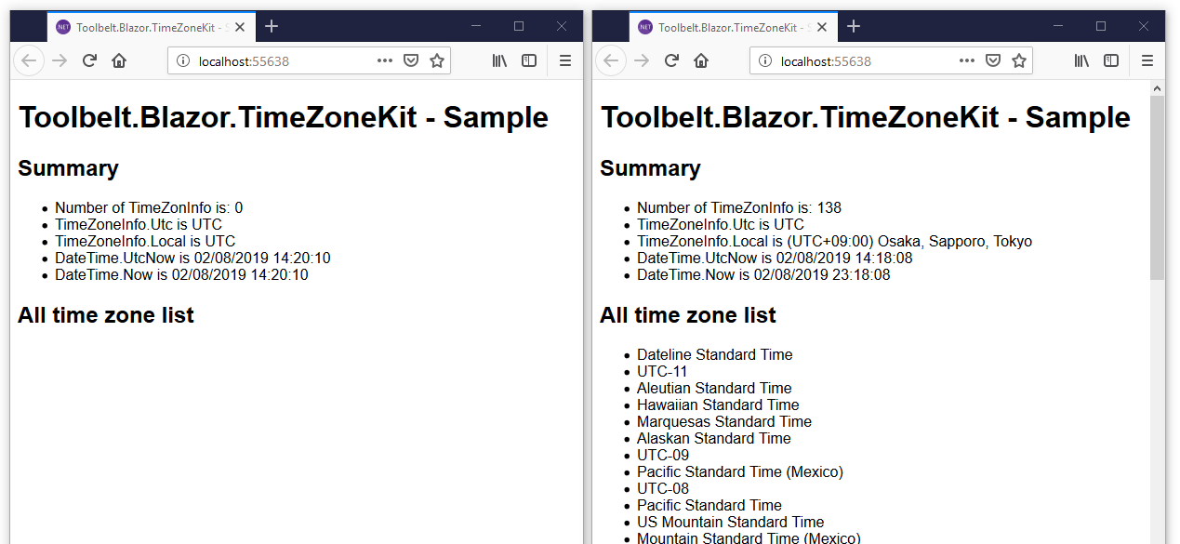

Blazor (~v.0.8.0) app has no time zone info, and the local time zone is always UTC wherever.

"Blazor Time Zone Kit" install time zone list that is compatible with .NET Framework to the Blazor app, in addition, it initializes the local time zone by browser's time zone.