Power BI

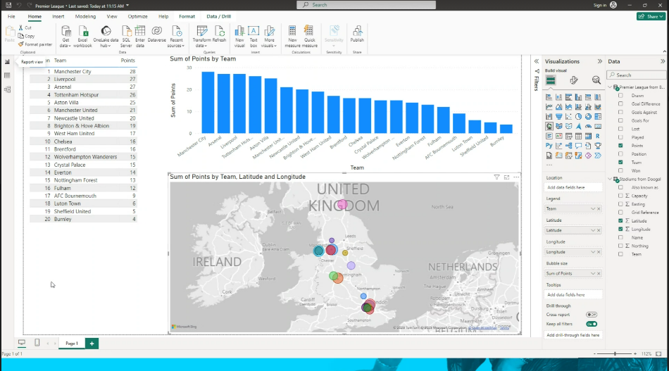

If I want to add a column so that the map will find a place using Google maps –

Create a new column and in the Dax space write the following:

Weblink = "https://www.google.com/maps/place/" & [City]