Abstract:

Questions:

1. Describe the spectrograms of the signals \tone," \sweep," and \noise"

using the default settings.

The spectrogram of “tone” shows that its frequency is constant for the full time, since it is a single tone. The spectrogram of “sweep” shows a sweep in frequency across the 2 second time period. The default settings for this spectrogram indicates a 50% overlap of the window and signal, which causes a “rougher image”. Changing the setting inputs will make the FFT much smoother. The noise is clearly very discontinuous, no patterns really can be observed other than the fact that it’s a noisy signal.

2. If L = 256-point analysis windows are used with NOL = 240 sample overlaps, what is the length of the window increment (\hop") in seconds? As a function of the variables NOL and L, determine the rate at which successive FFTs are calculated in Hz (FFTs/second).

If the window L = 256 points Is used and Nol = 240 samples, the length of the increment for the window is 16 samples. ($256-240=16 samples)$. In seconds, this would simply be: $16\frac{samples}{8000Hz}=0.002 seconds$. The rate at which successive FFTS are calculated is **TODO**

Male Sentence:

1. When the window length is long (i.e., L = 480), what do the horizontal striations during voiced sounds correspond to?

When the widow length is long, the horizontal striations occur due to harmonics of voiced sounds.

2. When the window length is short (i.e., L = 60), why do vertical striations occur in the spectrogram?

When the window length is short, the vertical striations occur due to the window’s limited frequency resolution.

3. Of the previous four parameter sets, which set results in the spectrogram which is best for estimating the formant frequencies for the male sentence?

The parameters (240, 180) seemed to have been the best for eliminating formant frequencies for the male sentence, while in the 480 samples window, the formant frequencies are still very apparent. The spectrogram of 60, 45 suffers from vertical striations, so (240, 180) seems to be the best choice.

Linear Prediction Order:

1. Does the spectral analysis provided by the zpfft script correspond to narrowband or wideband analysis?

**TODO**

2. Approximate the spectral locations of the first 3 formant frequencies.

**TODO**

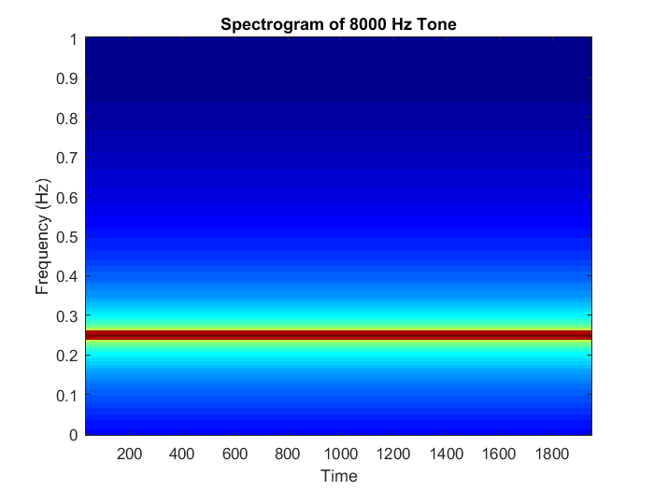

Figure 1: Spectrogram of 8000 Hz Tone.

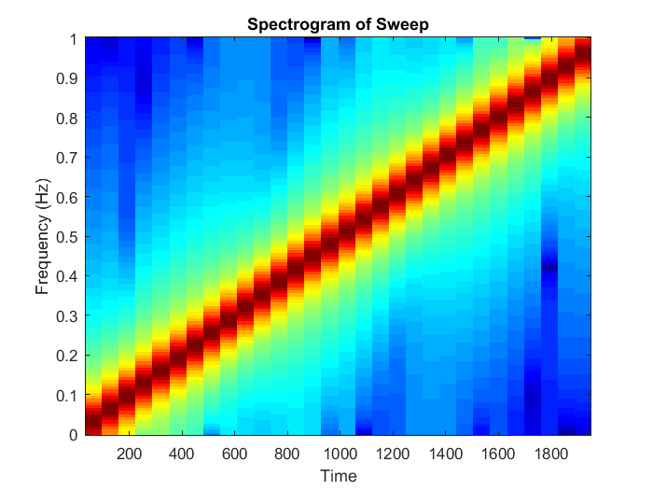

Figure 2: Spectrogram of a Sweep

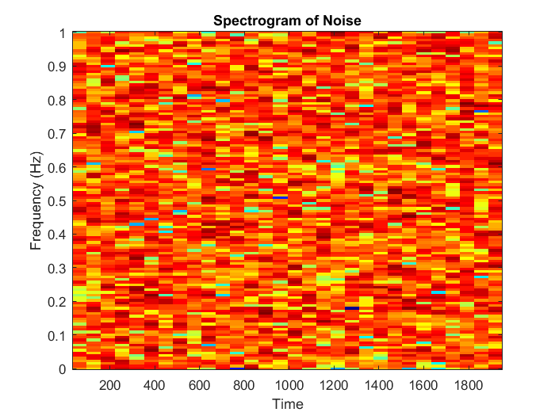

Figure 3: Spectrogram of Noise

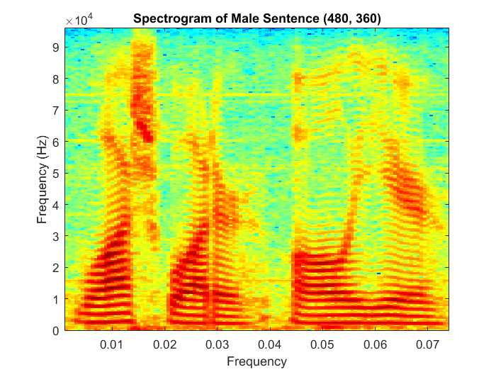

Figure 4: Spectrogram of Male Sentence with parameters (480, 360)

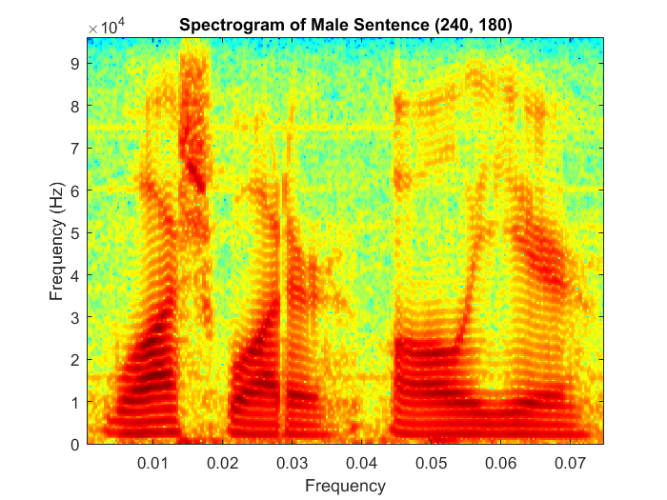

Figure 5: Spectrogram of Male Sentence with parameters (240, 180)

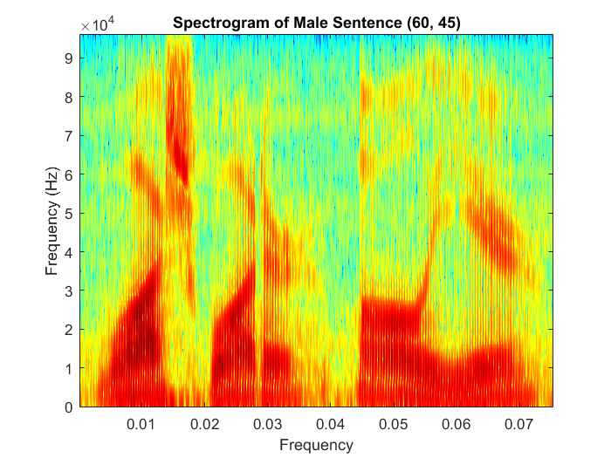

Figure 6: Spectrogram of a male sentence with parameters (60, 45)

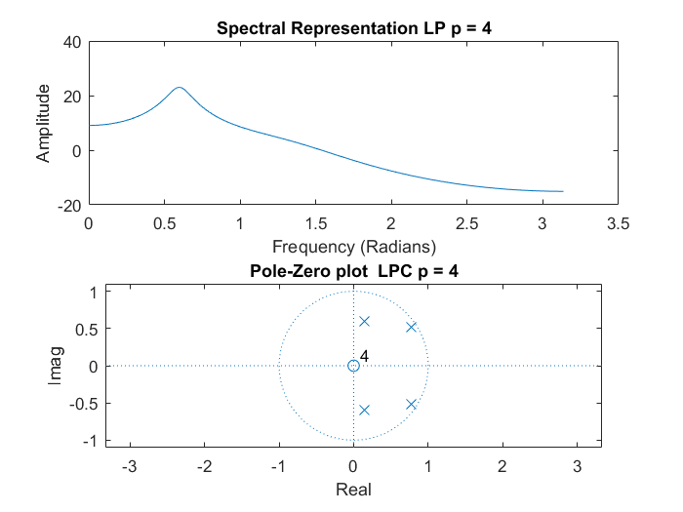

Figure 7: Spectral Representation with p = 4

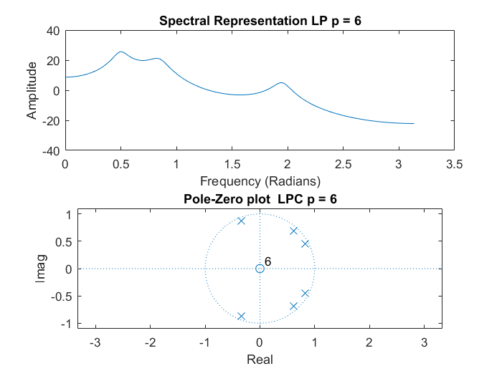

Figure 8: Spectral Representation with p = 6

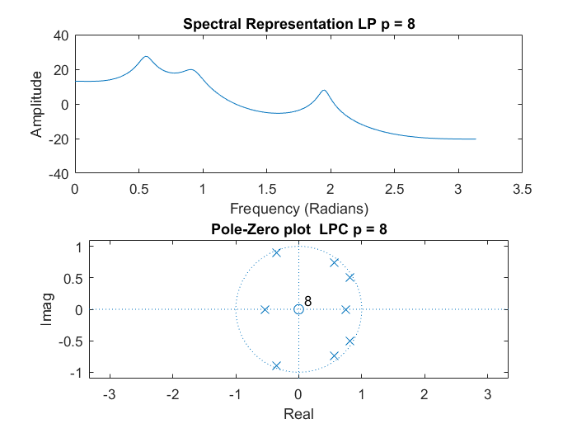

Figure 9: Spectral Representation with p = 8

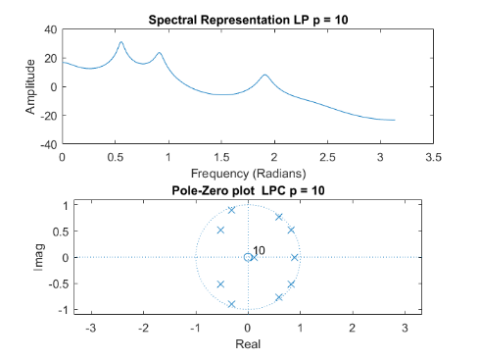

Figure 10: Spectral Representation with p = 10

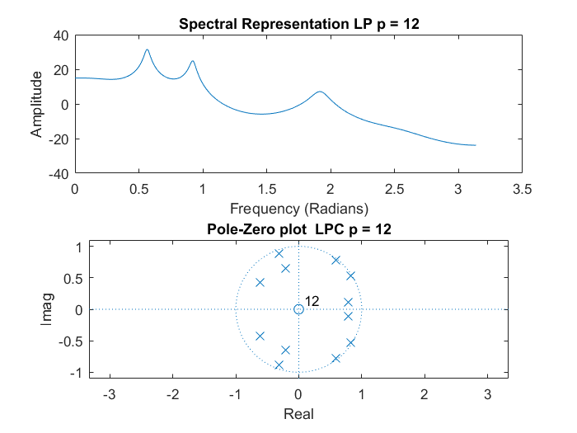

Figure 11: Spectral Representation with p = 12

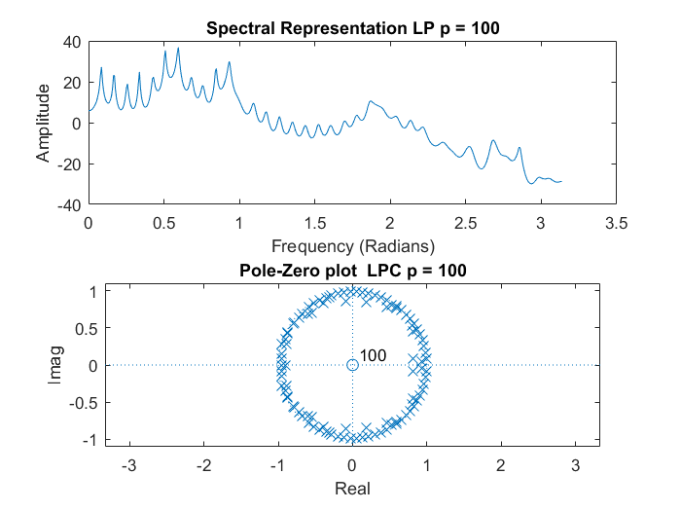

Figure 12: Spectral Representation with p = 100

Note that all of these spectral representations were calculated with Fs = 192000, picked arbitrarily. TODO: Is this right? I saw other solutions with 8000 Hz but that did not seem right.