Simulation of the python socket client / server programs worked on my computer.

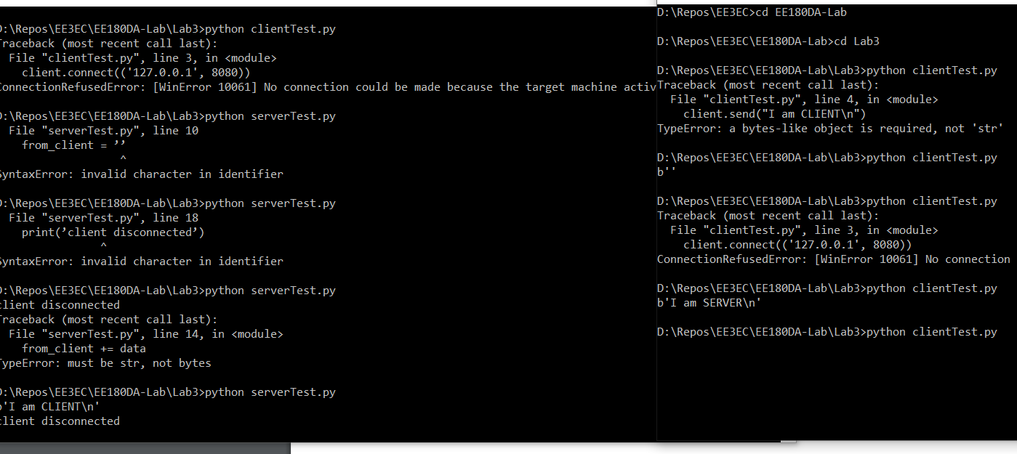

We then moved this program to the raspberry pi and tested the client on the RBP (with the PC acting as a server) and the server acting as the client (with the RBP acting as the server). There were no significant differences as can be observed in the below images.

Additionally, the simulation of MQTT worked well on my single computer.

