I2C does indeed work on my raspberry pi

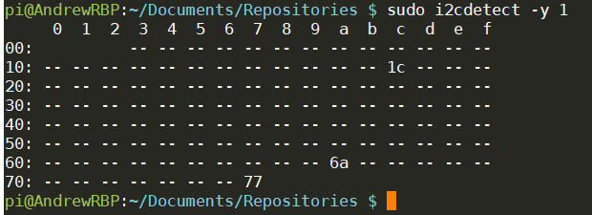

I was also able to run the BerryIMU script.

